What do people do at different festivals? Write.

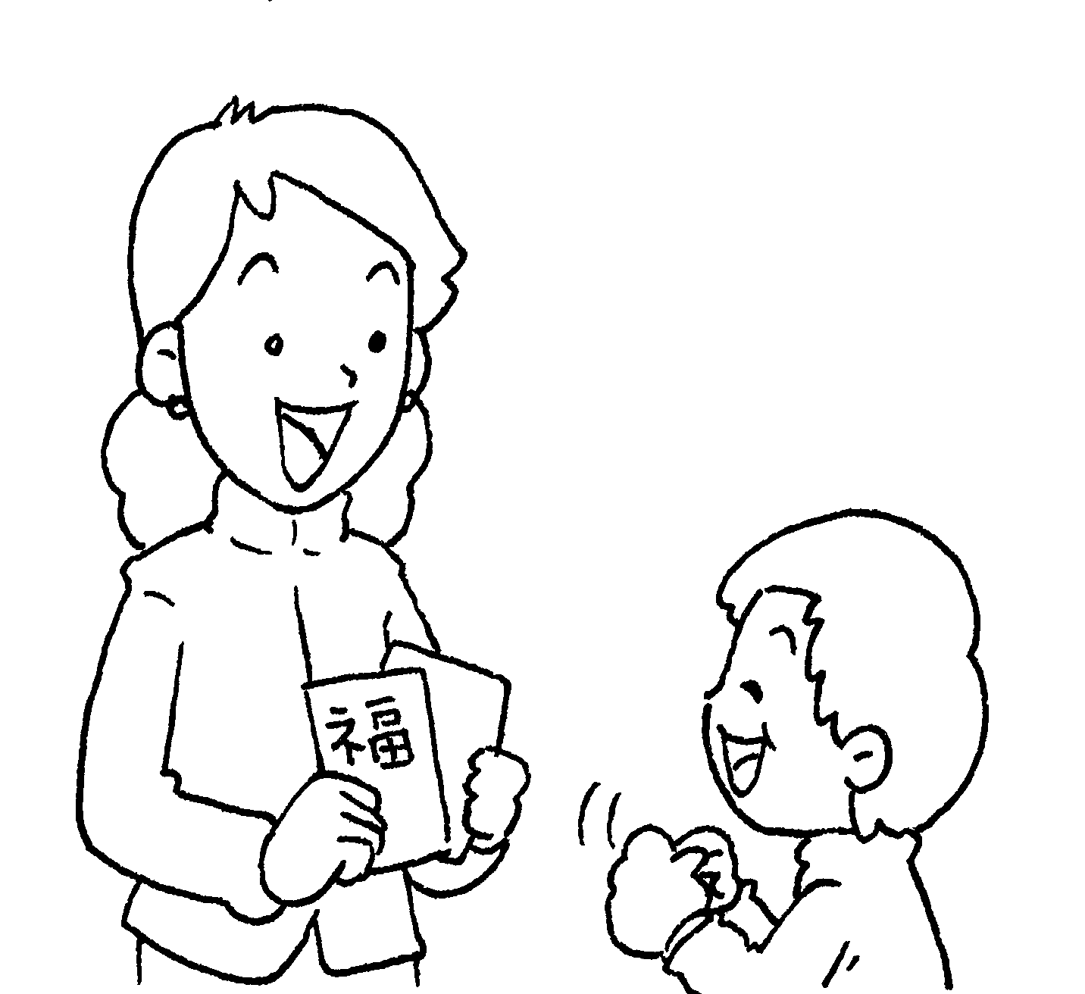  1  2  3  8  9  4  5  6  7 | 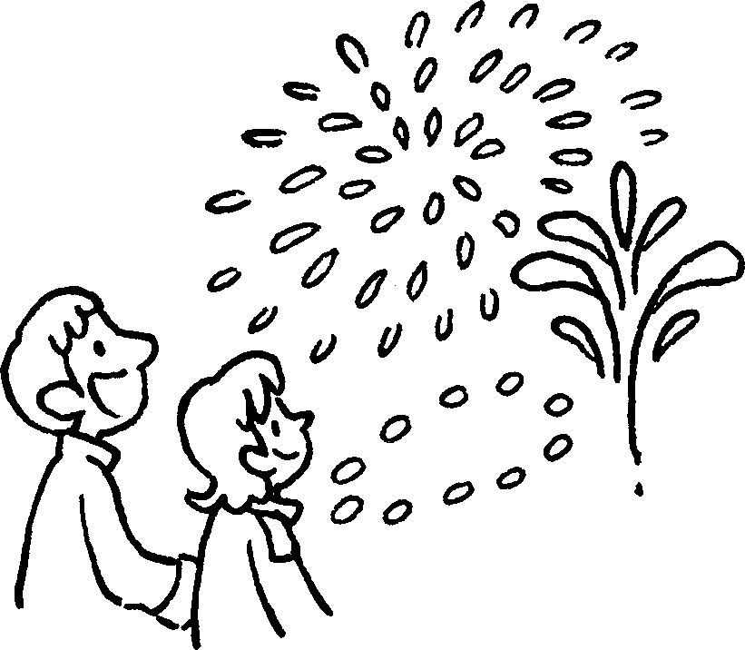 | 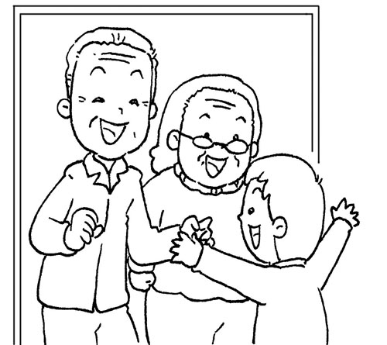
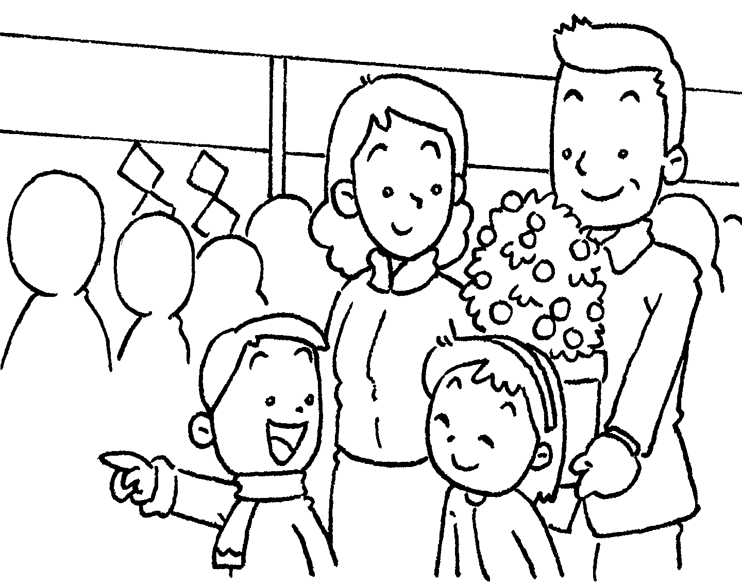 | 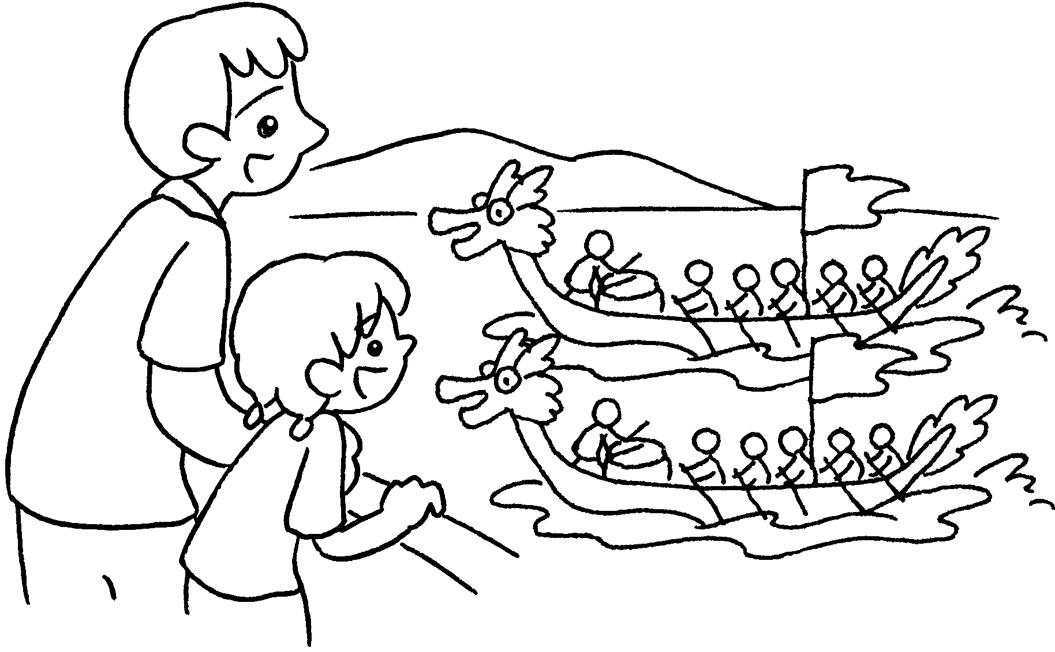 | 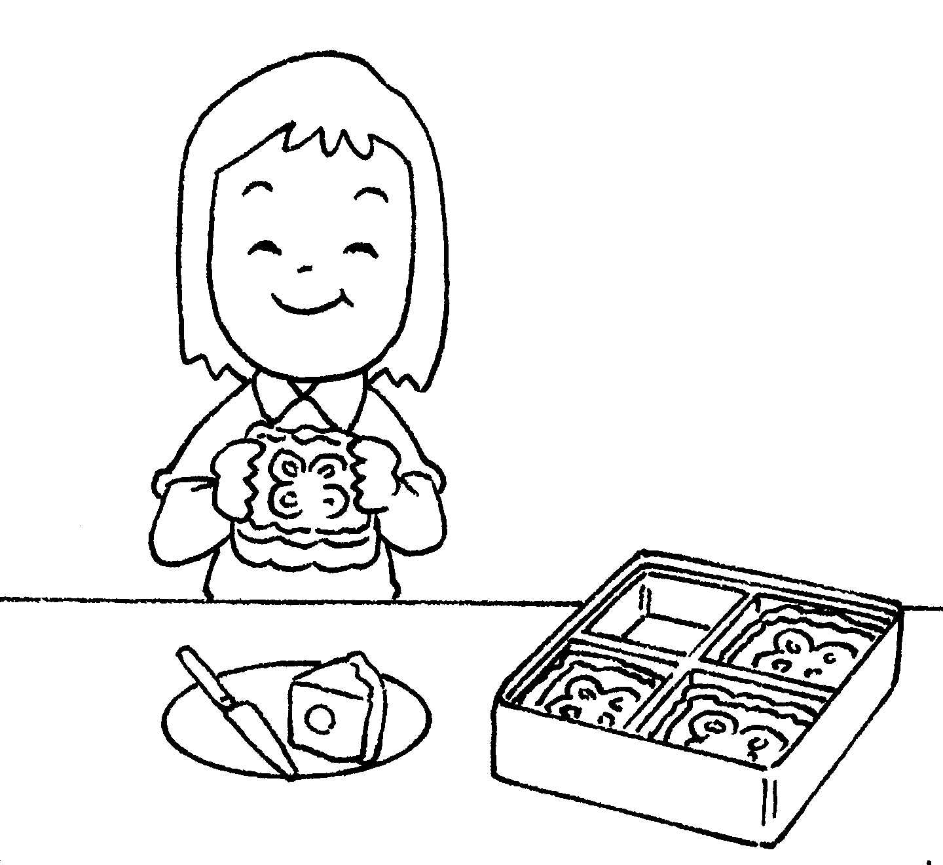
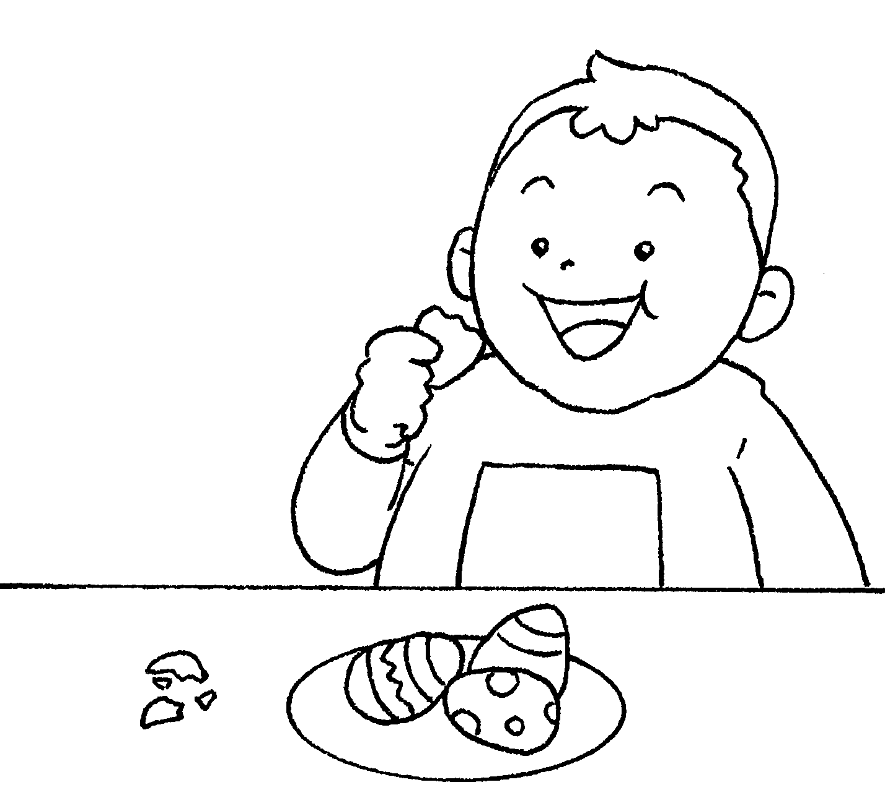 | 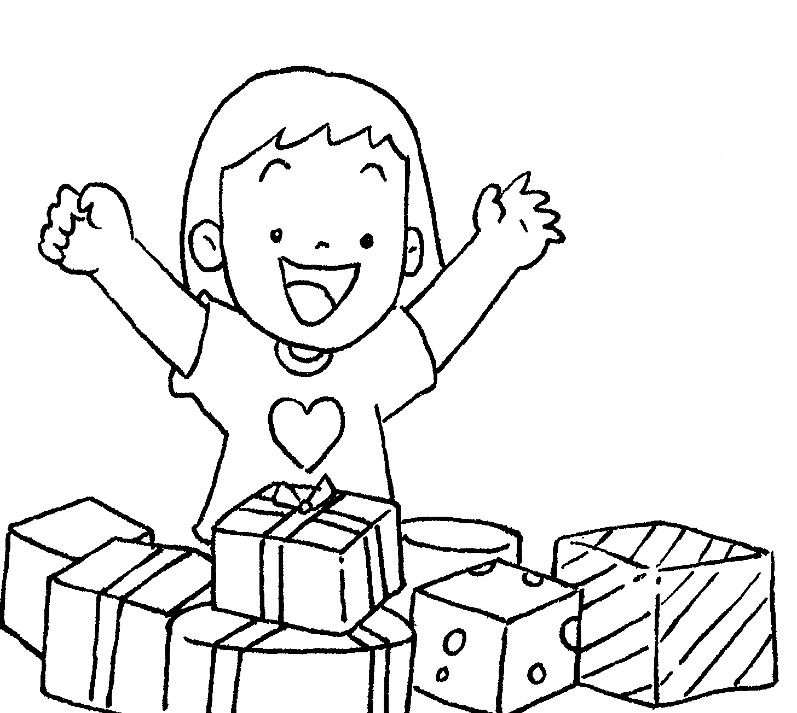 | 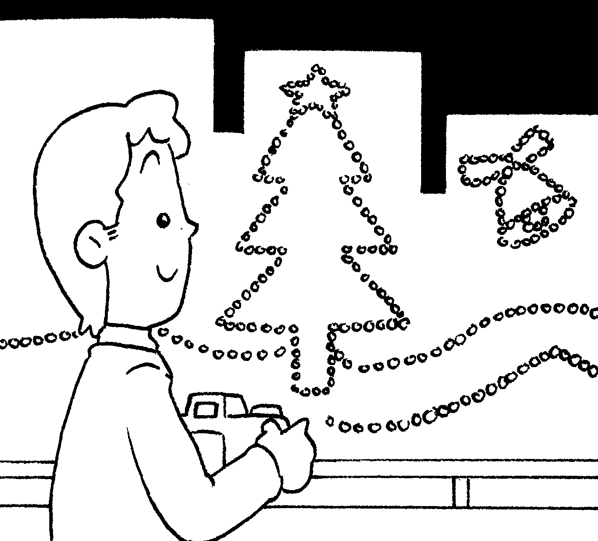
Chinese New Year Mid-Autumn Festival
1 get red p 6 eat
2 watch f Easter
3 visit r 7 eat
4 go to the
Christmas
Dragon Boat Festival 8 get
5 watch 9 look at the



Book 2B Chapter 6 Graded Worksheets
Worksheet 1⬇⬇⬇

packets
- fireworks
- relatives
- flower market
- dragon boat races
- moon cakes
- chocolate eggs
- presents
- Christmas lights

