Finish the sentences.

 | like | ...ing | at

1 | 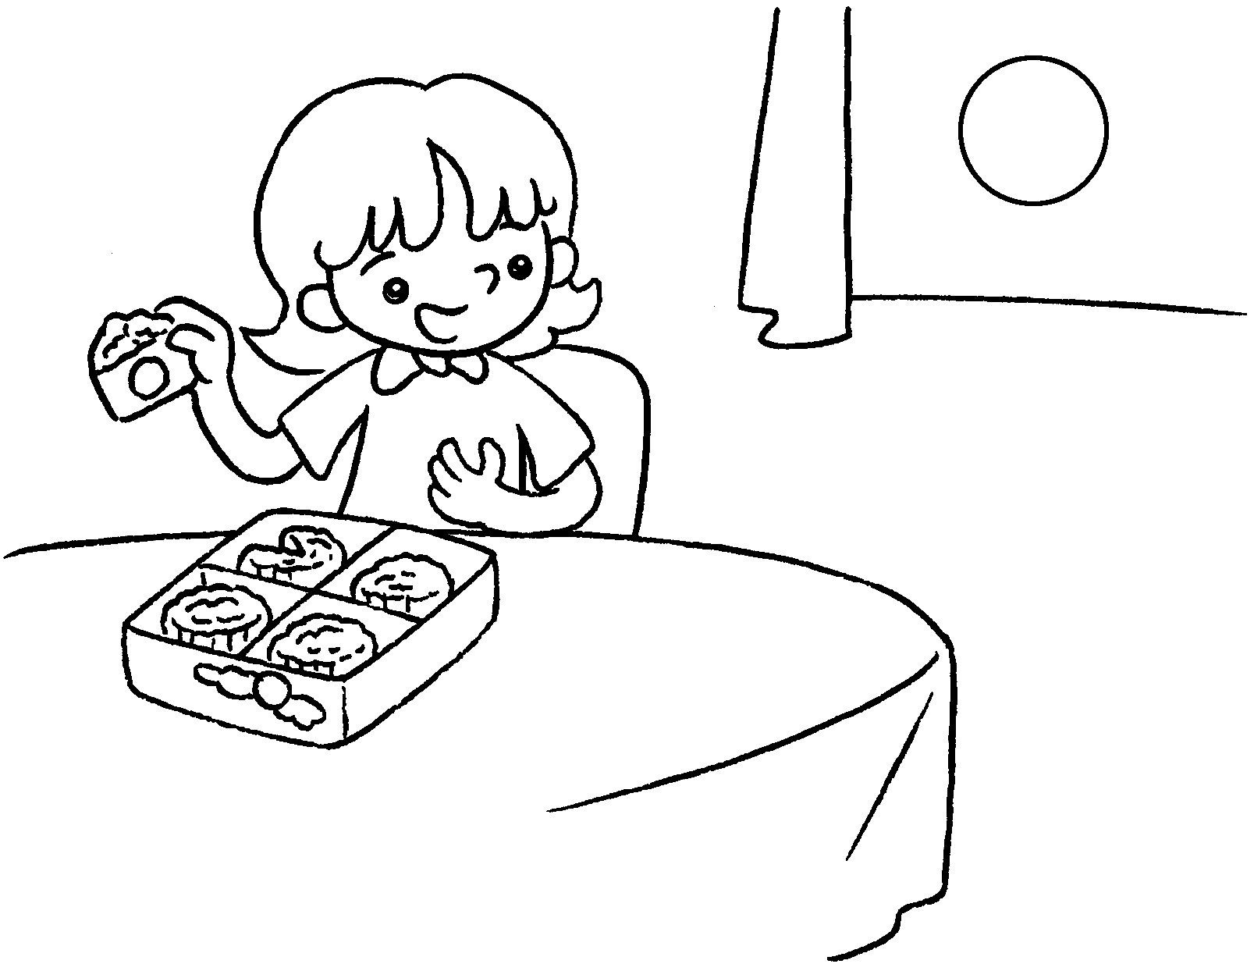  … | I like eating moon cakes  Mid-Autumn Festival.
2 | 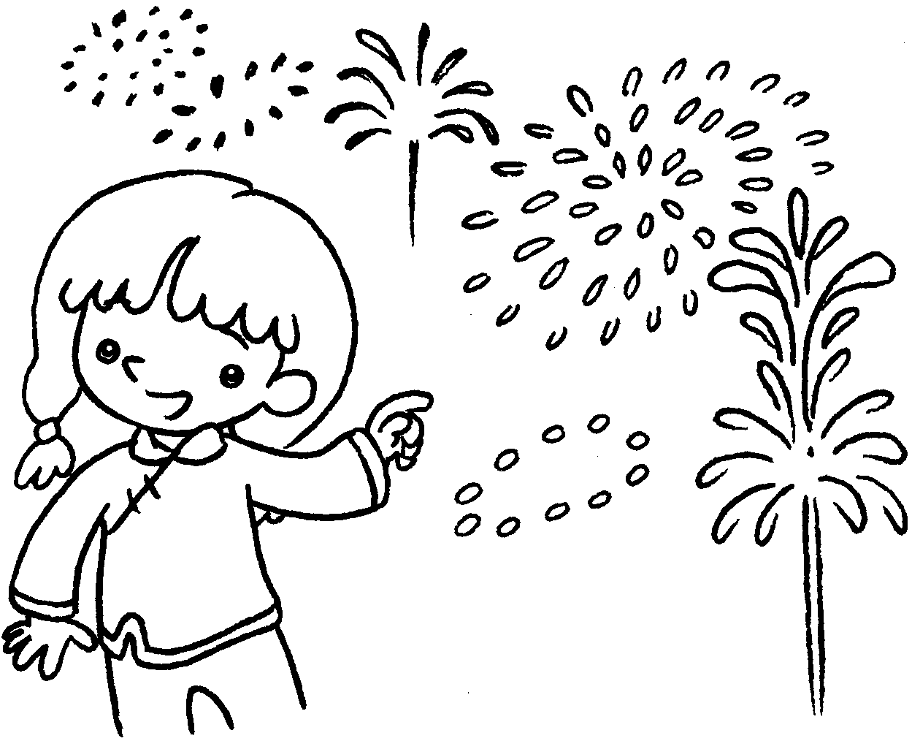  … | I like ( watch ) fireworks at Chinese New Year.
3 | 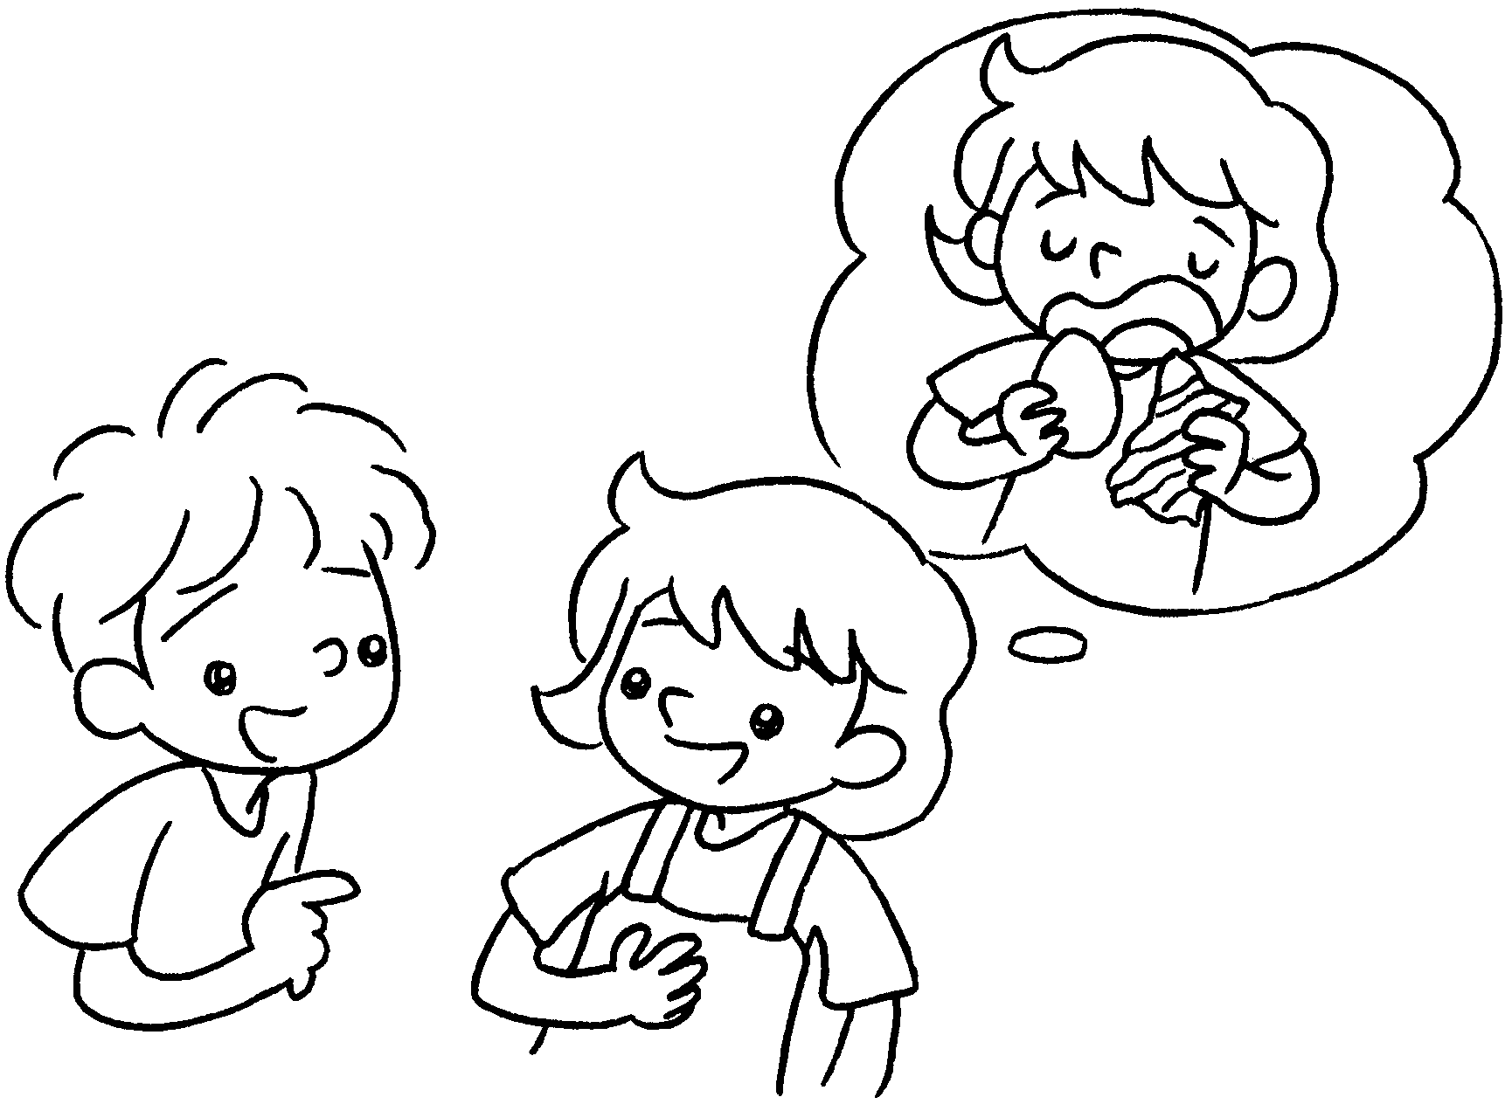  B  A | A : What do you like doing  Easter?  B : I  ( eat ) chocolate eggs at  Easter.
4 | 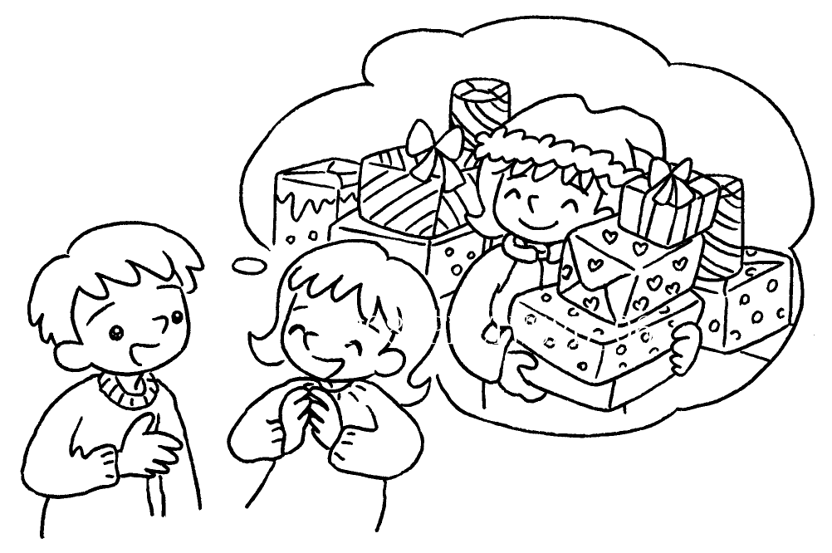  B  A | A : What do you  ( do ) at  Christmas?  B : I  ( get ) presents  Christmas.


Book 2B Chapter 6 Graded Worksheets
Worksheet 2⬇
- at
- watching
- at
like eating
4 like doing
like getting at

