What do the people like doing at different festivals? Write.

watch fireworks get presents
at
eat chocolate eggs

1 | 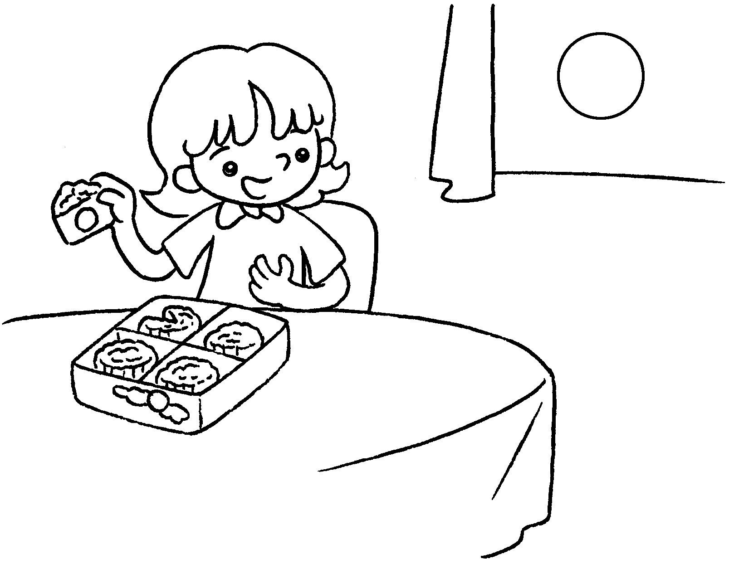  … | I like eating moon cakes  Mid-Autumn Festival.
2 | 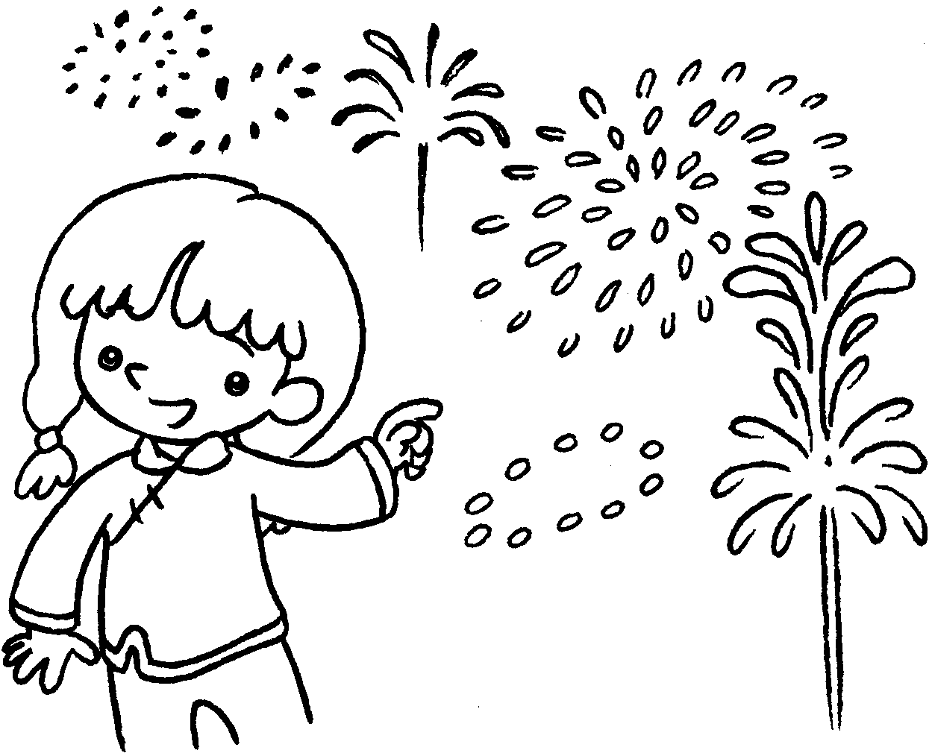  … | I like  at Chinese New Year.
3 | 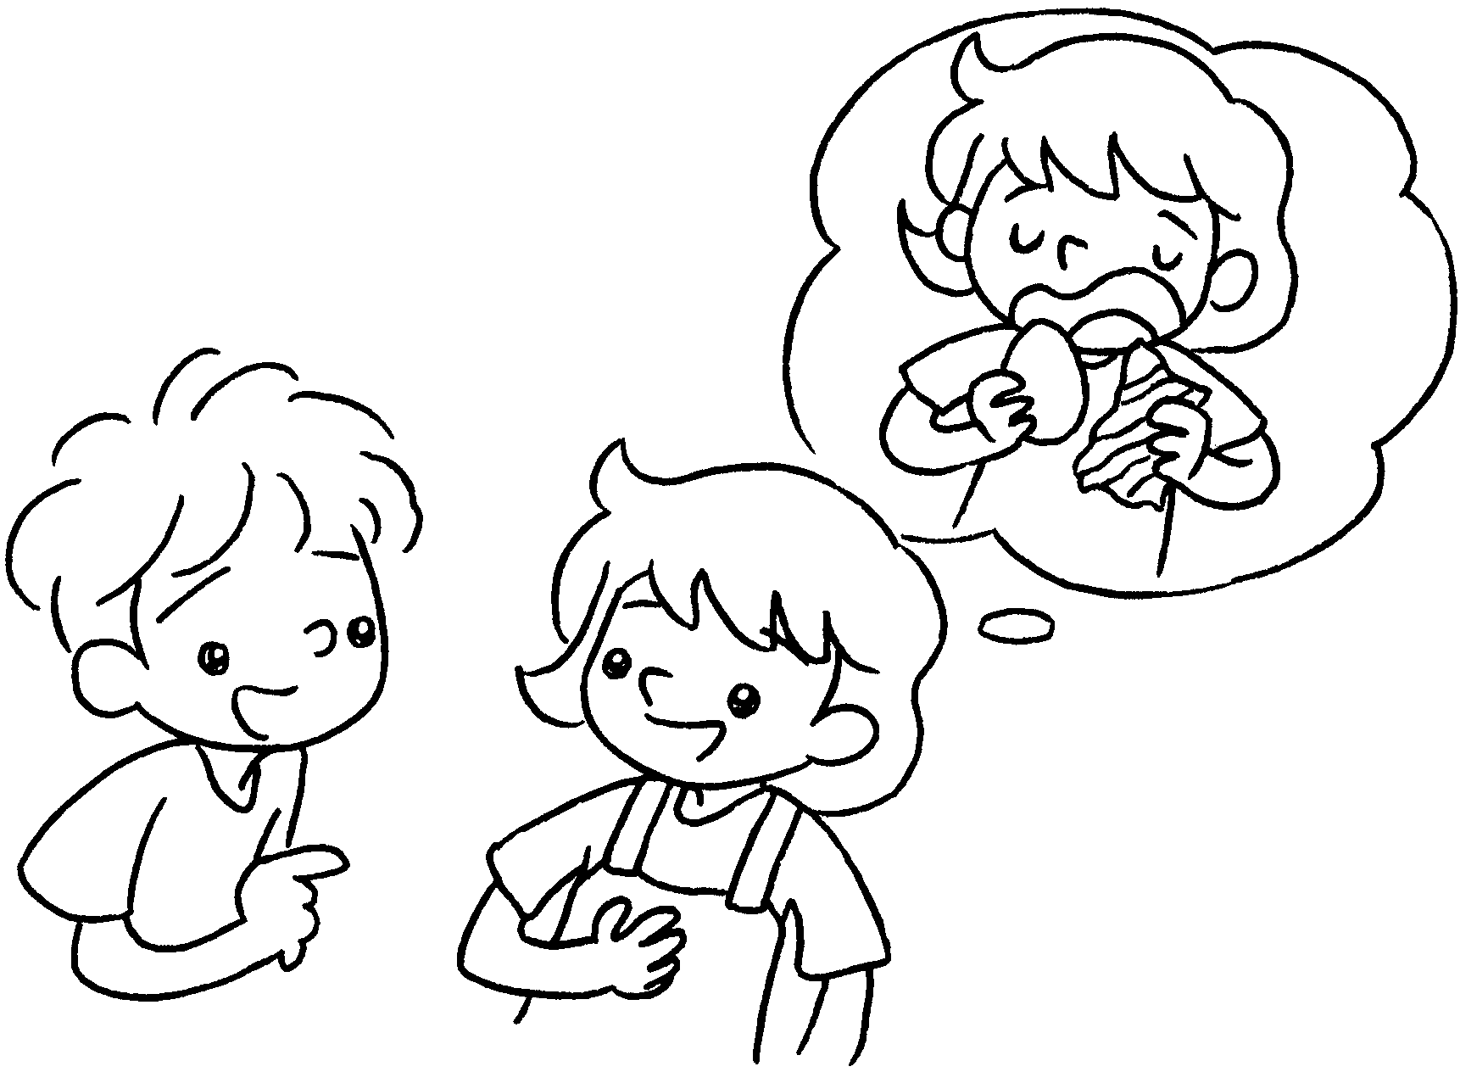  B  A | A : What do you like doing  Easter?  B : I  Easter.
4 | 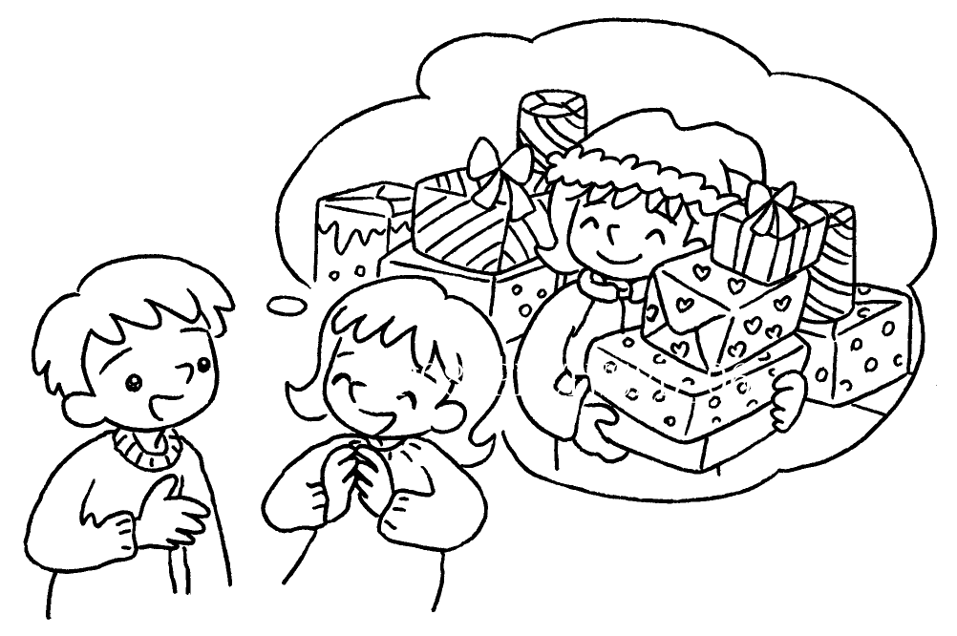  B  A | A : What do you  at Christmas?  B : I  .


Book 2B Chapter 6 Graded Worksheets
Worksheet 2⬇⬇
- at
- watching fireworks
- at
like eating chocolate eggs at
- like doing
like getting presents at Christmas

