What do the people like doing at different festivals? Write.

1 | 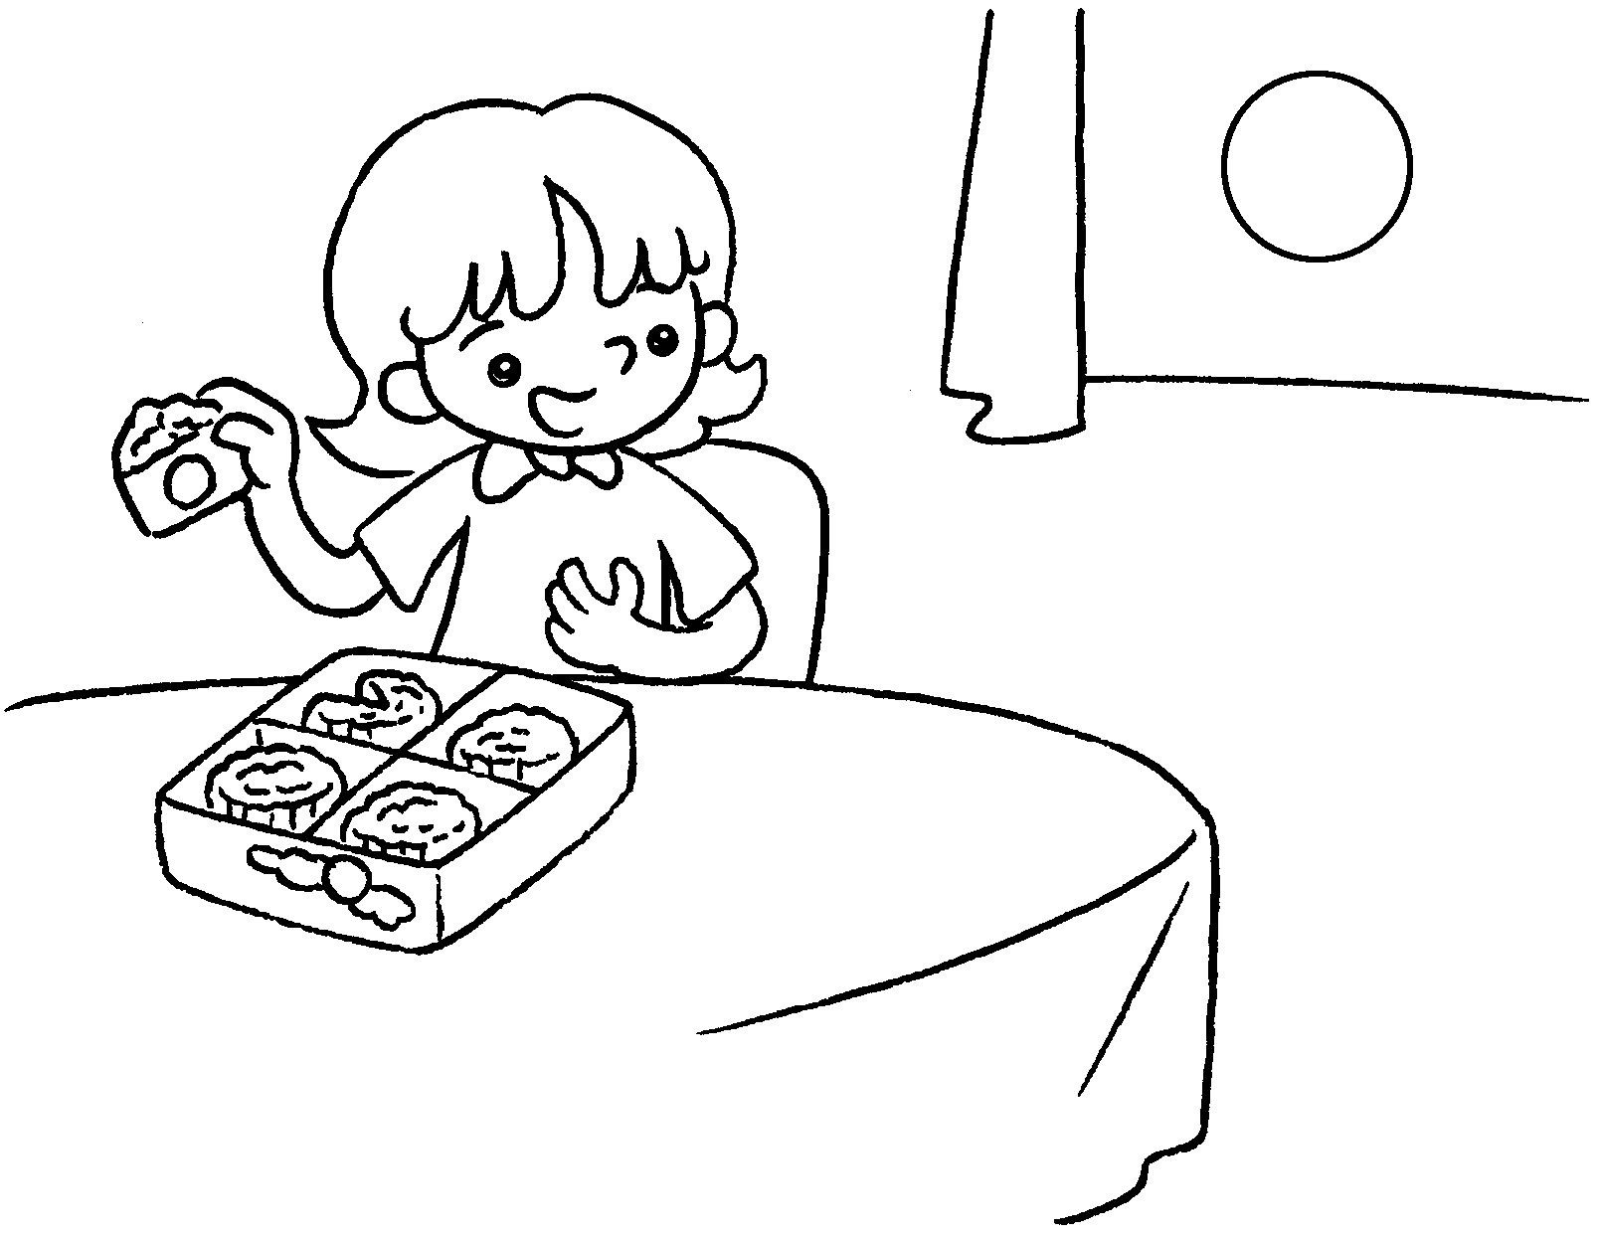  … | I like eating moon cakes  Mid-Autumn Festival.
2 | 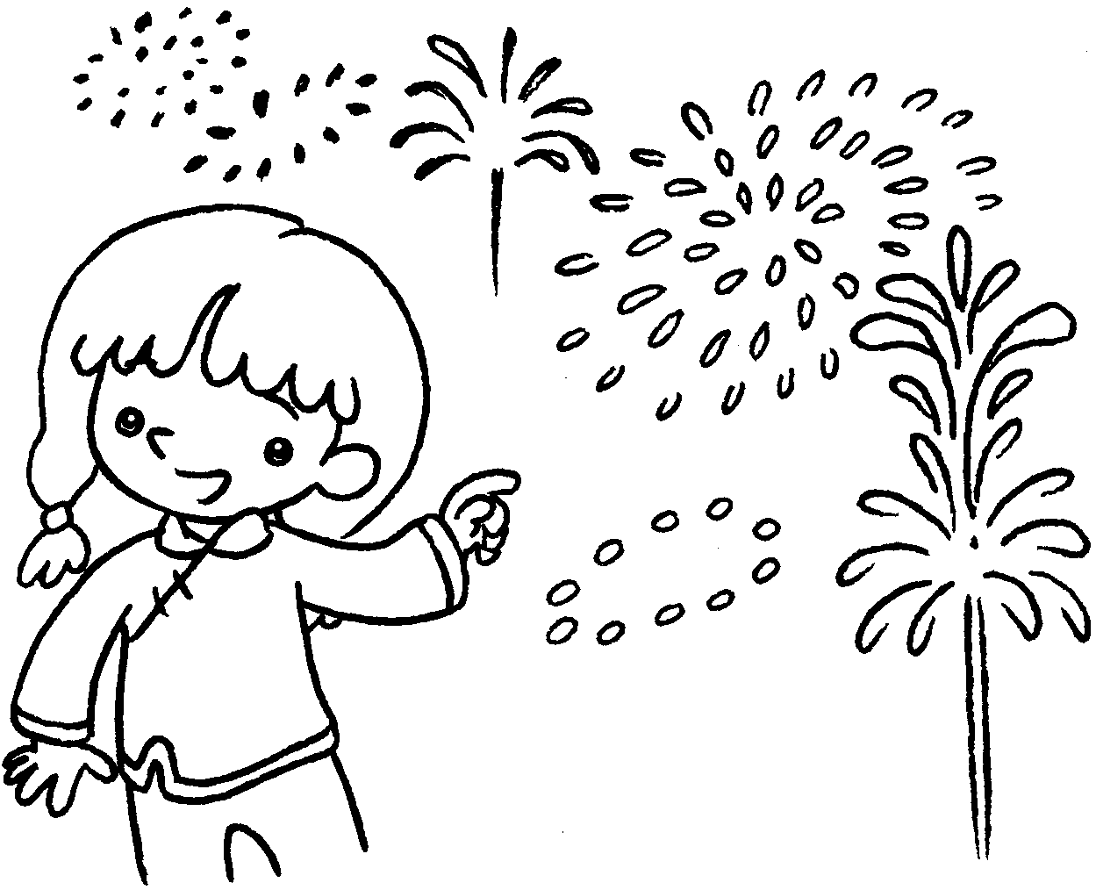  … | I like fireworks Chinese New Year.
3 | 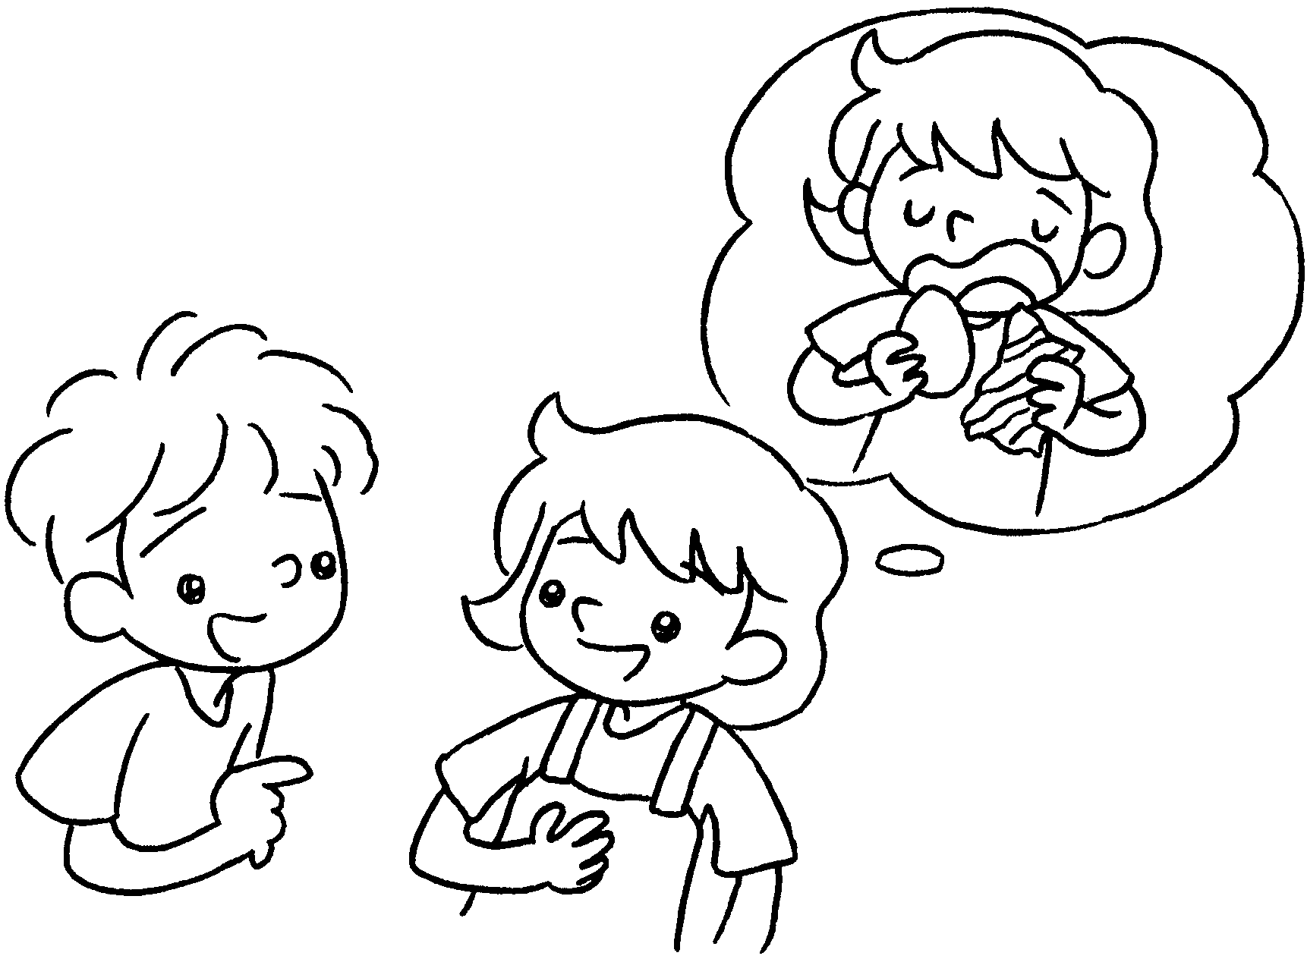  B  A | A : What do you like doing  Easter?  B : I  chocolate eggs  .
4 | 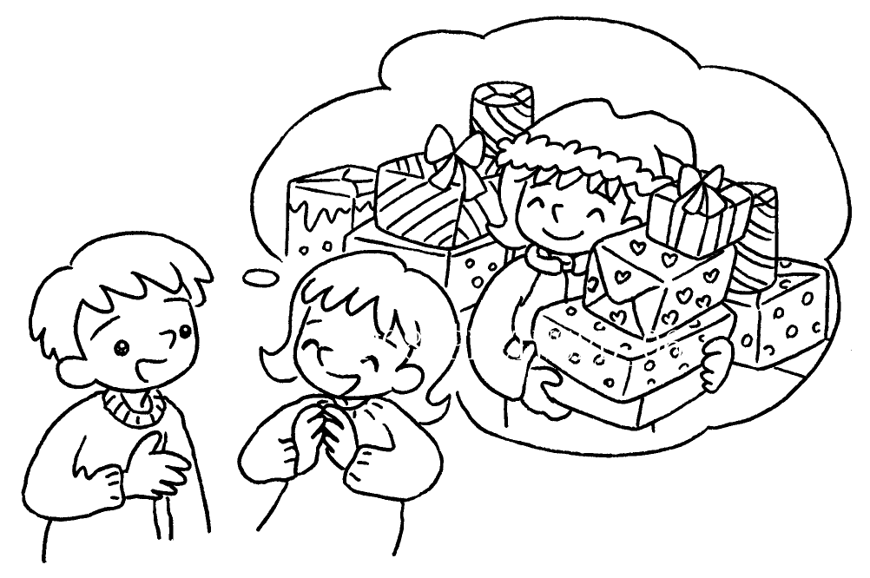  B  A | A : What do you  Christmas?  B :


Book 2B Chapter 6 Graded Worksheets
Worksheet 2⬇⬇⬇
- at
- watching at
- at
like eating at Easter
- like doing at
I like getting presents at Christmas.

