Choose and write.

 | What | Why |  | Because

1 |   B  A | A : My favourite festival is Chinese  New Year.  B : ?  A : Because I like getting red packets.
2 | 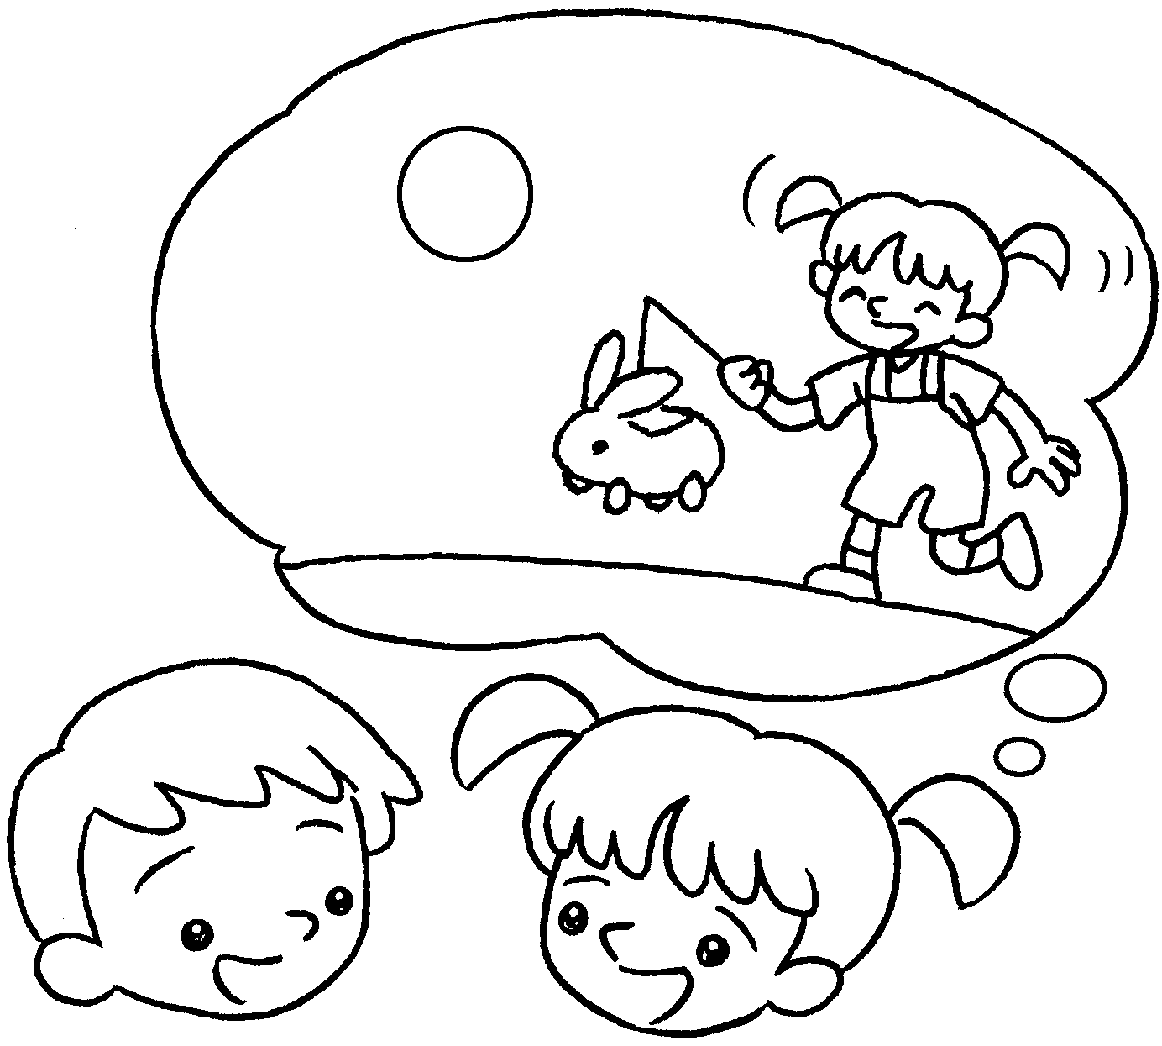  B  A | A : is your favourite  festival?  B : My favourite festival is  Mid-Autumn Festival.
3 | 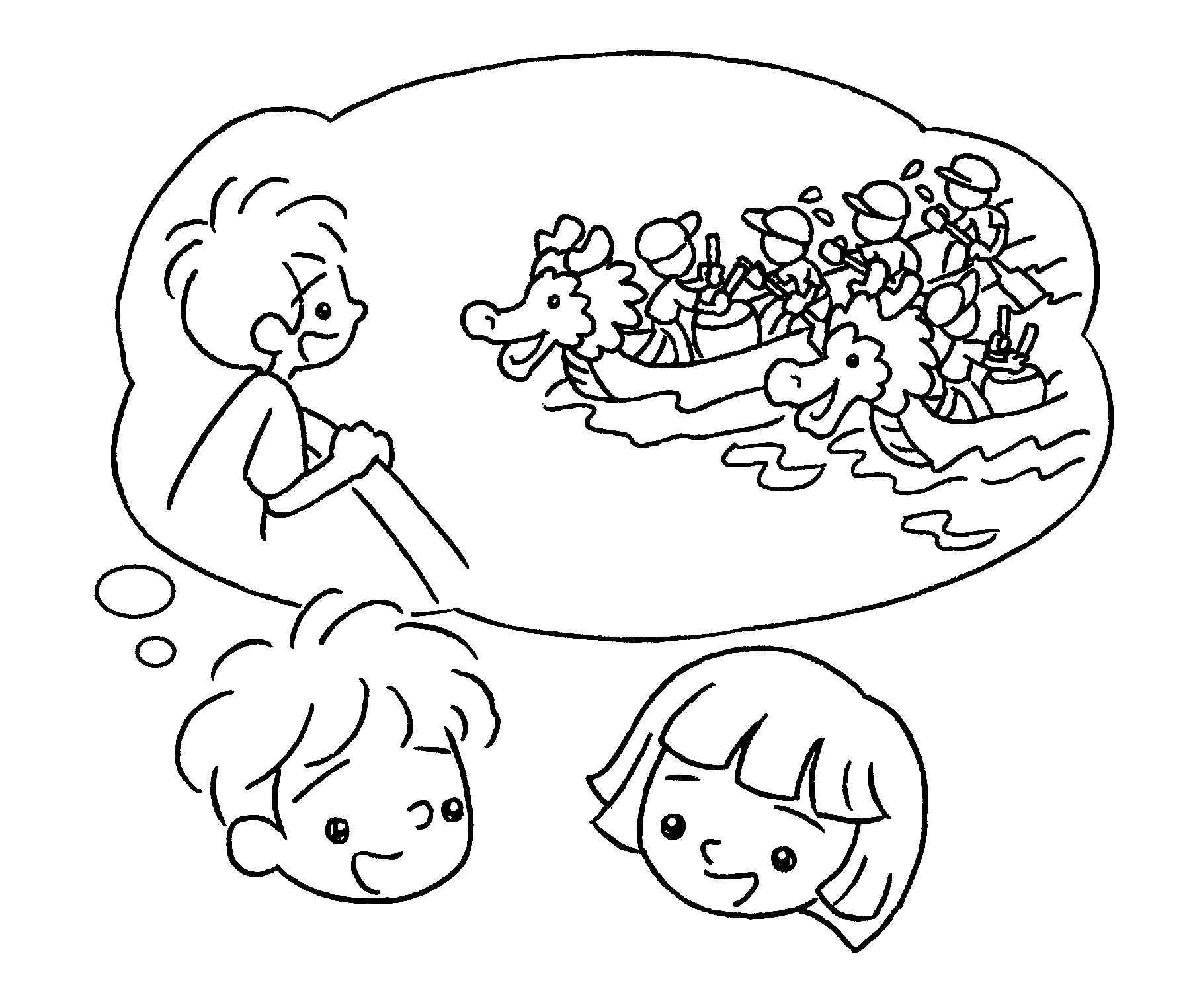  B  A | A : My favourite festival is Dragon  Boat Festival.  B : ?  A : I like watching  dragon boat races.
4 | 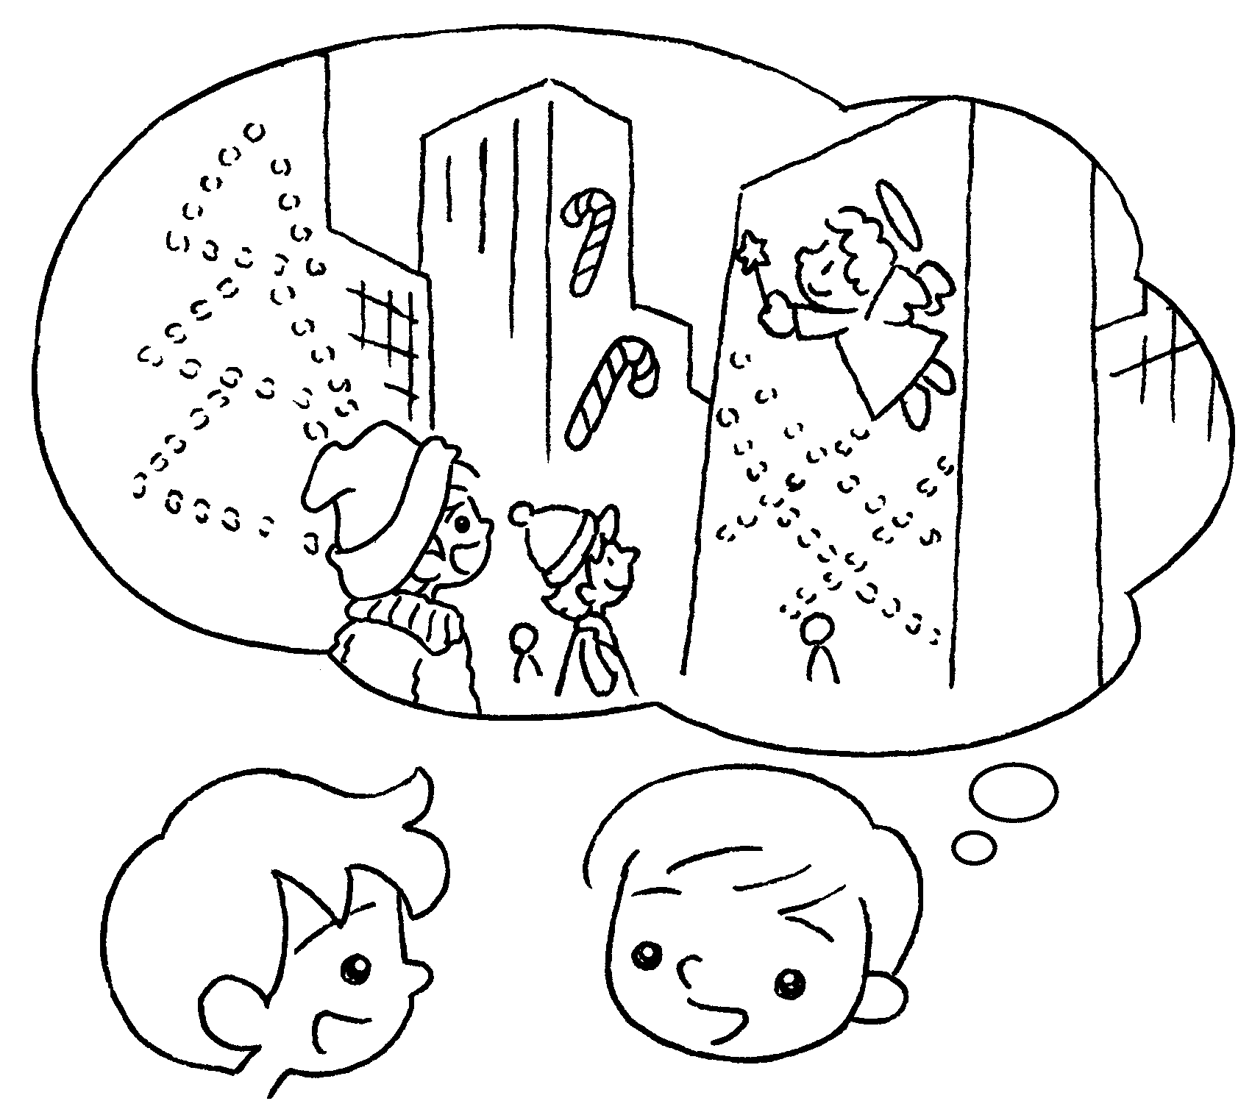  B  A | A : is your favourite  festival?  B : My favourite festival is Christmas.  A : ?  B : I like looking at  the Christmas lights.


Book 2B Chapter 6 Graded Worksheets
Worksheet 3⬇
- Why
- What
- Why
Because
- What
Why
Because

