Finish the questions and answers.

What Why look at get watch

1 |   B  A | A : My favourite festival is Chinese  New Year.  B : ?  A : Because I like  red packets.
2 | 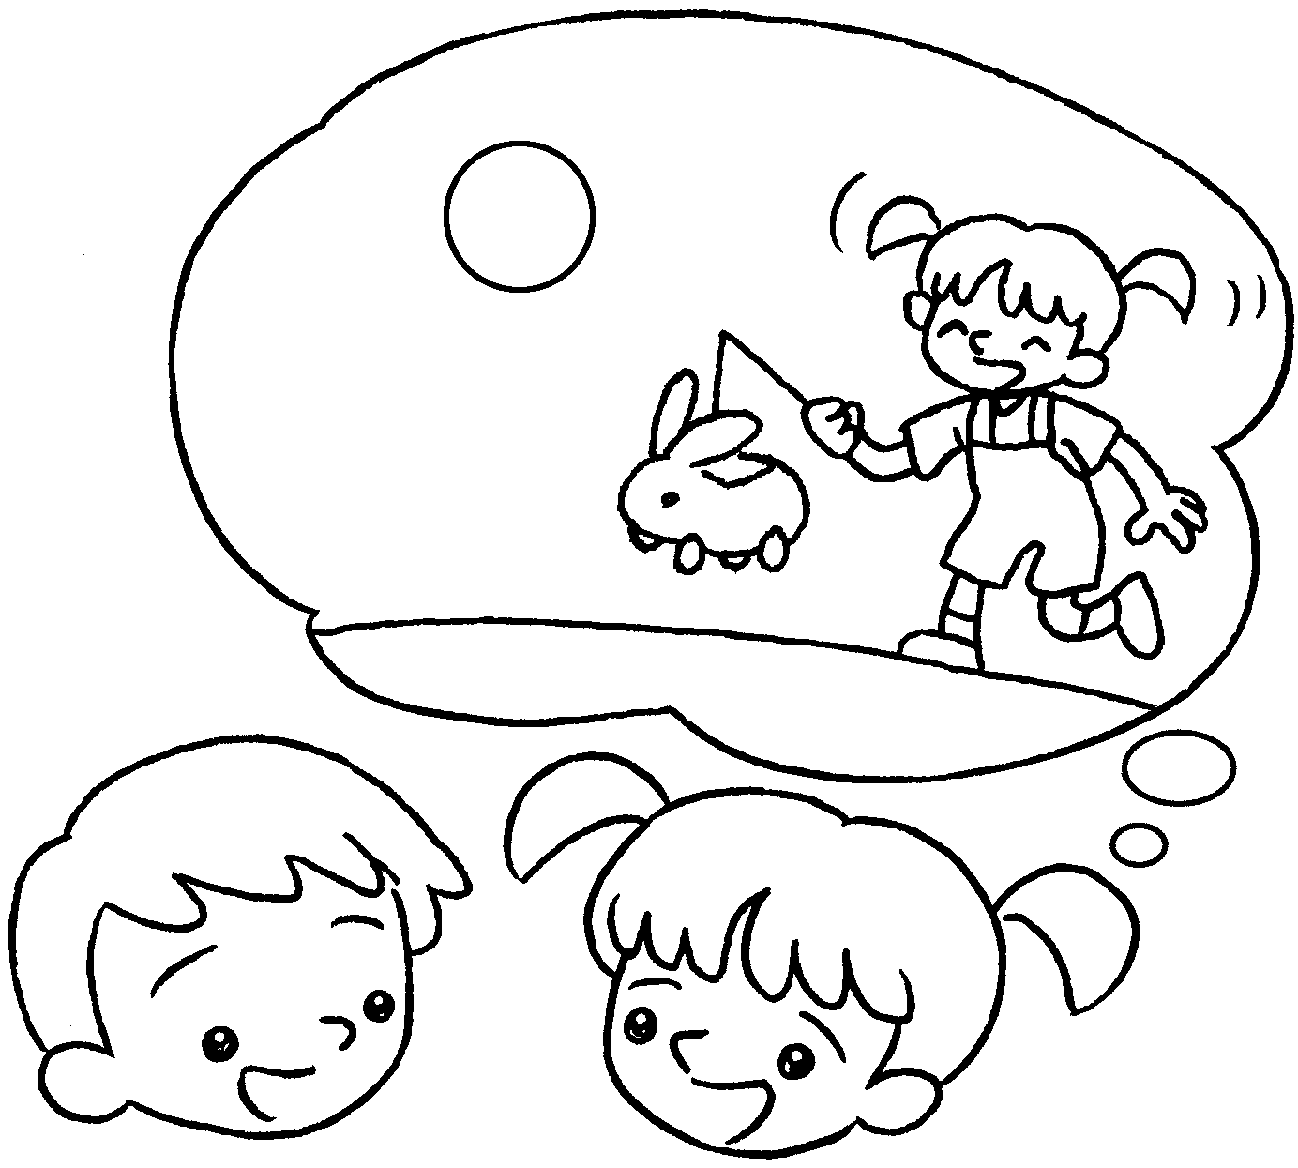  B  A | A : is your favourite  festival?  B : My festival is  Mid-Autumn Festival.
3 | 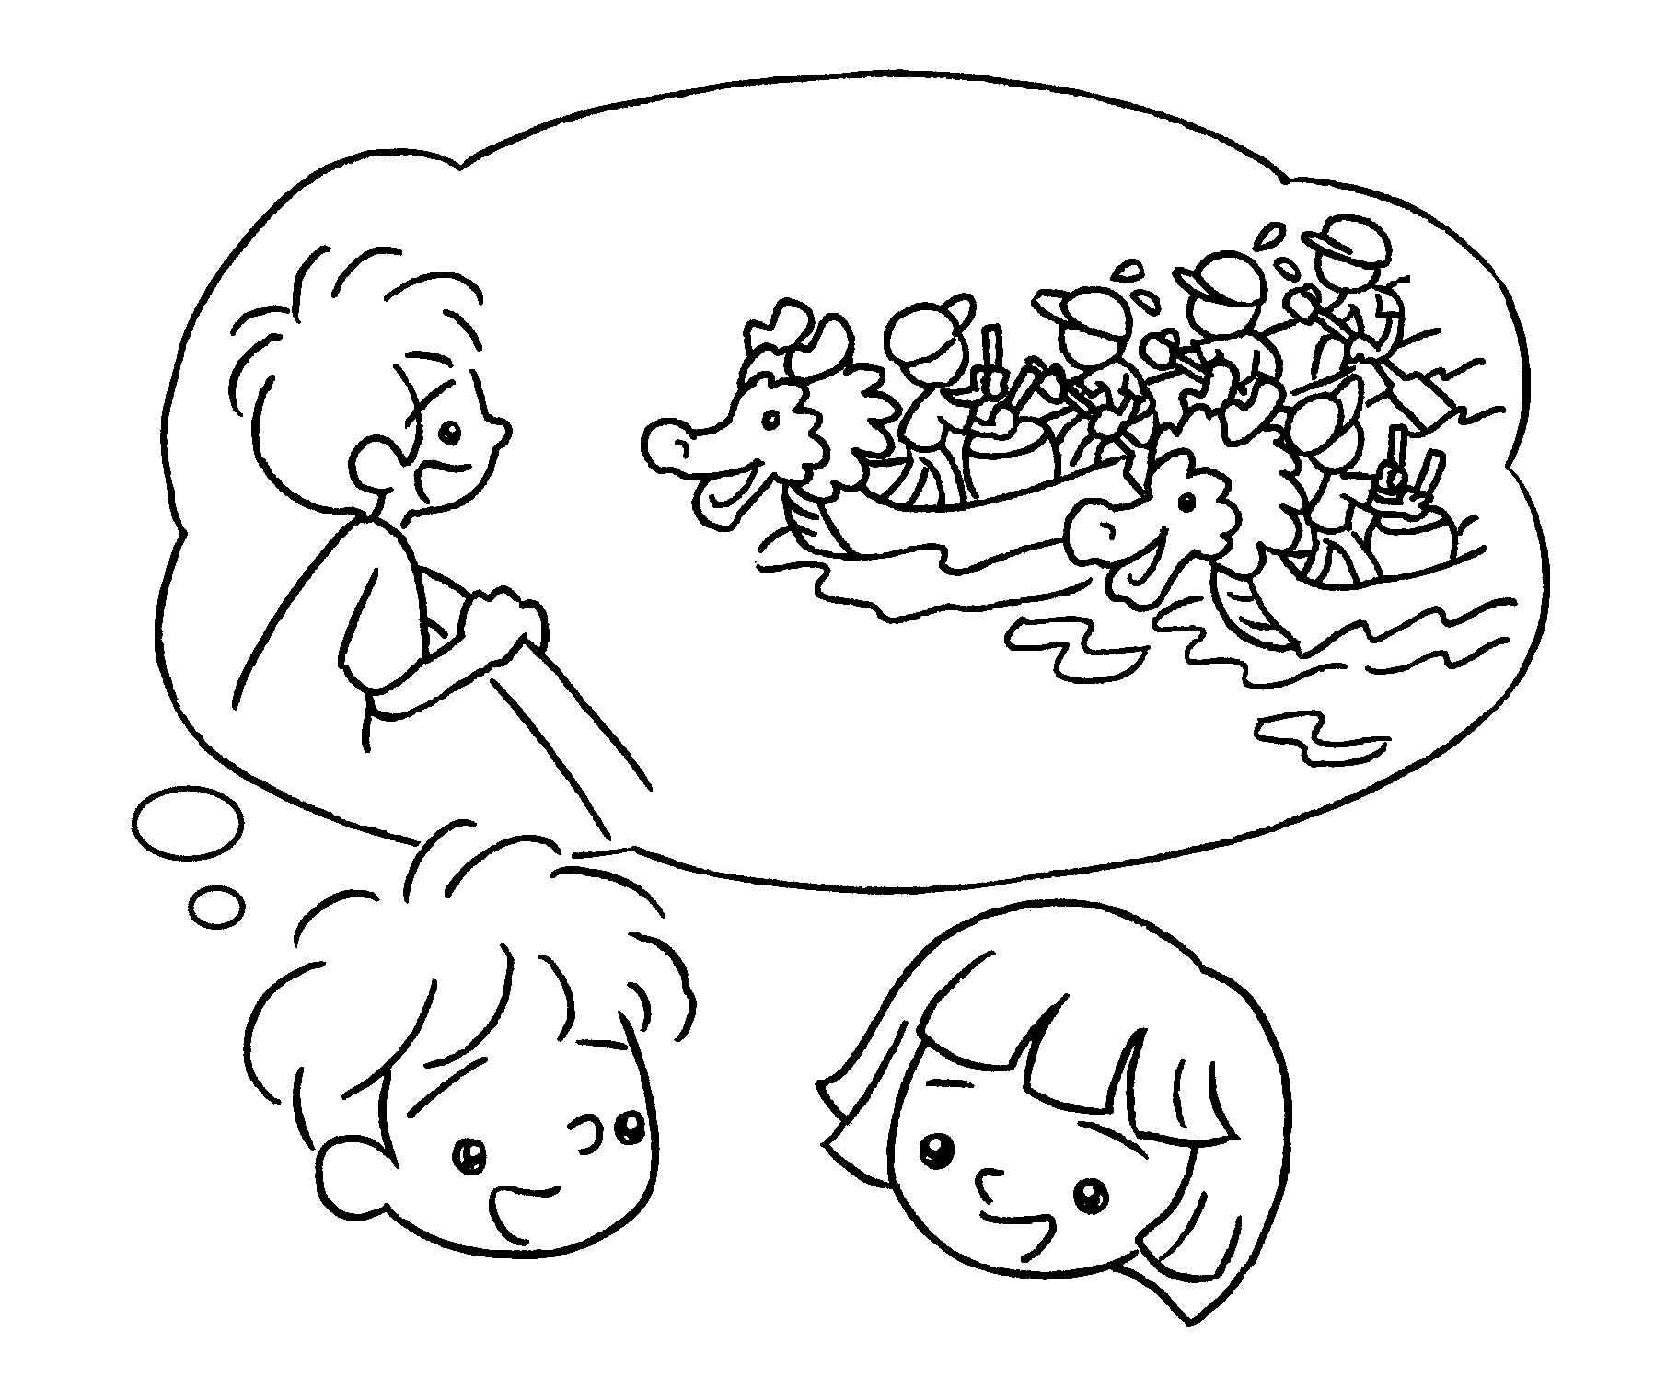  B  A | A : My favourite festival is Dragon  Boat Festival.  B : ?  A : I like dragon boat races.
4 | 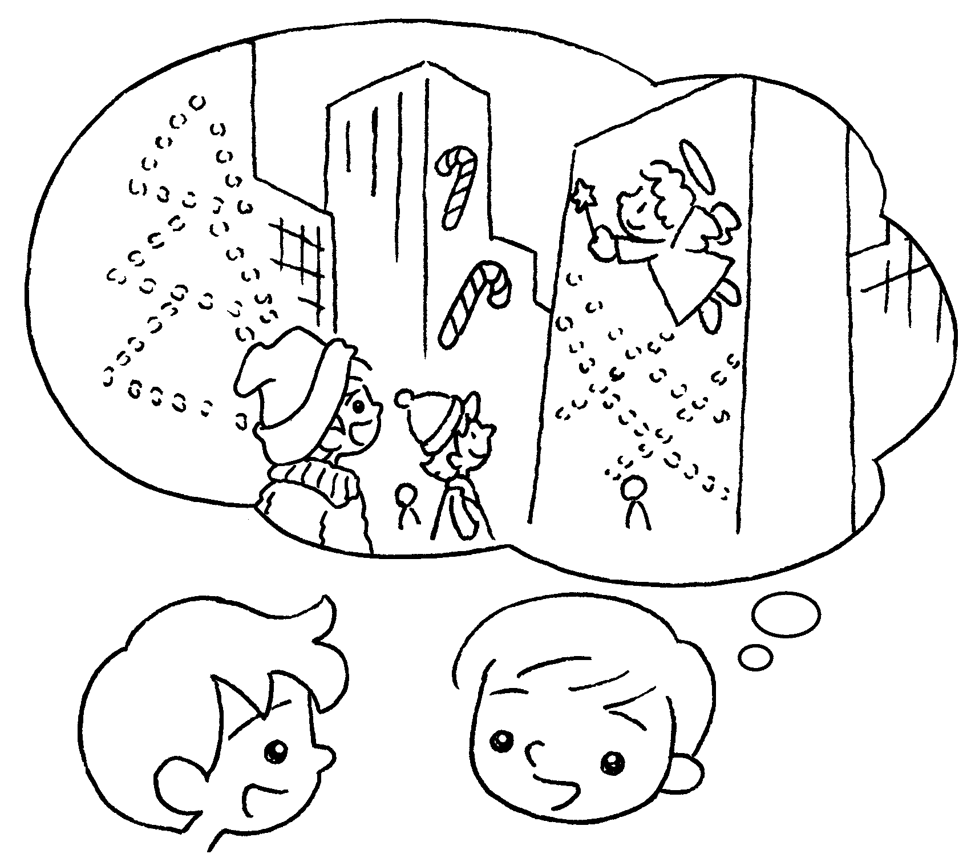  B  A | A : is your favourite  festival?  B : My favourite festival is Christmas.  A : ?  B : I like  the Christmas lights.


Book 2B Chapter 6 Graded Worksheets
Worksheet 3⬇⬇
- Why
getting
- What
favourite
- Why
Because watching
- What
Why
Because looking at

