Finish the questions and answers.

1 |   B  A | A : My favourite festival is Chinese  New Year.  Why  B : ?  A : Because I like  red packets.
2 | 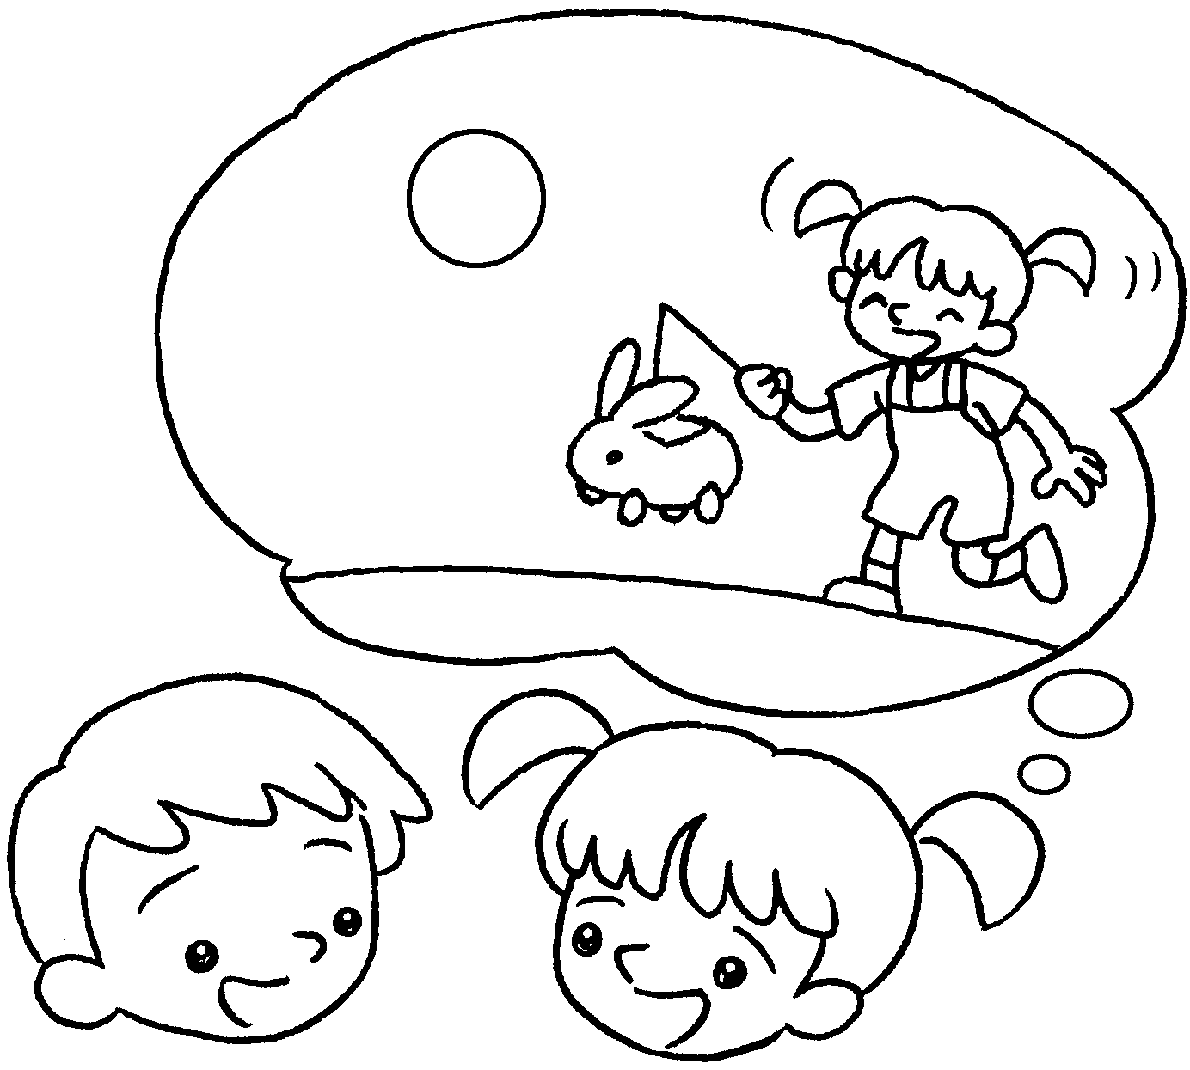  B  A | What  A : is your favourite  festival?  B : My festival is  .
3 | 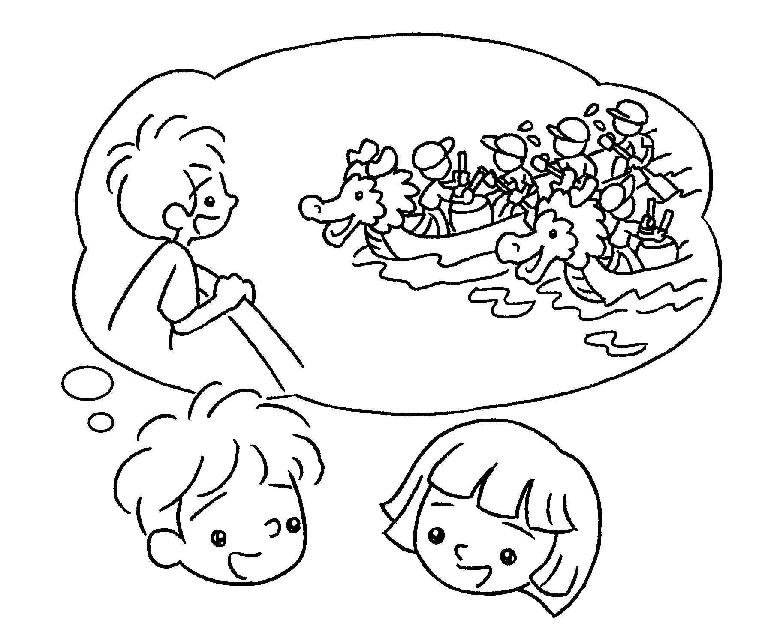  B  A | A : My favourite festival is  .  B : ?  A : I like dragon boat races.
4 | 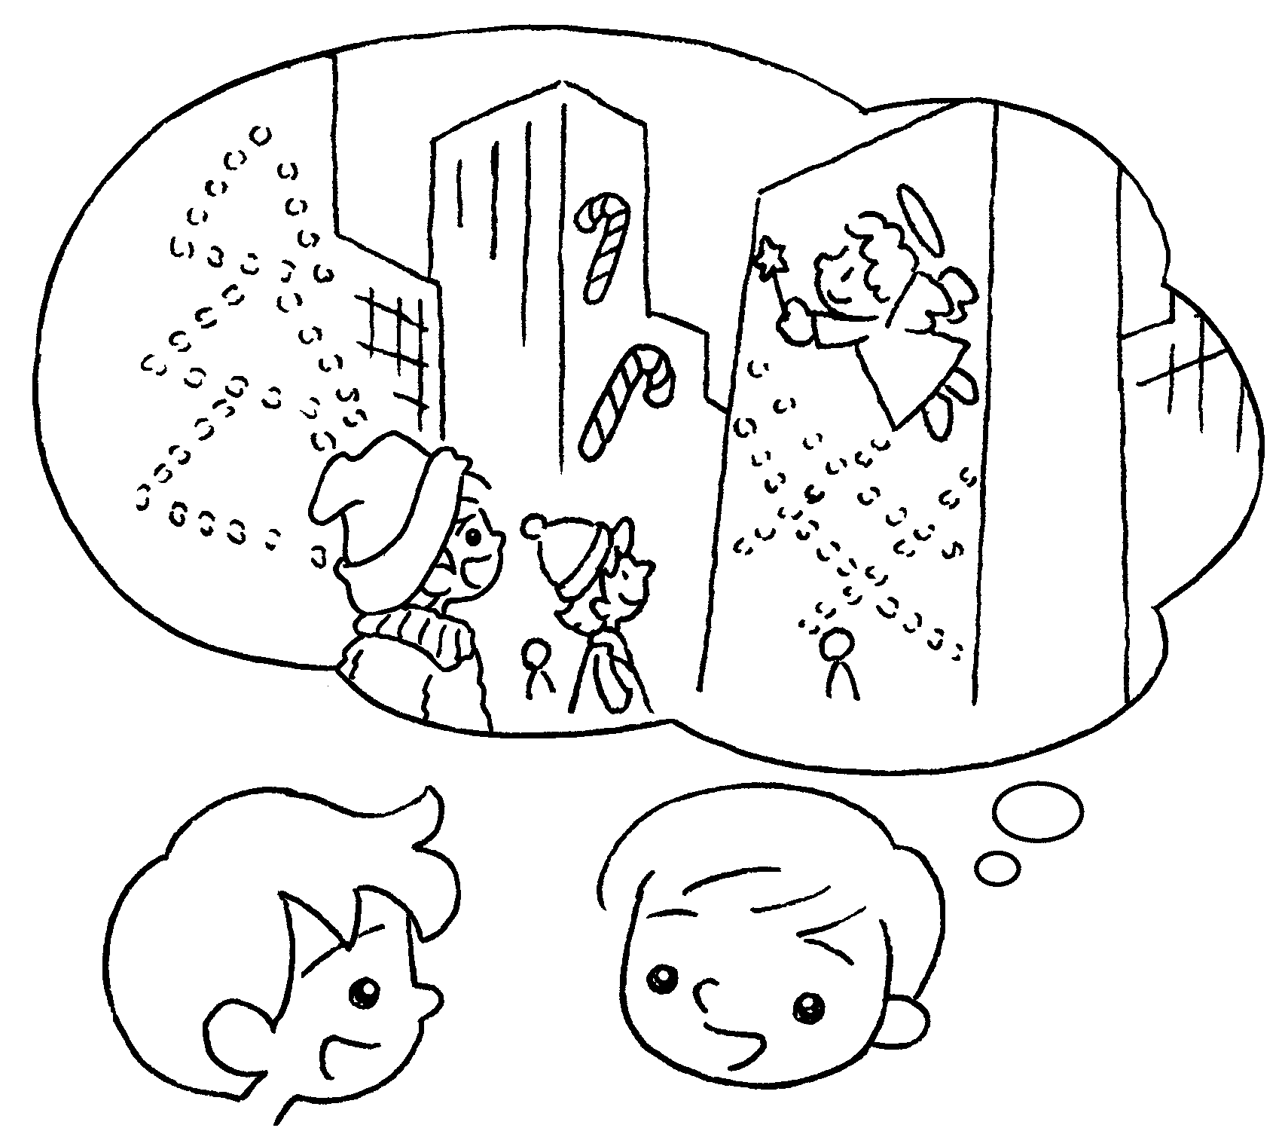  B  A | A : is your favourite  festival?  B : My  .  A : ?  B : I like  the Christmas lights.


Book 2B Chapter 6 Graded Worksheets
Worksheet 3⬇⬇⬇
- getting
- favourite Mid-Autumn Festival
- Dragon Boat Festival
Why
Because watching
- What
favourite festival is Christmas
Why
Because looking at

