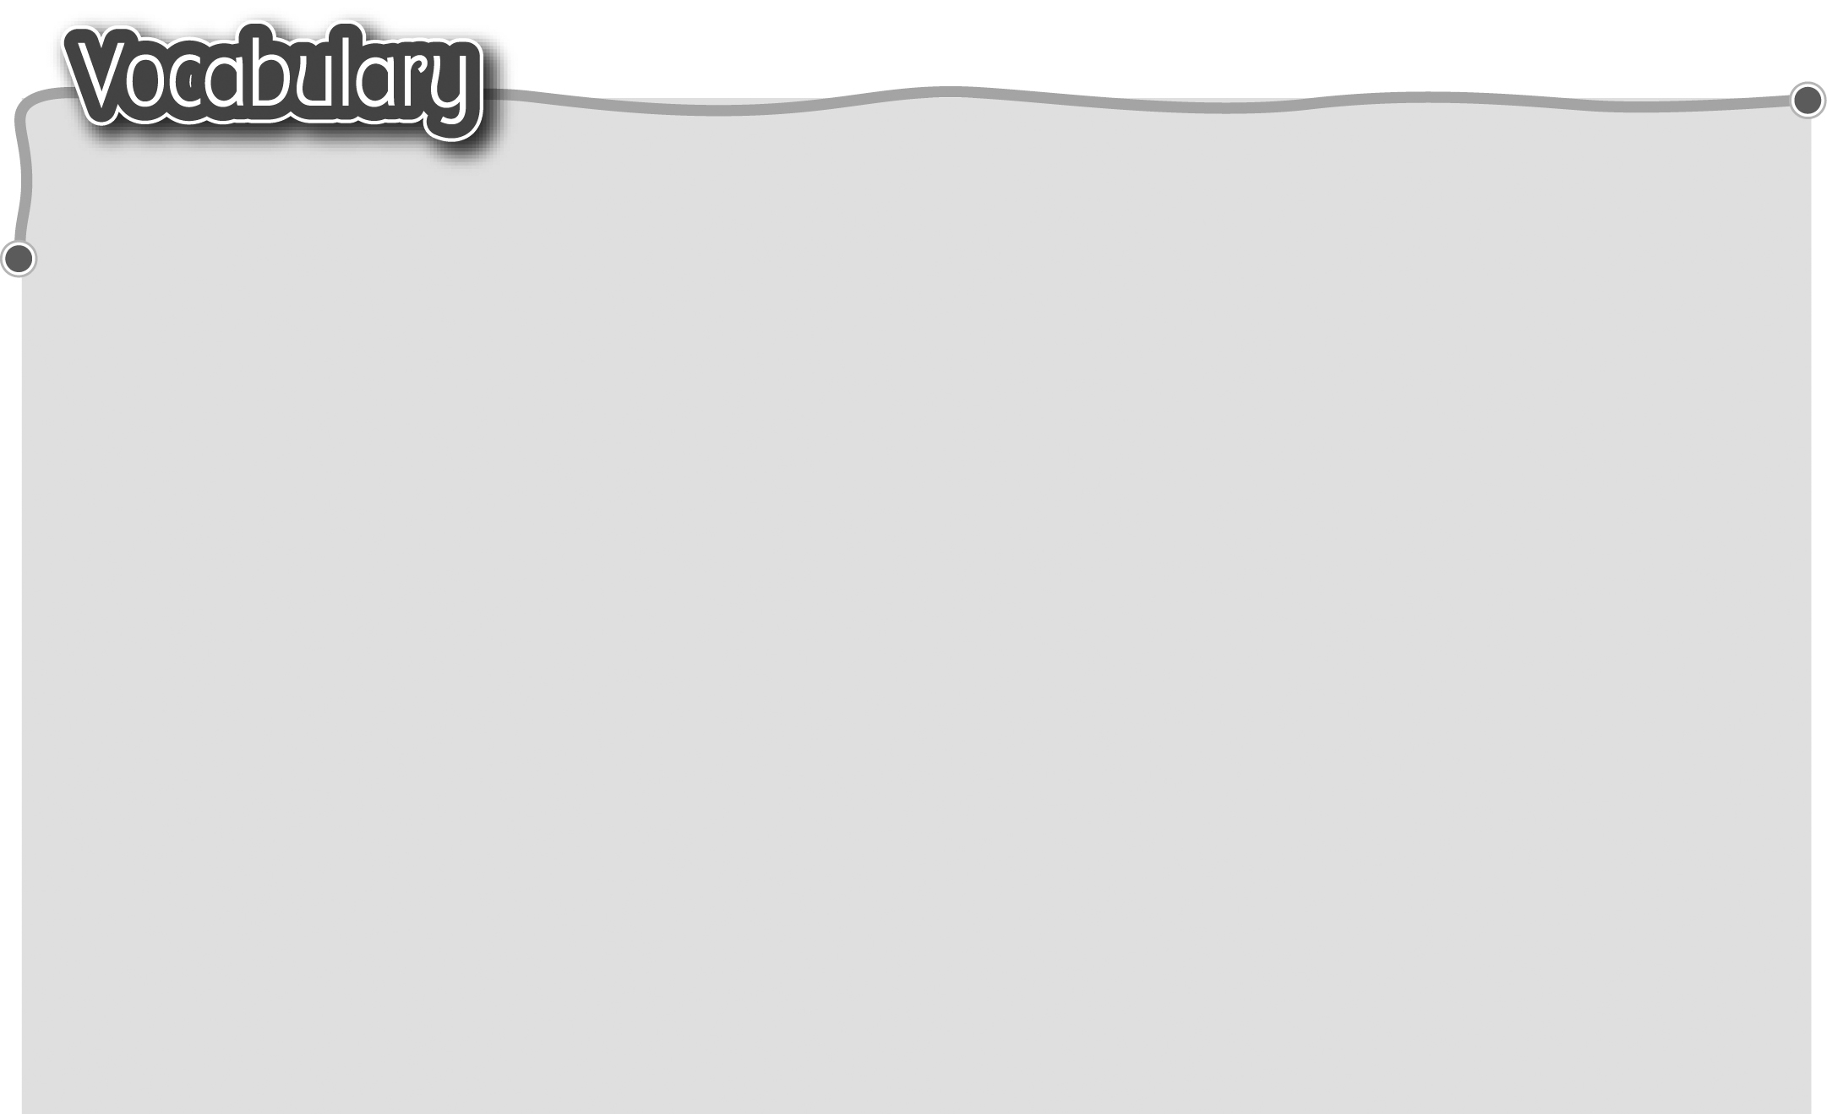
1 Easter復活節 9 look at the Christmas lights
2 eat chocolate eggs 看聖誕燈飾
吃朱古力蛋 10 Chinese New Year
3 Dragon Boat Festival 農曆新年
端午節 11 get red packets
4 watch dragon boat races 收紅封包/利是
觀看龍舟比賽 12 go to the flower market
5 Mid-Autumn Festival 逛花市
中秋節 13 visit relatives
6 eat moon cakes吃月餅 探望親戚/拜年
7 Christmas聖誕節 14 watch fireworks觀看煙花
8 get presents收禮物
The words marked with * have different meanings in other contexts. You can look up those meanings in a dictionary.
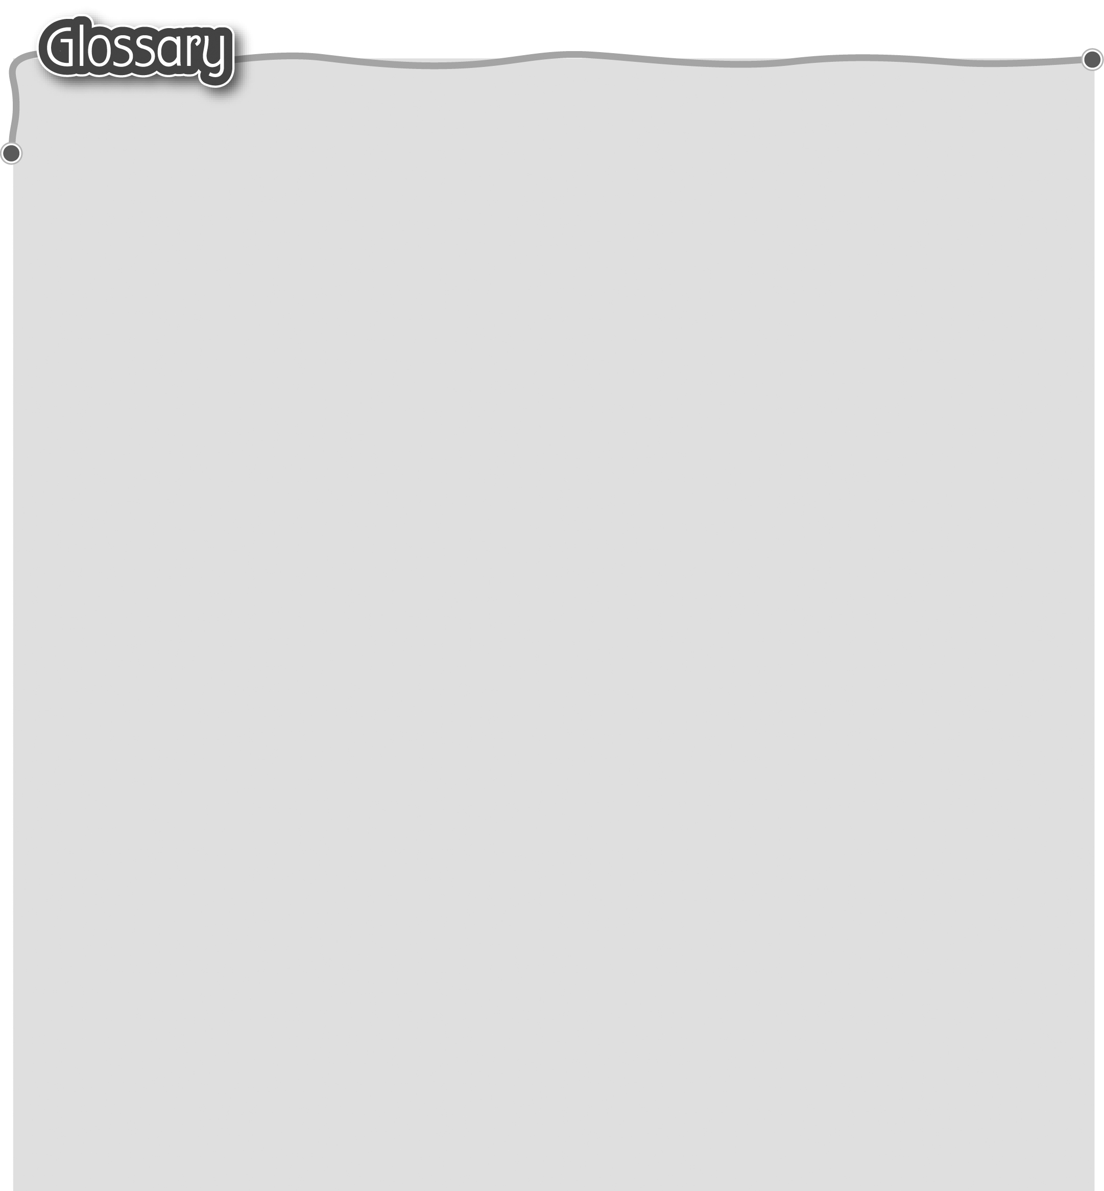
1 learn* (p.46) 認識 7 everything (p.46) 所有東西
2 because (p.46) 因為 8 cook a meal (p.46) 煮一頓飯
3 too* (p.46) 太…… 9 hide* (p.46) 把……藏起來
4 leaves (leaf) (p.46) 葉 10 collect* (p.46) 收集
- spring clean (p.46) 11 Easter bunnies (bunny) (p.46)
大掃除（名詞） 復活兔
6 clean* (p.46) 清潔（動詞）

