Choose and write.
mushroomonionjammilkcheesesugarbreadsalttomatobuttereggham

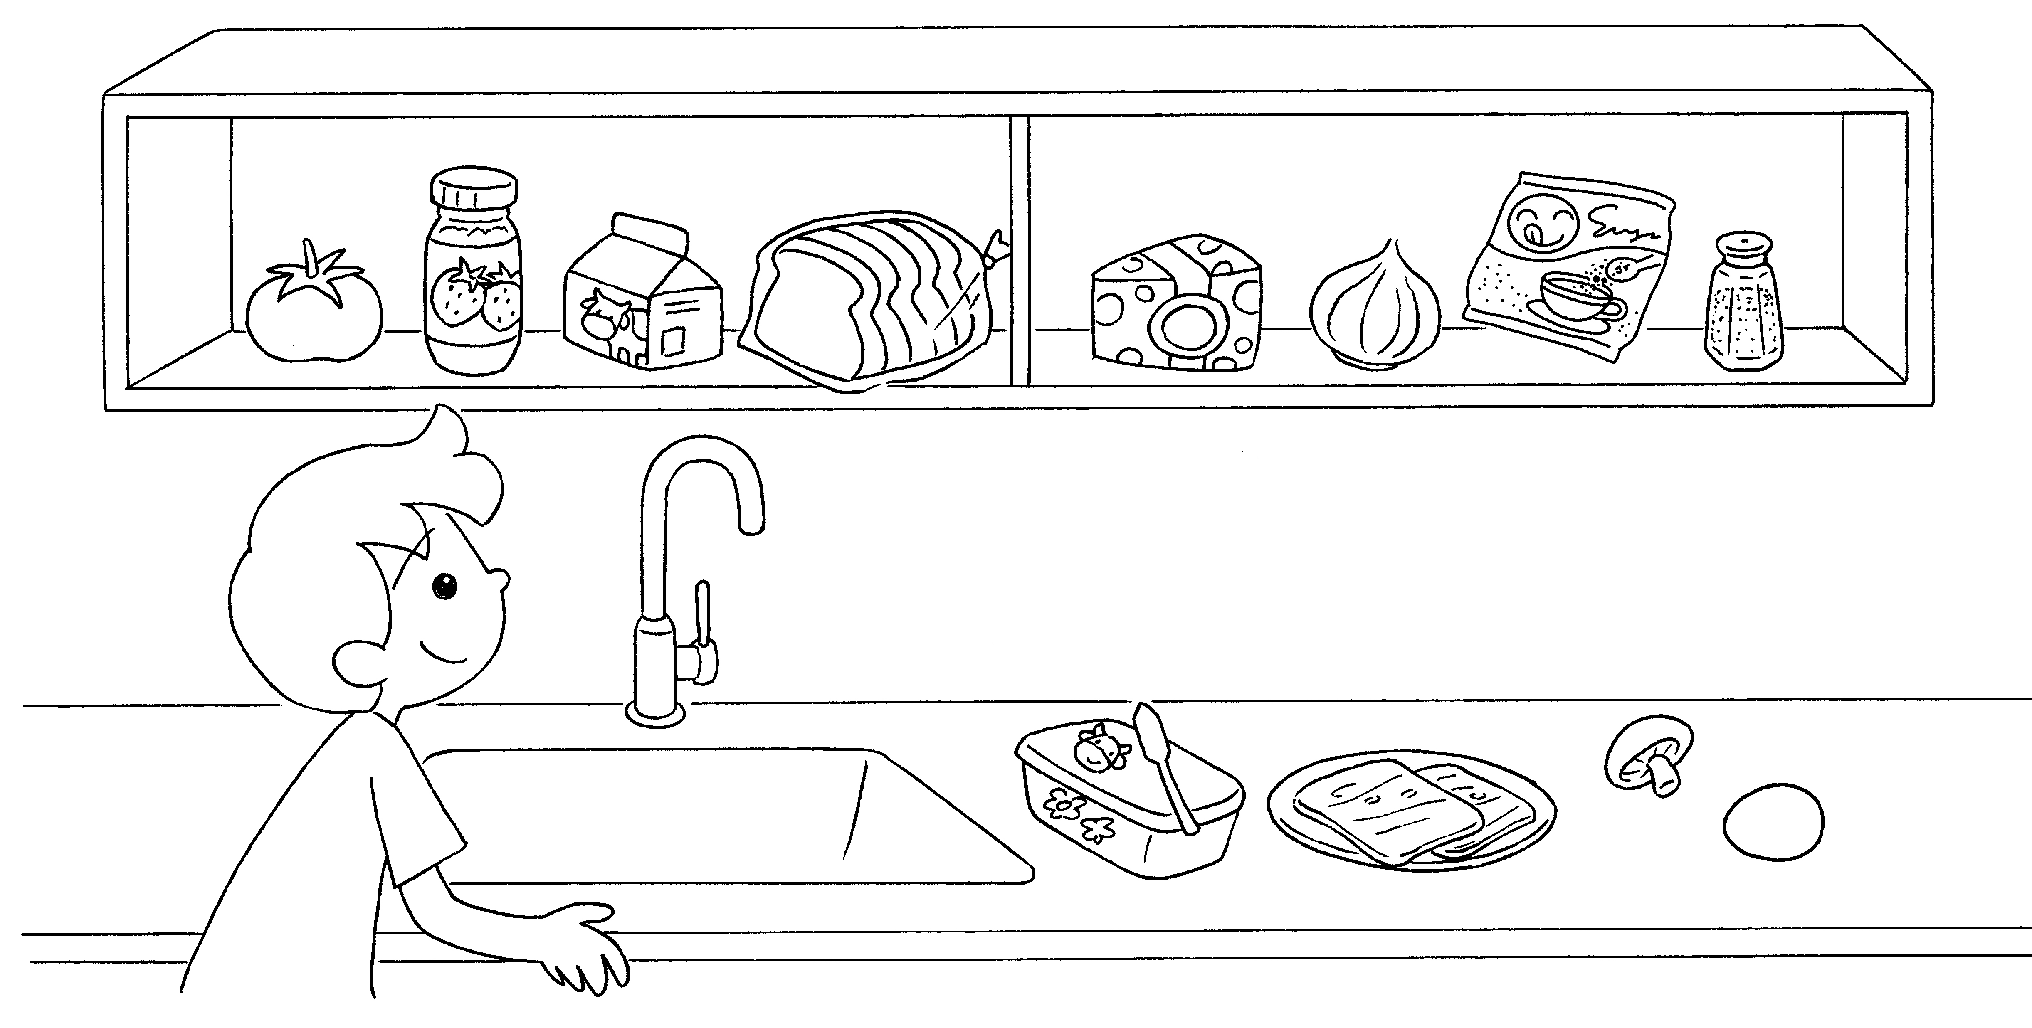
1

2
3
5

7

4

6

8

9

10

11

12

1 | a |  | 2
3 |  |  | 4
5 |  |  | 6 | an
7 |  |  | 8
9 |  |  | 10
11 | a |  | 12 | an



Book 3A Chapter 1 Graded Worksheets
Worksheet 1⬇
1 tomato 2 jam
3 milk 4 bread
5 cheese 6 onion
7 sugar 8 salt
9 butter 10 ham
11 mushroom 12 egg

