Fill in the missing letters.

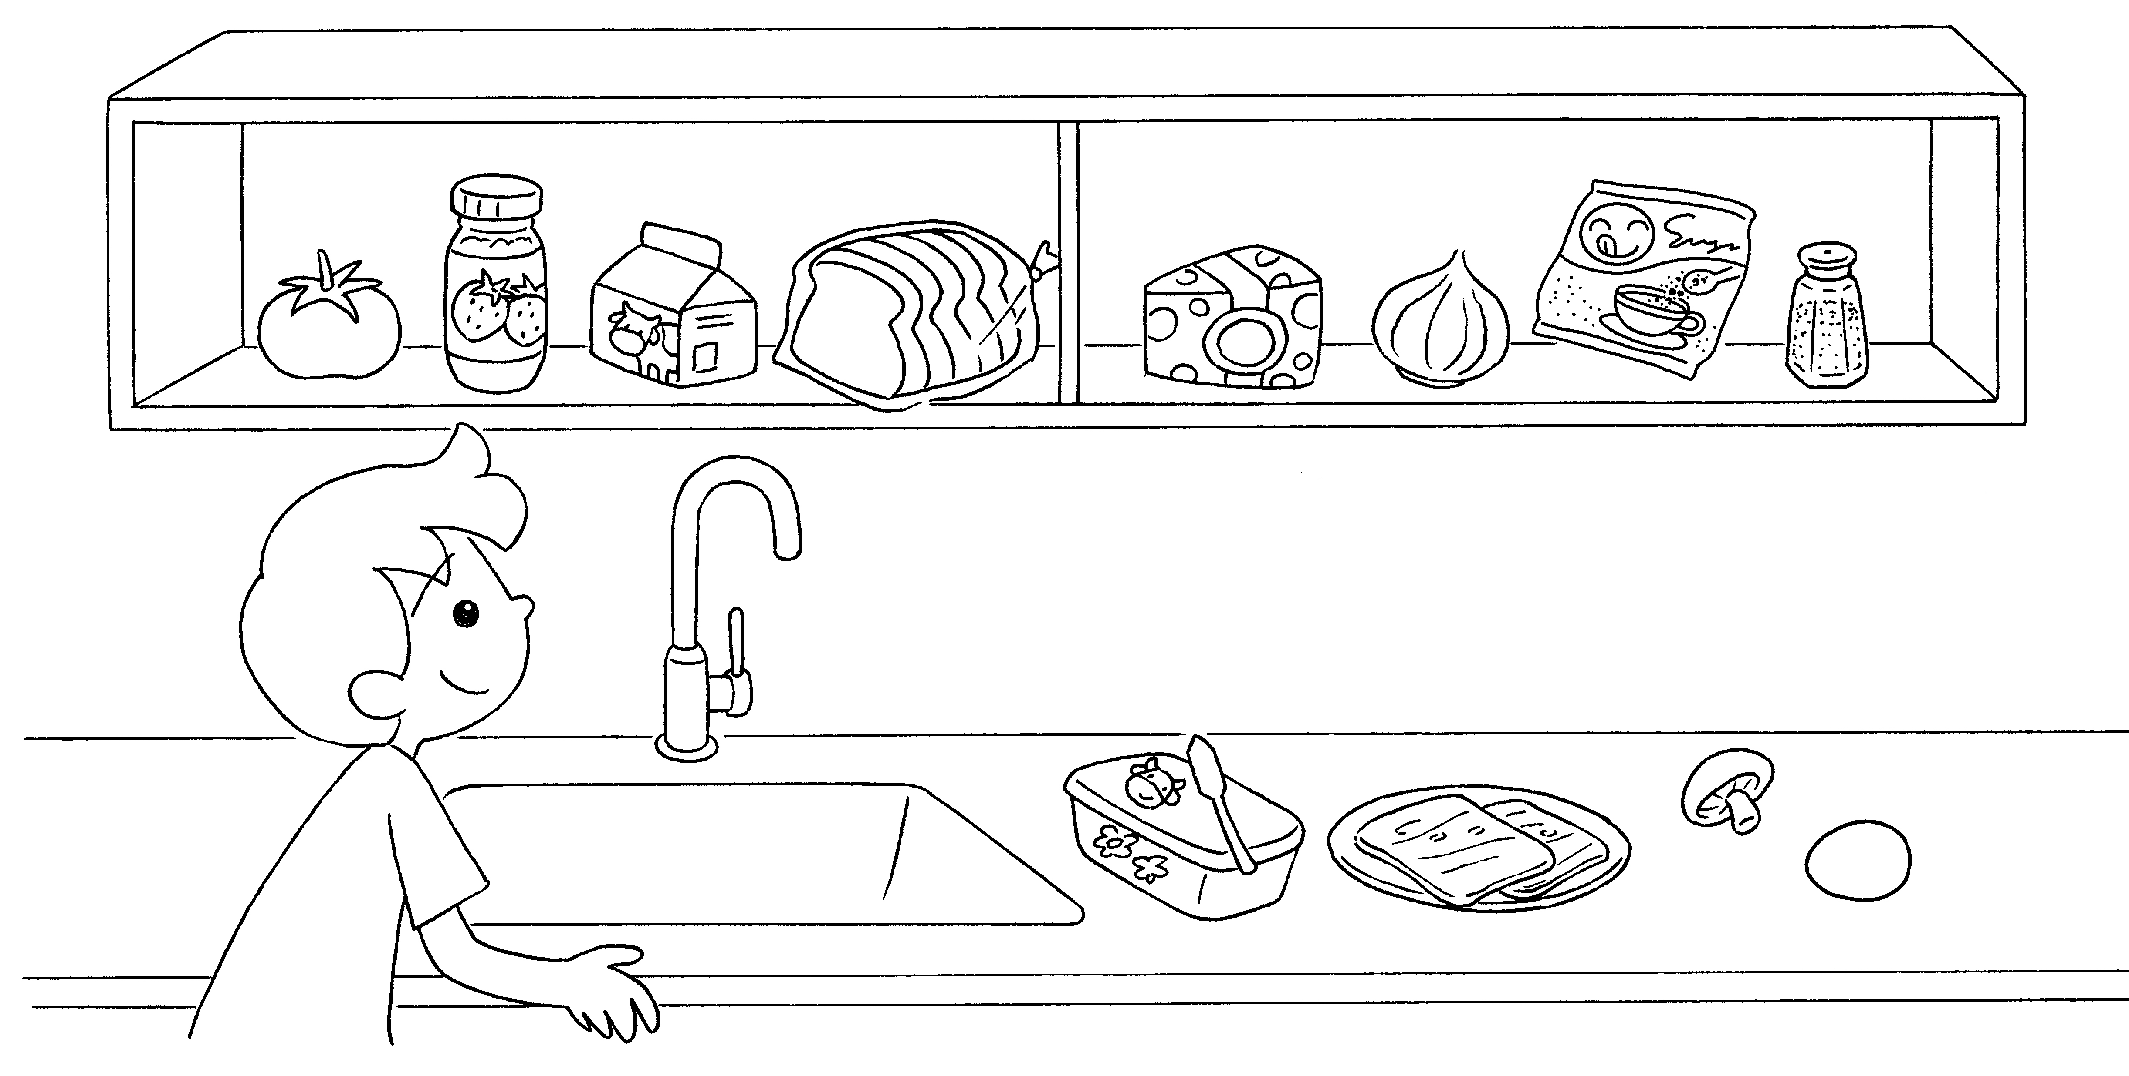
1

2
3
5

7

4

6

8

9

10

11

12

1 | a t __ __ __ __ __ |  | 2 | j __ __
3 | m __ __ __ |  | 4 | b __ __ __ __
5 | c __ __ __ __ __ |  | 6 | an o __ __ __ __
7 | s __ __ __ __ |  | 8 | s __ __ __
9 | b __ __ __ __ __ |  | 10 | h __ __
11 | a m __ __ __ __ __ __ __ |  | 12 | an e __ __


Book 3A Chapter 1 Graded Worksheets
Worksheet 1⬇⬇
1 t o m a t o 2 j a m
3 m i l k 4 b r e a d
5 c h e e s e 6 o n i o n
7 s u g a r 8 s a l t
9 b u t t e r 10 h a m
11 m u s h r o o m 12 e g g

