What food can you see? Write.

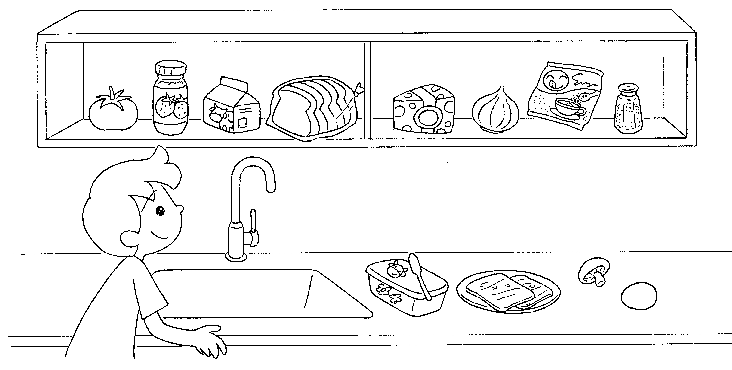
1

2
3
5

7

4

6

8

9

10

11

12

1 | a |  | 2
3 |  |  | 4
5 |  |  | 6
7 |  |  | 8
9 |  |  | 10
11 |  |  | 12


Book 3A Chapter 1 Graded Worksheets
Worksheet 1⬇⬇⬇
1 tomato 2 jam
3 milk 4 bread
5 cheese 6 an onion
7 sugar 8 salt
9 butter 10 ham
11 a mushroom 12 an egg

