Finish the steps. Then match the pictures with the steps. Write the correct numbers.

Egg sandwich
A

1 F pour the egg mixture into a pan.
2 T fry for 2 minutes.
3 Put some butter on a slice of bread.
4 put the egg on the bread.

a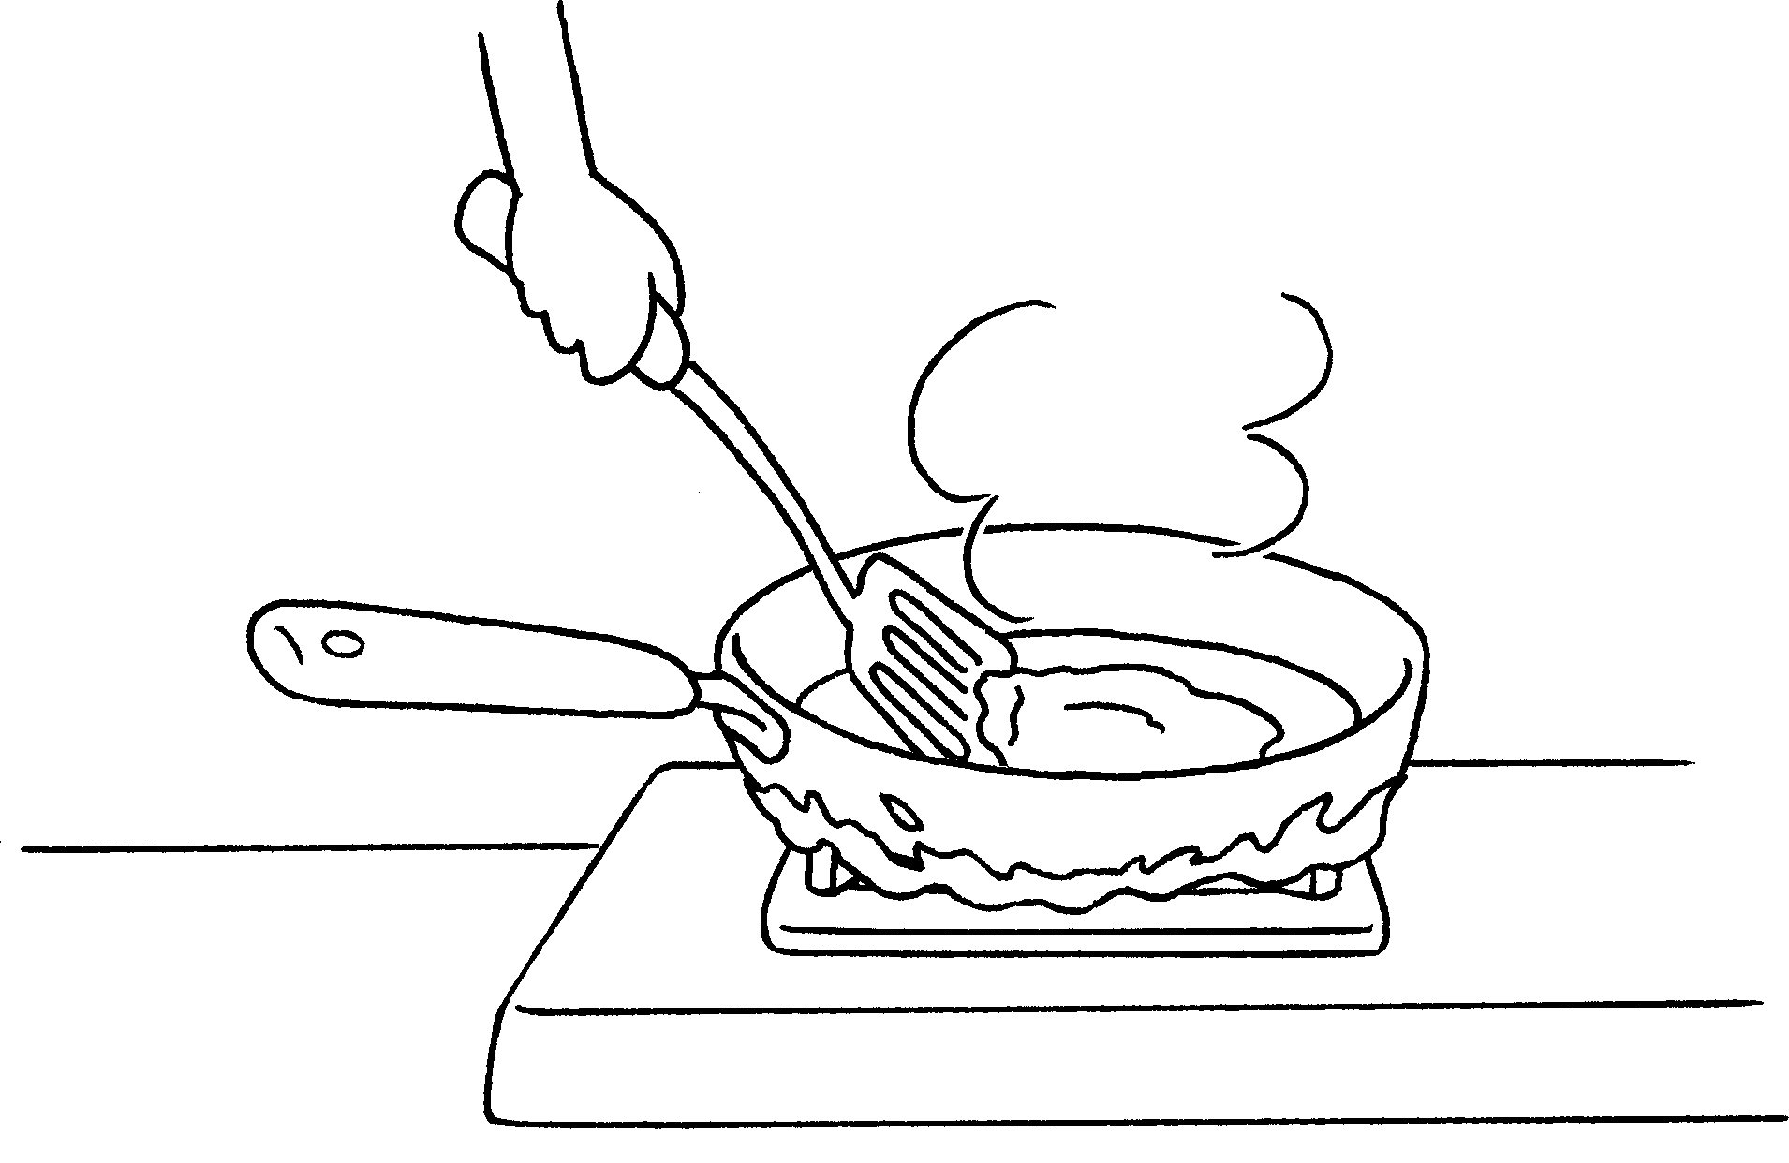 | b  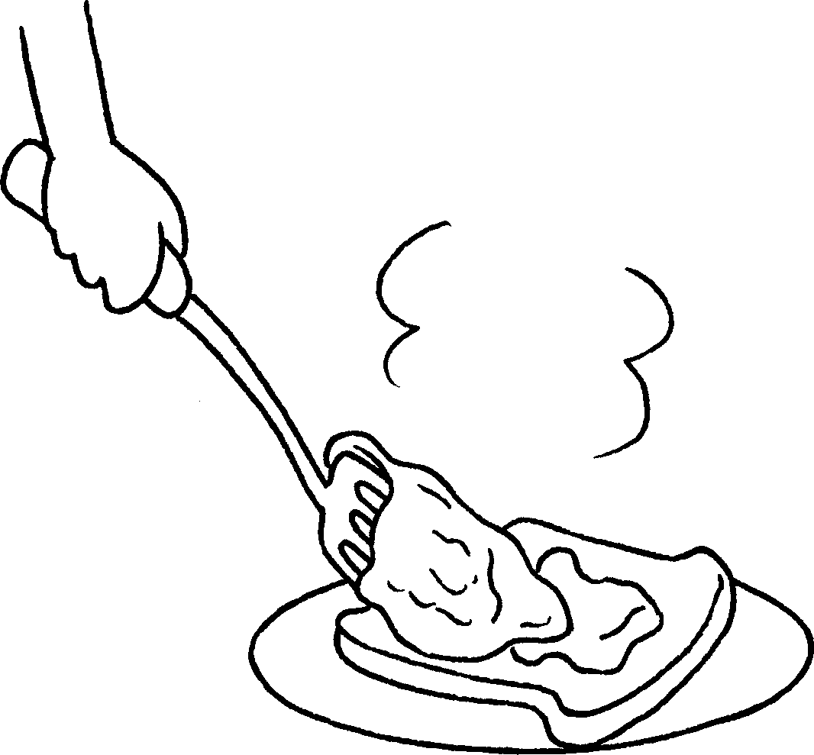 | c  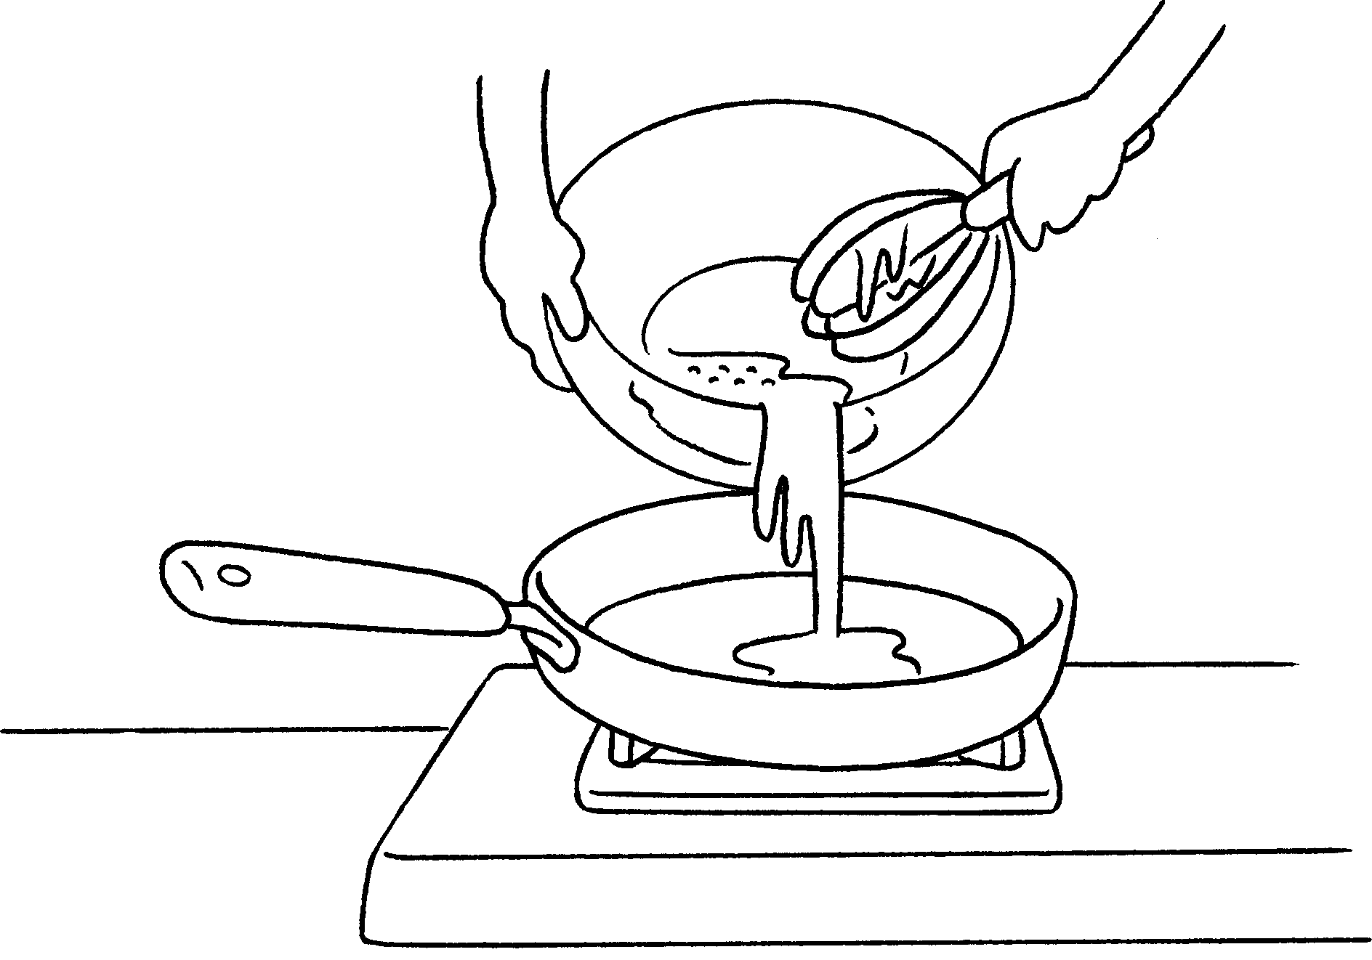 | d  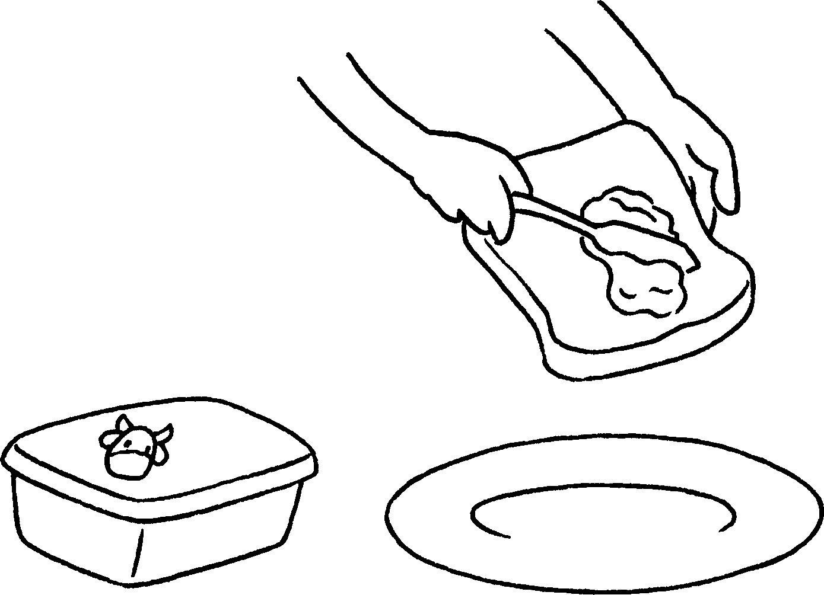
( ) | ( ) | ( 1 ) | ( )

Fruit salad
B

1 wash some fruit.
2 cut the fruit into small pieces.
3 put the fruit into a bowl and mix.
4 Add some salad dressing to the salad.

a  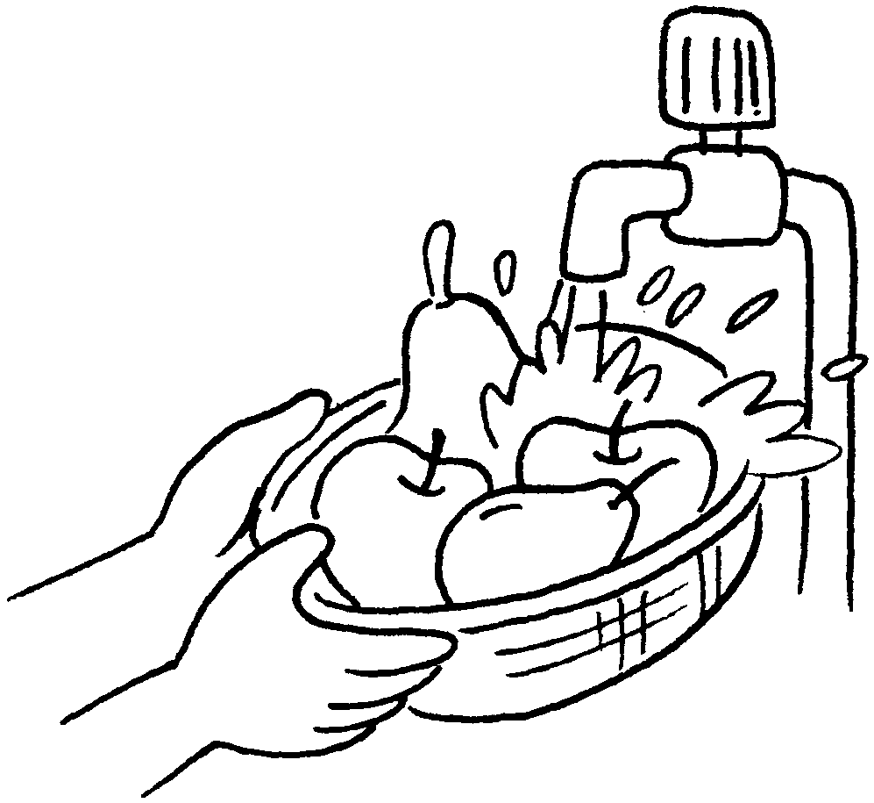 | b  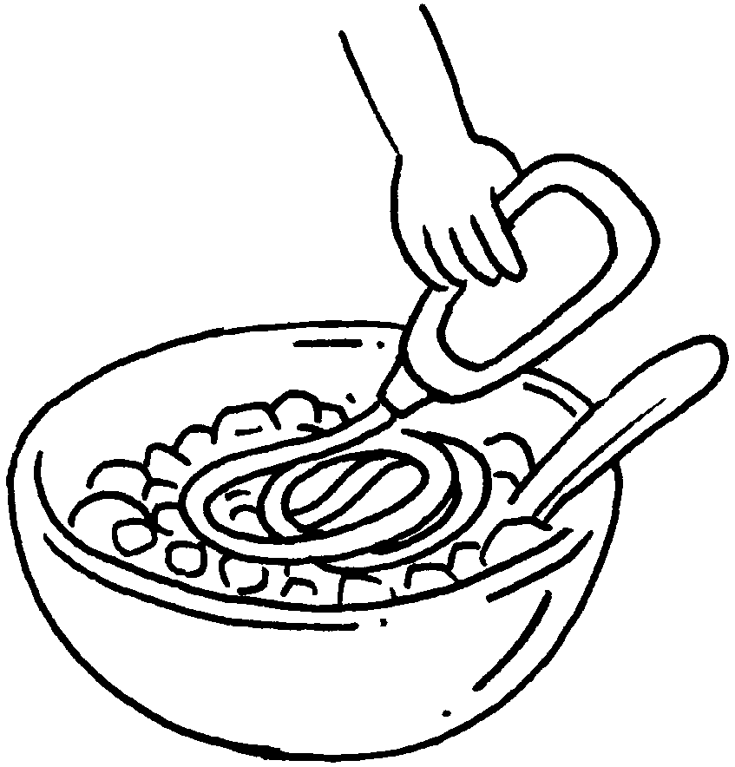 | c  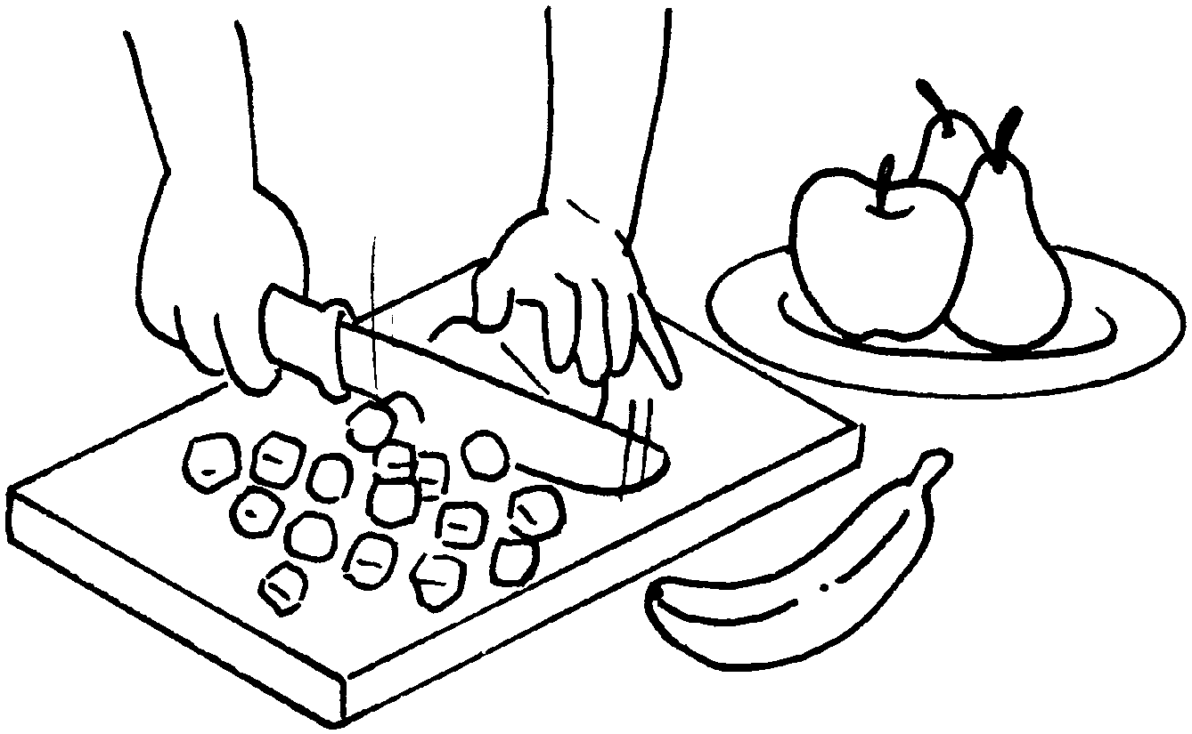 | d  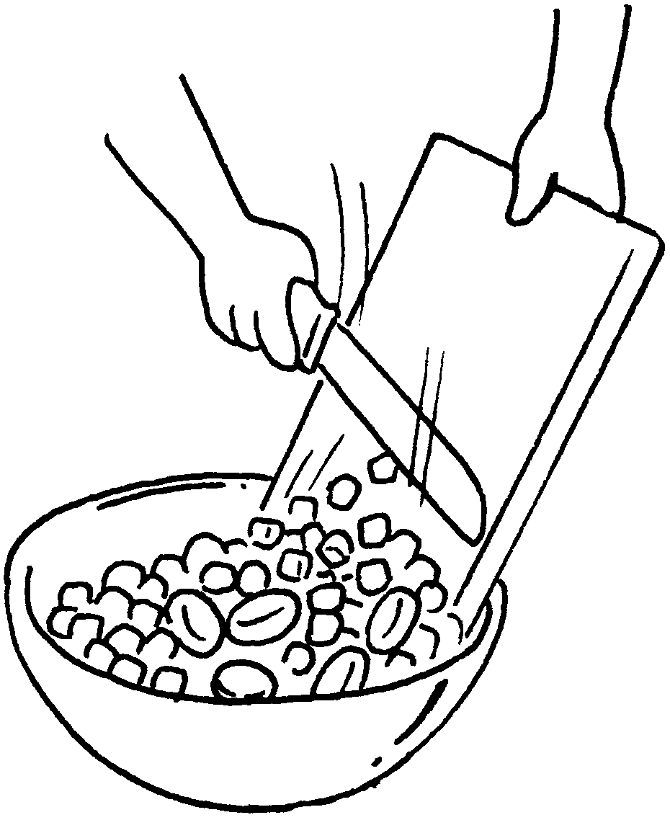
( ) | ( ) | ( ) | ( )


Book 3A Chapter 1 Graded Worksheets
Worksheet 2⬇⬇
A 1 First
2 Then
4 Then
a (2) b (4) d (3)
B 1 First
2 Then
3 Then
a (1) b (4) c (2) d (3)

