Circle the correct answers.
1 | Wash the tomatoes.  Cut ( it / them ) into small pieces. | 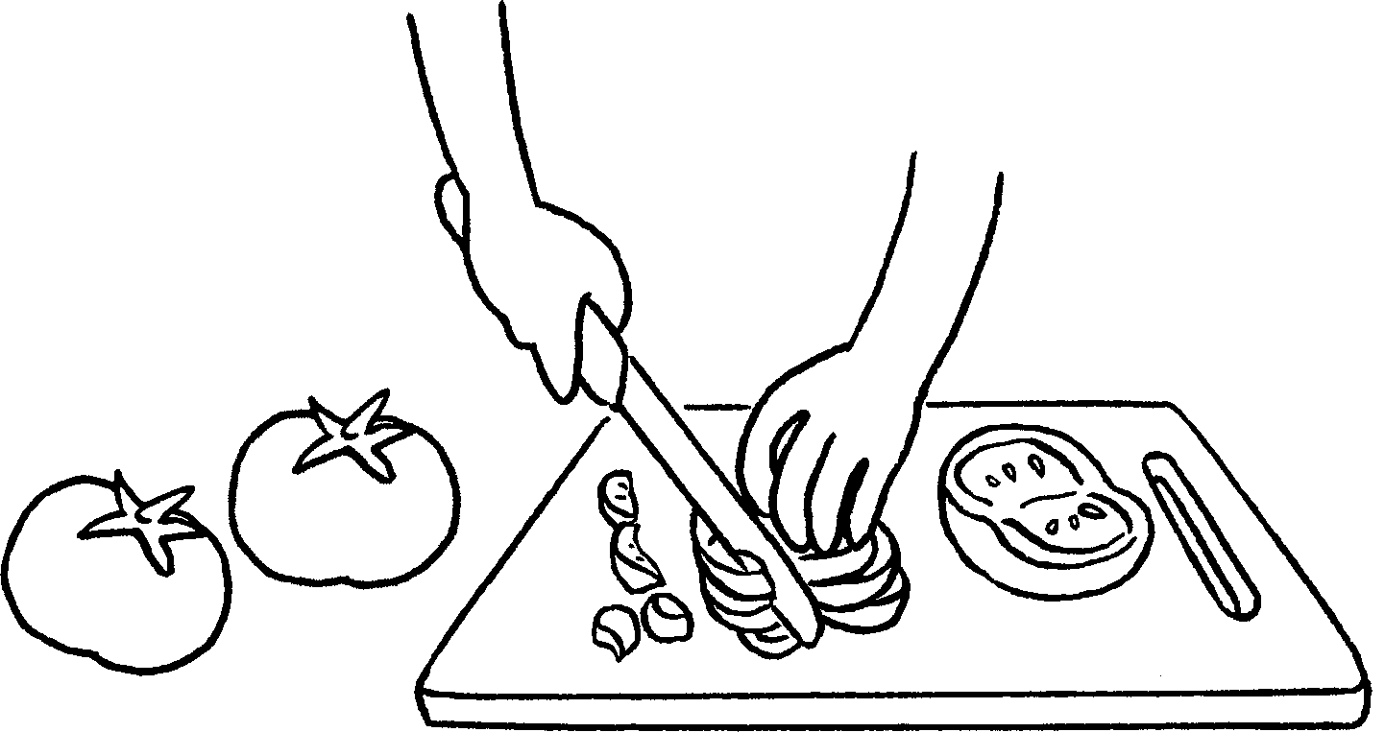
2 | Take the bread out of the oven.  Sit down and enjoy ( it / them ). | 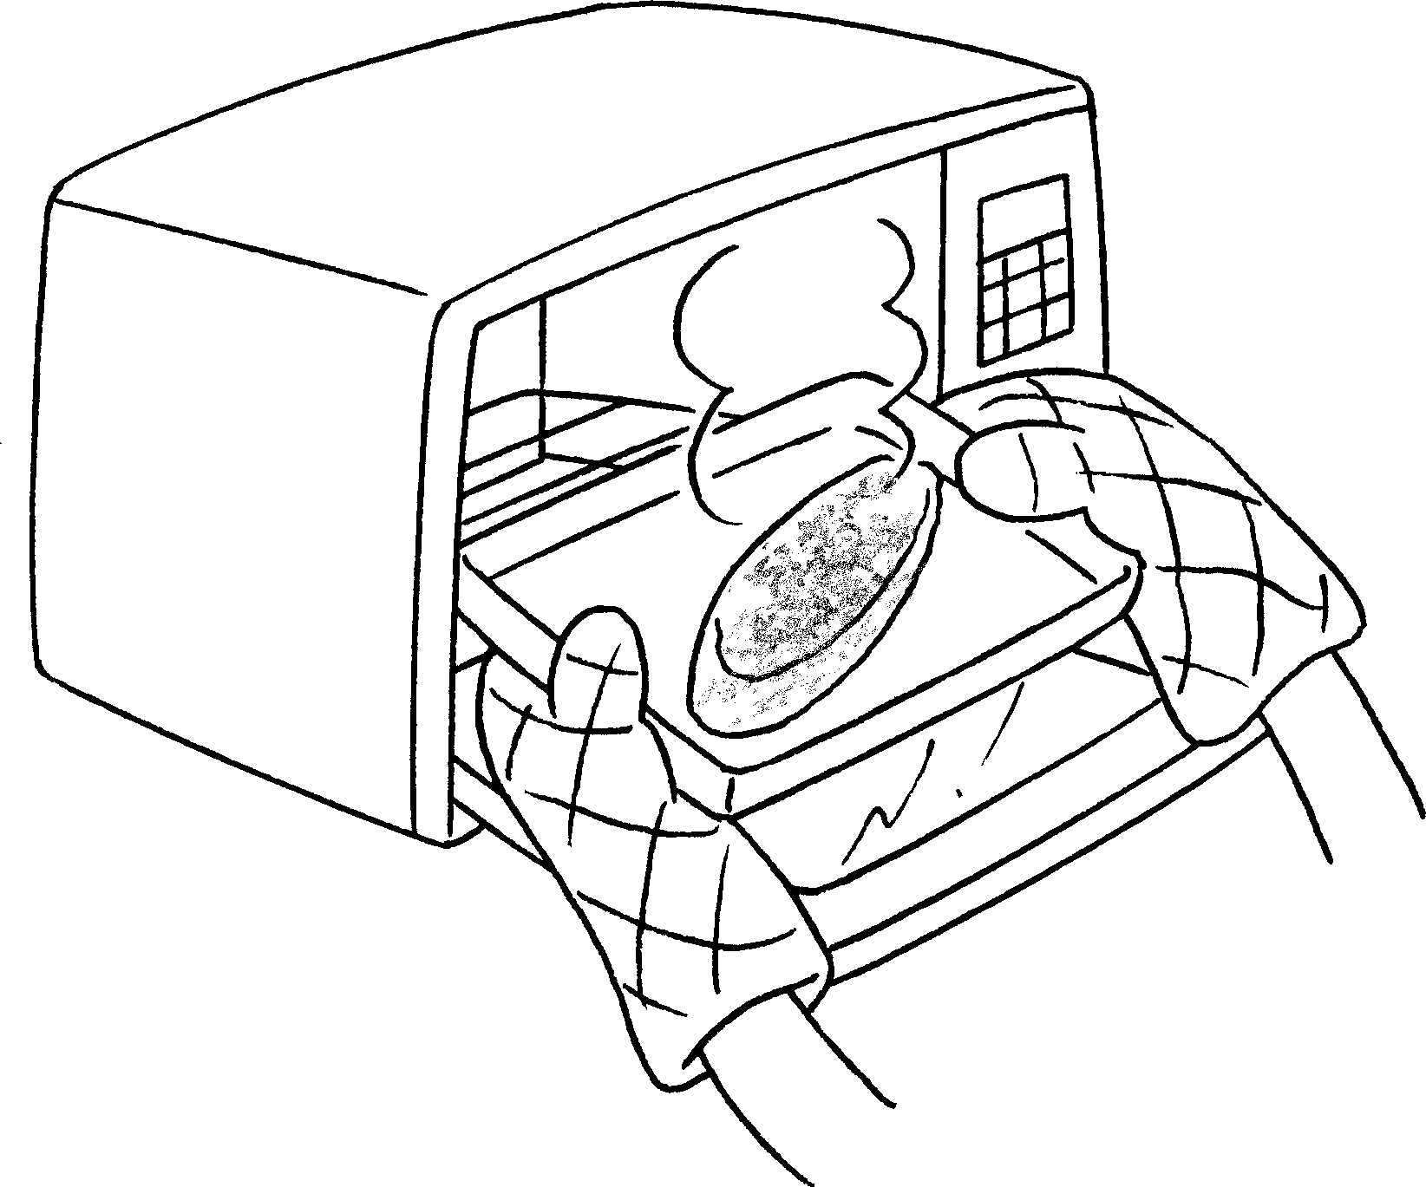
3 | Put the onions, egg and milk into a bowl.  Mix ( it / them ) together. | 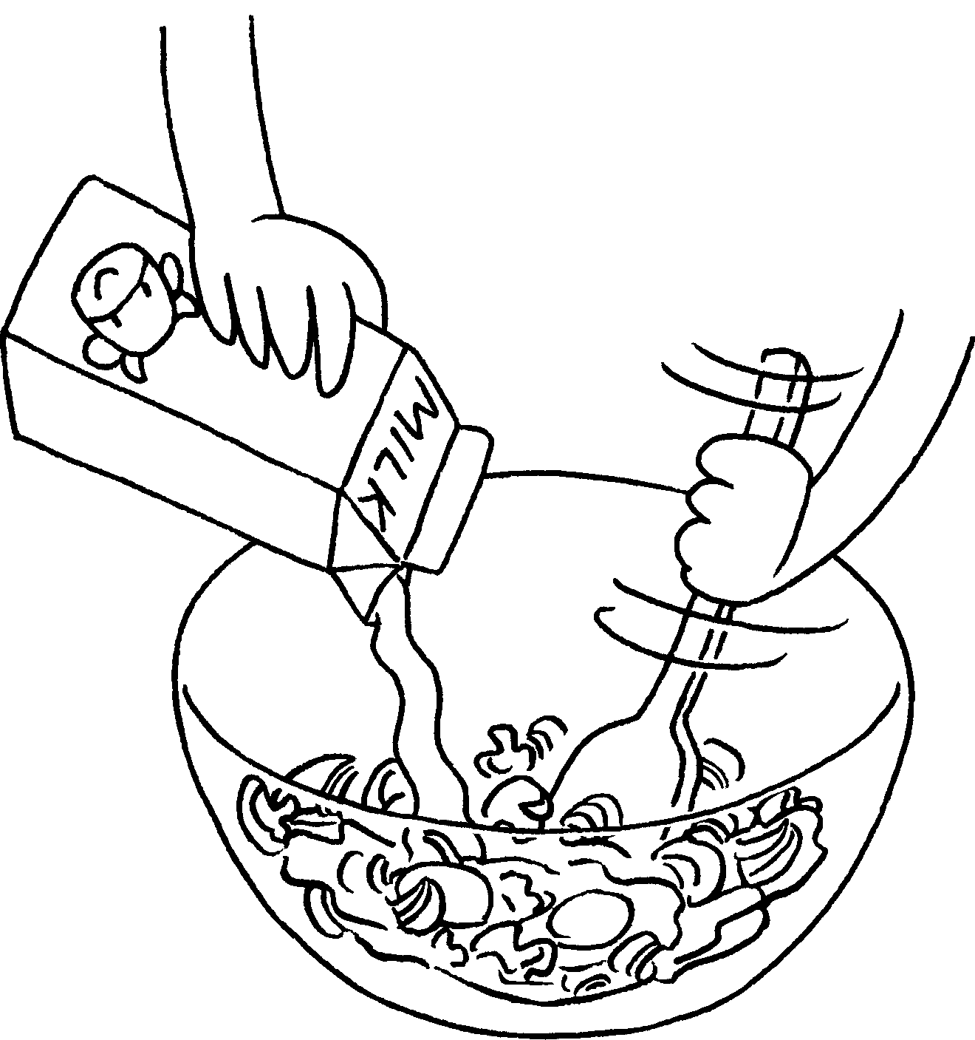
4 | Cut the onion and mushrooms into small pieces.  Put ( it / them ) into a bowl. | 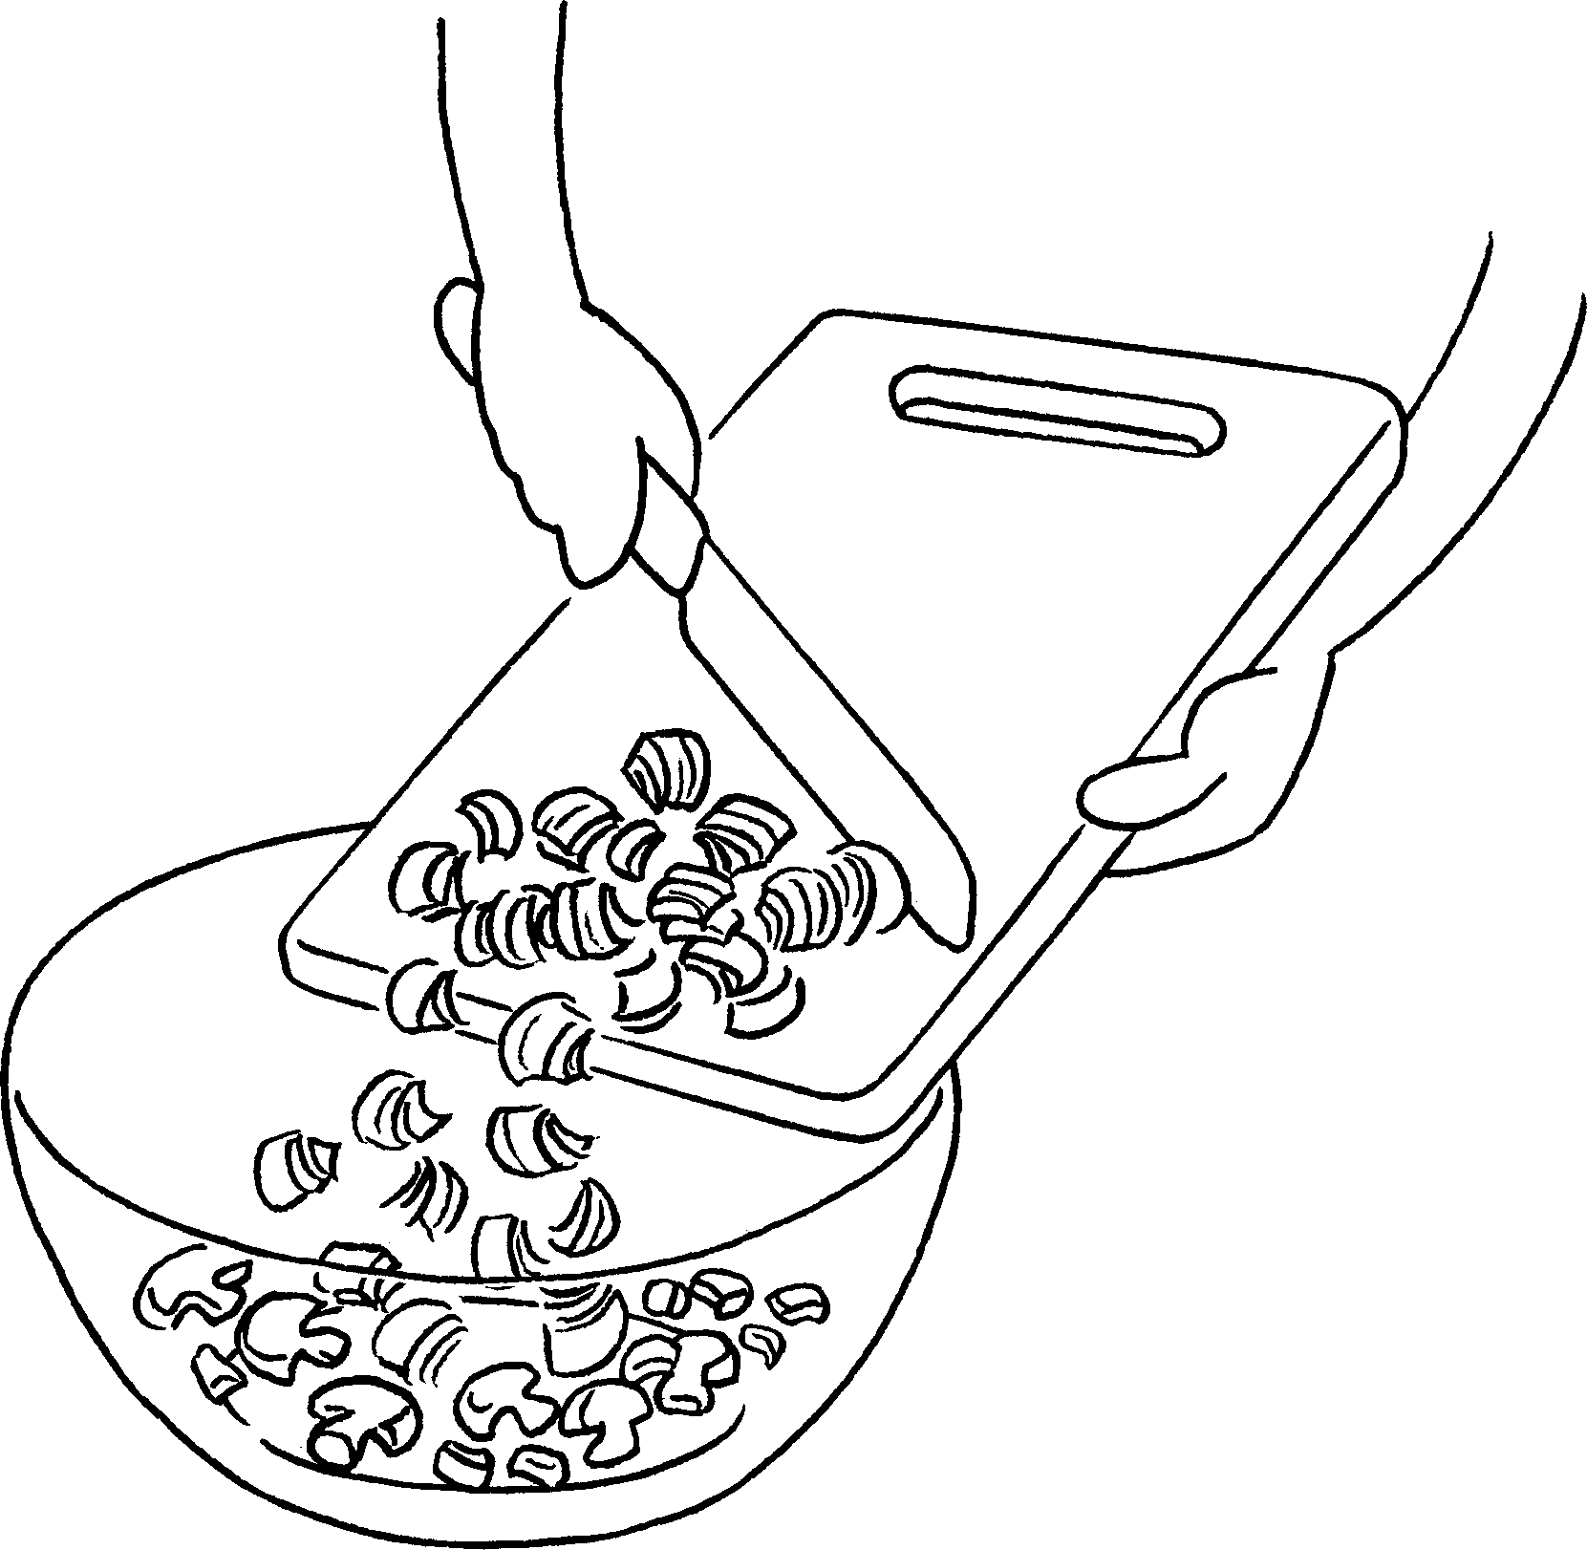
5 | Pour the egg mixture into a pan.  Fry ( it / them ) for 3 minutes. | 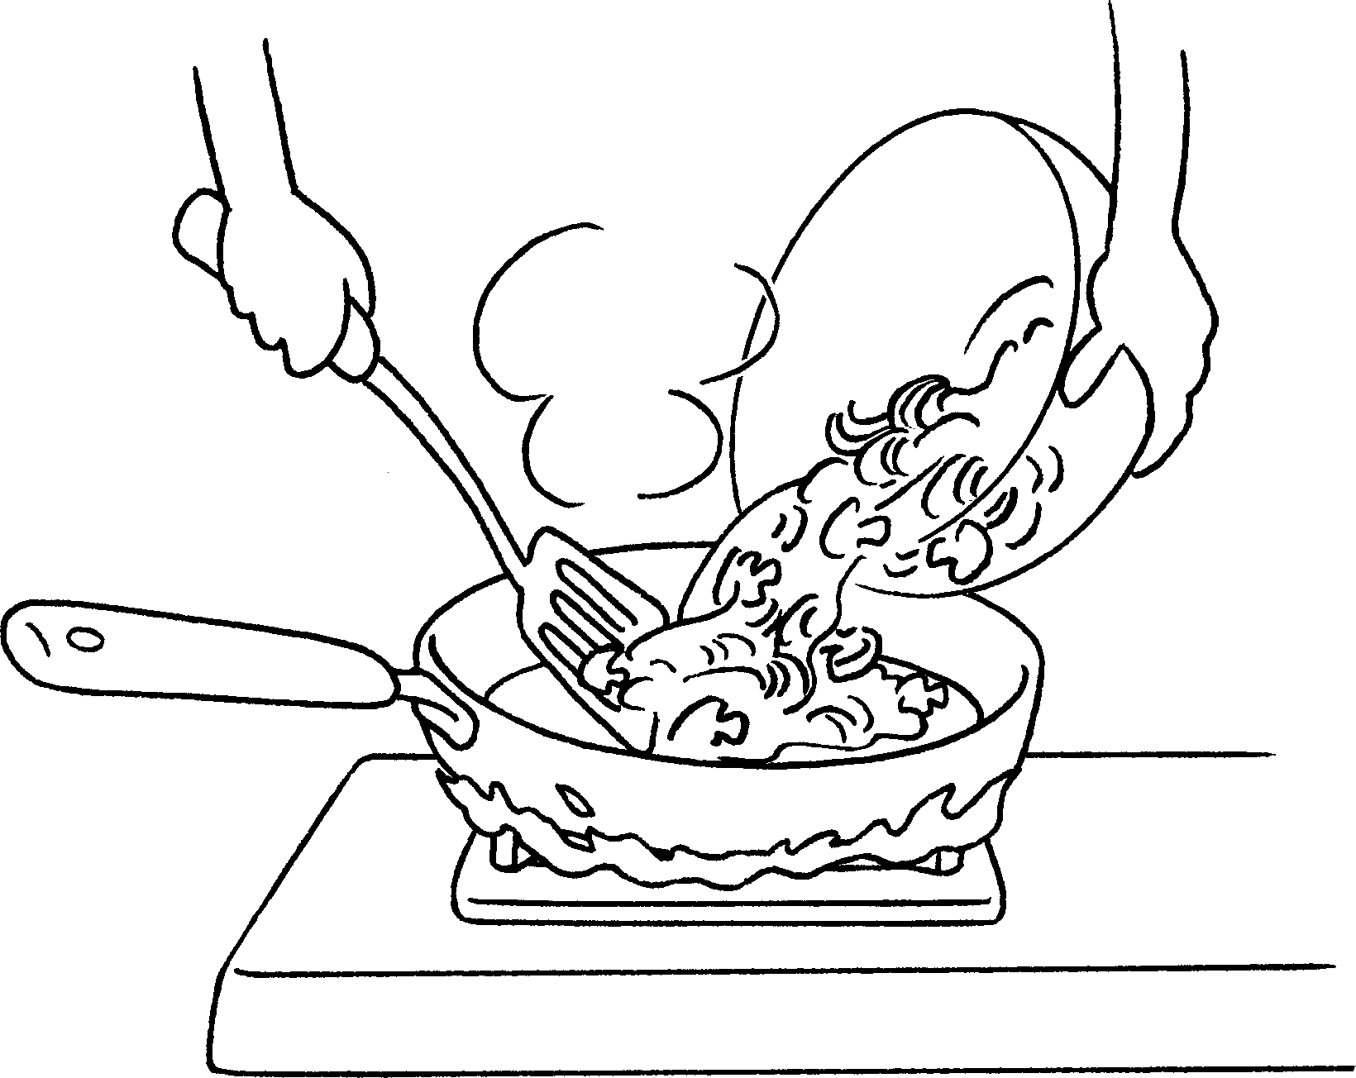


Book 3A Chapter 1 Graded Worksheets
Worksheet 3⬇
- ( it / them )
- ( it / them )
- ( it / them )
- ( it / them )
- ( it / them )

