Circle and write.

milk pour bread cut

1 | Wash the tomatoes.  Cut ( it / them ) into small pieces. | 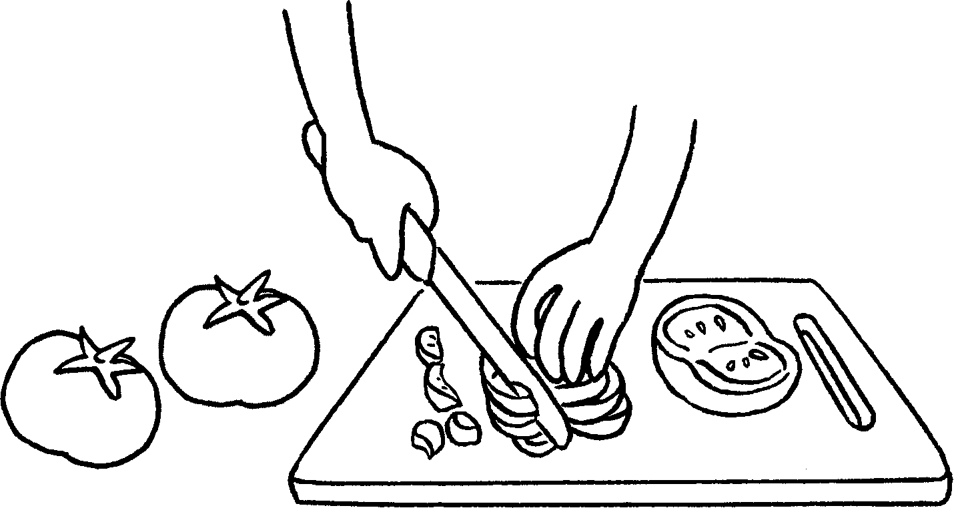
2 | Take the out of the oven.  Sit down and enjoy ( it / them ). | 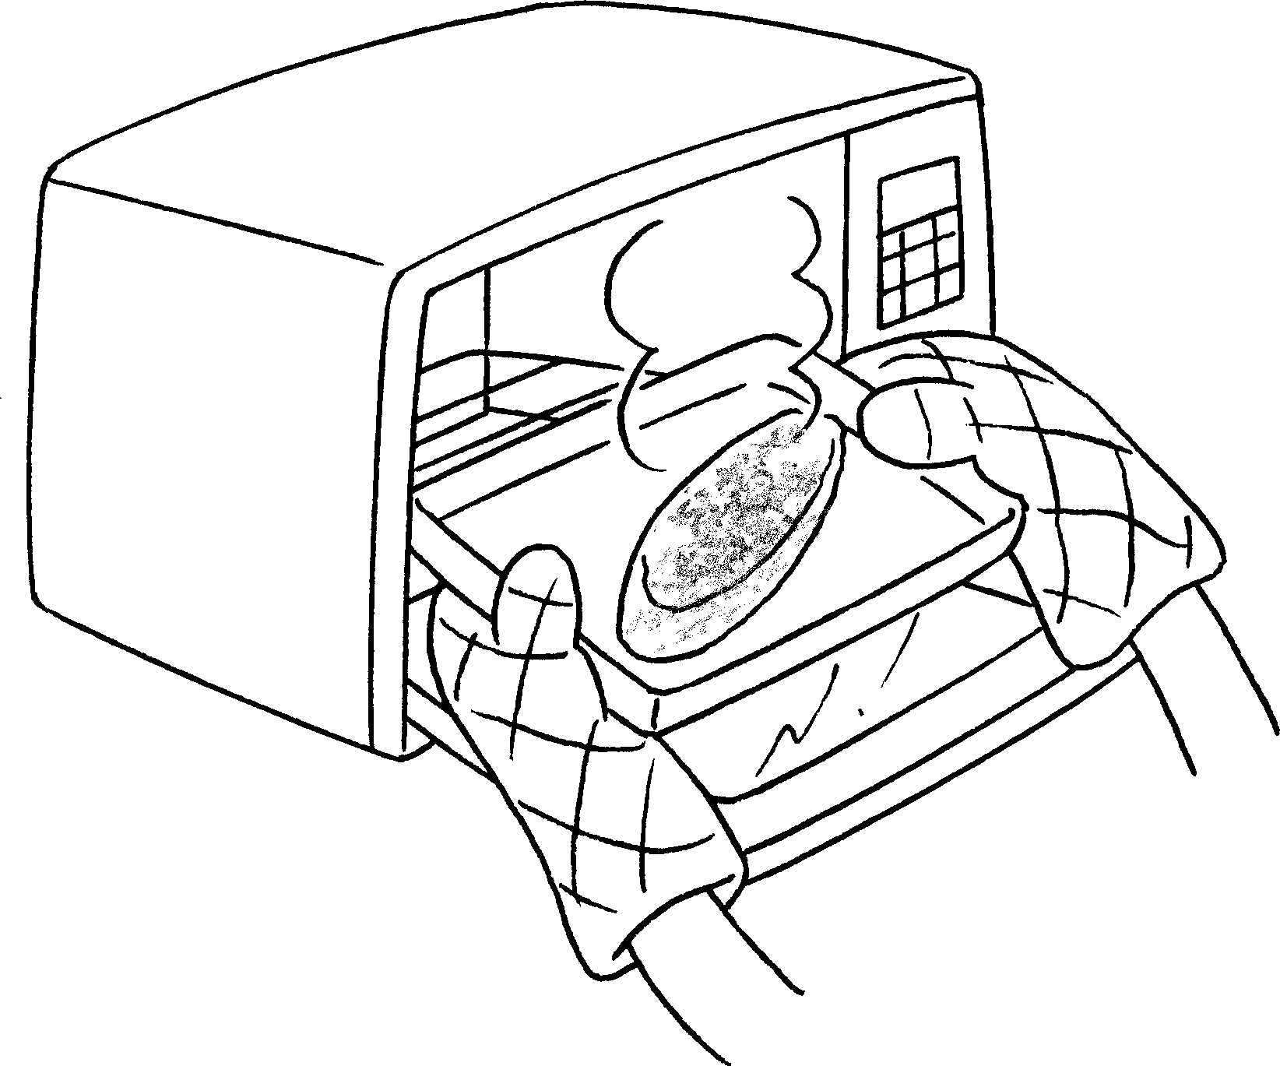
3 | Put the onions, egg and  into a bowl.  Mix ( it / them ) together. | 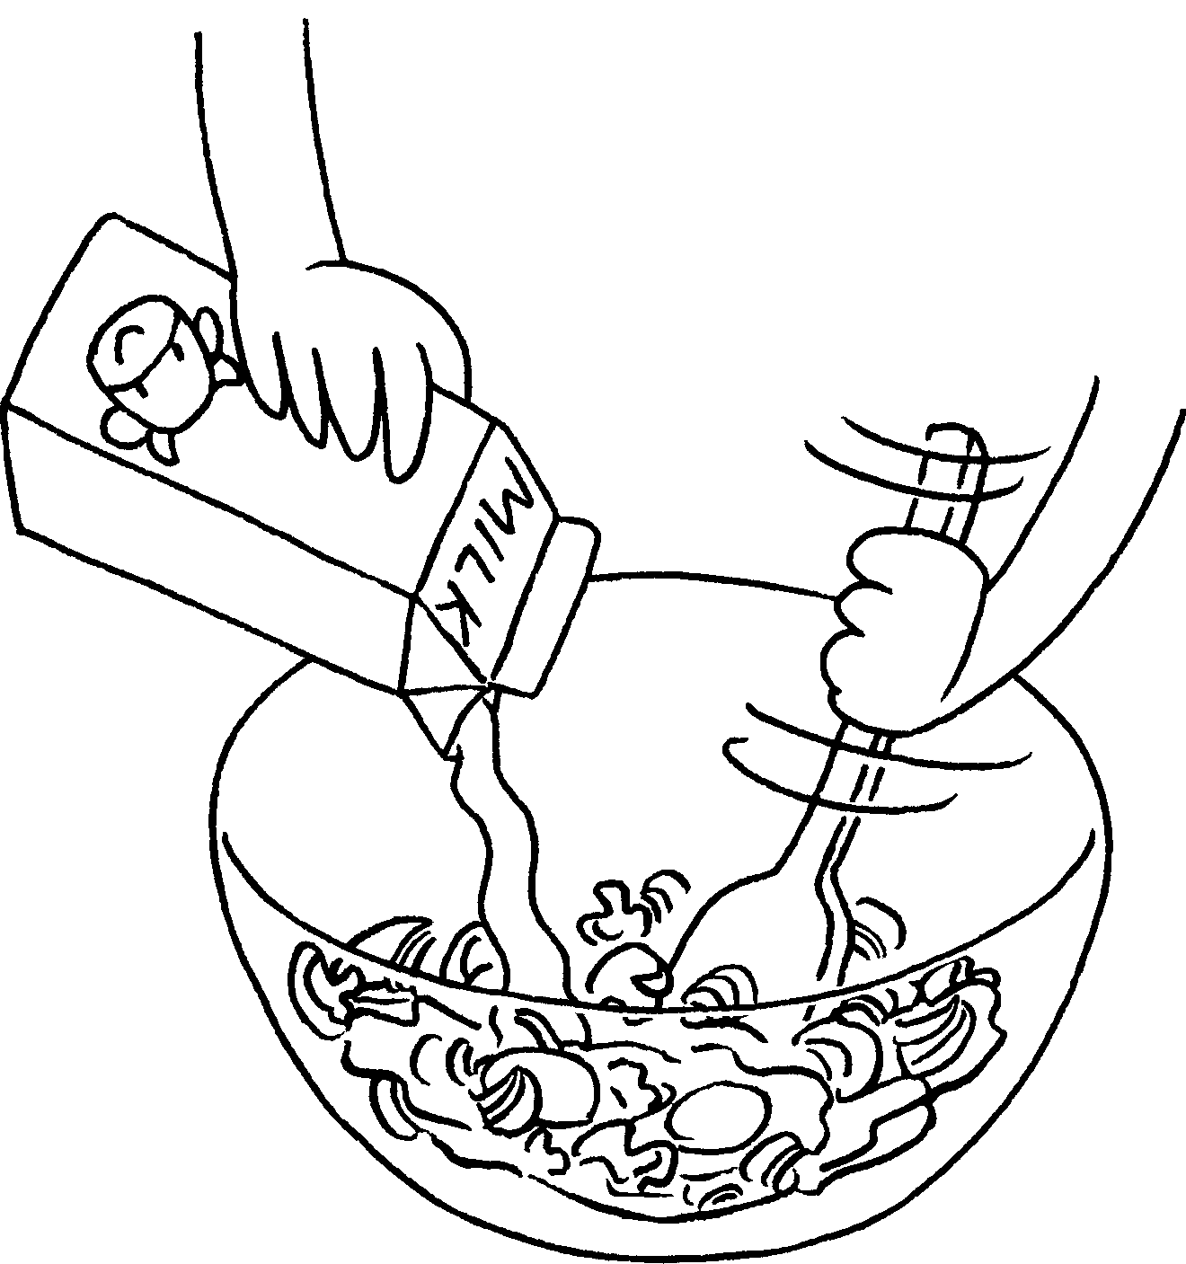
4 | the onion and  mushrooms into small pieces.  Put ( it / them ) into a bowl. | 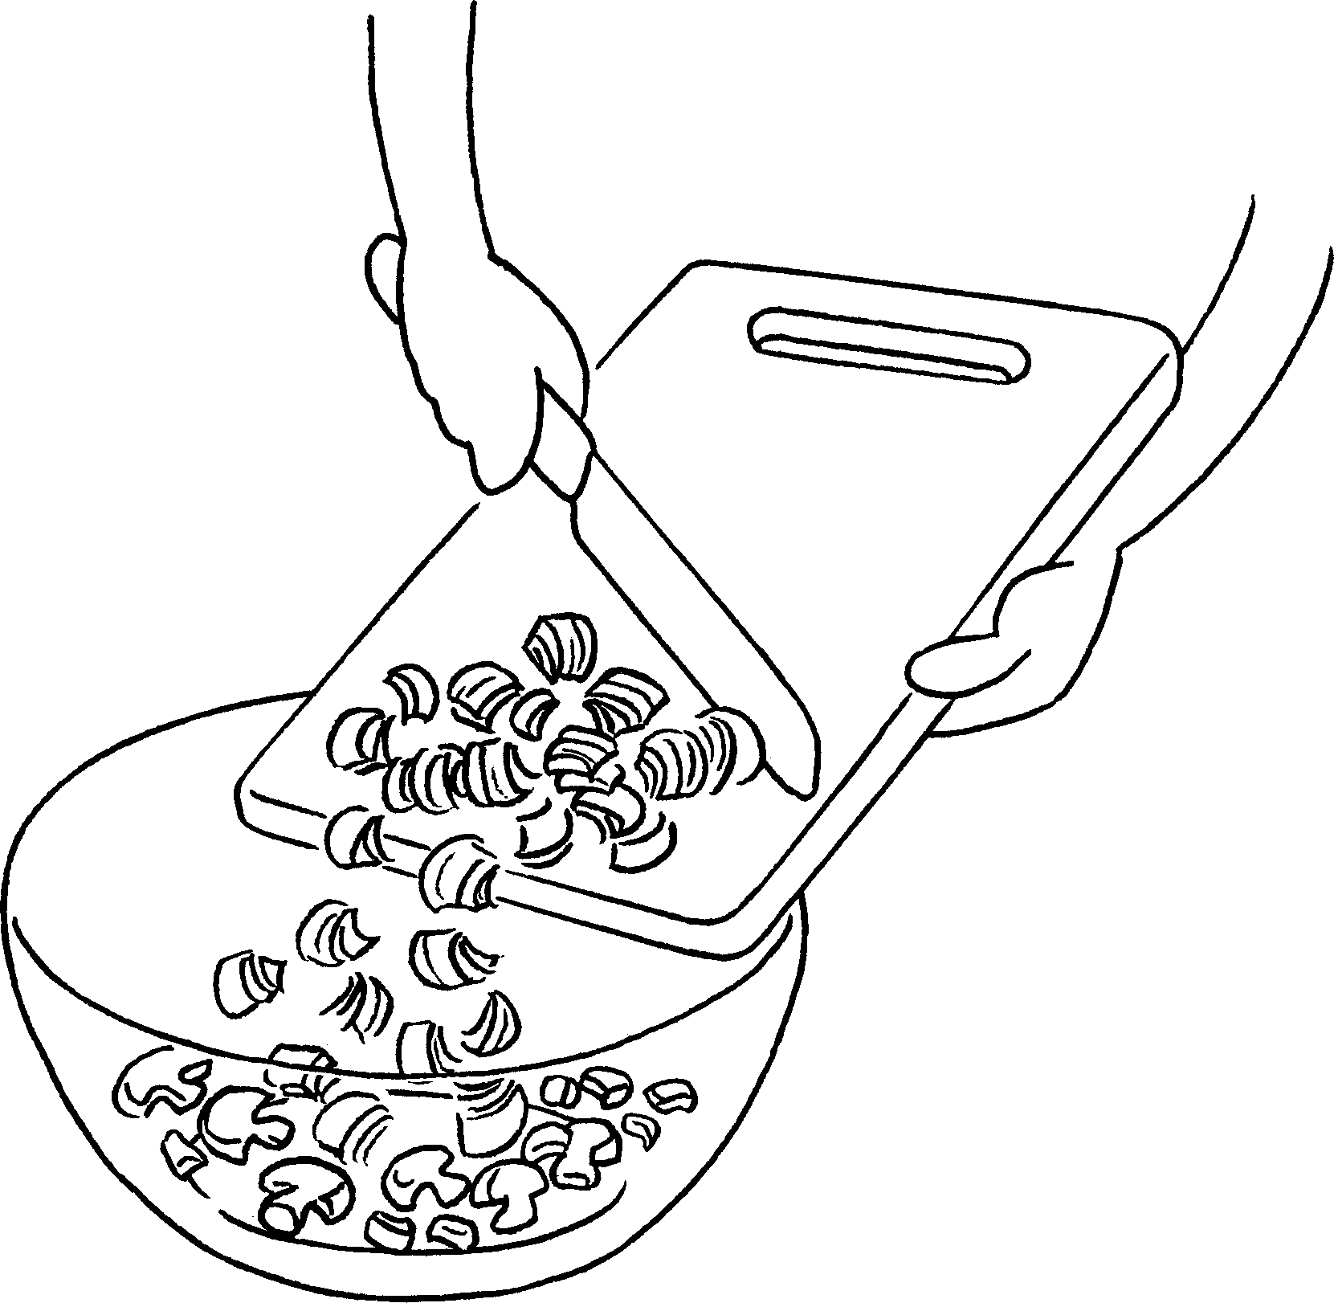
5 | the egg mixture into a pan.  Fry ( it / them ) for 3 minutes. | 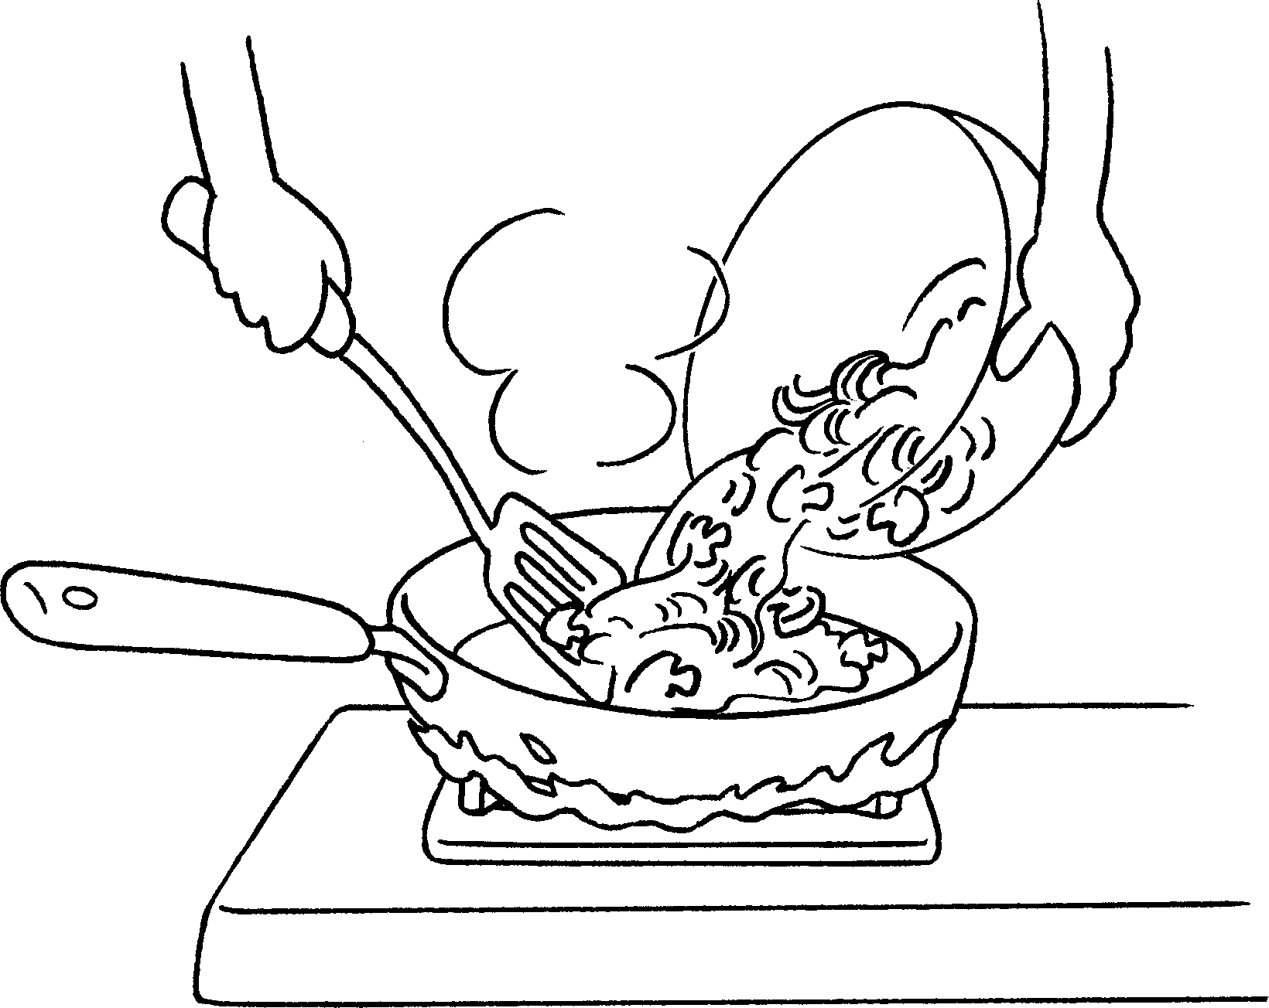


Book 3A Chapter 1 Graded Worksheets
Worksheet 3⬇⬇
- ( it / them )
- bread
( it / them )
- milk
( it / them )
- Cut
( it / them )
5 Pour
( it / them )

