Fill in the blanks.

it them

1 | Wash the tomatoes.  Cut into small pieces. | 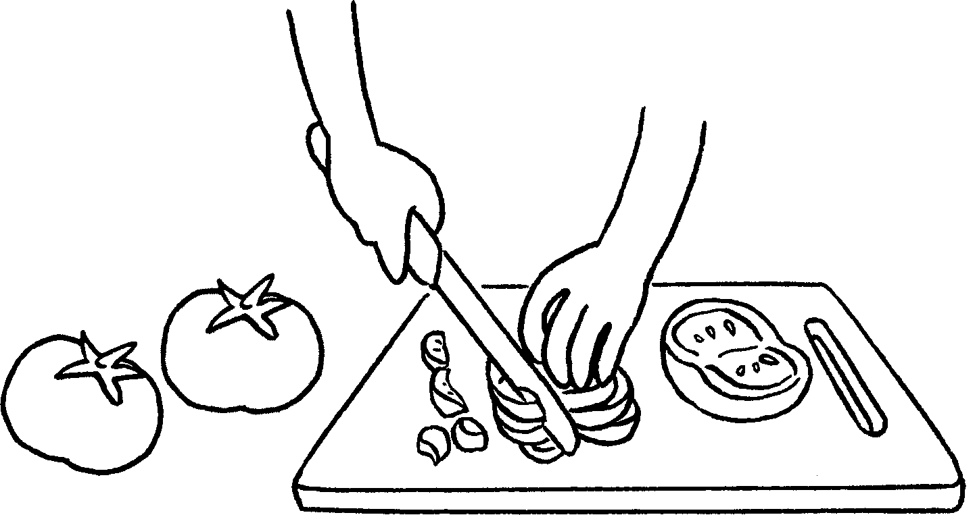
2 | Take the b out of the oven.  Sit down and enjoy . | 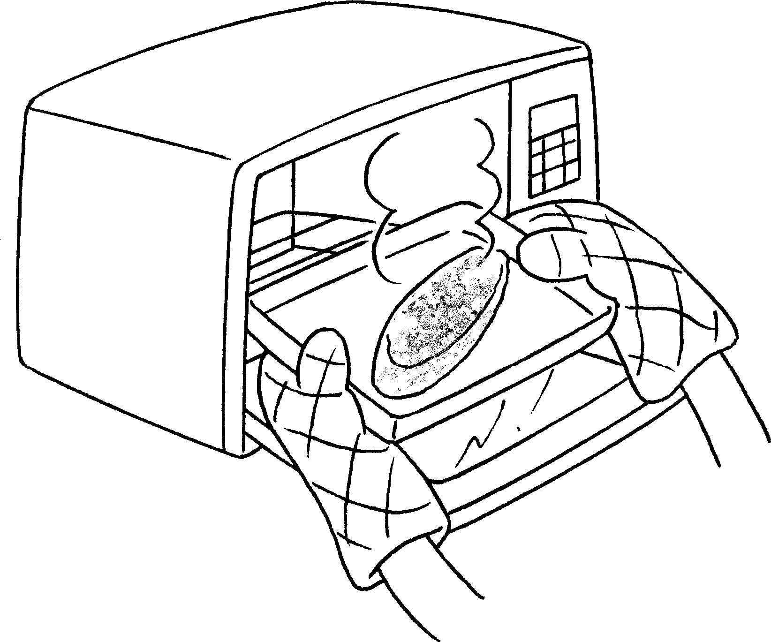
3 | Put the onions, egg and  m into a bowl.  Mix together. | 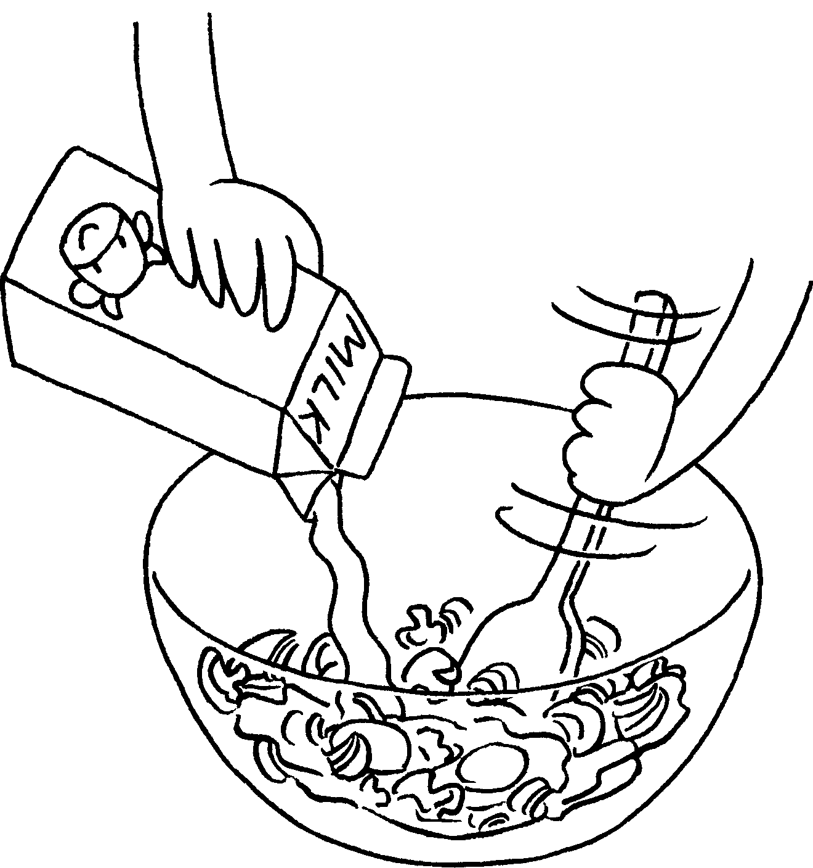
4 | C the onion and  mushrooms into small pieces.  Put into a bowl. | 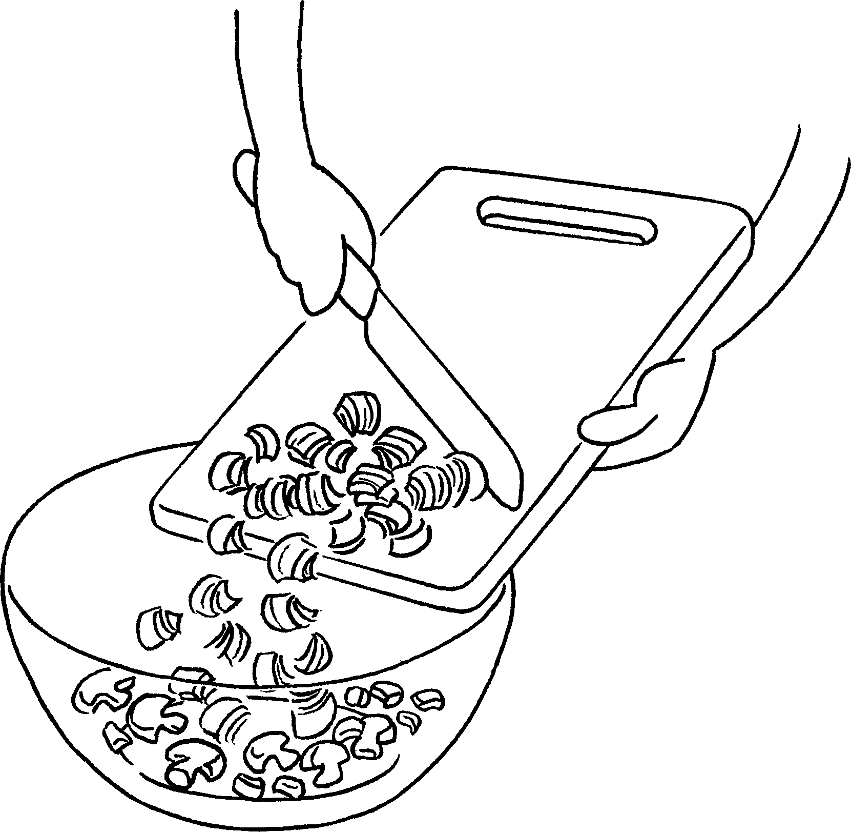
5 | P the egg mixture into a pan.  Fry for 3 minutes. | 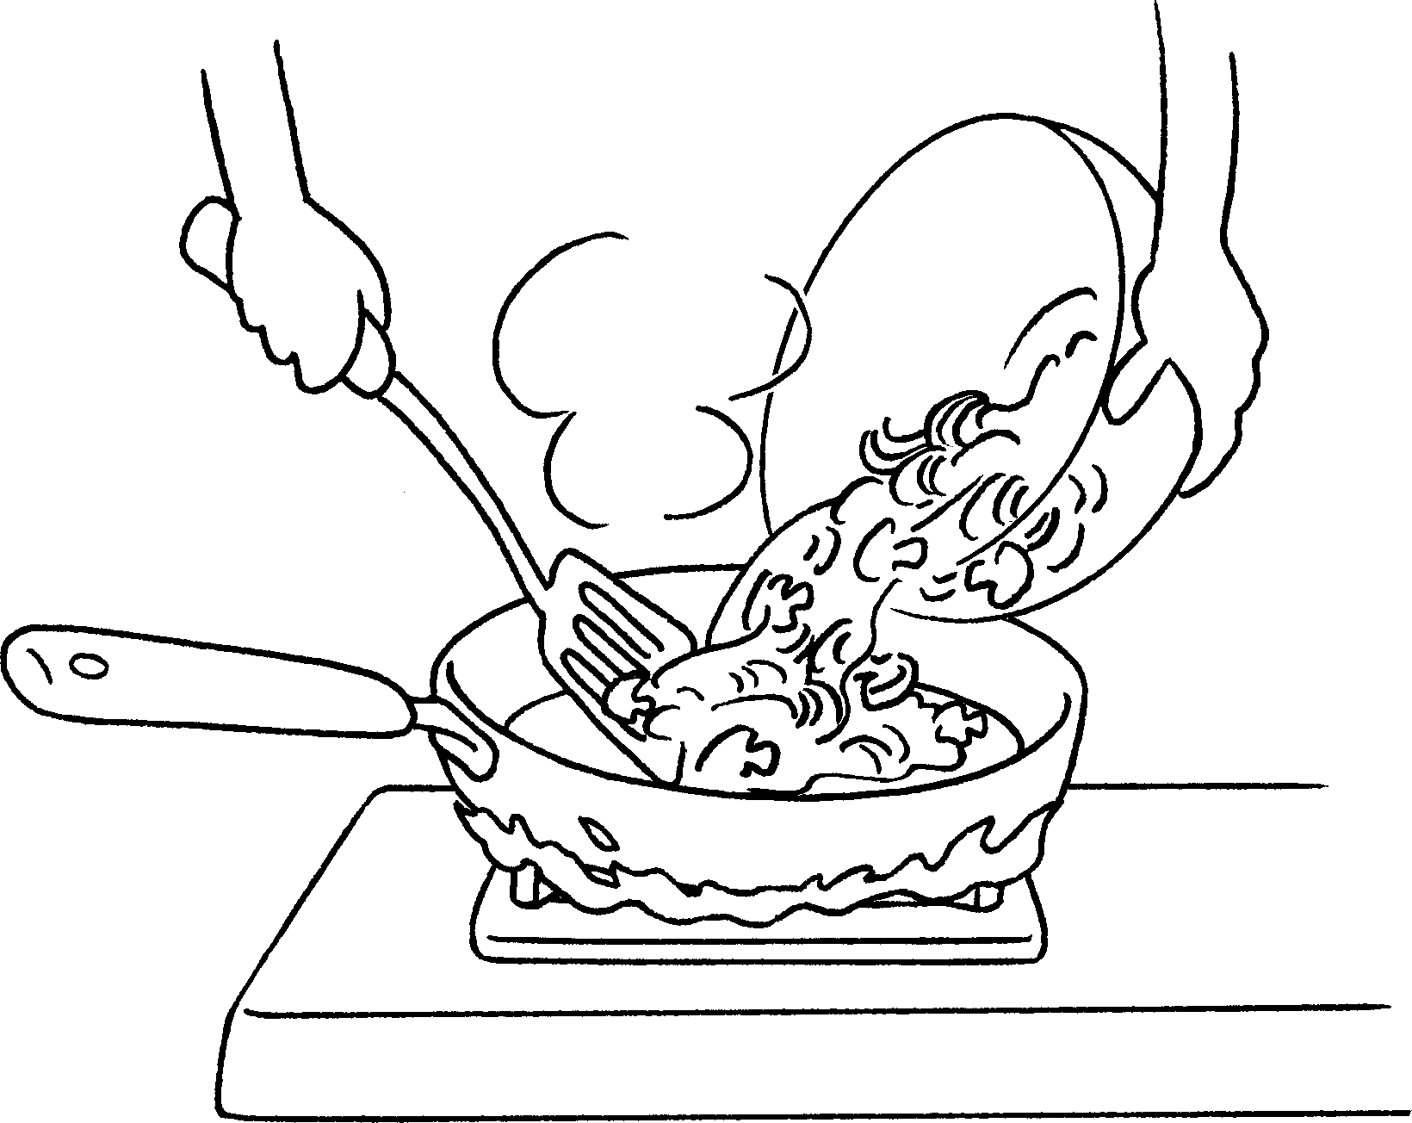


Book 3A Chapter 1 Graded Worksheets
Worksheet 3⬇⬇⬇
- them
- bread
it
- milk
them
- Cut
them
- Pour
it

