1 Fun with cooking
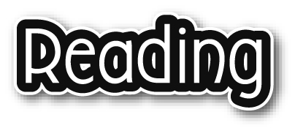
How to make French toast

What kind of food do you like? Do you like sweet, salty, sour or spicy food?
I like sweet food best. Let me teach you how to make something sweet and yummy.
You need:
● one slice of bread  one egg
● some milk  some sugar
● some butter  some jam
1 First take a slice of bread. Cut it into two triangles.
2 Then put the egg, sugar and milk into a bowl and mix them together.
3 Put the bread into the egg mixture.
4 Then put some butter into a pan and heat it. Ask a grown-up, for
example, your mum or dad, to help you.
5 Fry the bread in the pan.
6 Put the bread on a plate. Put some butter and jam on it.
7 Sit down and enjoy your French toast!
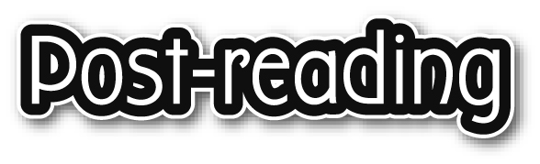
Write the answers and blacken  the circles.

1 How many slices of bread do you need to make French toast?
_________________________

2 What do you put into the pan to fry the bread?
_________________________

3 You do NOT need ___ to make the egg mixture.
 A. sugar
 B. milk
 C. egg
 D. butter

4 Which sentence is true?
 A. You cut the bread into two triangles.
 B. You put some sugar into the pan.
 C. You need two eggs to make French toast.
 D. You need some jam to fry the bread.

Answers:
1 One / 1. 2 (Some) butter. 3 D 4 A

