Contents pages
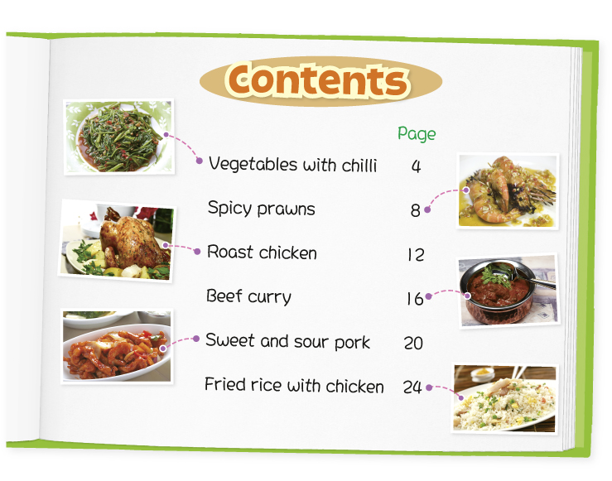
Write the answer and blacken  the circles.

1 You can read about a dish with rice on page _____ .

2 You need ___ to make the dish on page 8.
 A. beef
 B. chicken
 C. prawns
 D. pork

3 You can turn to page ___ for a dish with chicken.
 A. 8
 B. 12
 C. 16
 D. 20

4 Which dish is spicy?
 A. Vegetables with chilli
 B. Roast chicken
 C. Sweet and sour pork
 D. Fried rice with chicken

Answers:
1 24 2 C 3 B 4 A

