Fill in the missing letters.

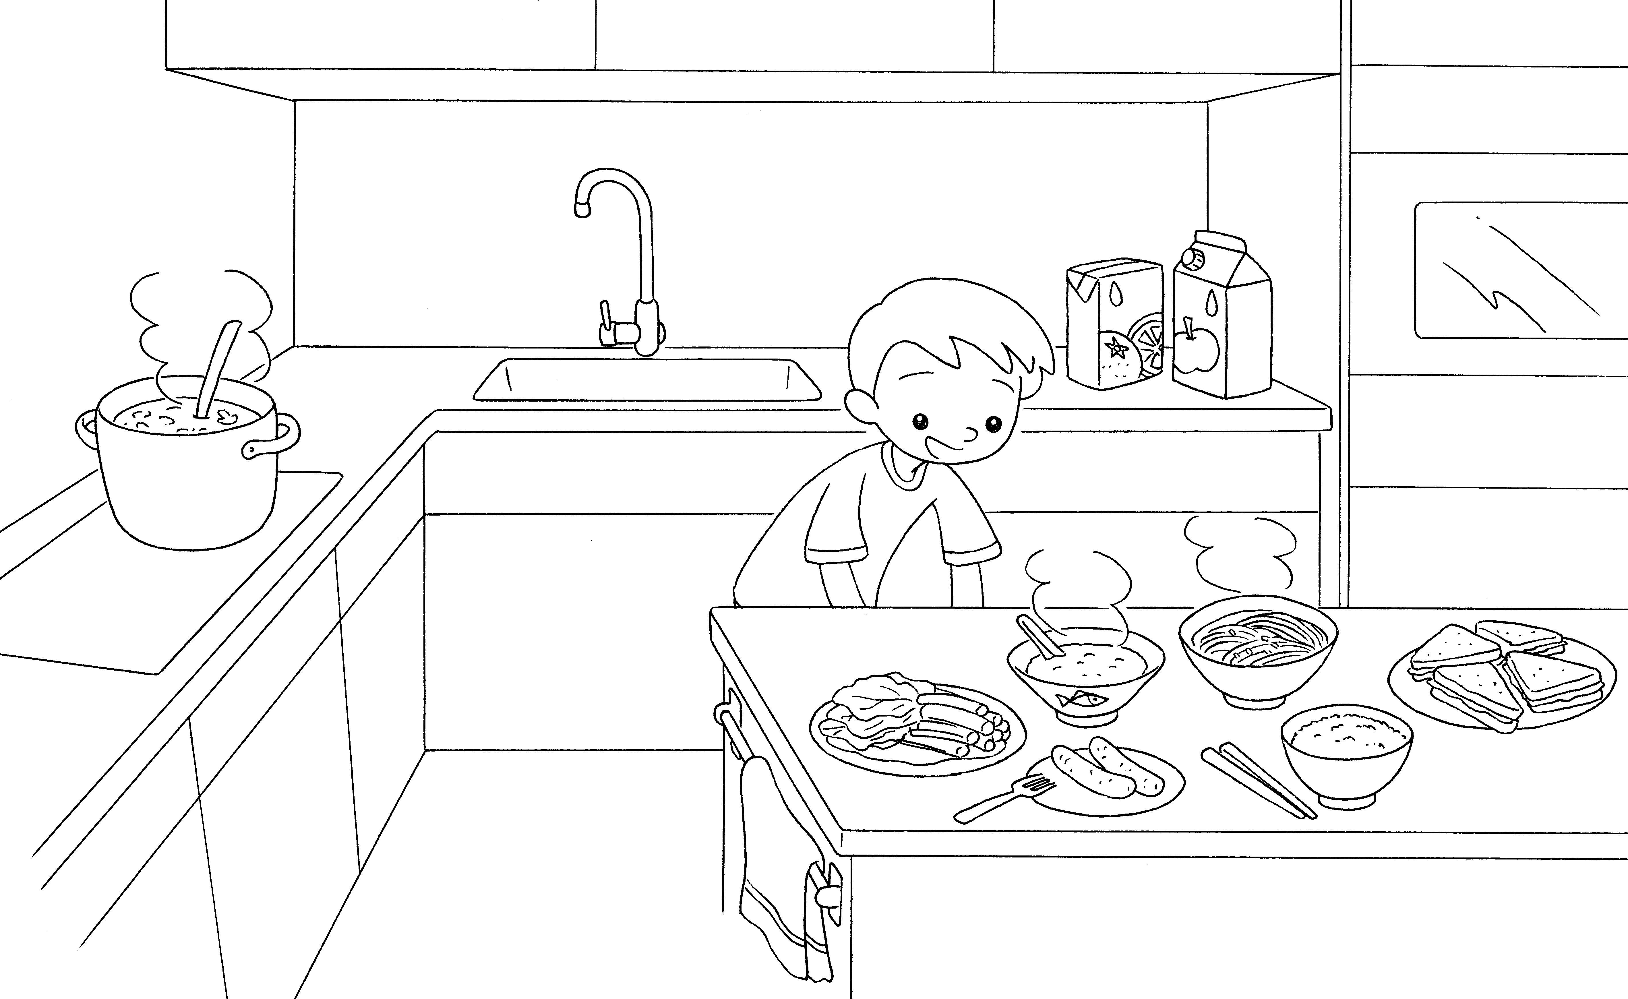

2
1

4
5
6
3

8
7

1 | s __ __ __ |  | 2 | j __ __ __ __
3 | v __ __ __ __ __ __ __ __ __ |  | 4 | c __ __ __ __ __
5 | n __ __ __ __ __ __ |  | 6 | s __ __ __ __ __ __ __ __ __
7 | s __ __ __ __ __ __ __ |  | 8 | r __ __ __


Book 3A Chapter 2 Graded Worksheets
Worksheet 1⬇⬇
1 s o u p 2 j u i c e
3 v e g e t a b l e s 4 c o n g e e
5 n o o d l e s 6 s a n d w i c h e s
7 s a u s a g e s 8 r i c e

