What food can you see? Write.

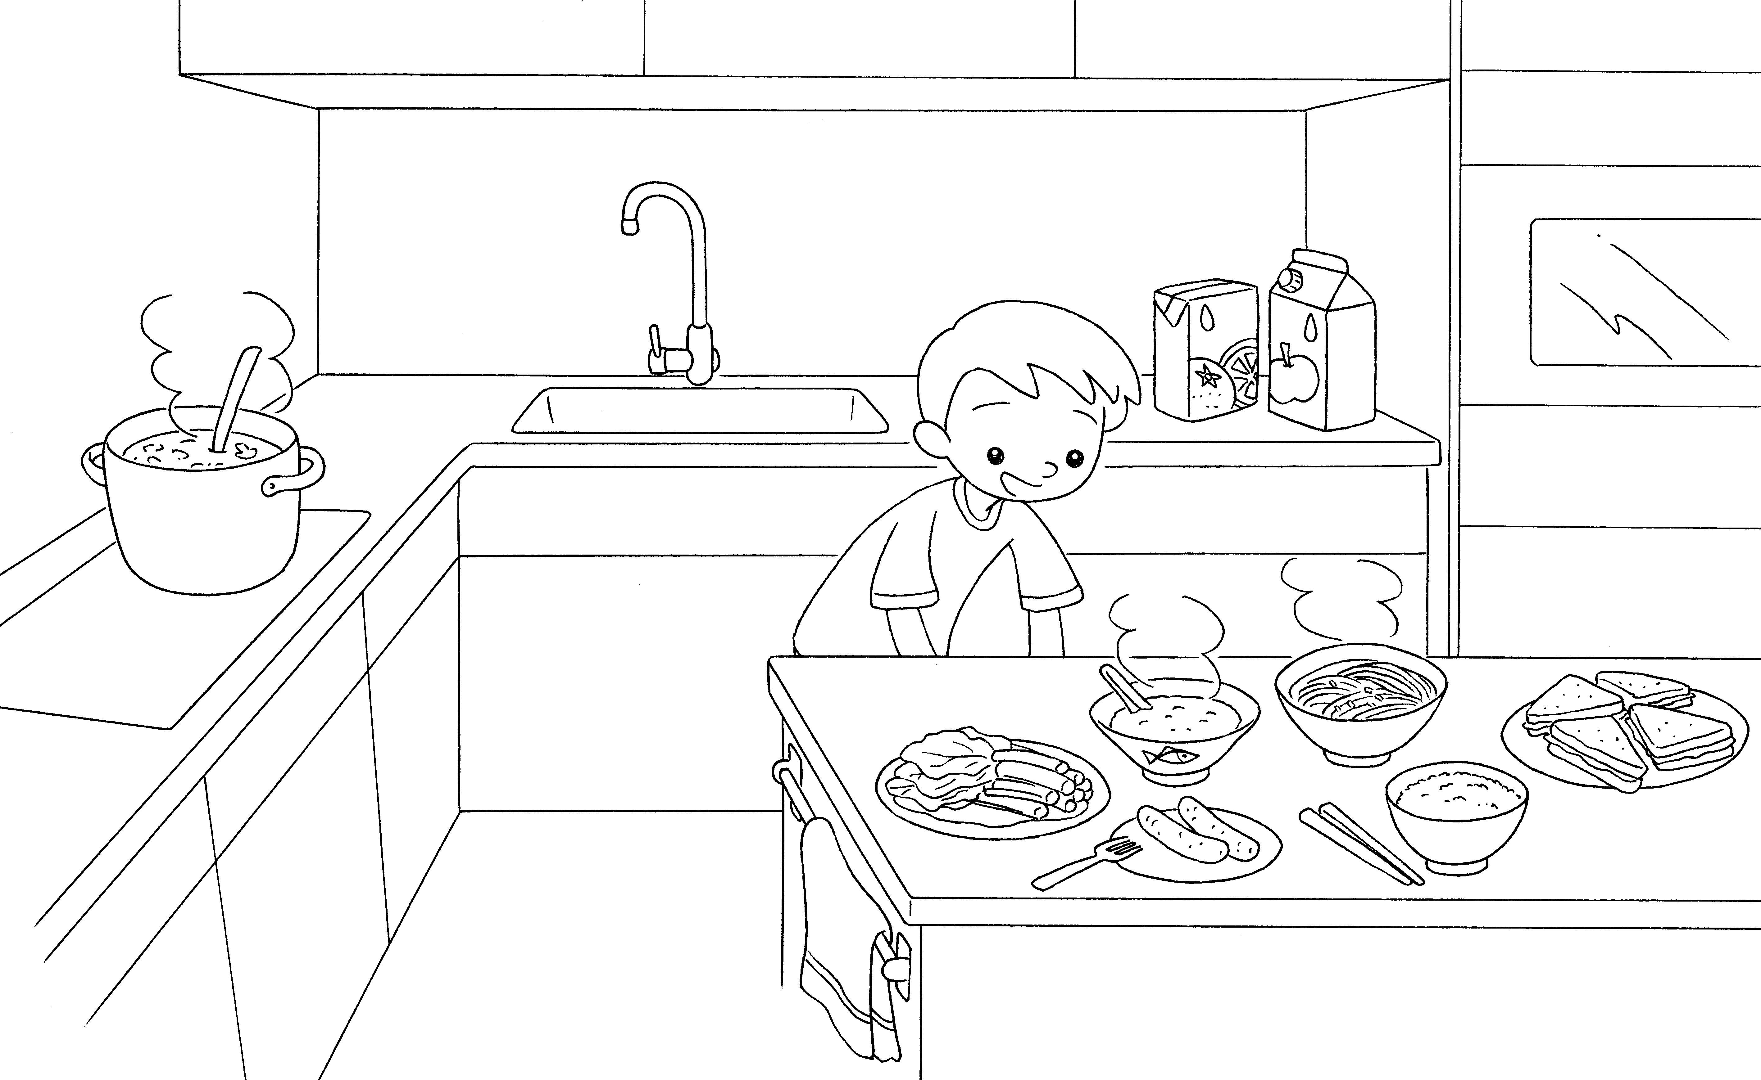

2
1

4
5
6
3

8
7

1 | s |  | 2
3 |  |  | 4
5 |  |  | 6
7 |  |  | 8


Book 3A Chapter 2 Graded Worksheets
Worksheet 1⬇⬇⬇
1 soup 2 juice
3 vegetables 4 congee
5 noodles 6 sandwiches
7 sausages 8 rice

