Circle the correct answers.
1 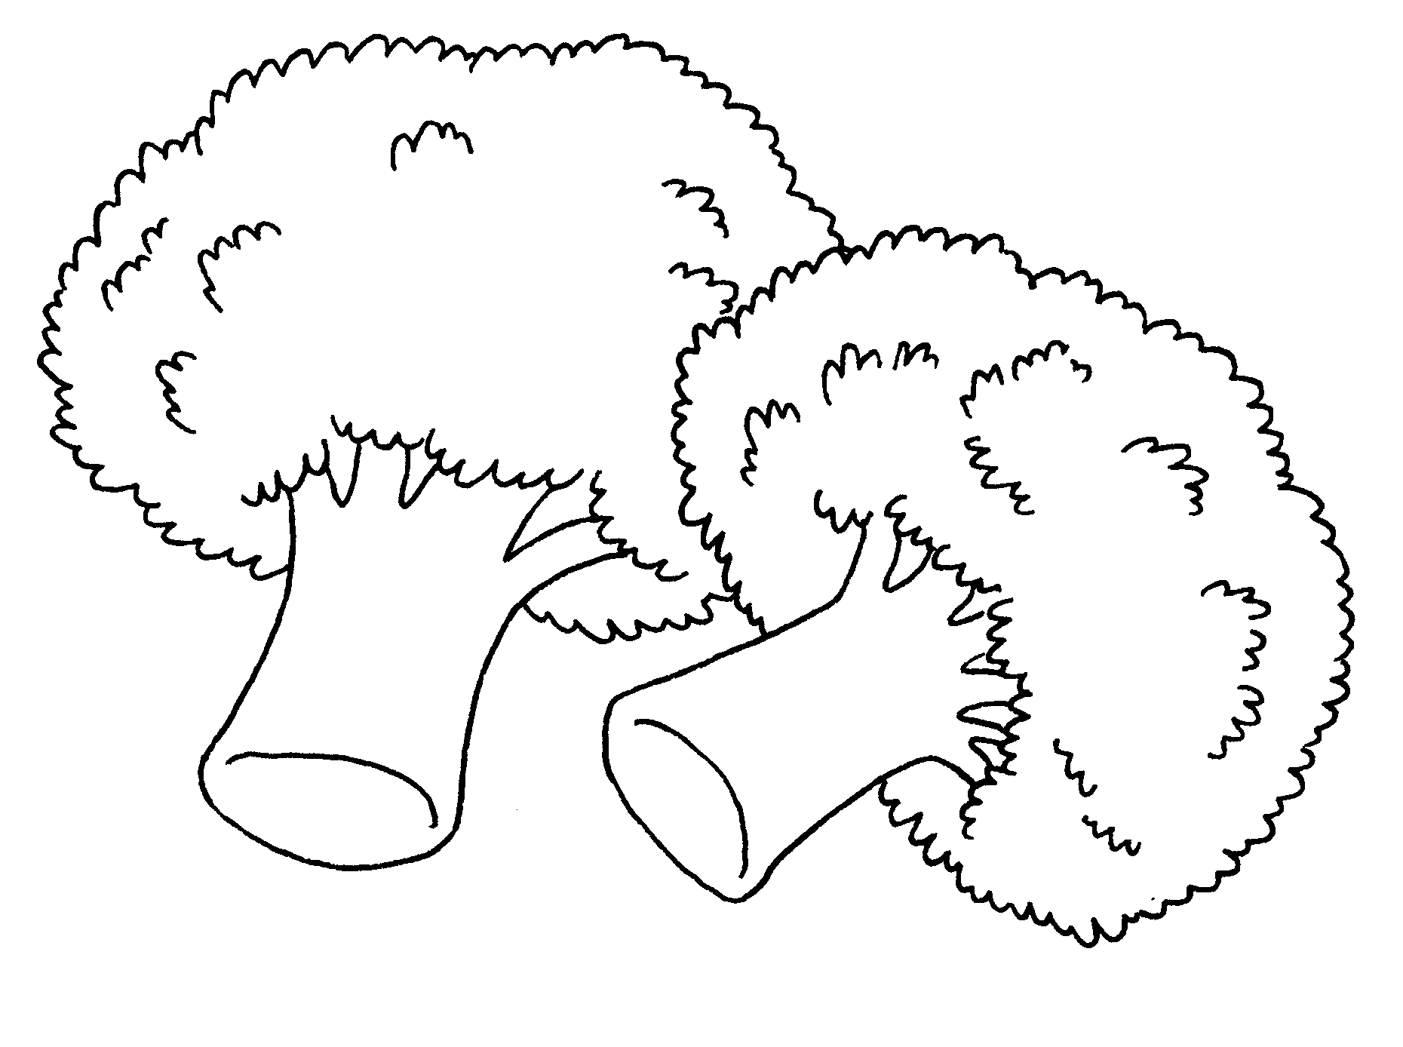  There are ( some / any )  vegetables. |  | 2 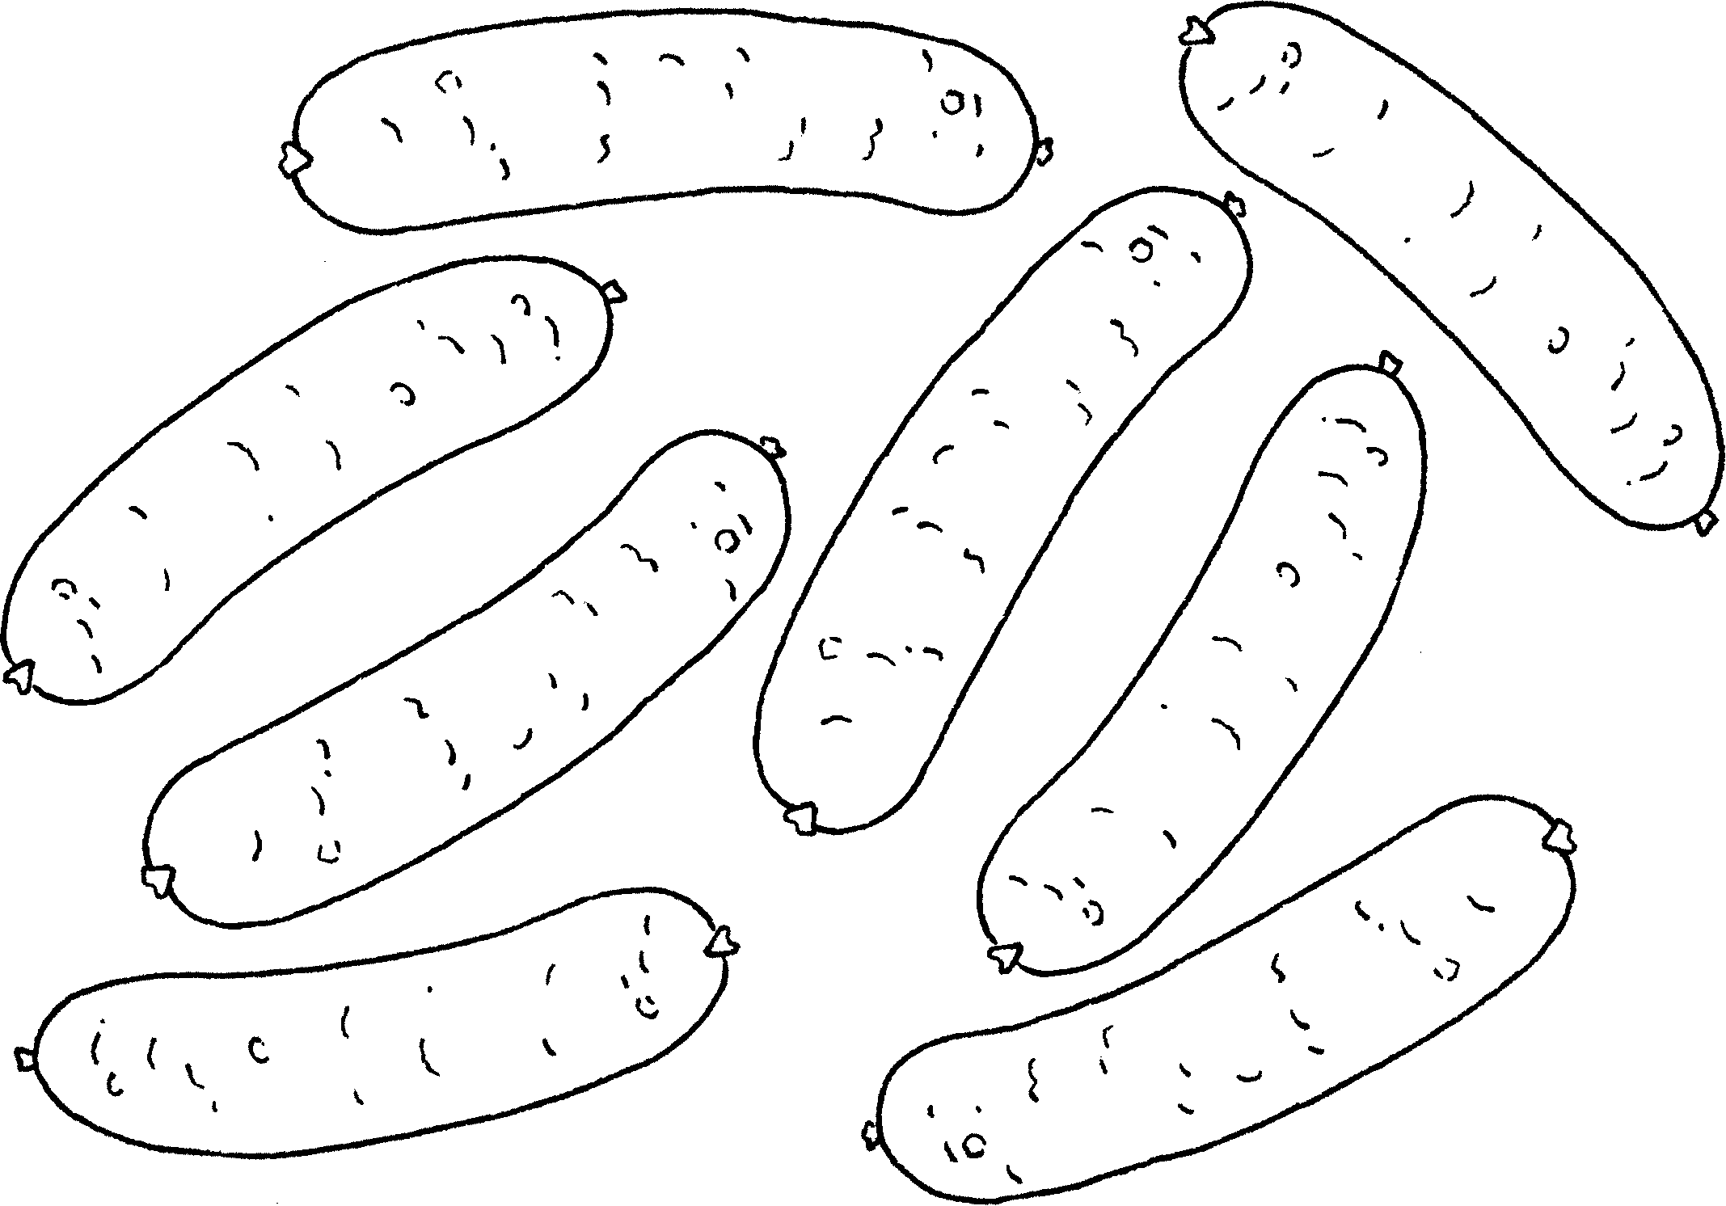  There are ( any / a lot of )  sausages.
3  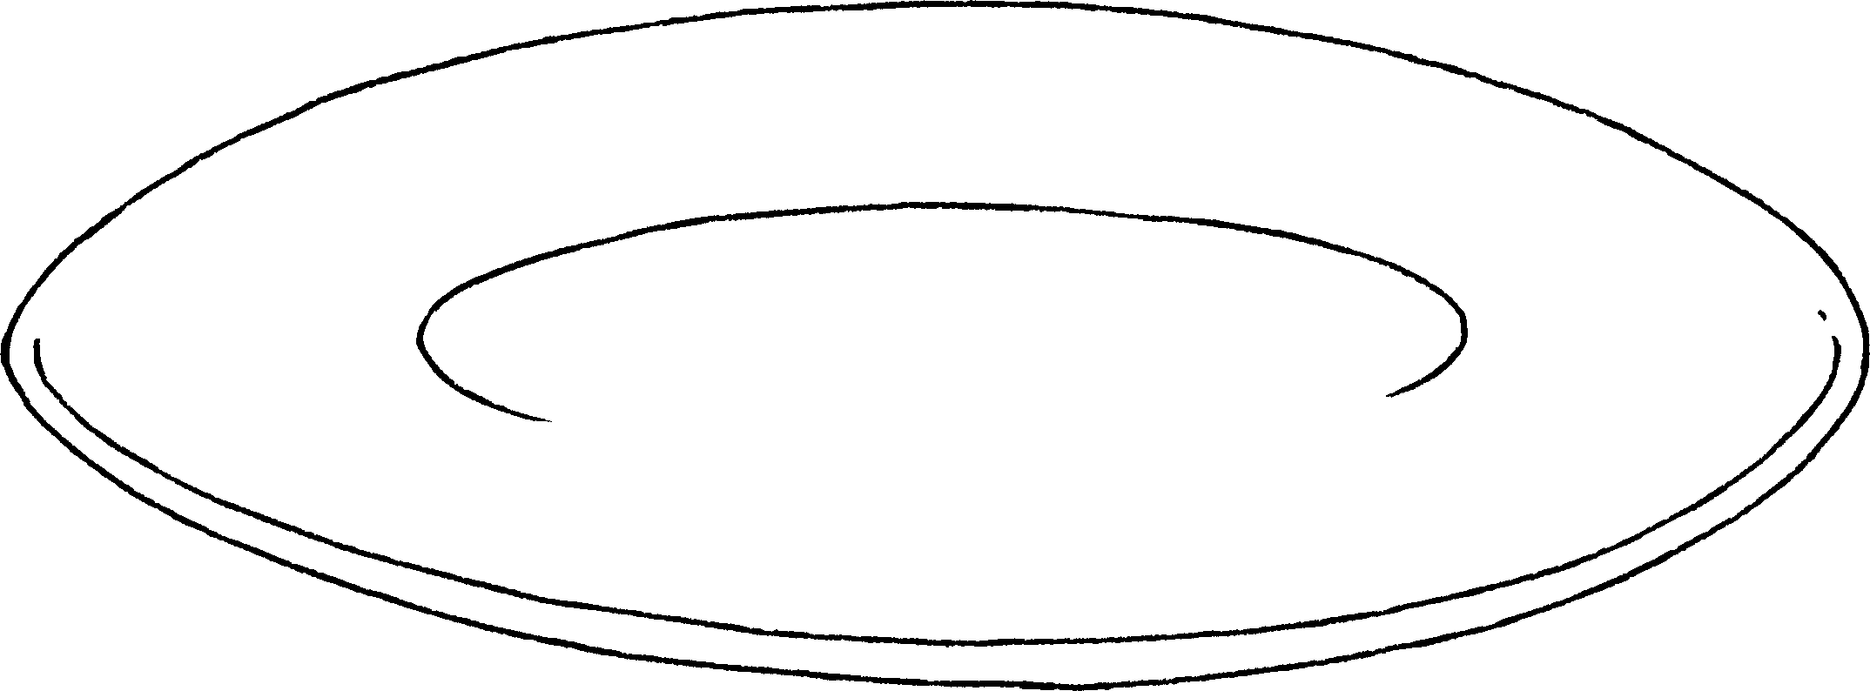  There aren’t  ( some / any ) noodles. |  | 4 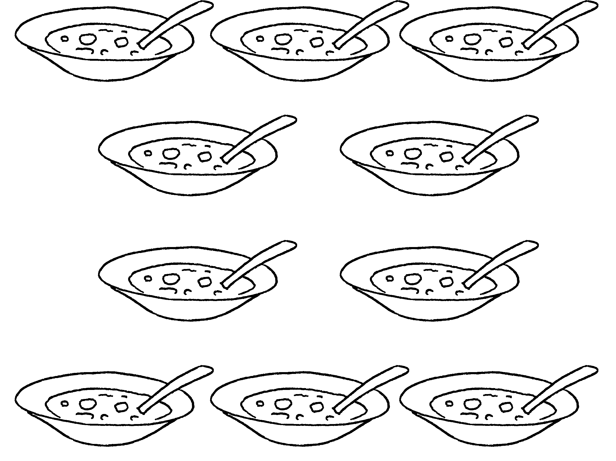  There is ( a lot of / any ) soup.
5 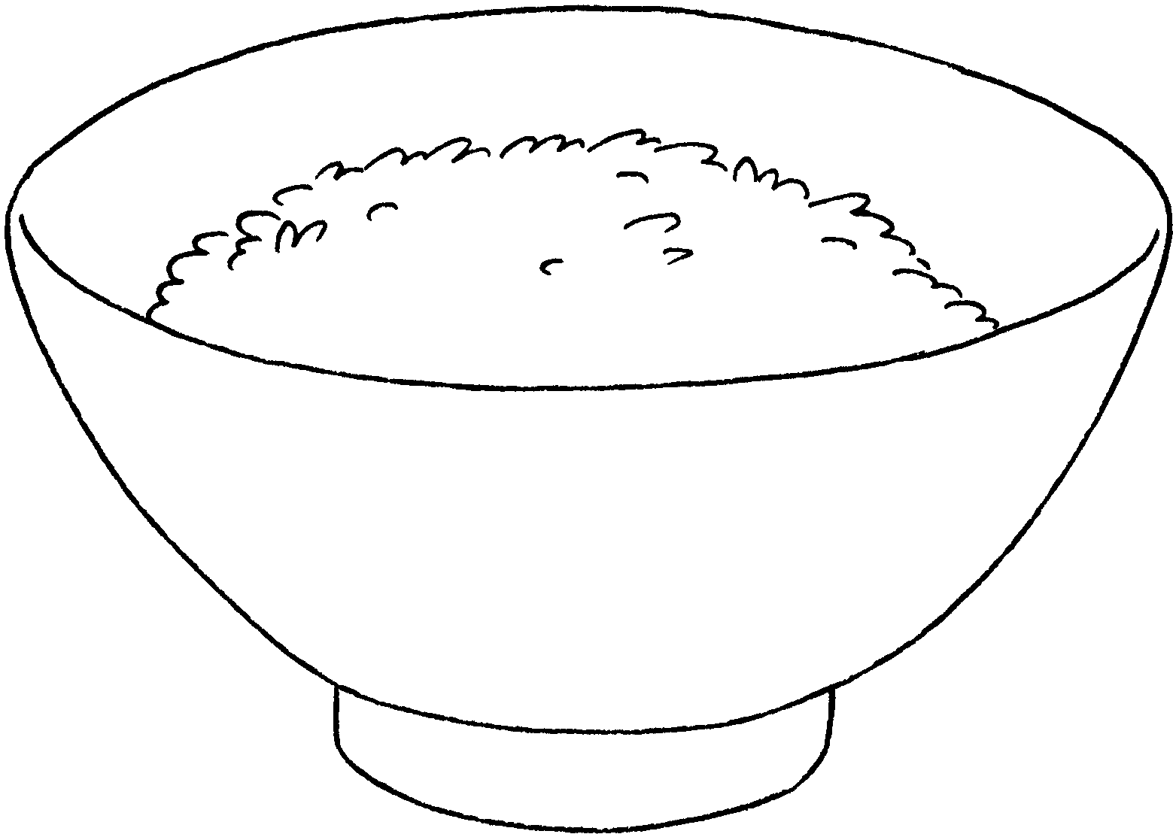  There is ( any / some ) rice. |  | 6 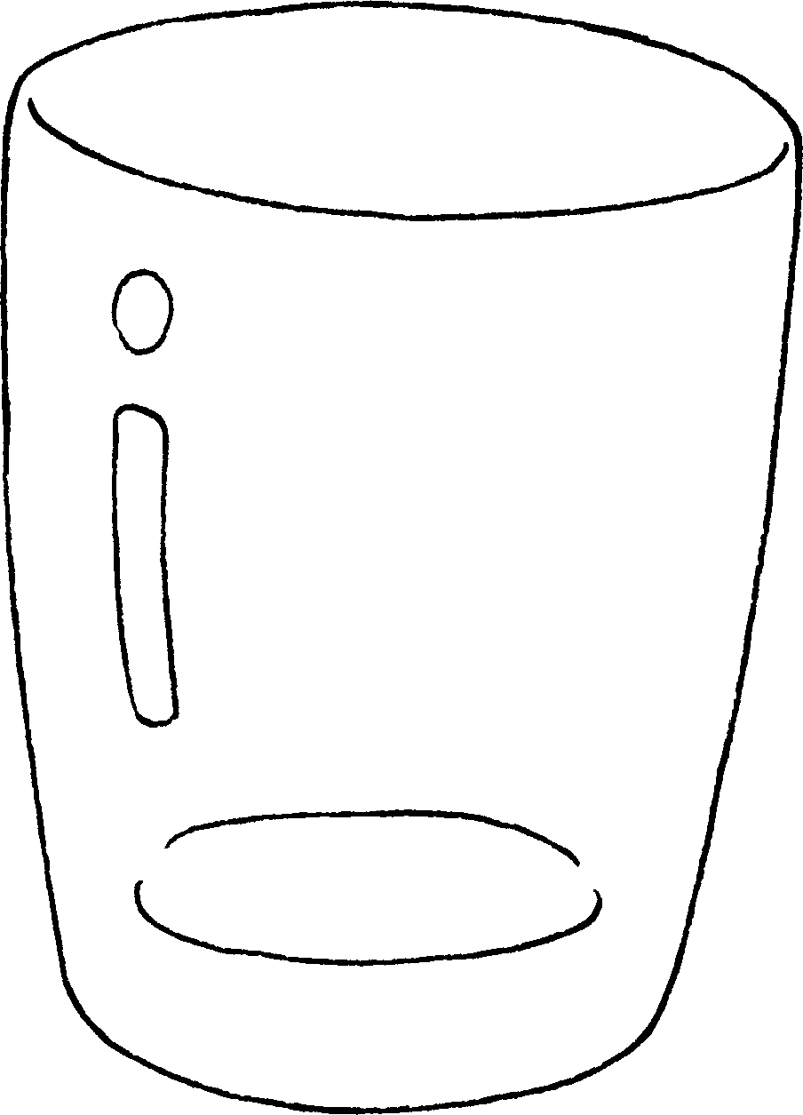  There isn’t ( any / a lot of ) juice.



Book 3A Chapter 2 Graded Worksheets
Worksheet 2⬇
- ( some / any )
- ( any / a lot of )
- ( some / any )
- ( a lot of / any )
- ( any / some )
- ( any / a lot of )

