Choose and write.

any some a lot of

1 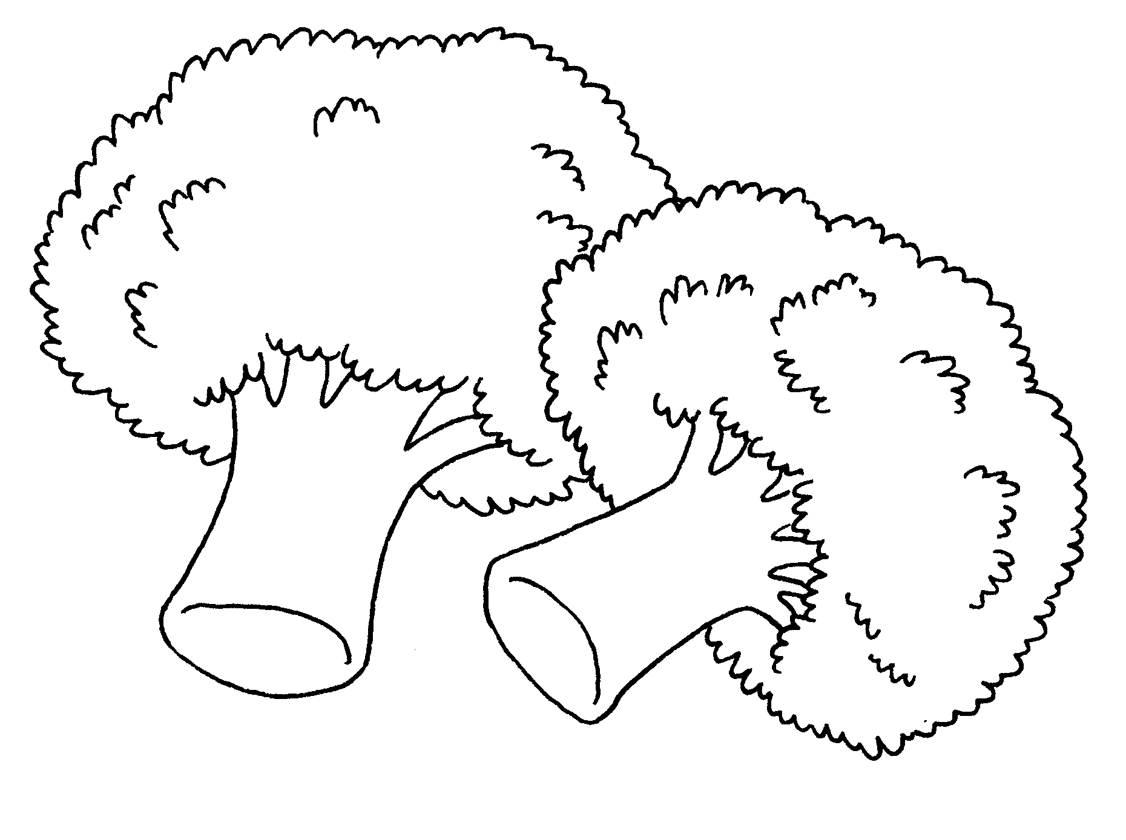  There are  vegetables. |  | 2 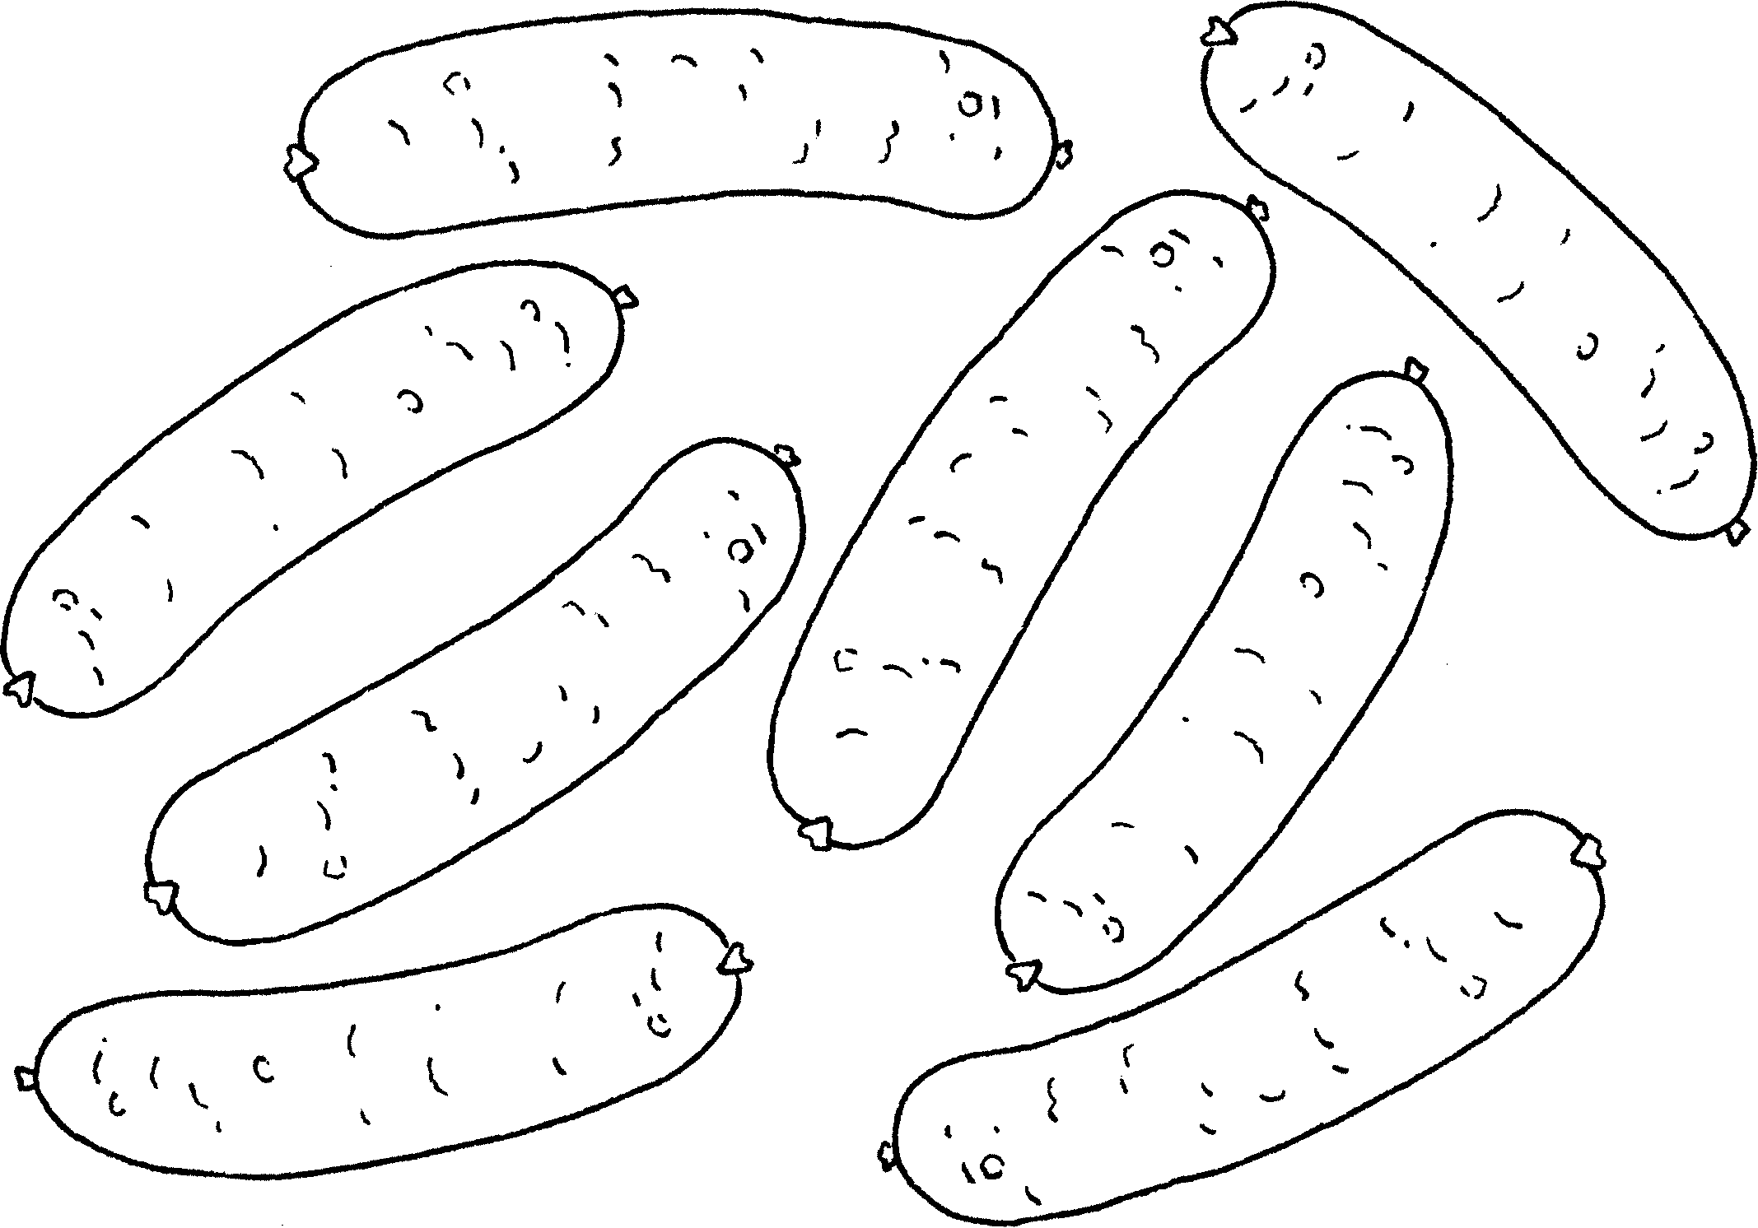  There are  sausages.
3  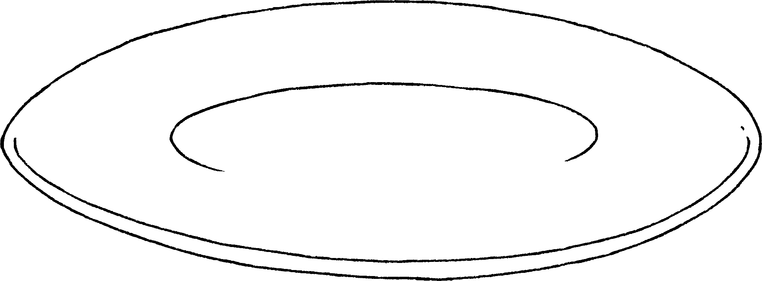  There aren’t  noodles. |  | 4 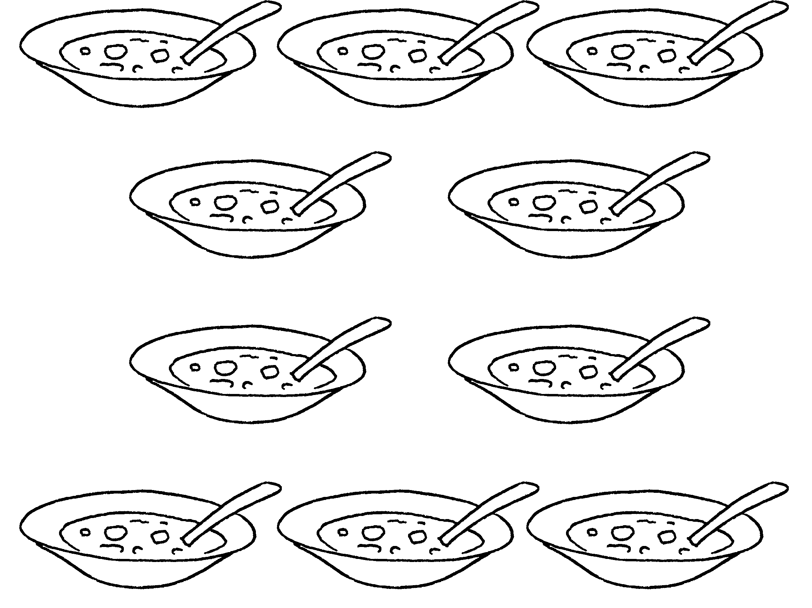  There is soup.
5 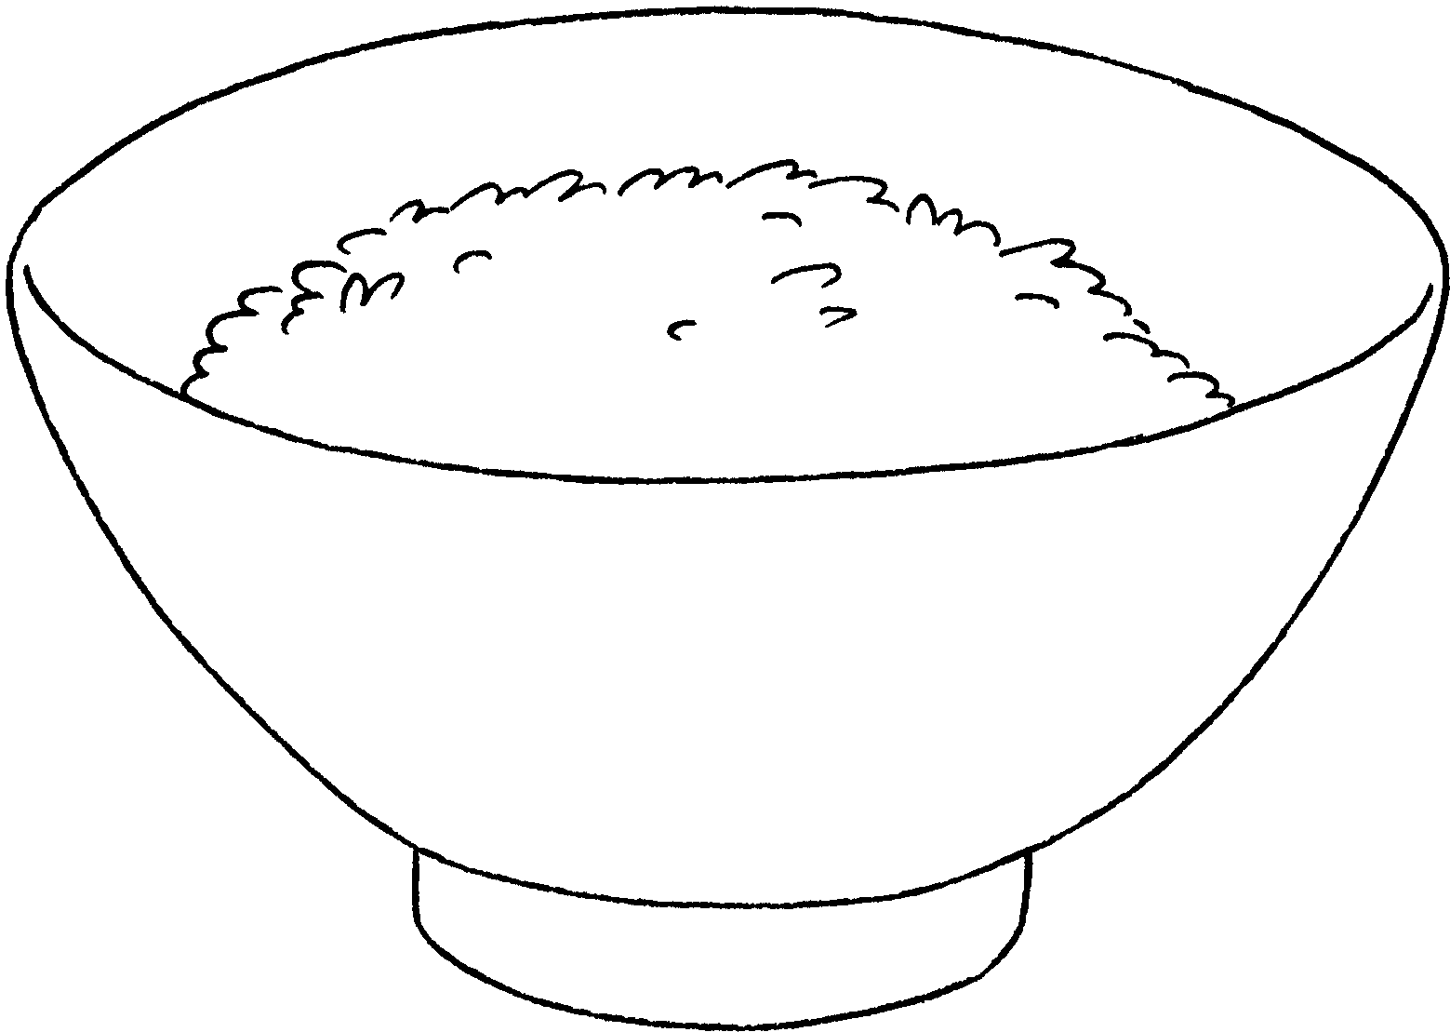  There is rice. |  | 6 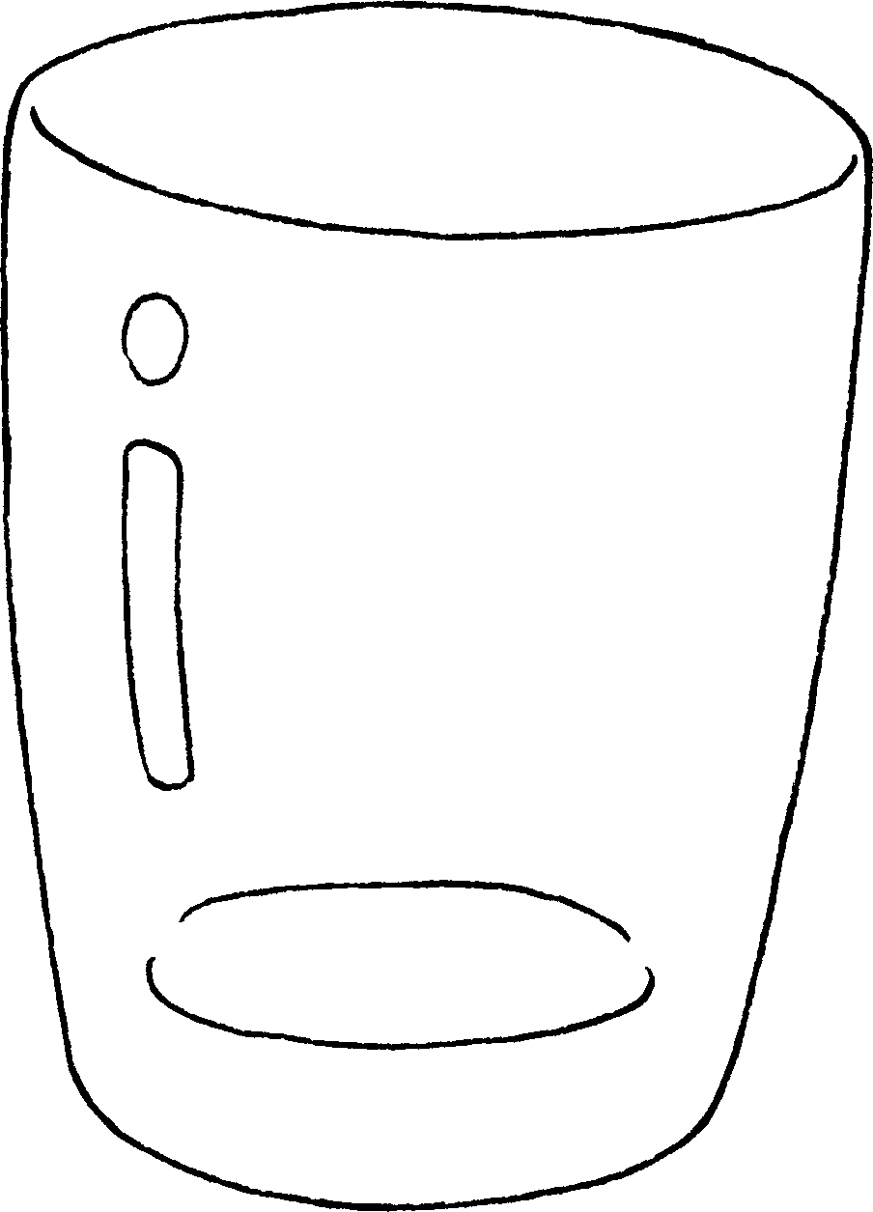  There isn’t juice.


Book 3A Chapter 2 Graded Worksheets
Worksheet 2⬇⬇
- some
- a lot of
- any
- a lot of
- some
- any

