Choose and write.

is are isn’t aren’t any some a lot of

1 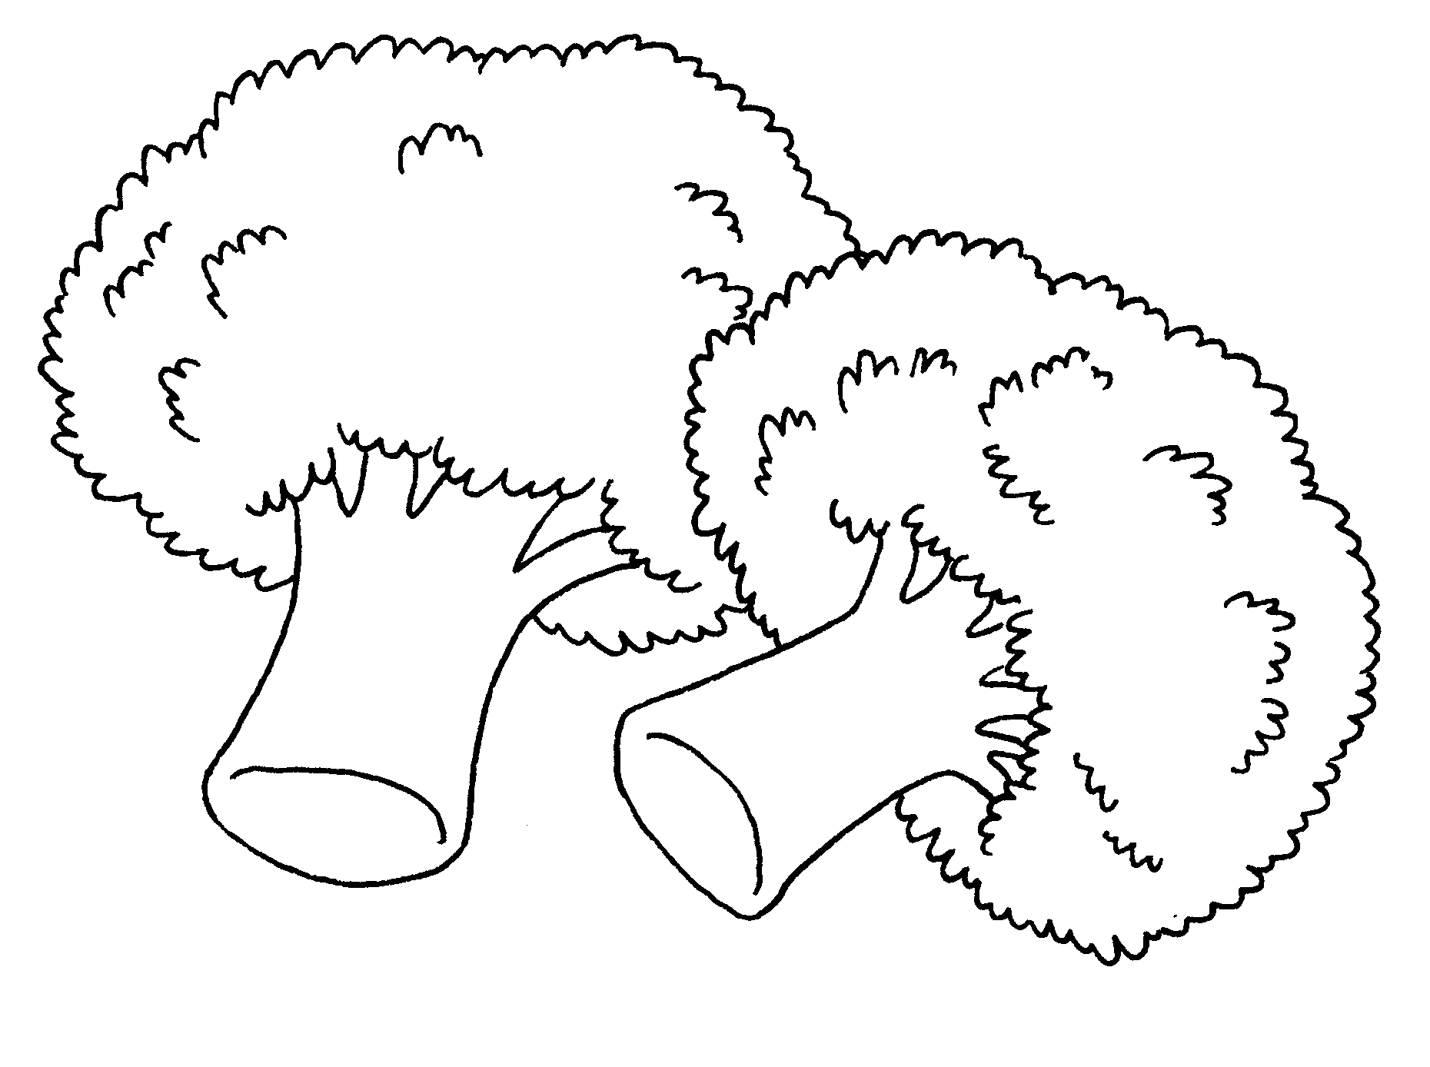  There are  vegetables. |  | 2 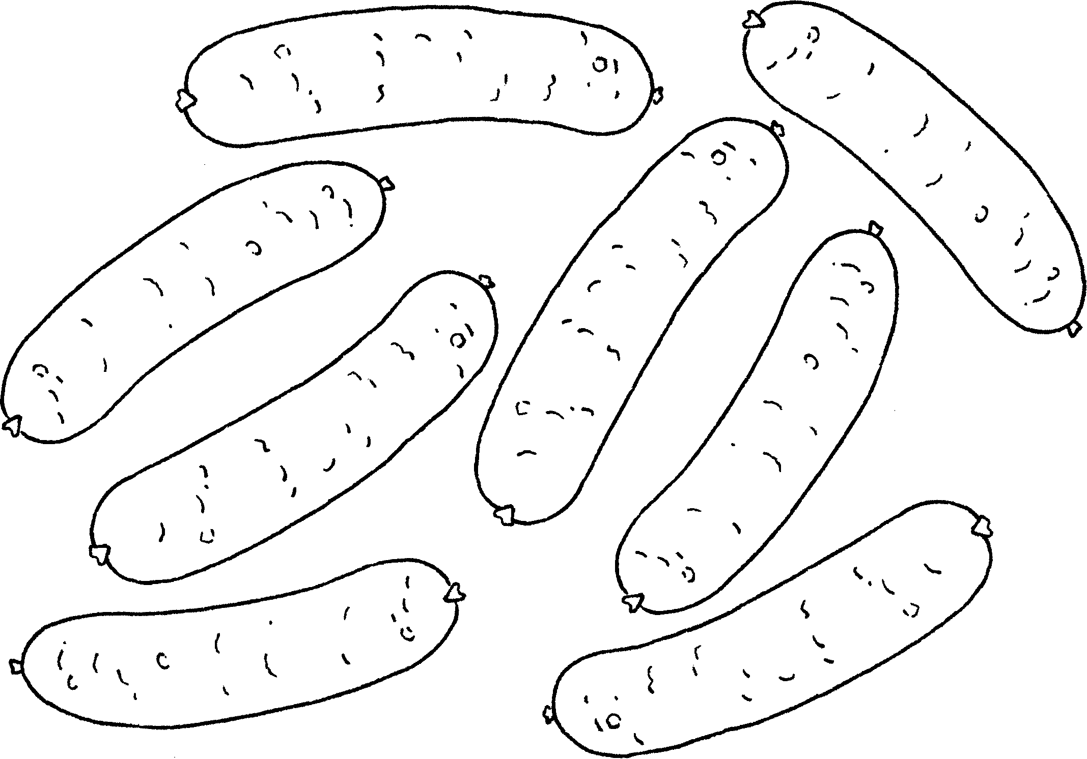  There  sausages.
3  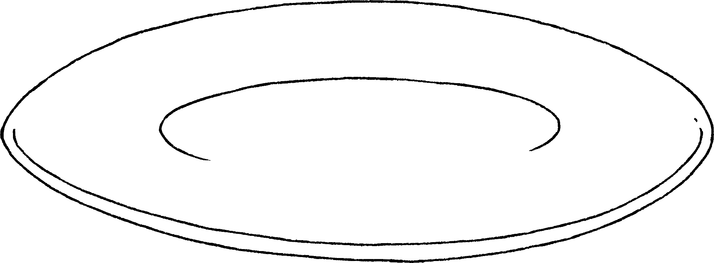  There  noodles. |  | 4 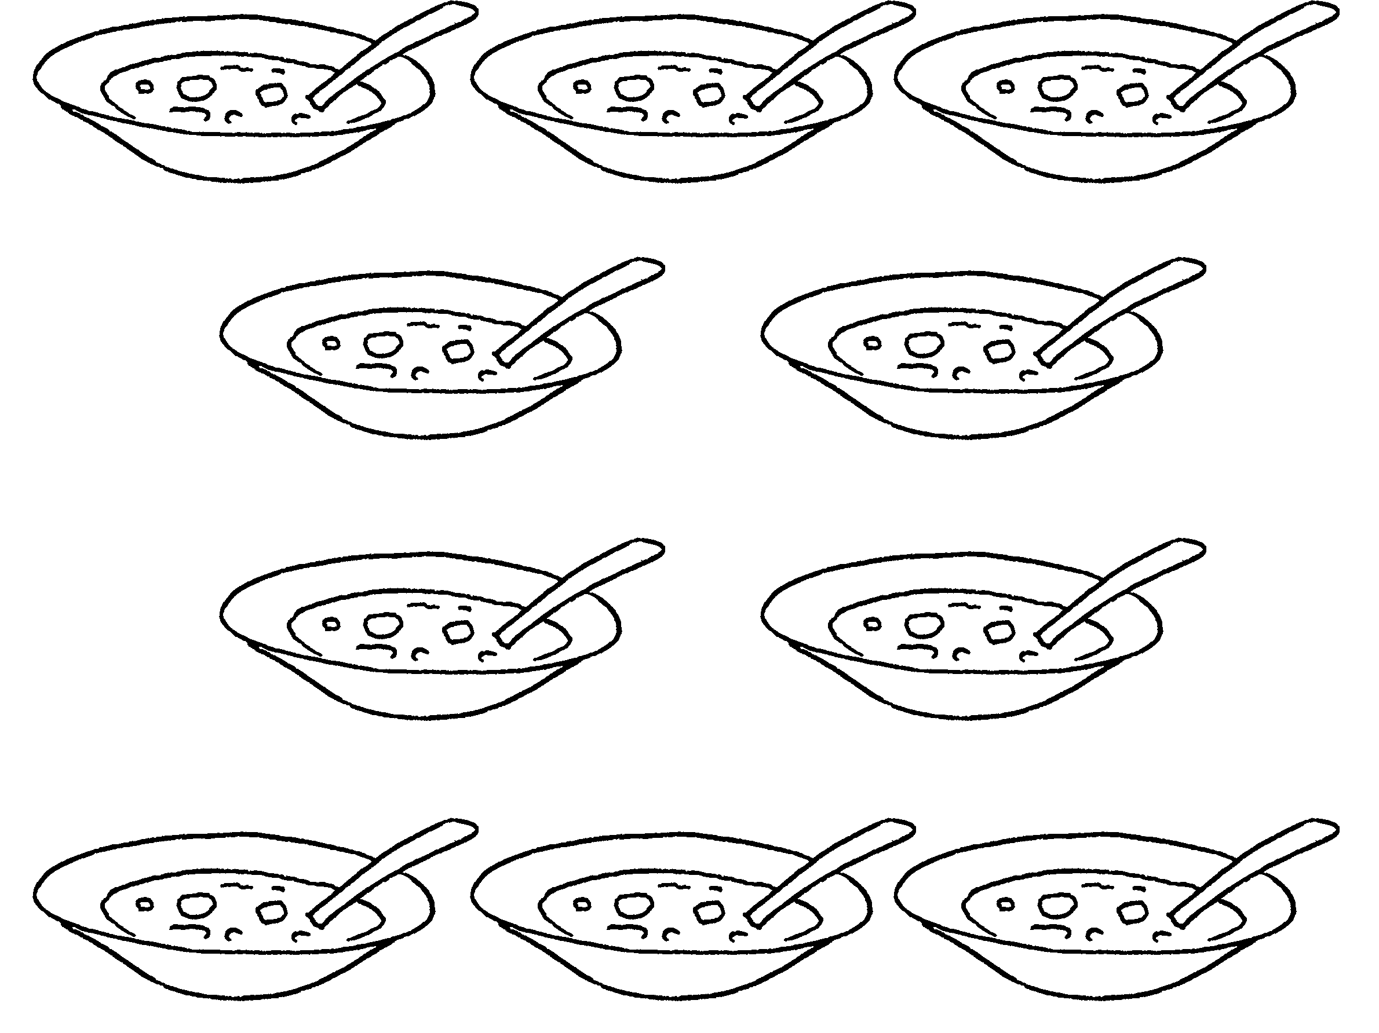  There soup.
5 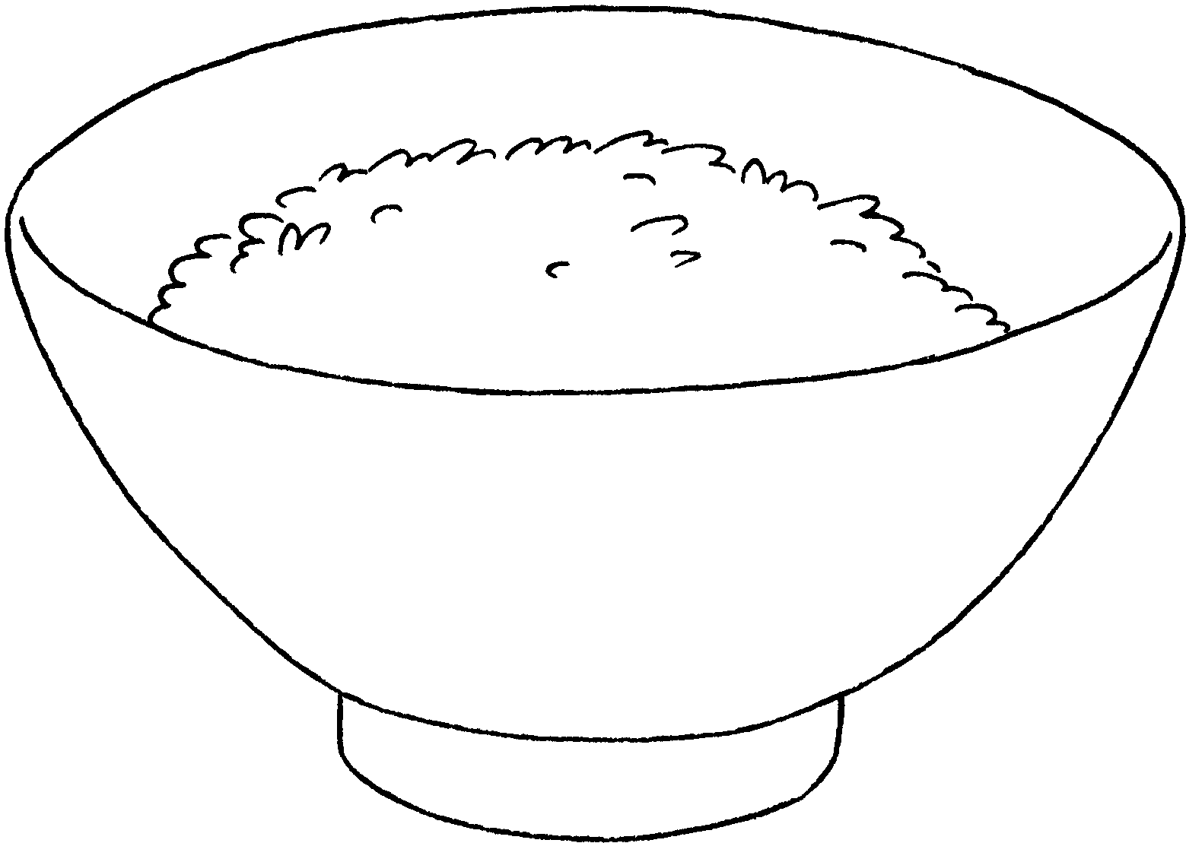  There rice. |  | 6 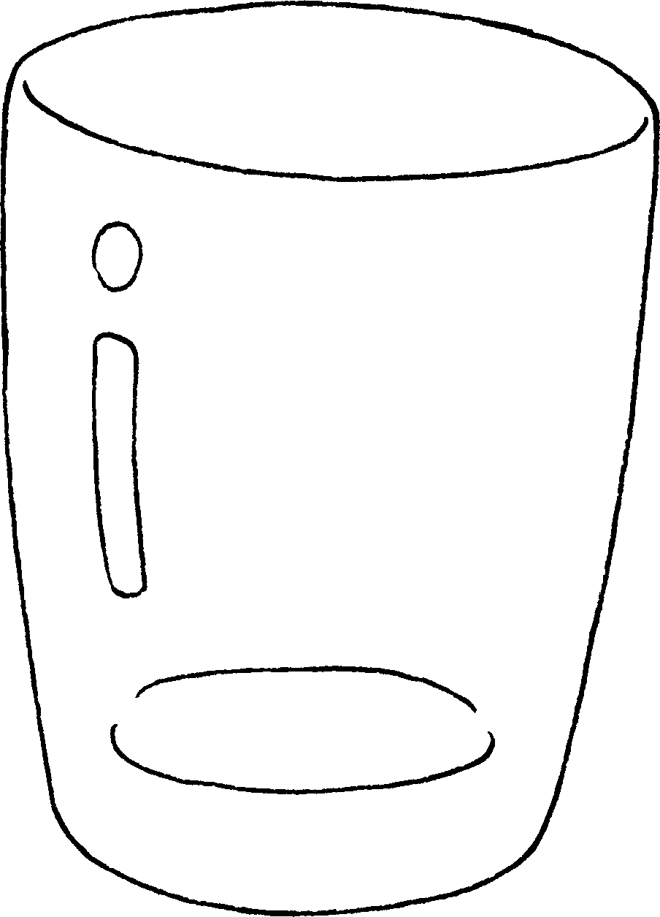  There juice.


Book 3A Chapter 2 Graded Worksheets
Worksheet 2⬇⬇⬇
- some
- are a lot of
- aren’t any
- is a lot of
- is some
- isn’t any

