A
B

A
B

A
B

A
B

A
B

Choose and write.

Is there
there is
there isn’t
Are there
there are
there aren’t
1  | A : any  sausages?  B : Yes, there are.
2  | A : Is there any juice?  B : No, .
3  | A : Are there any sandwiches?  B : Yes, .
4 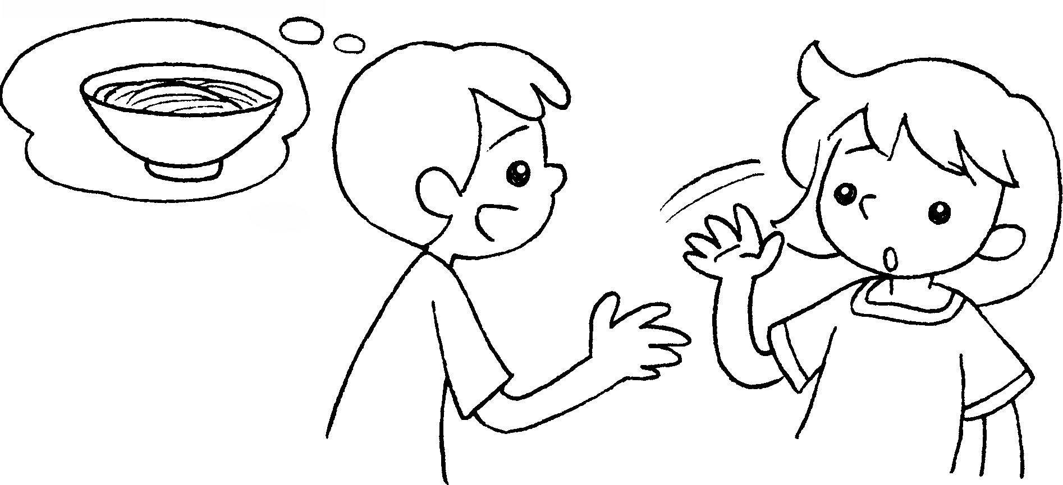 | A : any noodles?  B : No, .
5 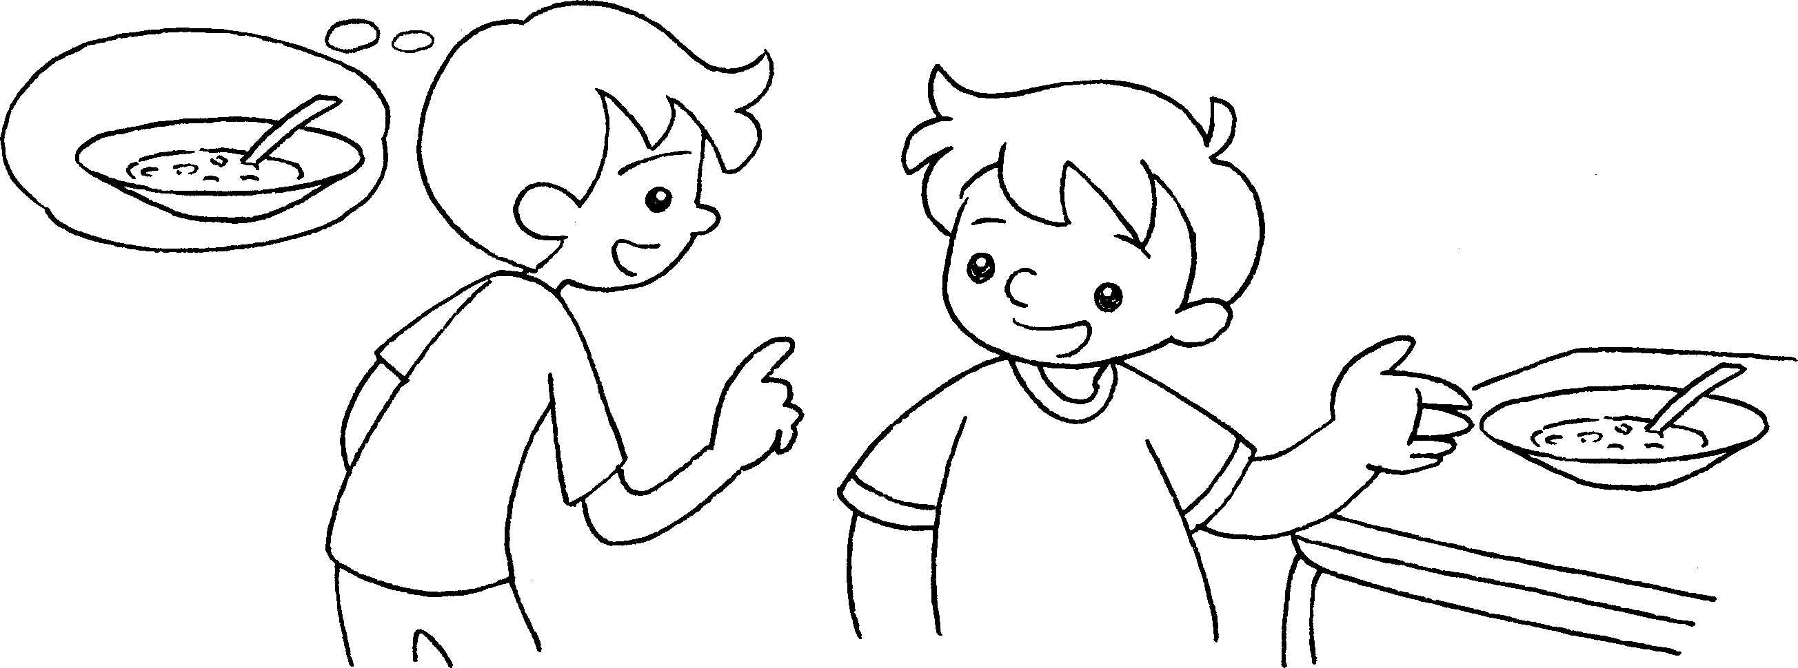 | A : any soup?  B : Yes, .



Book 3A Chapter 2 Graded Worksheets
Worksheet 3⬇
- Are there
- there isn’t
- there are
- Are there
there aren’t
- Is there
there is

