A
B

A
B

A
B

A
B

A
B

Choose and write.
there
is isn’t
arearen’t

1  | A : there any  sausages?  B : Yes, there are.
2  | A : any juice?  B : No, .
3  | A : any  sandwiches?  B : Yes, .
4  | A : any noodles?  B :
5 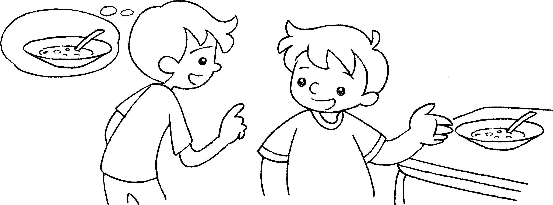 | A : any soup?  B :


Book 3A Chapter 2 Graded Worksheets
Worksheet 3⬇⬇
- Are
- Is there
there isn’t
- Are there
there are
- Are there
No, there aren’t.
- Is there
Yes, there is.

