Finish the questions and answers.
A
A
A
B

B

B

1   A  B  B | A : there any  sausages?  B : Yes, there are.
2   A | A : Is any juice?  B : No, there .
3  | A :  sandwiches?  B :
4 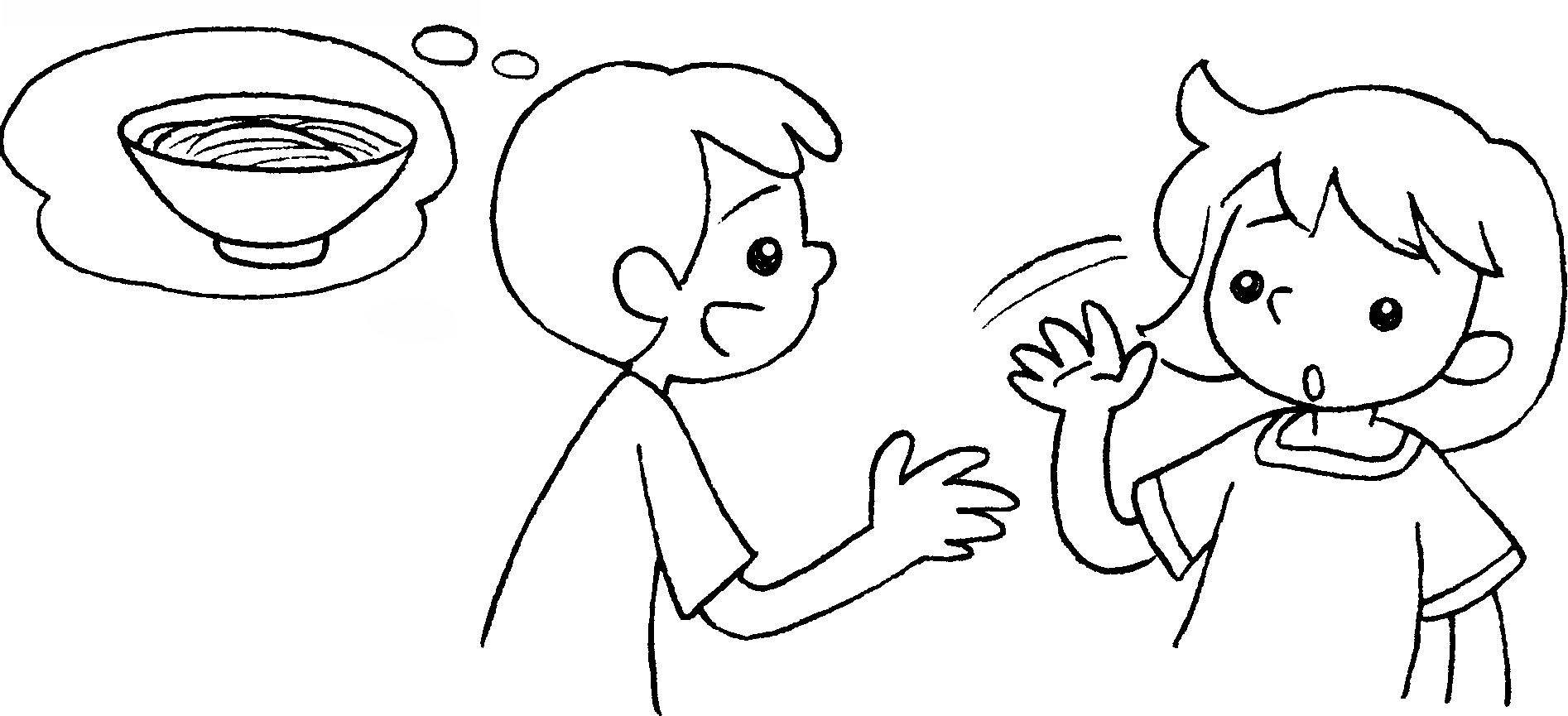 | A : noodles?  B :
5 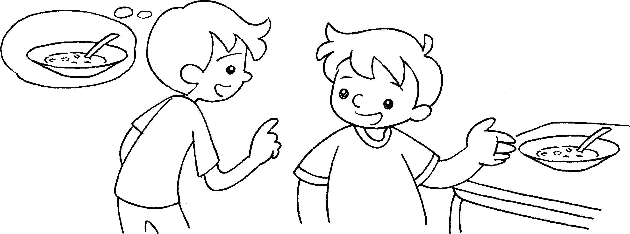 | A : soup?  B :


Book 3A Chapter 2 Graded Worksheets
Worksheet 3⬇⬇⬇
- Are
- there
isn’t
- Are there any
Yes, there are.
- Are there any
No, there aren’t.
- Is there any
Yes, there is.

