- Meal time!
Carla the country mouse is visiting her cousin Timmy the town mouse. Is Carla enjoying her holiday? Read the play and find out.

The Town Mouse and the Country Mouse
Characters
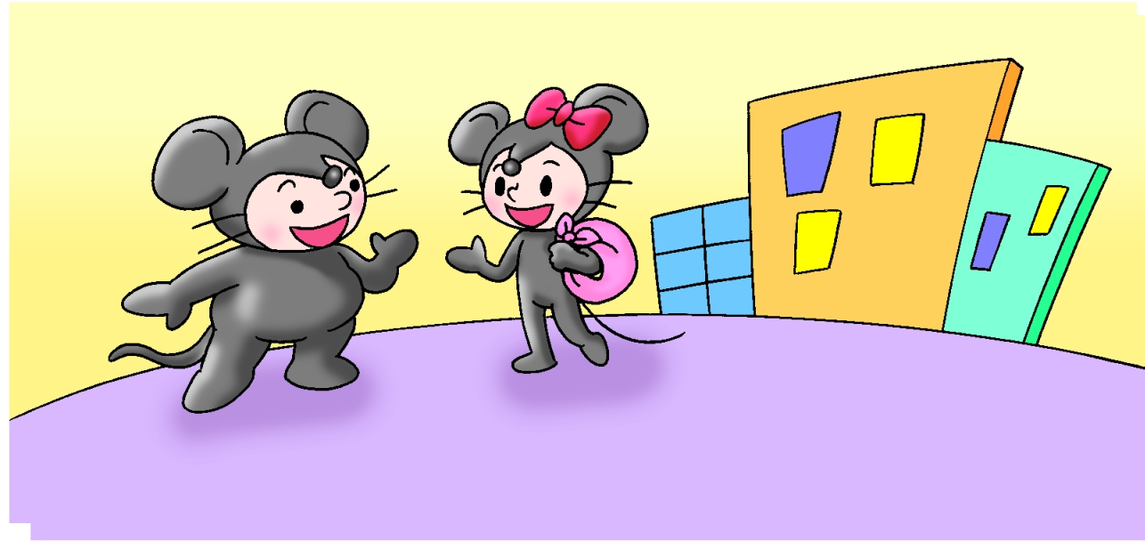
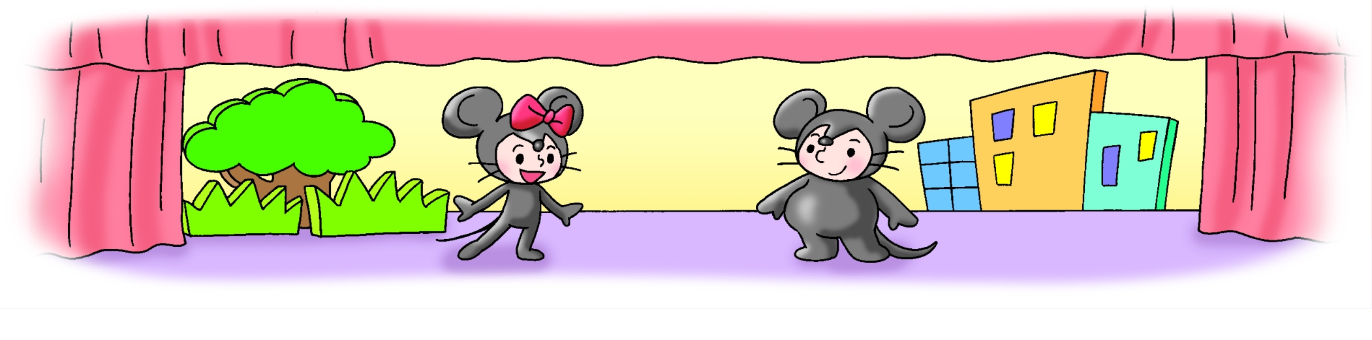
Carla the country mouse
Timmy the town mouse
Scene 1
Narrator:Carla is visiting Timmy in the town.
Carla:Hello!
Timmy:Hi, Carla! Let’s get
some lunch.
Carla:Great!

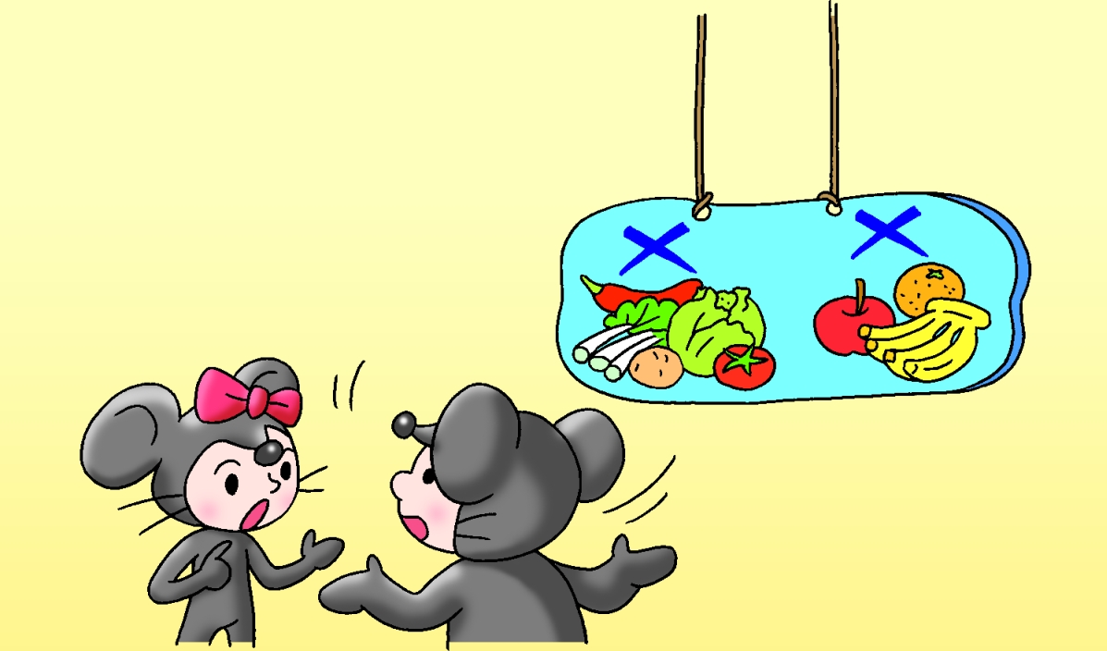
Scene 2
Narrator:Timmy and Carla are in Timmy’s kitchen.
Carla:Are there any vegetables?
Timmy:No, there aren’t any vegetables.
Carla:Is there any fruit? I can make
a fruit salad.
Timmy:Erm ... No, there isn’t any fruit.

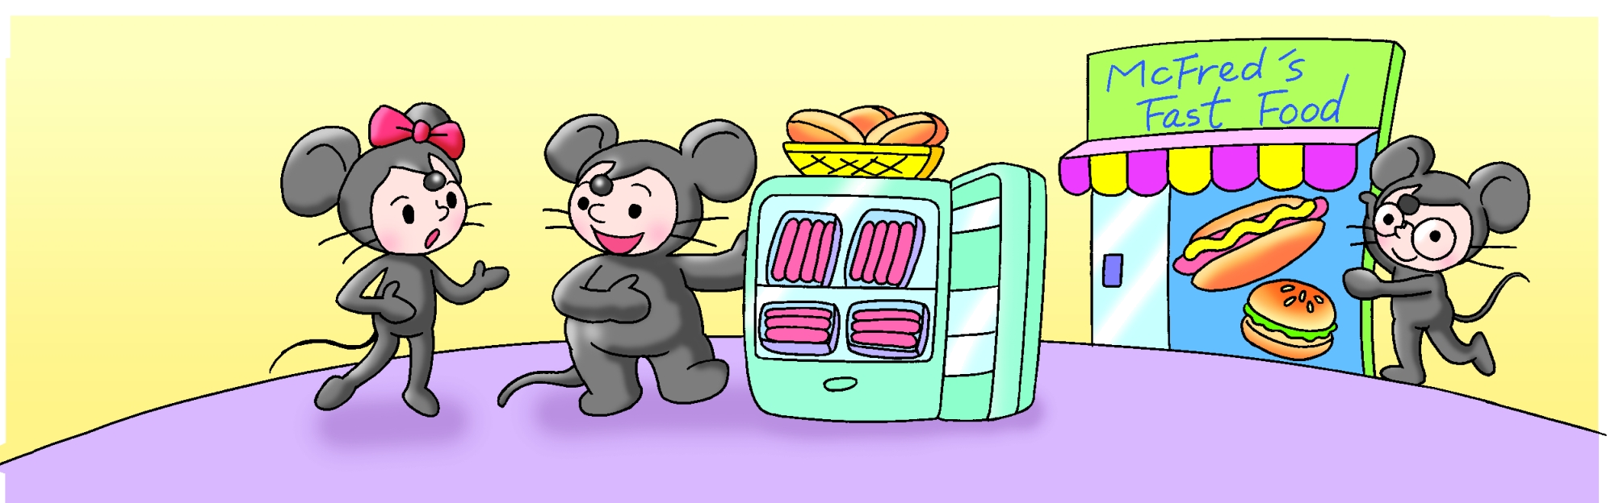
This tells us what the character does.
This tells us how the character feels or speaks.
Carla:What can we eat?
Timmy:There’s some bread. (Looking in the fridge) There are a lot of sausages. Maybe we can have hot dogs.
Carla:(Shocked) Dogs! I don’t eat dogs!
Timmy: No, Carla. Hot dogs are sausages in bread. Let’s not cook. Let’s go to McFred’s Fast Food!
Carla:OK.

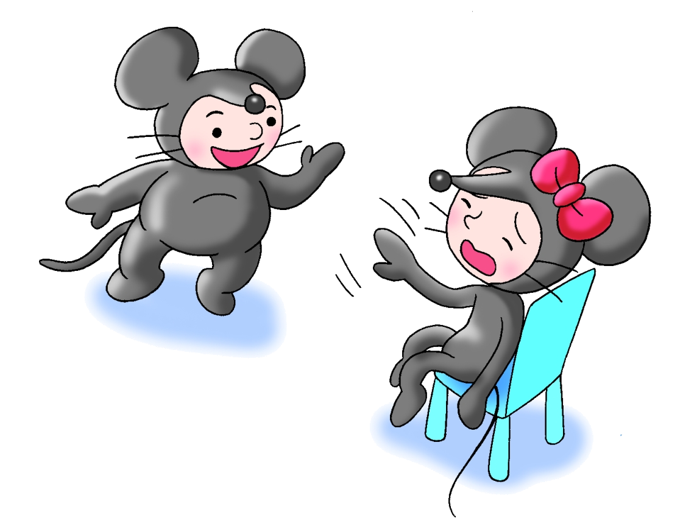
Narrator:One week later.
Timmy:Let’s go to McFred’s again.
Carla:Yuck! We go there every day. I don’t feel well. I need some good food.
Scene 3

