Task — Finishing the play ‘The Town Mouse and the Country Mouse’

1 Choose one of the dishes and put a tick ( ) in the □ below. Then
complete the sentence.

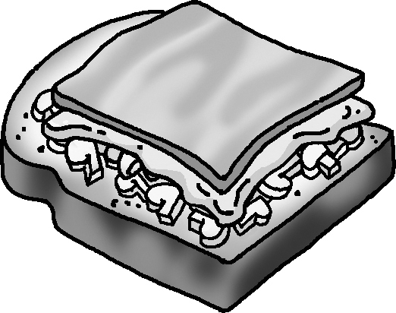
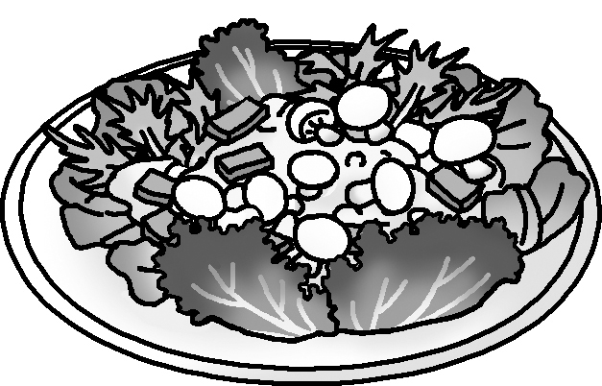

an open sandwich
a salad

Carla is a good cook. She wants to make ___________________.

- First add the stickers for the ingredients in the space on page 16 of the Pupil’s Book. Then complete the shopping list and finish the sentence below.
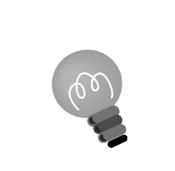
Hint: Choose either bread or salad dressing. Then add two more ingredients.

Shopping list
mushrooms
bread / salad dressing

She needs mushrooms, ____________________, ____________________

and ____________________.
3 Now Carla is asking Timmy about the ingredients. Complete the
questions and answers.
Hint: Remember to look at the ingredients on page 16 and use some or a lot of.
Carla : Is there any ?
Timmy : Yes, there is .
Carla :
Timmy :
Carla :
Timmy :
Carla :
Timmy :

4 Carla explains the recipe. Write the steps.
Hint: You can look at the recipes on page 7. Remember to use Then.
Carla : First

5 Does Timmy like the food? Look at the speaking tips on page 11. Write
what Timmy says.
Timmy :

Checklist for Ch 2 Task

Check your writing and tick (✓ ).

Checking for myself | ☺ ☺ | ☺ | ☹
- I can think of a dish and write a recipe.
- I can use my own words to write ideas.
- I can spell all the words (check spellings using the textbook).
- I can write questions using Is there …? / Are there …? and answers using Yes, … / No, …
- I can end each sentence with a full-stop (.), a question mark (?), or an exclamation mark (!).
- I can use countable and uncountable nouns correctly (e.g. ham, vegetables).
- I can make correct plural forms (e.g. sausages).

Now ask your partner to check your writing and tick (✓ ).

Checking by ( _________________ ) | ☺ ☺ | ☺ | ☹
- Do I understand my partner’s writing?
- Does my partner spell all the words correctly?
- Does my partner write questions and answers correctly?
- Does my partner end each sentence with a full-stop (.), a question mark (?), or an exclamation mark (!)?
- Does my partner use countable and uncountable nouns correctly?
- Does my partner make correct plural forms?

Remember to make changes to your writing before you hand it in.

