Task — Finishing the play ‘The Town Mouse and the Country Mouse’

1 Choose one of the dishes and put a tick ( ) in the □ below or you can draw your picture in the space provided. Then complete the sentence.

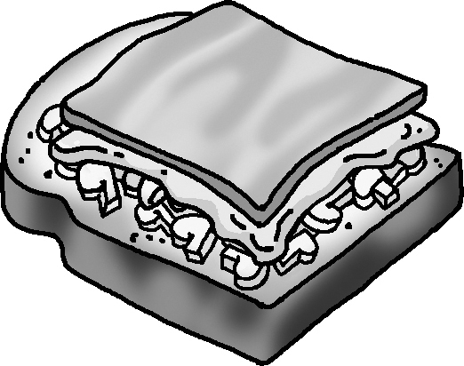
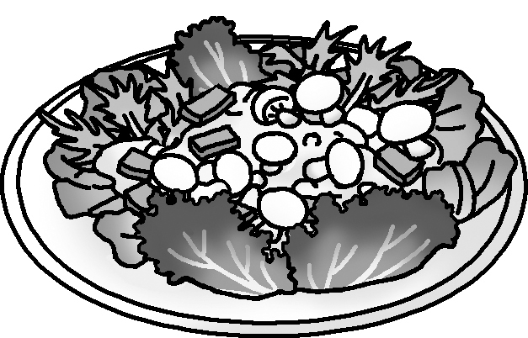

(your idea)
an open sandwich
a salad

Carla is a good cook. She wants to make ___________________.

2 First add the stickers or draw pictures for the ingredients in the space
on page 16 of the Pupil’s Book. Then complete the shopping list and
finish the sentence below.

Shopping list
mushrooms

She needs mushrooms, ____________________, ____________________

and ____________________.

3 Now Carla is asking Timmy about the ingredients. Complete the
questions and answers.
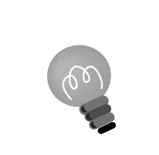
Hint: Remember to look at the ingredients on page 16 and use some or a lot of.
Carla : ?
Timmy :
Carla :
Timmy :
Carla :
Timmy :
Carla :
Timmy :

4 Carla explains the recipe. Write the steps.
Hint: You can look at the recipes on page 7. Remember to use First and Then.
Carla :

5 Does Timmy like the food? Look at the speaking tips on page 11 or use
you own ideas. Write what Timmy says.
Timmy :
Checklist for Ch 2 Task

Check your writing and tick (✓ ).

Checking for myself | ☺ ☺ | ☺ | ☹
- I can think of a dish and write a recipe.
- I can use my own words to write ideas.
- I can spell all the words (check spellings using the textbook).
- I can write questions using Is there …? / Are there …? and answers using Yes, … / No, …
- I can end each sentence with a full-stop (.), a question mark (?), or an exclamation mark (!).
- I can use countable and uncountable nouns correctly (e.g. ham, vegetables).
- I can make correct plural forms (e.g. sausages).

Now ask your partner to check your writing and tick (✓ ).

Checking by ( _________________ ) | ☺ ☺ | ☺ | ☹
- Do I understand my partner’s writing?
- Does my partner spell all the words correctly?
- Does my partner write questions and answers correctly?
- Does my partner end each sentence with a full-stop (.), a question mark (?), or an exclamation mark (!)?
- Does my partner use countable and uncountable nouns correctly?
- Does my partner make correct plural forms?

Remember to make changes to your writing before you hand it in.

