Circle the correct answers.
1 | 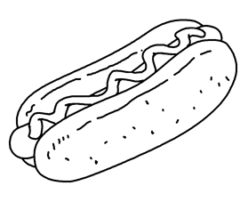 | 2 | 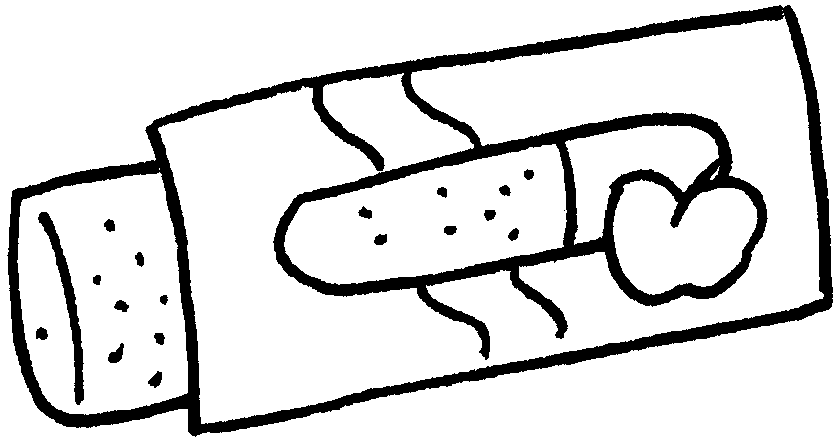
 | a ( hot dog / hamburger ) |  | an ( hot dog / apple pie )
3 | 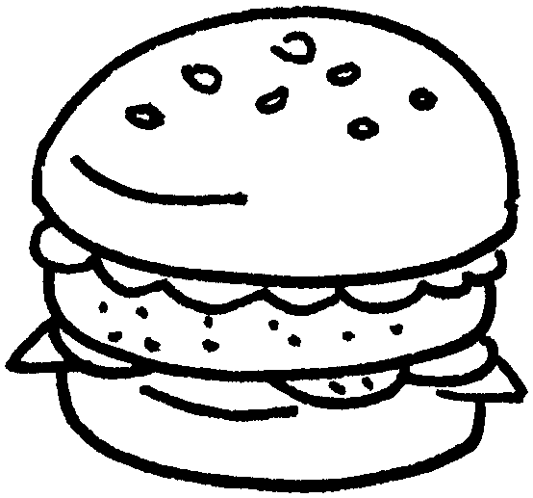 | 4 | 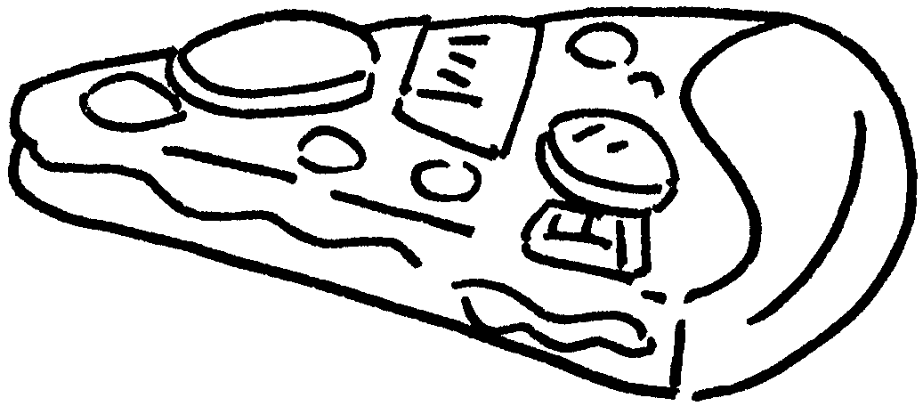
 | a ( hamburger / apple pie ) |  | a ( box / slice ) of  ( pizza / chicken wings )
5 | 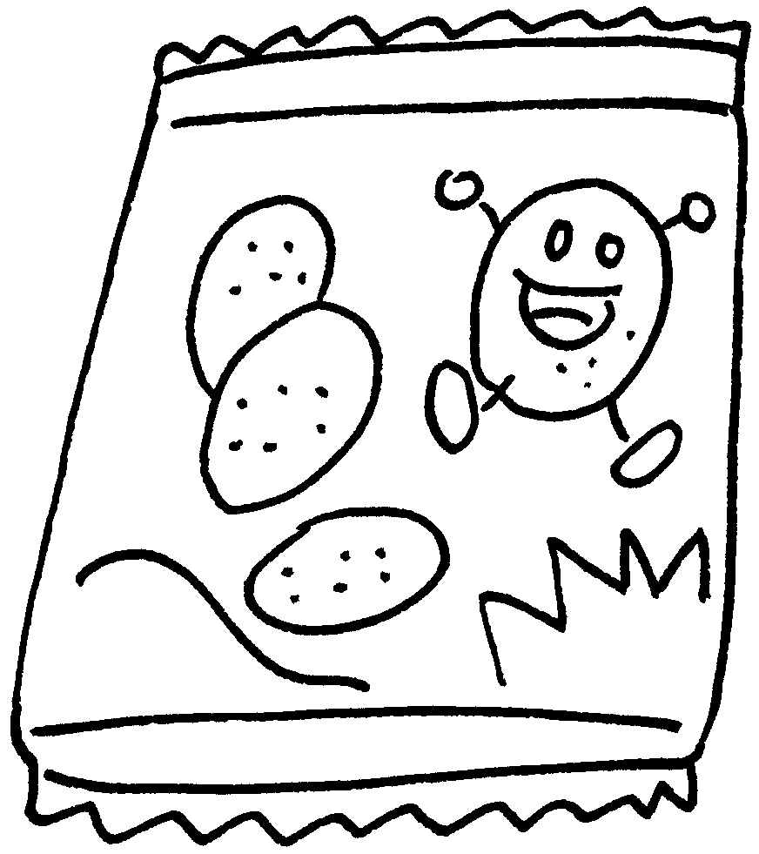 | 6 | 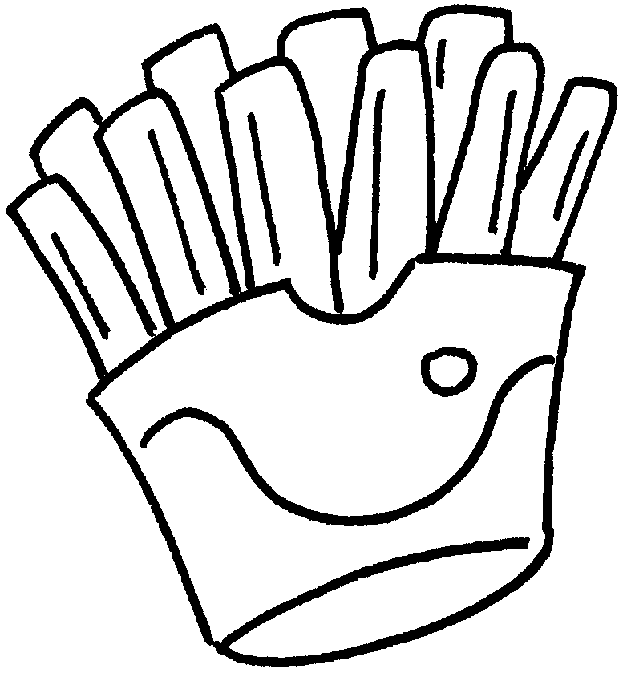
 | a ( packet / box ) of ( apple pie / potato chips ) |  | a ( cup / packet ) of ( pizza / French fries )
7 | 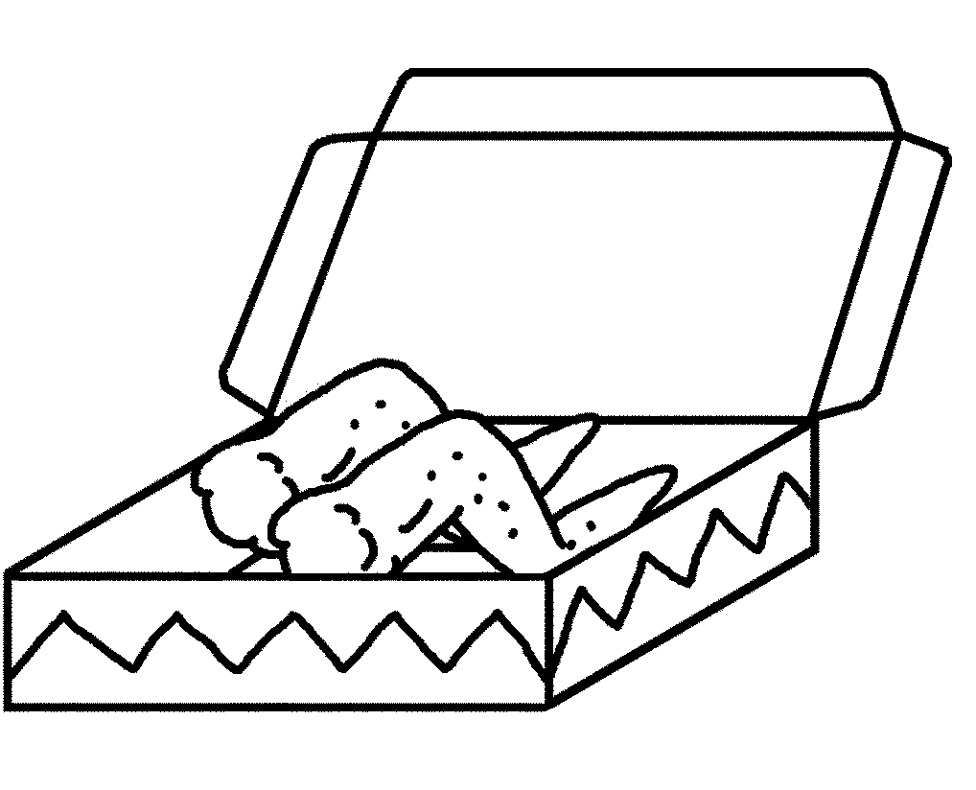 | 8 | 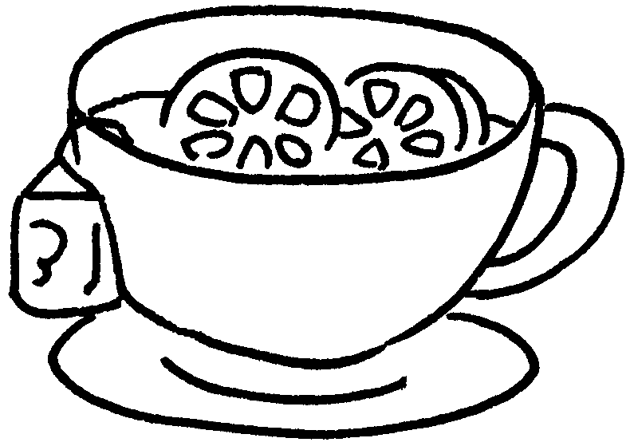
 | a ( slice / box ) of  ( hot dog / chicken wings ) |  | a ( bottle / cup ) of  ( lemon tea / water )
9 | 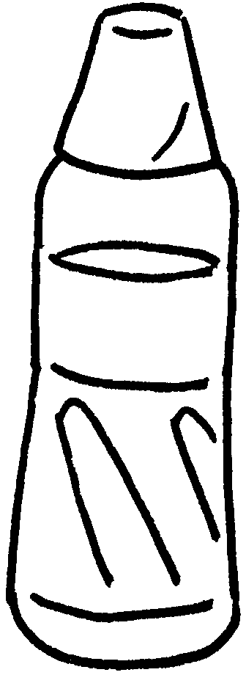 | 10 | 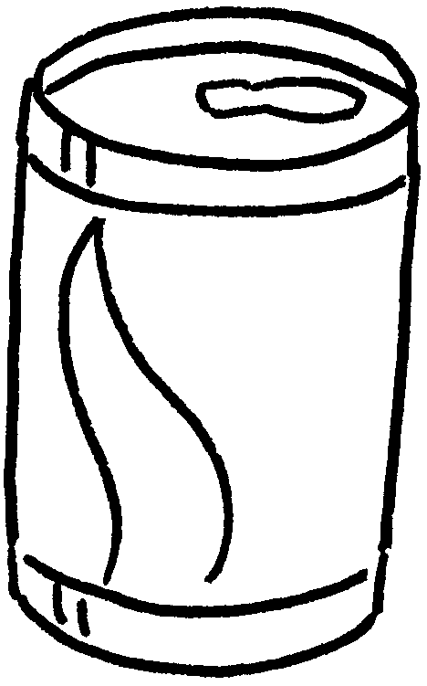
 |   a ( bottle / can ) of  ( water / lemon tea ) |  | a ( cup / can ) of  ( water / cola )  c


Book 3A Chapter 3 Graded Worksheets
Worksheet 1⬇

( hot dog / hamburger )
2 ( hot dog / apple pie )
3 (hamburger / apple pie )
4 ( box / slice )
( pizza / chicken wings )
- ( packet / box )
( apple pie / potato chips )
- ( cup / packet )
( pizza / French fries )
- ( slice / box )
( hot dog / chicken wings )
8 ( bottle / cup ) ( lemon tea / water )
9 ( bottle / can ) ( water / lemon tea )
10 ( cup / can ) ( water / cola )

