Choose and write.
apple pie water chicken wings French fries hamburger lemon tea
hot dog potato chips pizza cola
bottle box can cup packet slice

1 | 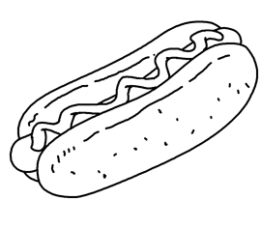 | 2 | 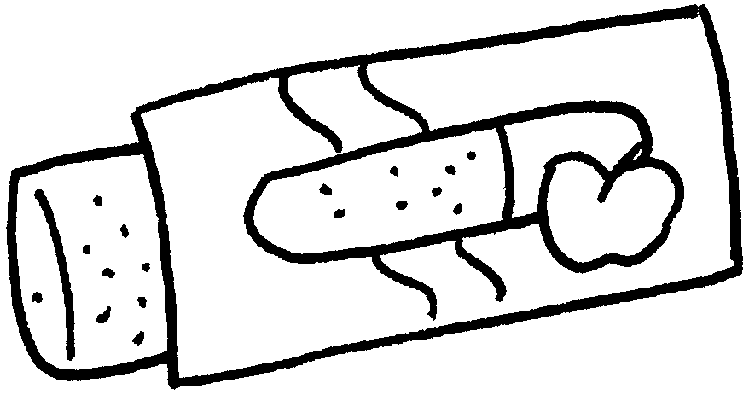
 | a |  | an
3 | 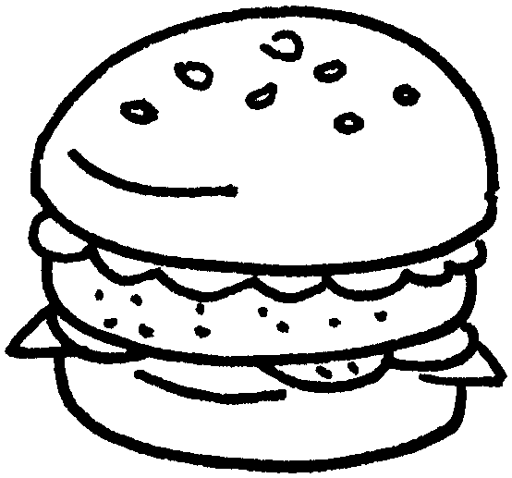 | 4 | 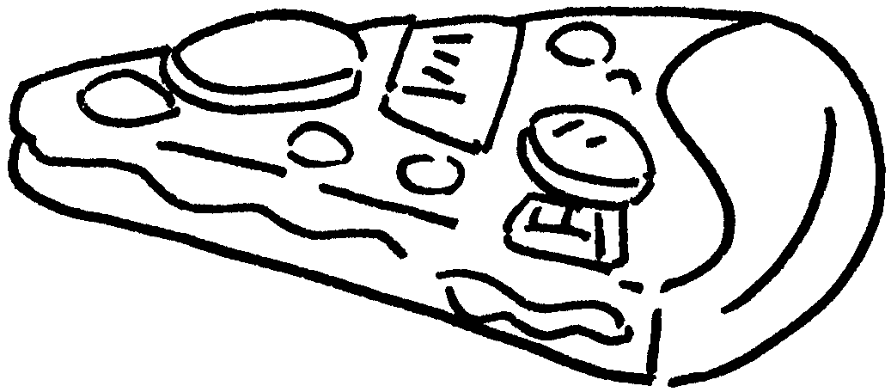
 | a |  | a of
5 | 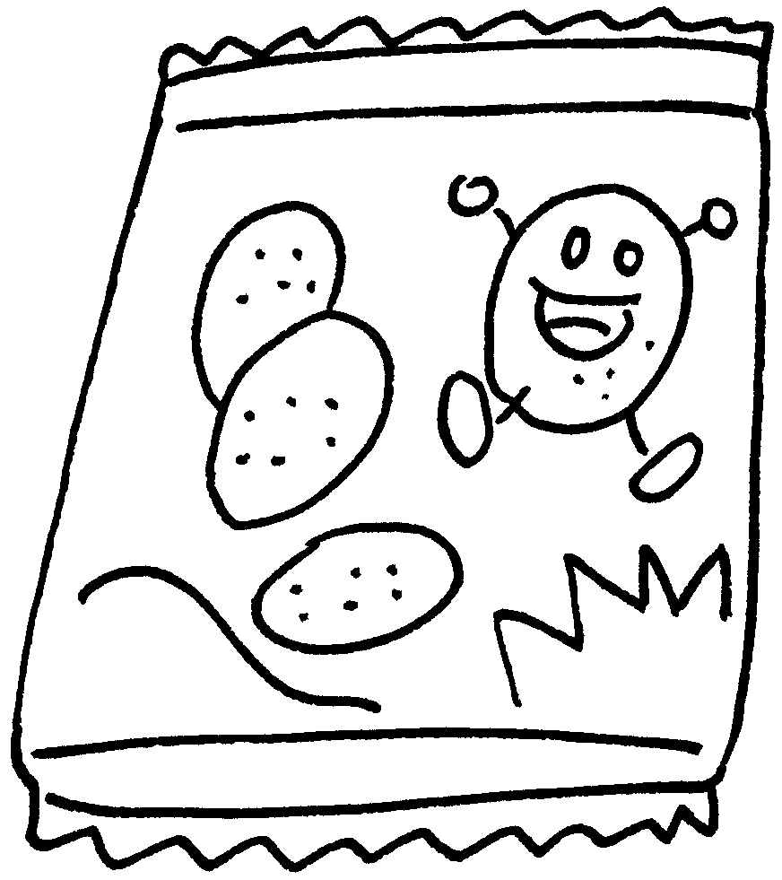 | 6 | 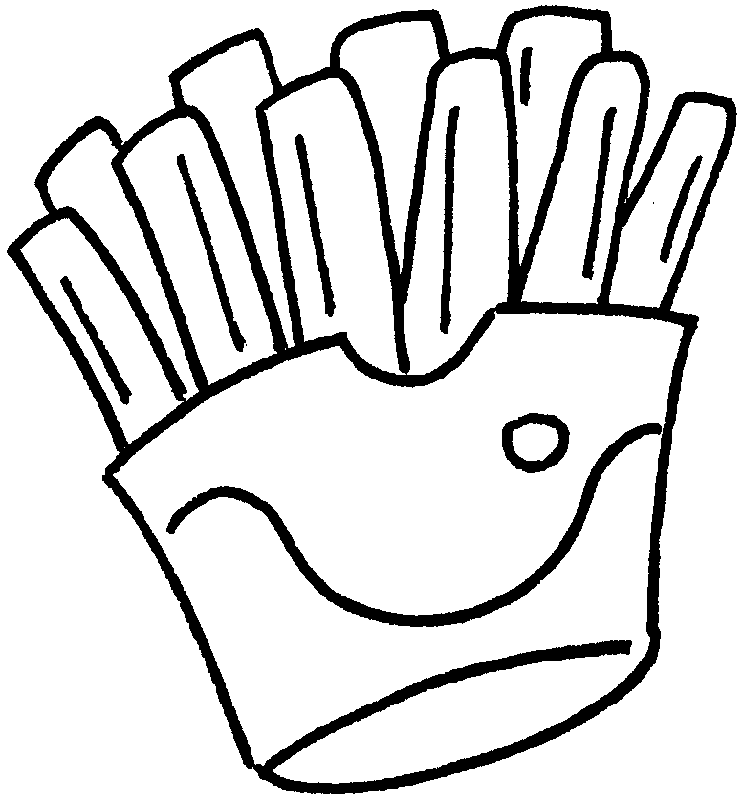
 | a of |  | a of
7 | 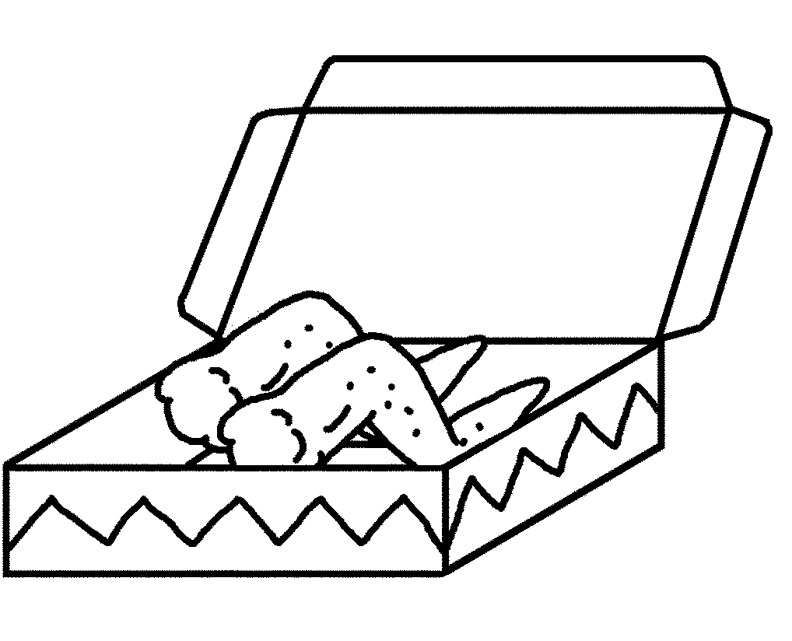 | 8 | 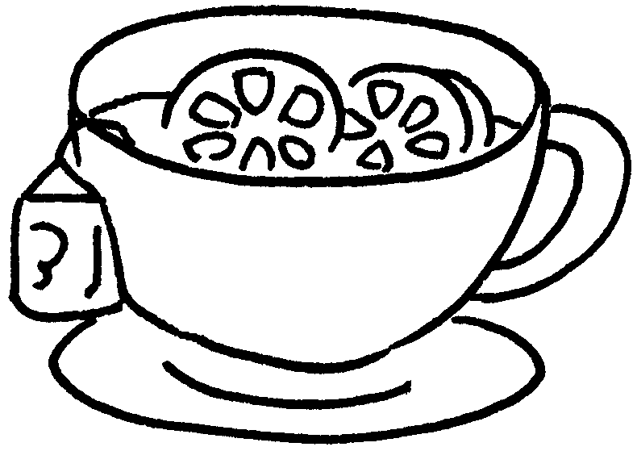
 | a of |  | a of
9 |   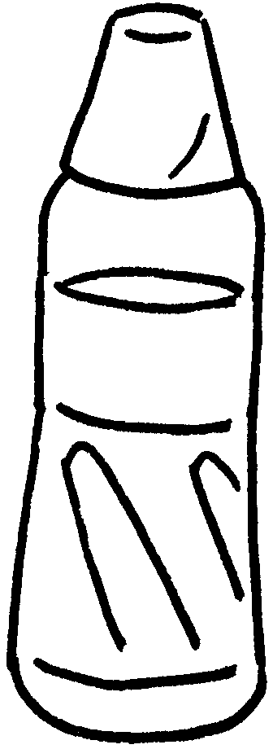 | 10 | 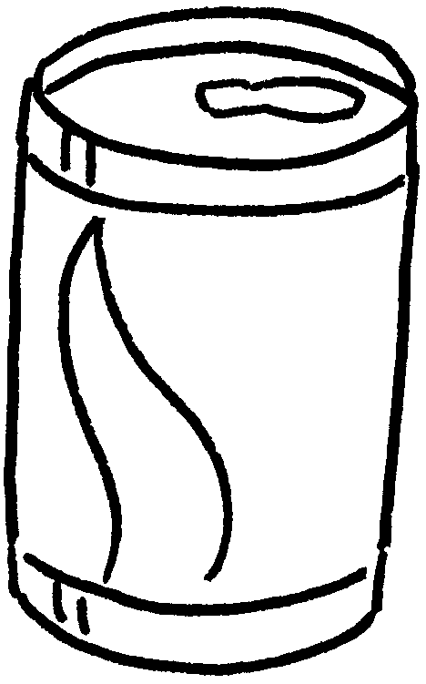  c
 | a of |  | a of


Book 3A Chapter 3 Graded Worksheets
Worksheet 1⬇⬇
- hot dog
- apple pie
- hamburger
- slice pizza
- packet potato chips
- packet French fries
- box chicken wings
- cup lemon tea
- bottle water
- can cola

