Choose and write.
How much | dollars | twelve | twenty
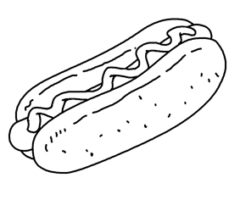
McMomo’s Food
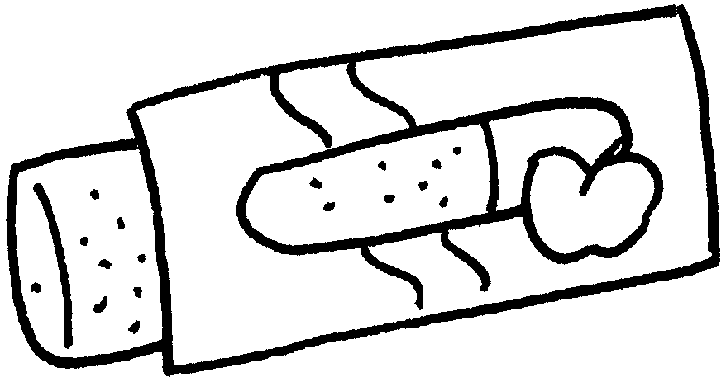
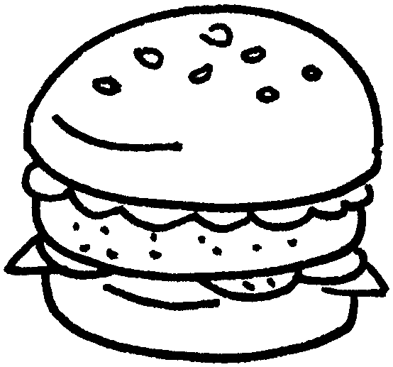
1
$22
2
3
$25

$24


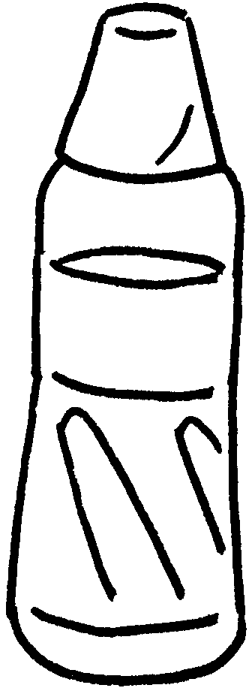

5
$20
4
$12

1 | A : is an apple pie?  B : It’s twenty-two dollars.
2 | A : How much is a hot dog?  B : It’s twenty-four .
3 | A : is a hamburger?  B : It’s twenty-five .
4 | A : is a bottle of water?  B : It’s .
5 | A : is a cup of lemon tea?  B : It’s .


Book 3A Chapter 3 Graded Worksheets
Worksheet 2⬇
- How much
- dollars
- How much
dollars
- How much
twelve dollars
- How much
twenty dollars

