How much is the food? Finish the questions and answers.

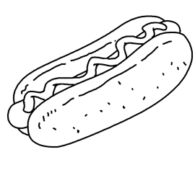
McMomo’s Food
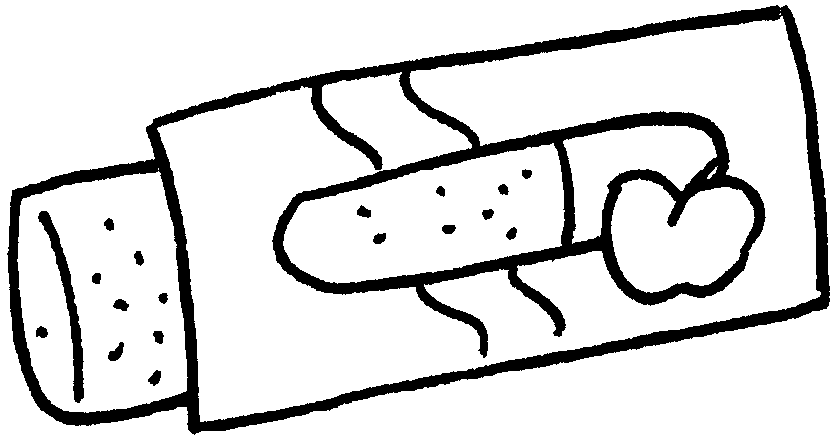
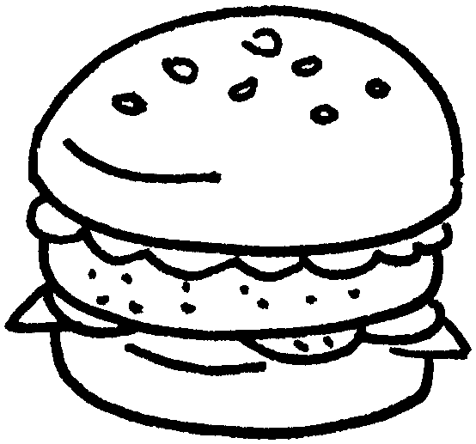
1
$22
3
$25
2

$24


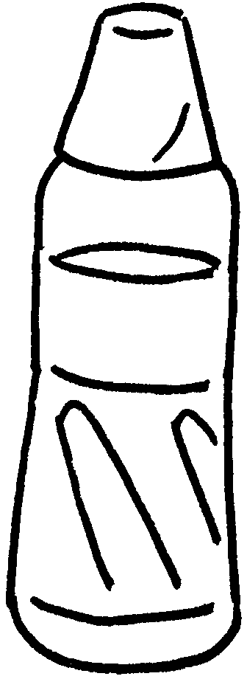

5
$20
4
$12

1 | A : How much is an apple pie?  B : It’s twenty-two .
2 | A : How much is a hot dog?  B : It’s .
3 | A : is a hamburger?  B : It’s .
4 | A : is a bottle of water?  B :
5 | A : a cup of lemon tea?  B :


Book 3A Chapter 3 Graded Worksheets
Worksheet 2⬇⬇
- dollars
- twenty-four dollars
- How much
twenty-five dollars
- How much
It’s twelve dollars.
- How much is
It’s twenty dollars.

