How much is the food? Finish the questions and answers.

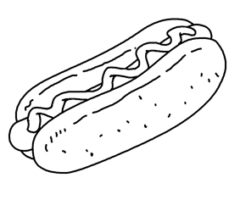
McMomo’s Food
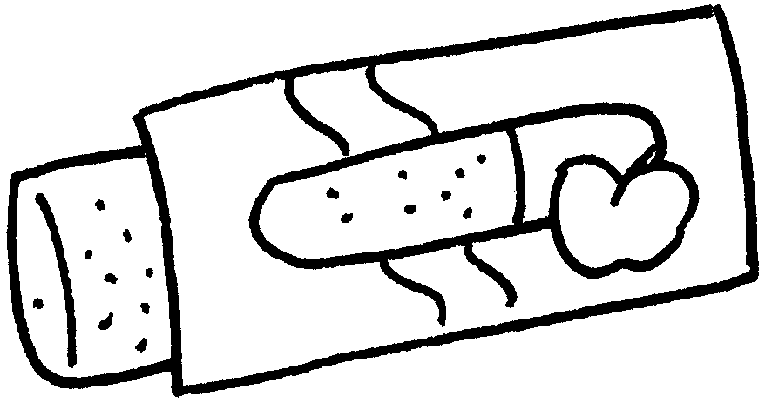
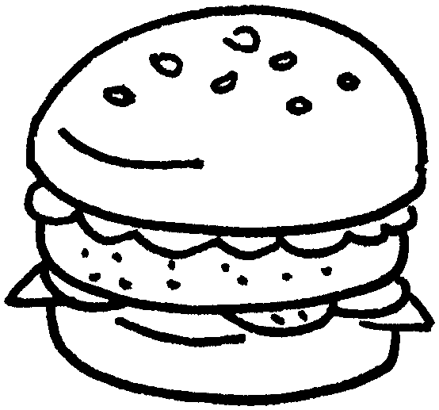
1
$22
3
$25
2

$24

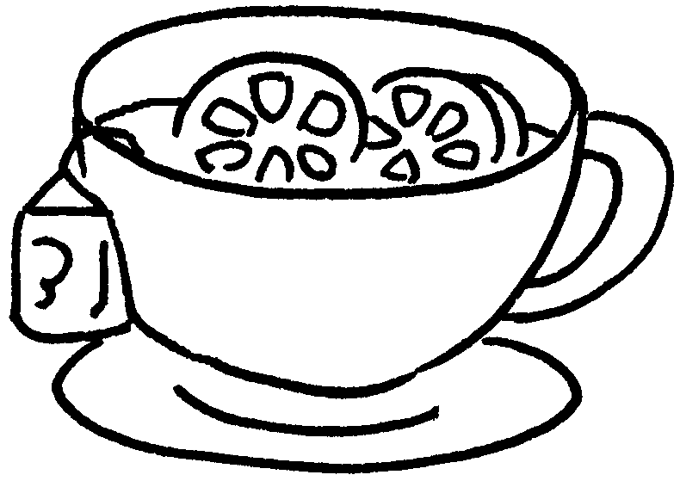
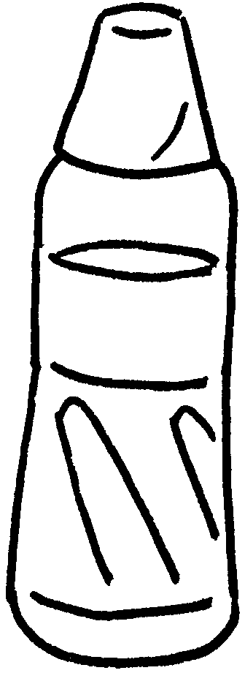

5
$20
4
$12

1 | A : How much is an ?  B : It’s twenty-two .
2 | A : How much is a ?  B : It’s .
3 | A :  B : It’s .
4 | A : a of ?  B :
5 | A : a of ?  B :


Book 3A Chapter 3 Graded Worksheets
Worksheet 2⬇⬇⬇
- apple pie
dollars
- hot dog
twenty-four dollars
- How much is a hamburger?
twenty-five dollars
4 How much is bottle water
It’s twelve dollars.
5 How much is cup lemon tea
It’s twenty dollars.

