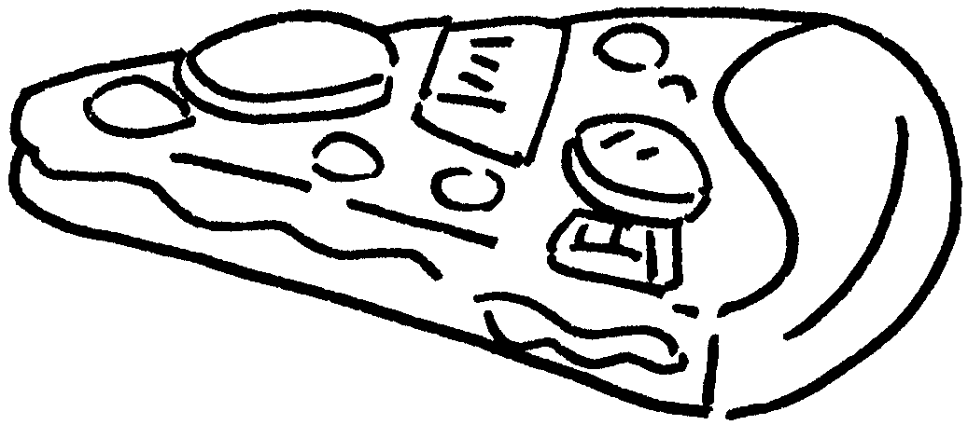




Choose and write.

can cup slice French fries cola lemon tea
packet box bottle pizza chicken wings water

1 | 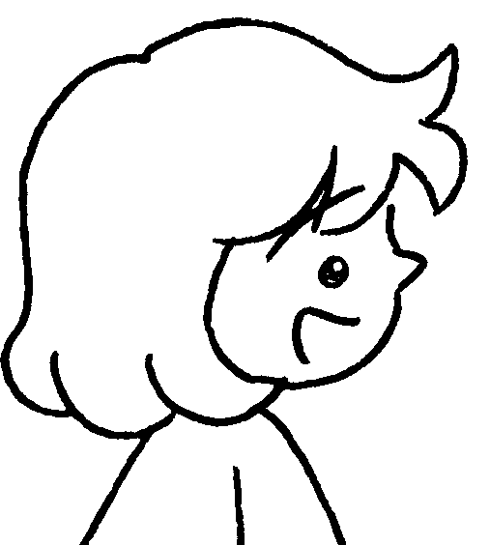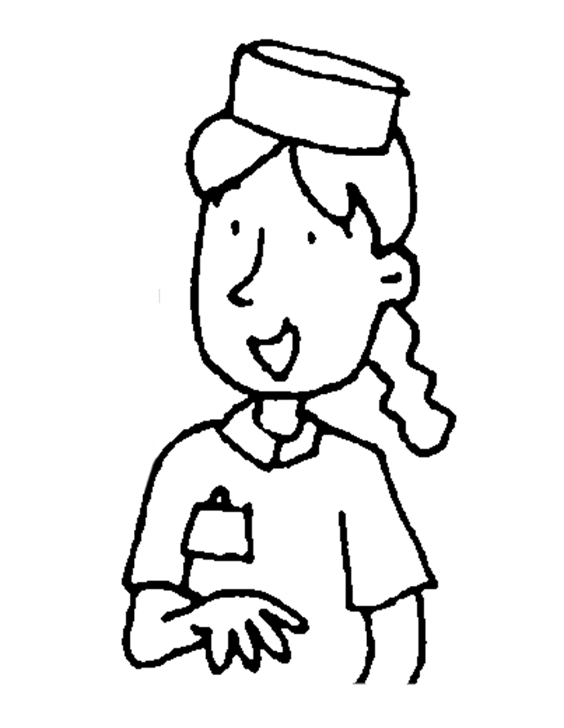  A  B  A  B  A  B  A  B |  | A : May I have a  of , please?  B : Here you are.
2    c | 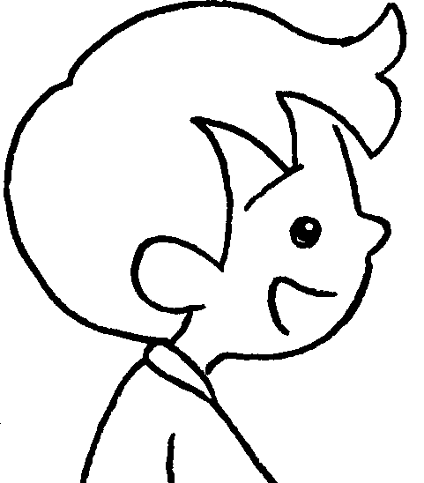 |  | A : May I have a  of and a  of , please?  B : Here you are.
3 | 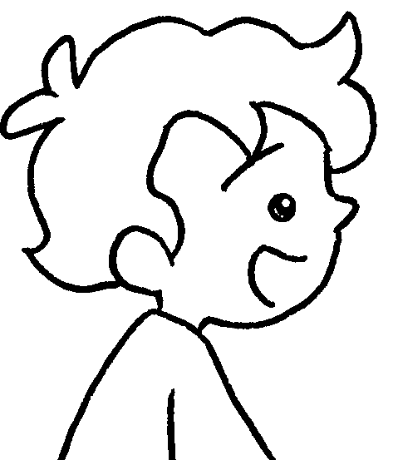 |  | A : May I have  and  , please?  B : Here you are.
4 | 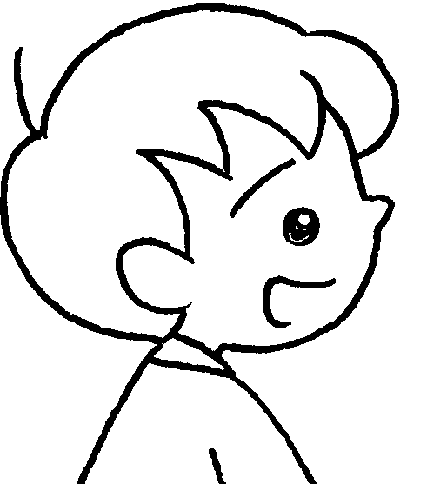 |  | A :  ,please?  B : Here you are.



Book 3A Chapter 3 Graded Worksheets
Worksheet 3⬇
1 slice pizza
2 packet French fries can cola
- a box of chicken wings a bottle of water
- May I have a slice of pizza, a packet of French fries and a cup of lemon tea
(Accept any reasonable answers.)

