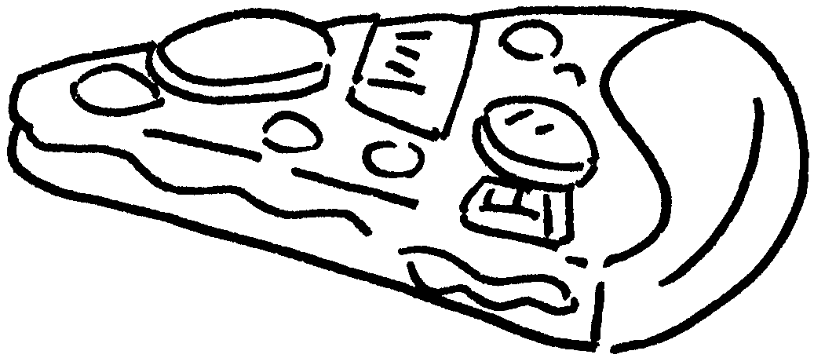




Finish the questions.
1 | 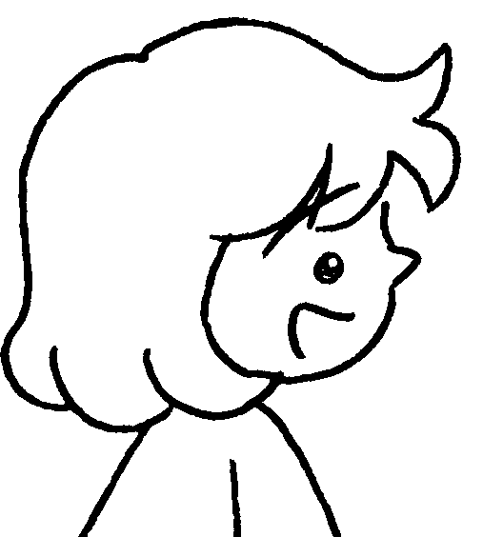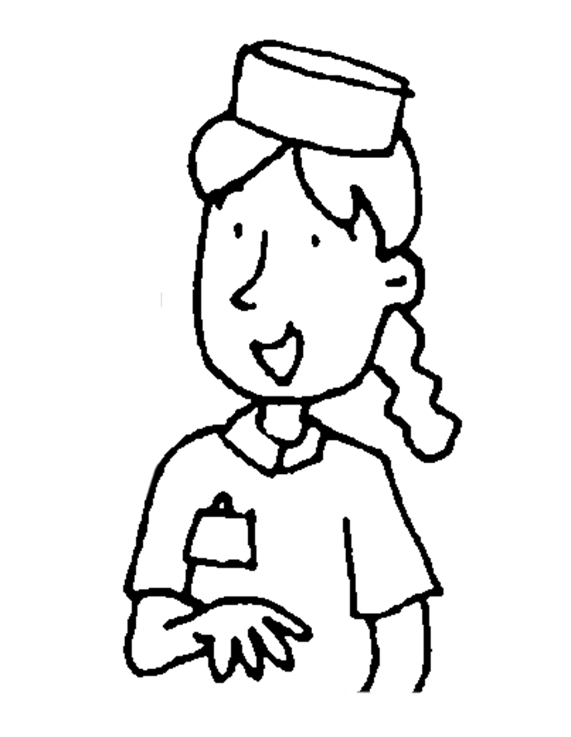  B  A  B  A  B  A  B  A |  | A : May I have a  of pizza, please?  B : Here you are.
2    c | 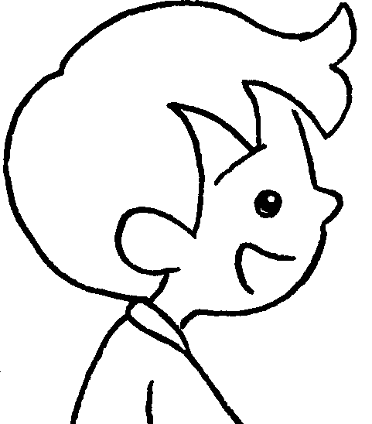 |  | A : May I have a  of French fries and  cola, please?  B : Here you are.
3 | 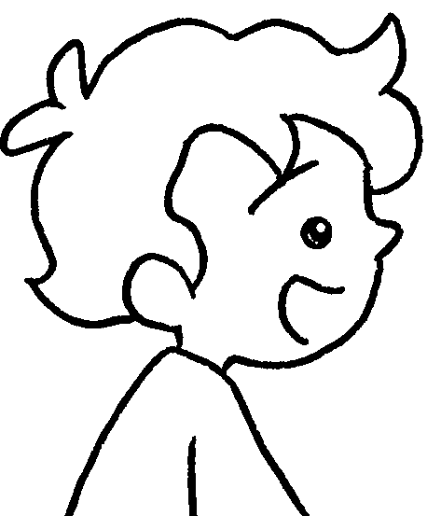 |  | A : May I have  chicken wings and  water, please?  B : Here you are.
4 | 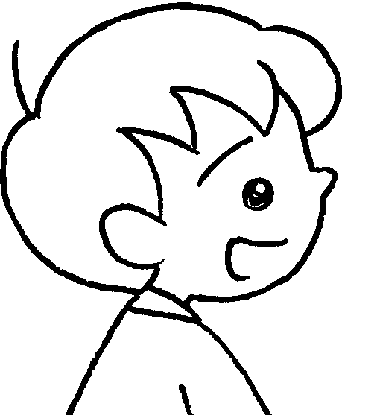 |  | A :  pizza,  French  fries and  lemon tea, please?  B : Here you are.



Book 3A Chapter 3 Graded Worksheets
Worksheet 3⬇⬇
- slice
- packet a can of
- a box of a bottle of
- May I have a slice of a packet of a cup of

