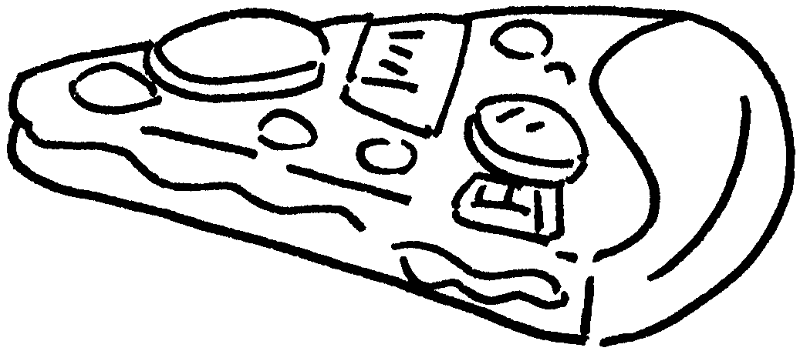




Finish what the people say.
1 | 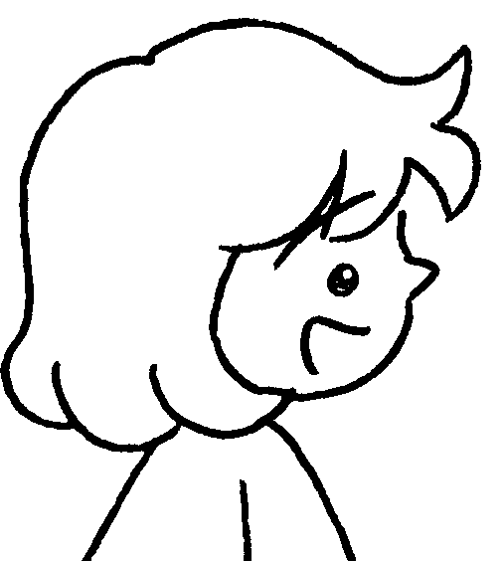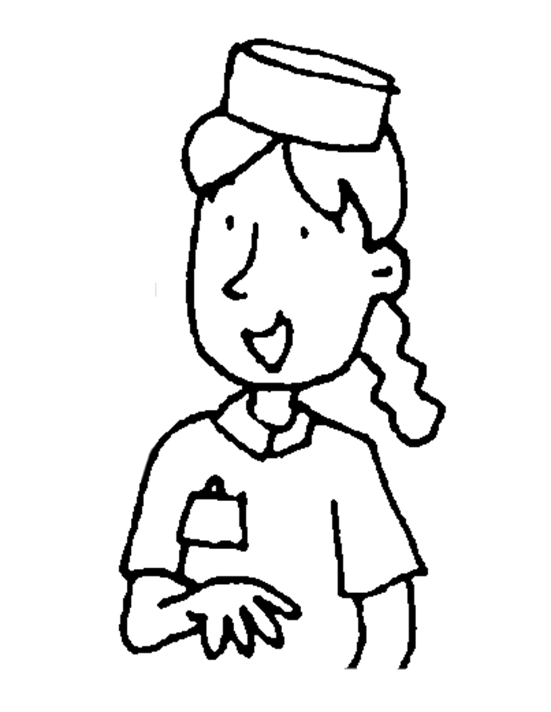  B  A  B  A  B  A  B  A |  | A : May I have a  of pizza, please?  B : Here you are.
2    c |  |  | A : May I have a  of and  cola, please?  B : Here you are.
3 |    |  |   A :  , please?  B : Here you are.
4 |      |  | A :  B :



Book 3A Chapter 3 Graded Worksheets
Worksheet 3⬇⬇⬇
- slice
- packet French fries a can of
- May I have a box of chicken wings and a bottle of water
- May I have a slice of pizza, a packet of French fries and a cup of lemon tea, please?
Here you are.
(Accept any reasonable answers.)

