- I’m hungry!
Today is a school holiday. Kelly and Henry are at Mike’s home. What happens? Read the story and find out.
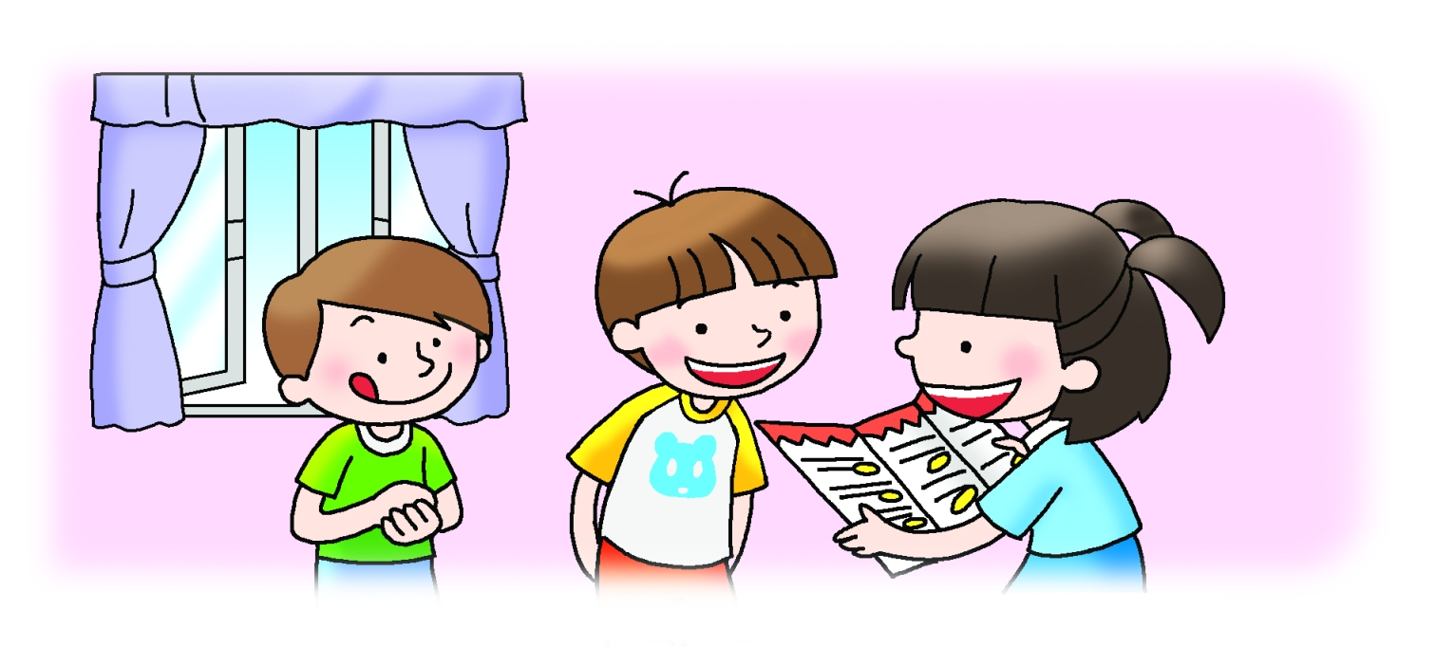


The children have $100. They want to order some food.
‘How much is a box of chicken wings?’ asks Henry.
‘It’s $60. We can share,’ says Kelly. The boys like this idea.
Mike asks, ‘How much is a packet of French fries?’
Kelly answers, ‘It’s $15.’
Mike says, ‘Sorry? Is it $50?’
Kelly replies, ‘No, it’s $15.’
‘OK. Let’s buy three packets then,’ says Henry.
‘How much is a can of cola?’ asks Mike.
‘It’s $5,’ says Kelly. ‘Look! We can buy one and get one free! We can share two cans.’
Kelly calls the delivery hotline.

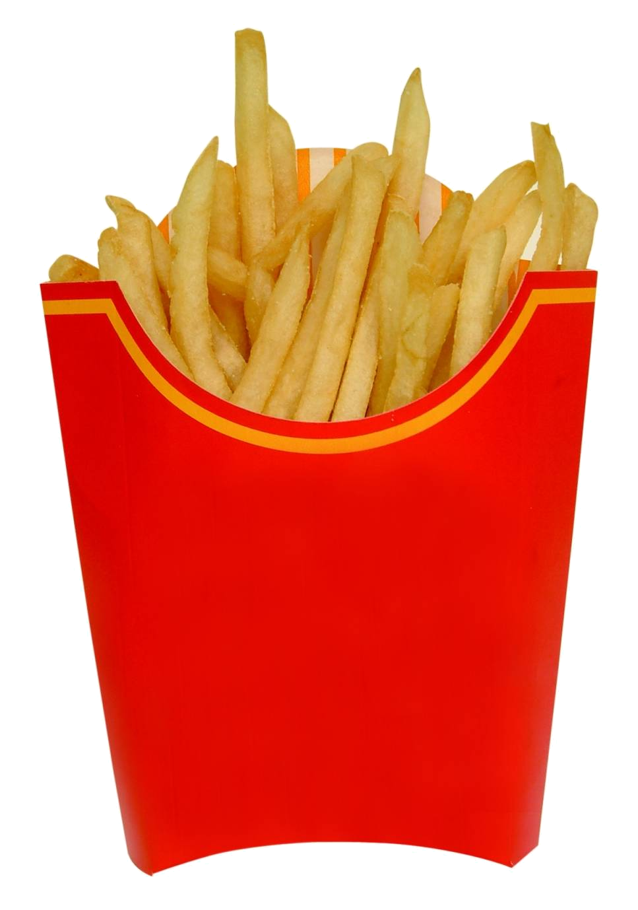
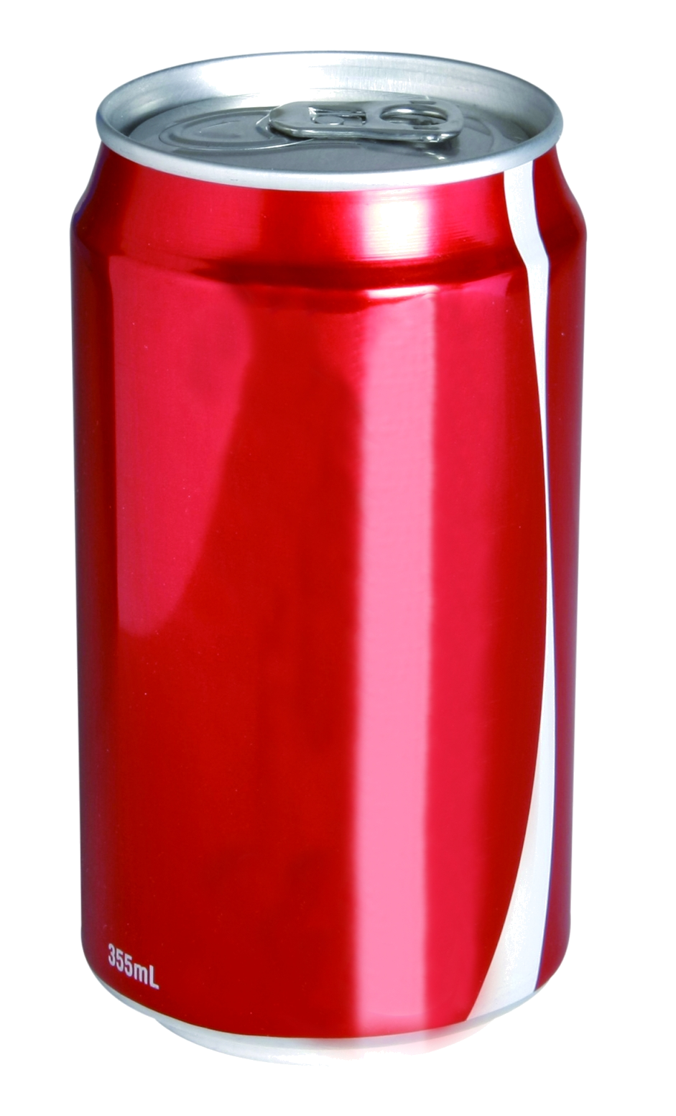
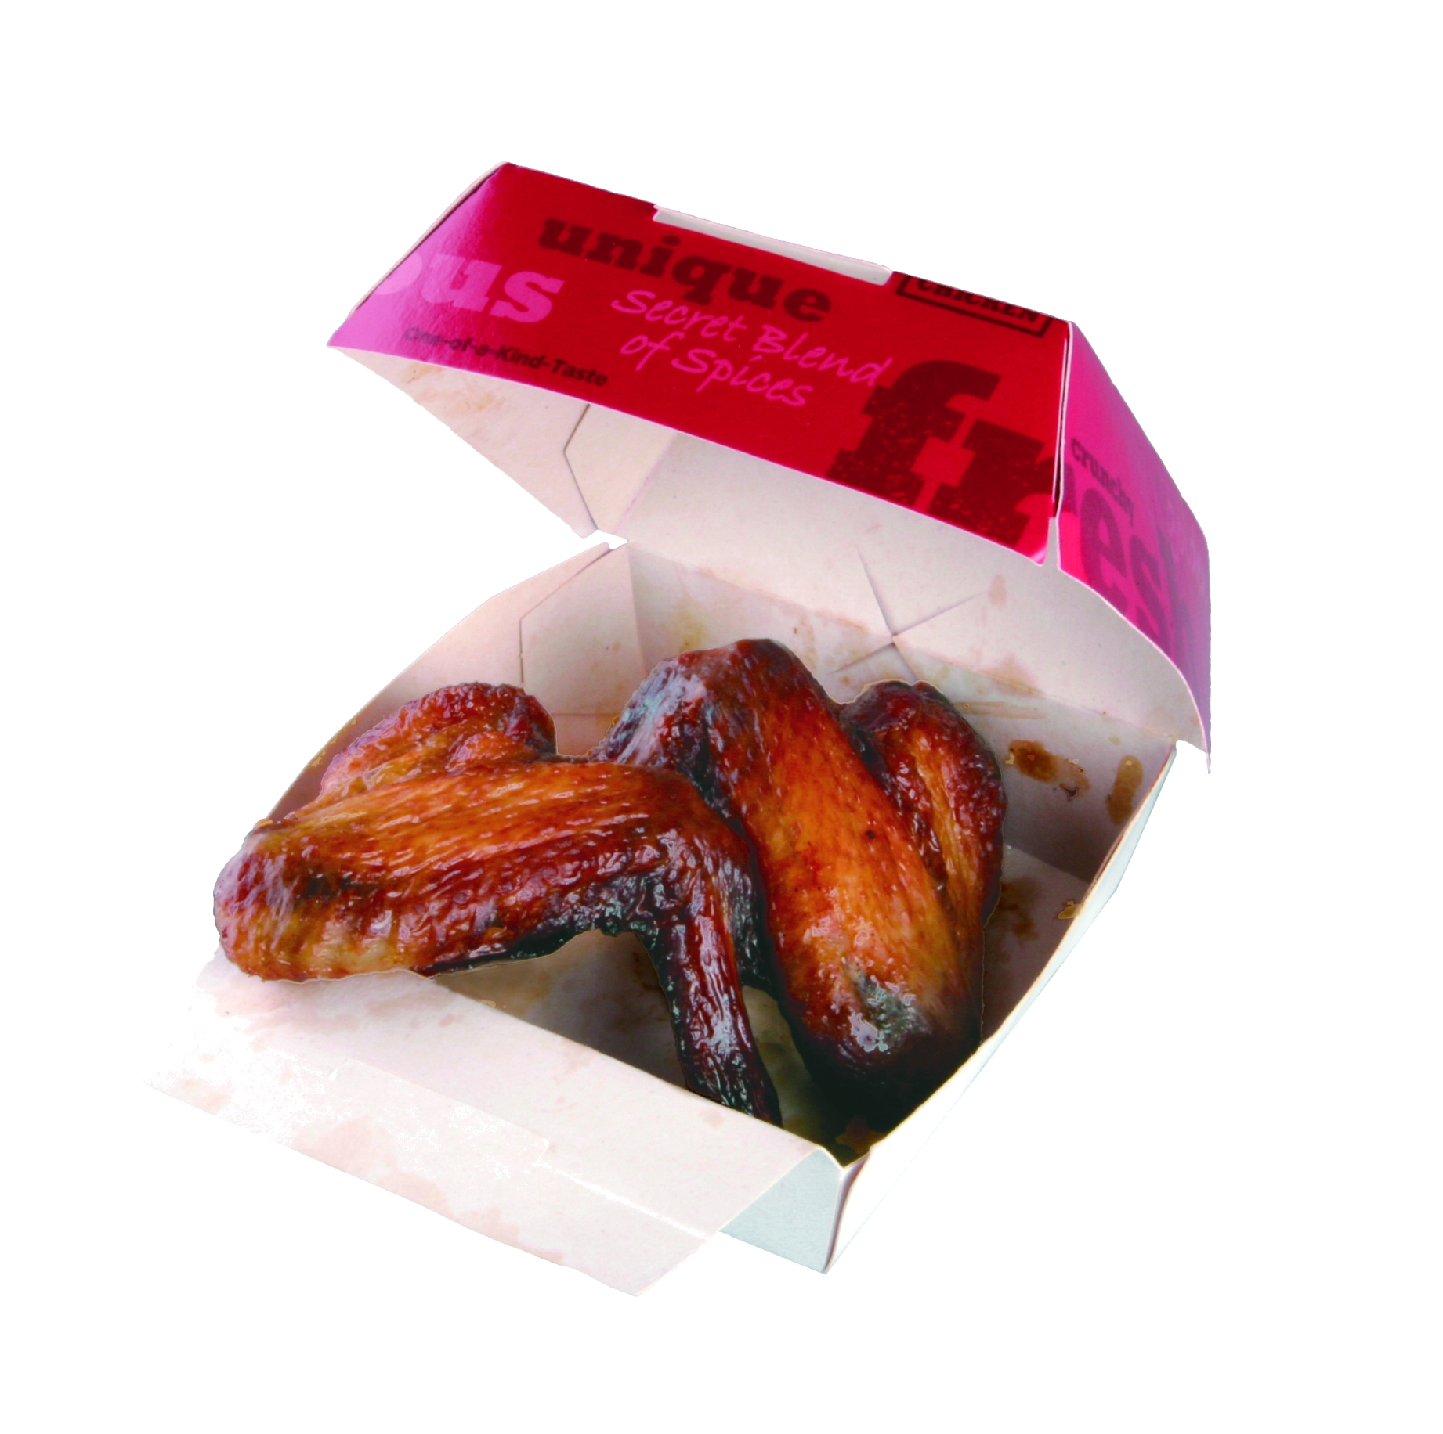

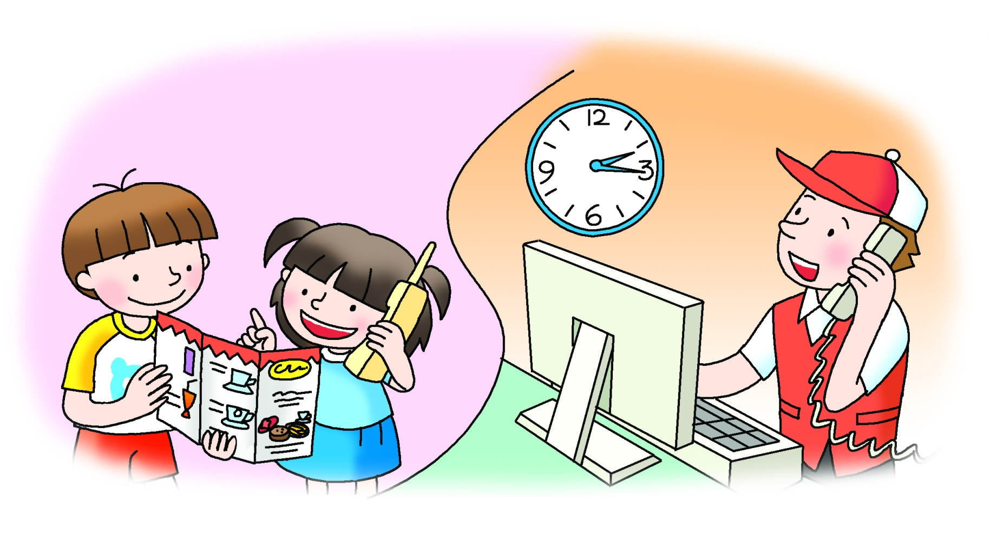

‘May I have a box of chicken wings, three packets of French fries and two cans of cola, please?’ asks Kelly.
‘Sure,’ says the man on the hotline.
‘We have a coupon,’ says Kelly. ‘Is it $100 altogether?’
Fun Fun Fast Food Delivery
Lunchtime Special
COUPON
12:30 p.m. − 2:00 p.m.
•Spend over $100 and get $10 off your bill!
•All drinks ― Buy one get one FREE!
Fun Fun Fast Food Delivery
Teatime Special
COUPON
2:30 p.m. − 6:00 p.m. (Mon − Fri)
Half price for
all items!



‘No,’ the man says. ‘You’re too late. You can’t use the coupon now.’

