Advertisements
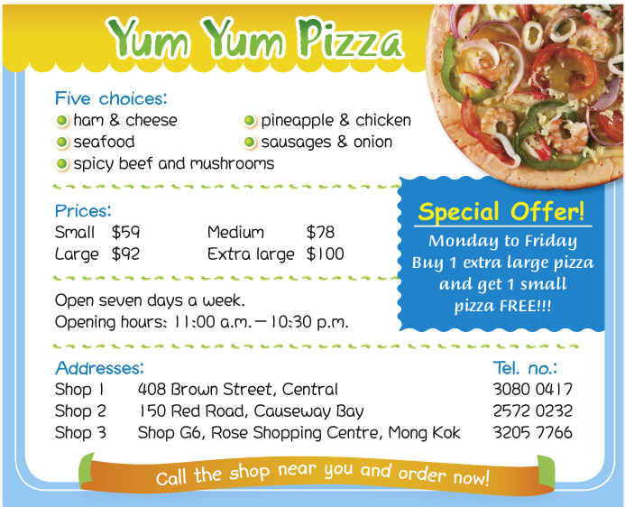

Write the answer and blacken • the circles.

1 Which pizza has fruit in it?

2 Ted wants to buy an extra large and a small pizza on Sunday. He pays ___ .
 A. $59
 B. $100
 C. $159
 D. $200

3 You cannot find ___ in the advertisement.
 A. a special offer
 B. the opening hours of the shops
 C. the phone numbers of all the shops
 D. the prices of drinks

4 Which sentence is true?
 A. Yum Yum Pizza sells seafood salad.
 B. Yum Yum Pizza has three shops.
 C. Yum Yum Pizza is open from Monday to Friday only.
 D. Yum Yum Pizza opens at 10:30 a.m. every day.

Answers:
1 The pineapple and chicken pizza. 2 C 3 D 4 B

