Choose and write.
buffet lunch |  | card | comic
afternoon tea |  | dim sum | film
jeans | sweets and chocolate |  |  | trainers
2
1 | 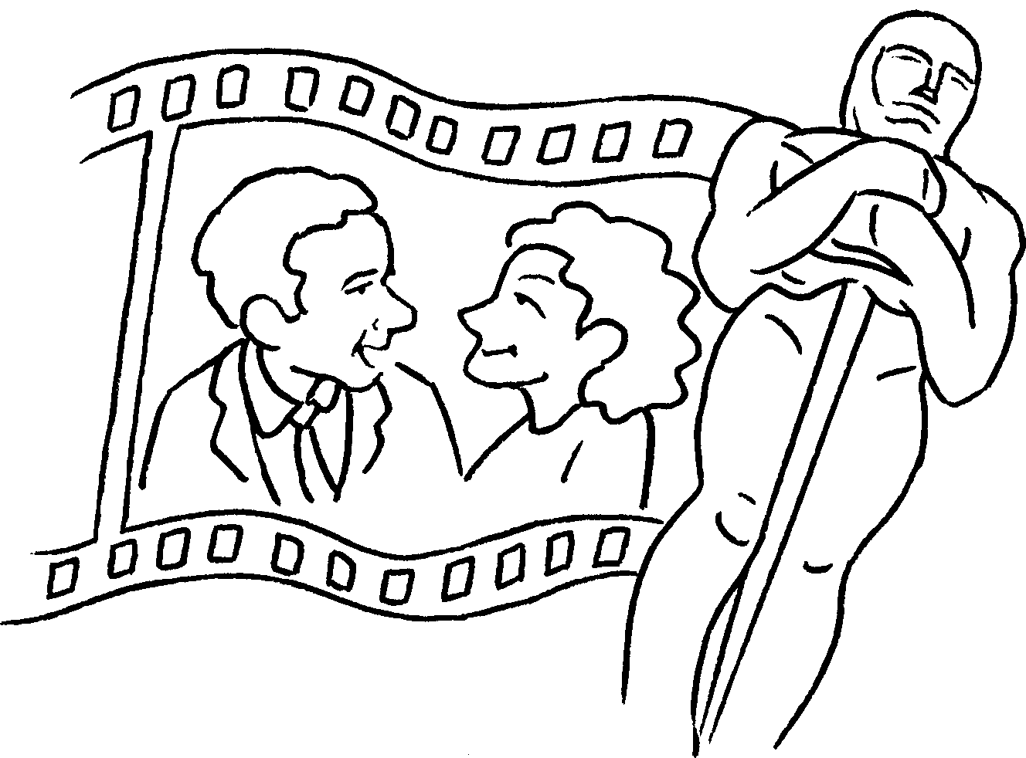 |  | 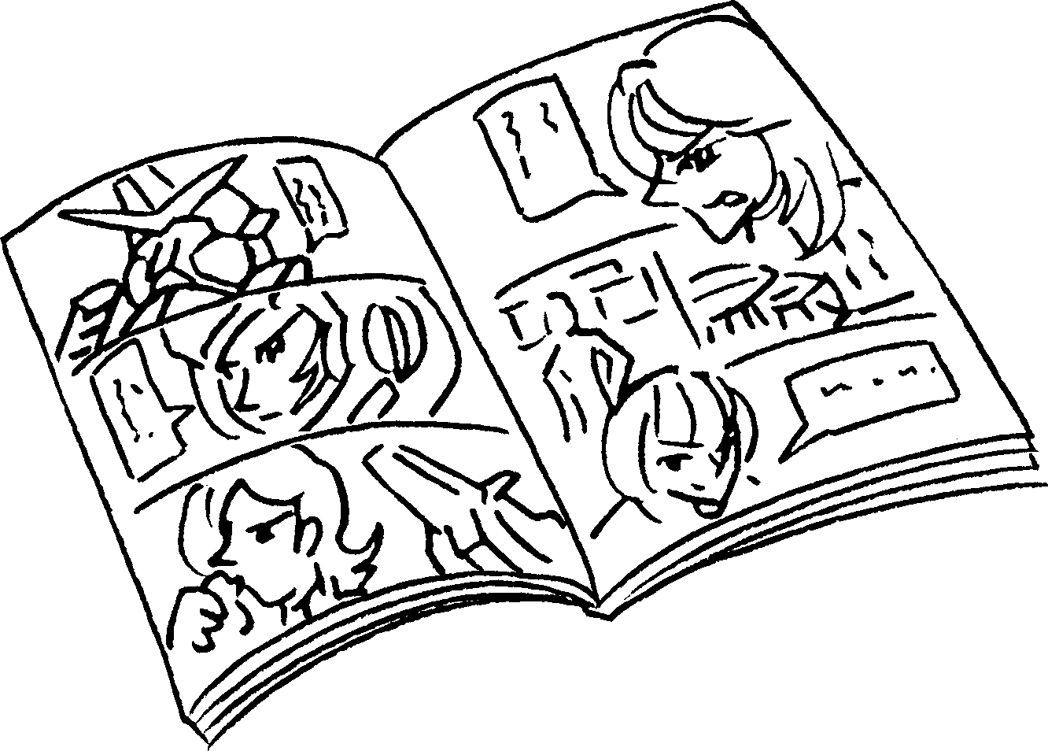 | 3 | 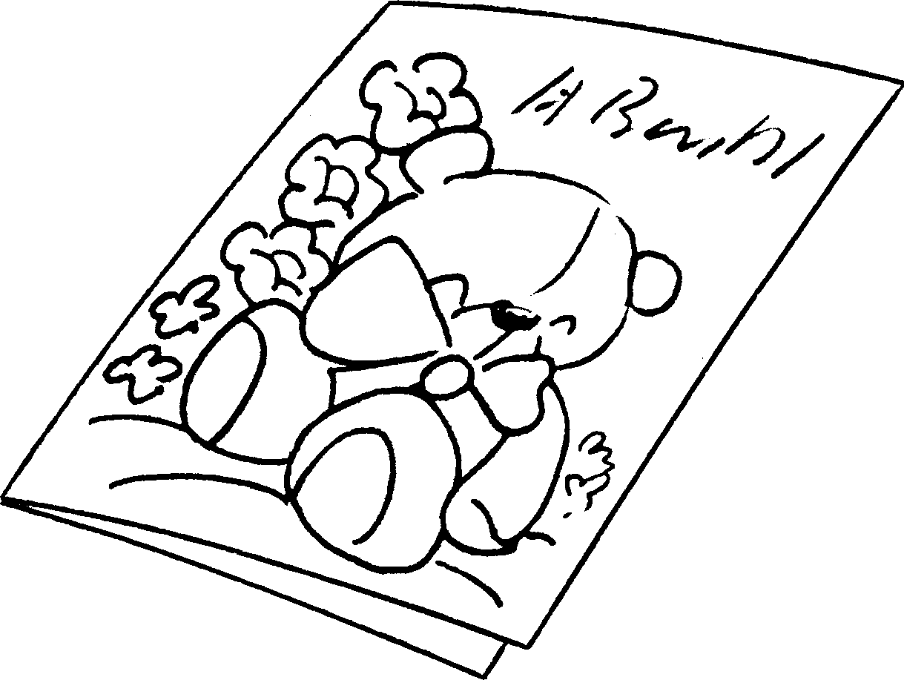
4 | 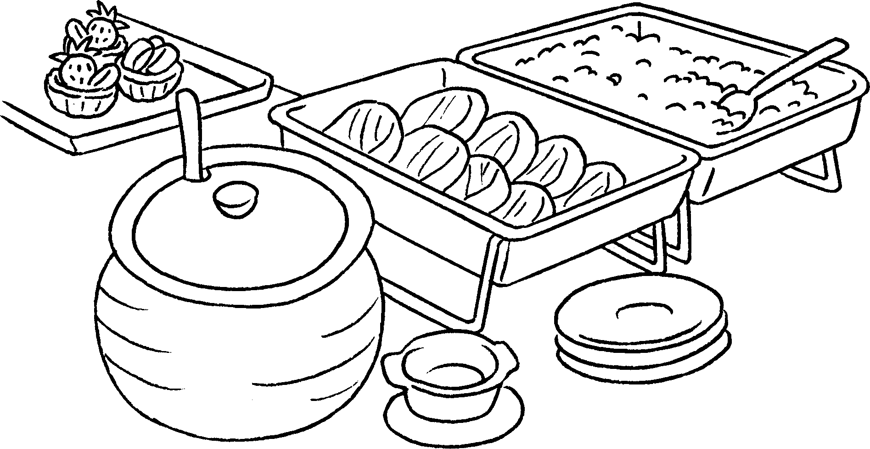 | 5 | 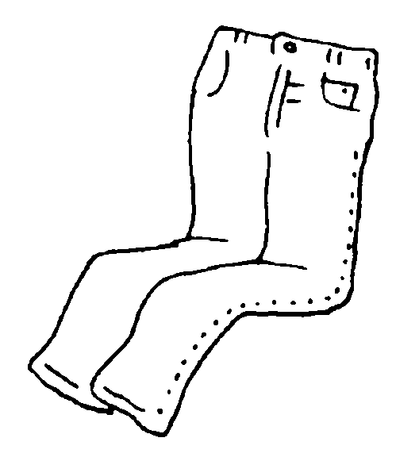 | 6 | 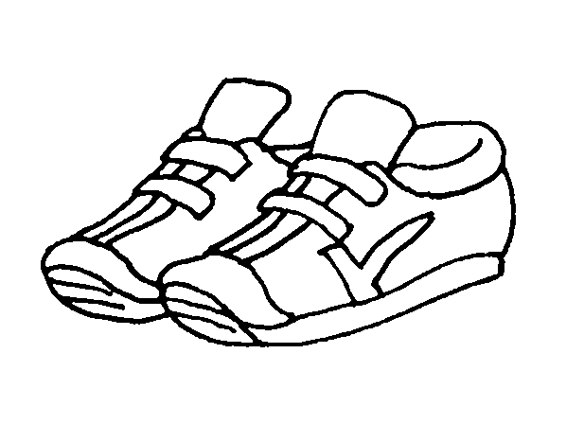
7 | 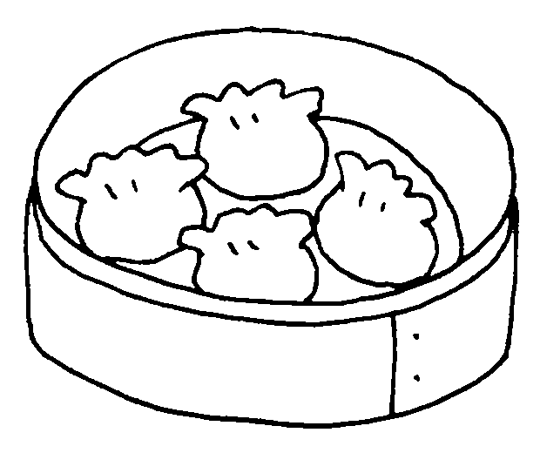 | 8 | 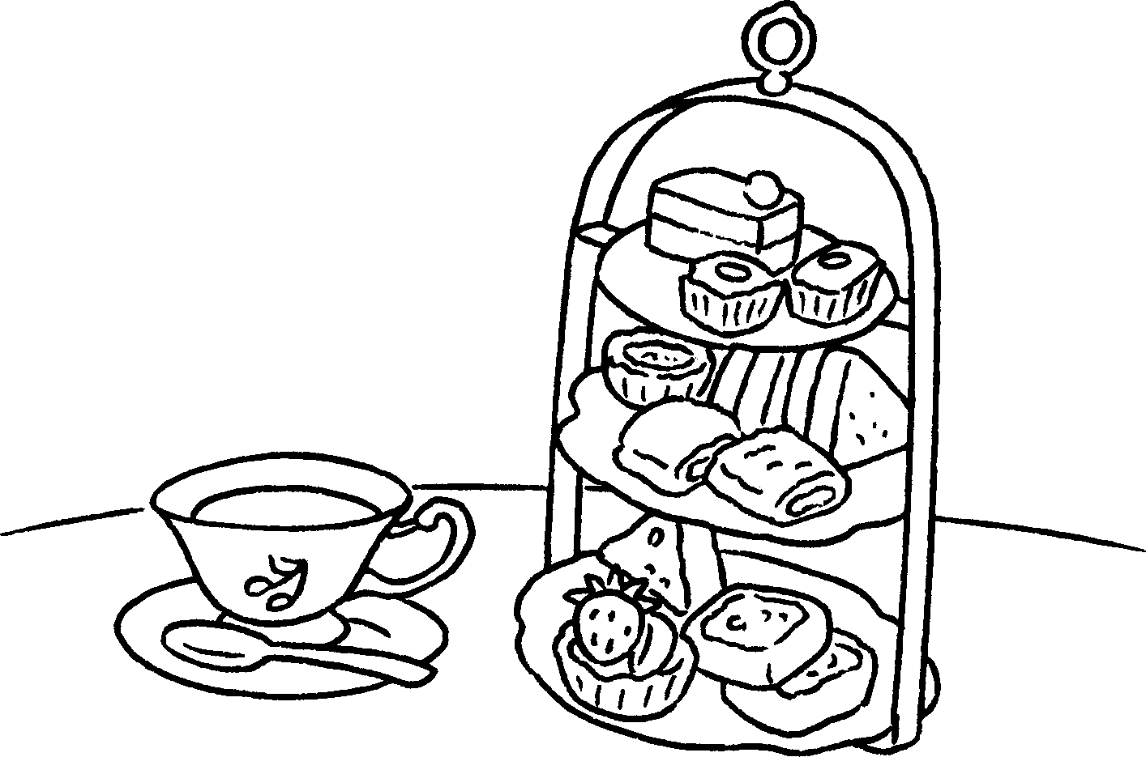 | 9 | 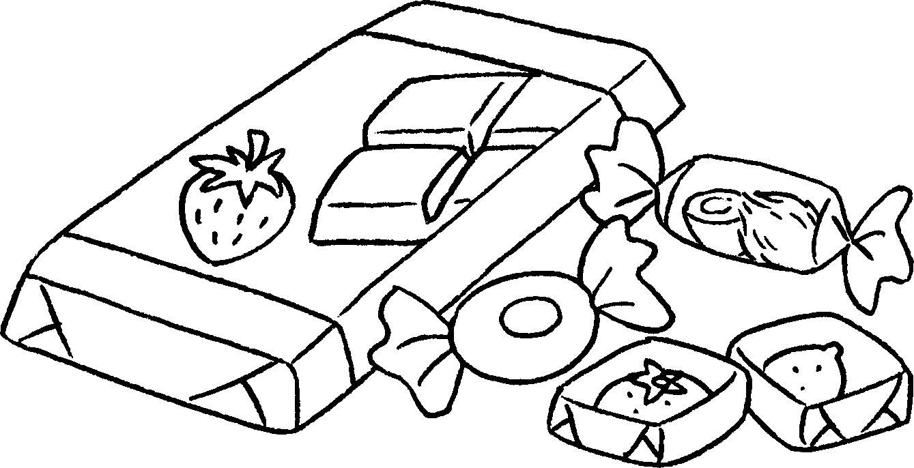

1 | a |  | 2 | a
3 | a |  | 4 | a
5 |  |  | 6
7 |  |  | 8
9


Book 3A Chapter 4 Graded Worksheets
Worksheet 1⬇
1 film 2 comic
3 card 4 buffet lunch
5 jeans 6 trainers
7 dim sum 8 afternoon tea
9 sweets and chocolate

