What are they? Fill in the missing letters.

1 | 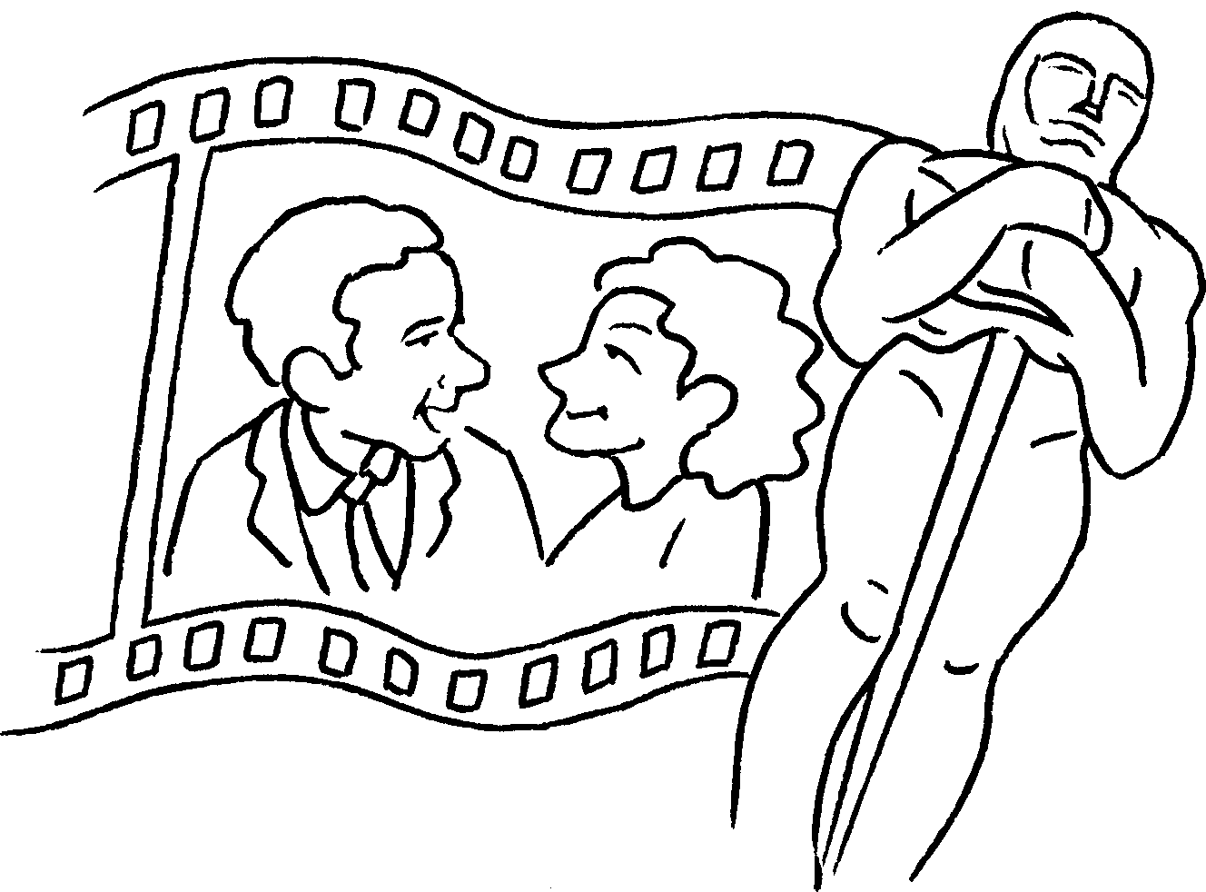 | 2 | 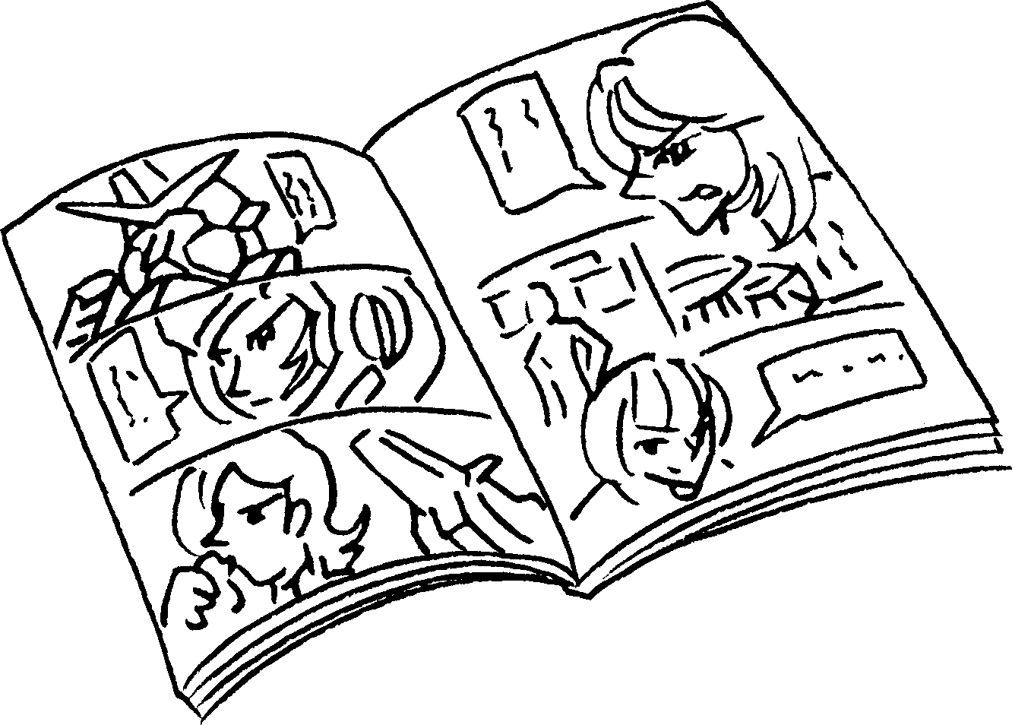 | 3 | 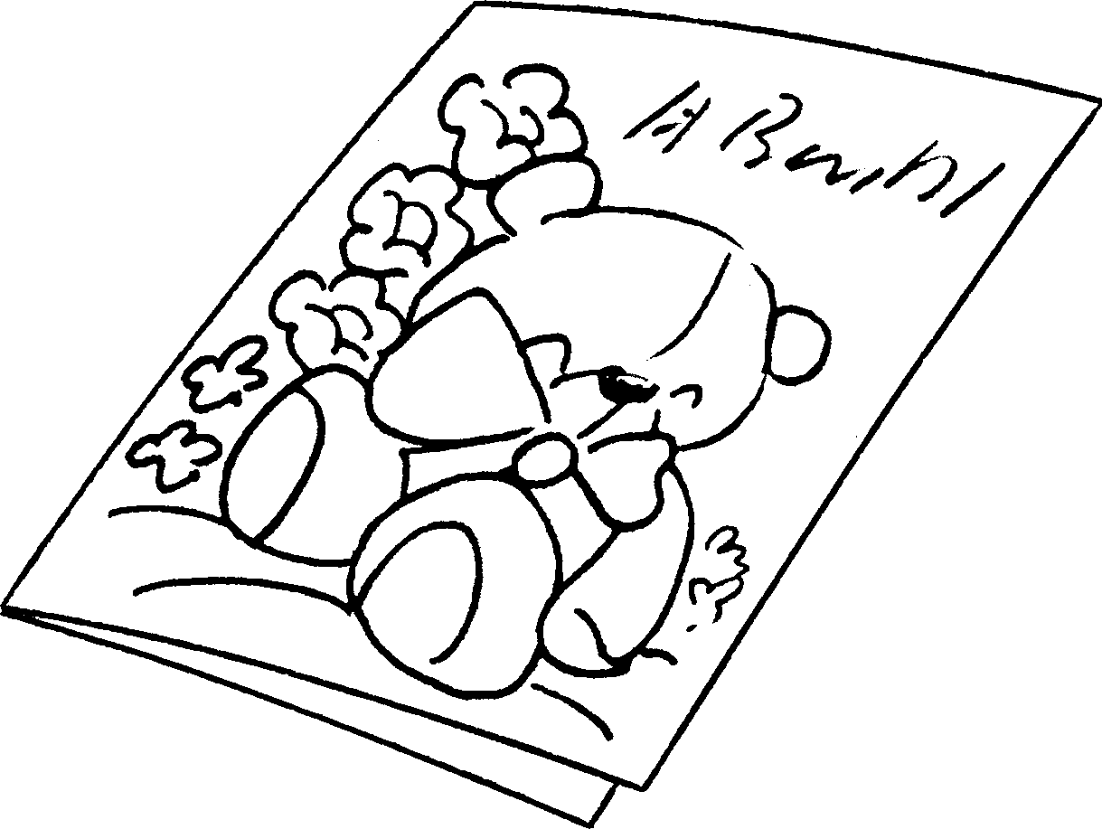
4 | 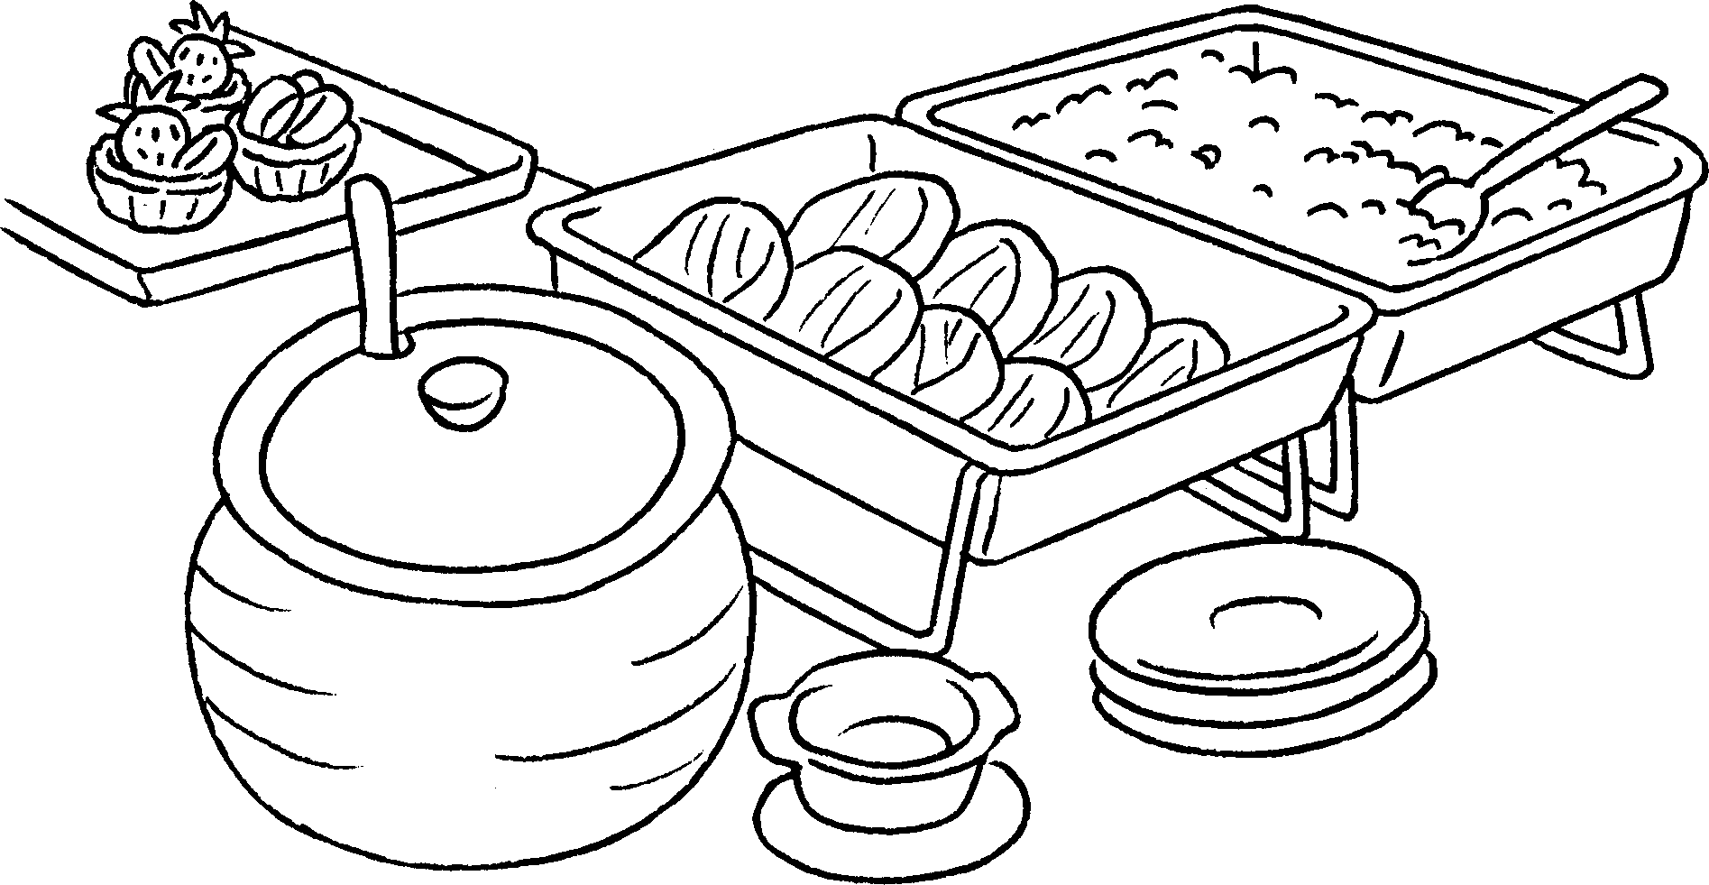 | 5 | 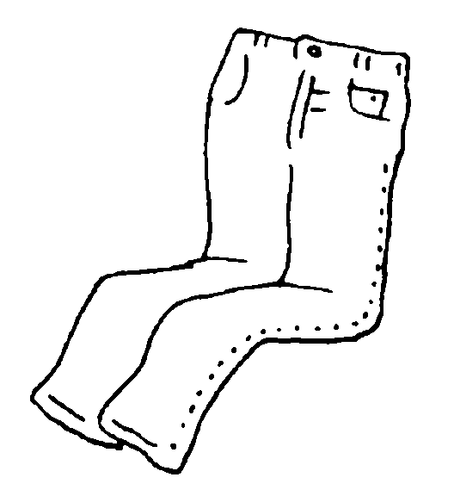 | 6 | 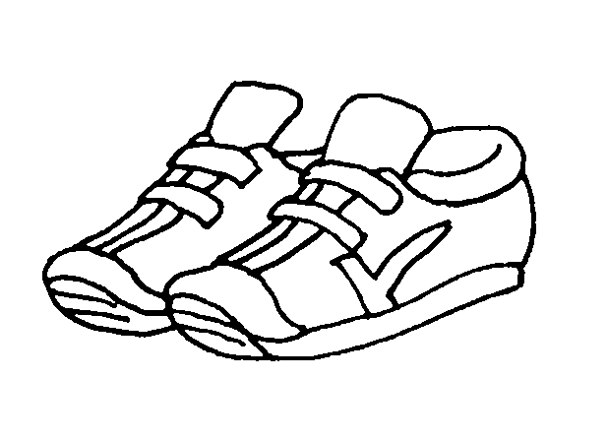
7 | 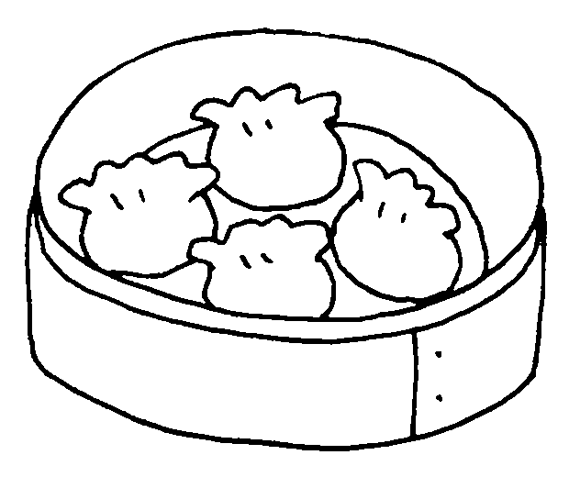 | 8 | 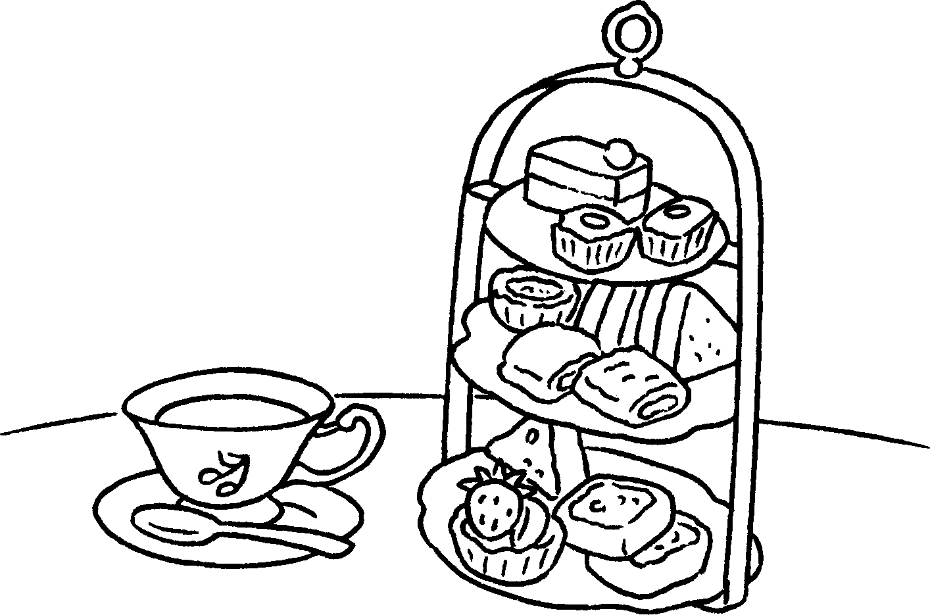 | 9 | 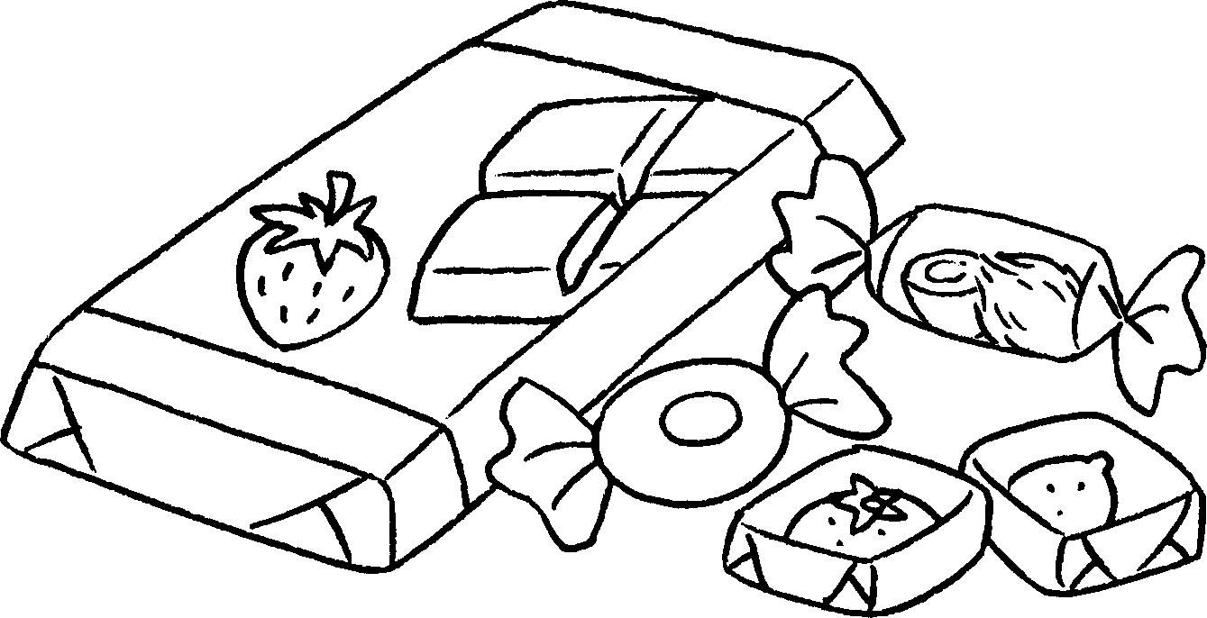

1 | a f __ __ __ |  | 2 | a c __ __ __ __
3 | a c __ __ __ |  | 4 | a b __ __ __ __ __ lunch
5 | j __ __ __ __ |  | 6 | t __ __ __ __ __ __ __
7 | d __ __ s __ __ |  | 8 | a __ __ __ __ __ __ __ __ tea
9 | s __ __ __ __ __ and c __ __ __ __ __ __ __ __


Book 3A Chapter 4 Graded Worksheets
Worksheet 1⬇⬇
1 f i l m 2 c o m i c
3 c a r d 4 b u f f e t
5 j e a n s 6 t r a i n e r s
7 d i m s u m 8 a f t e r n o o n
9 s w e e t s and c h o c o l a t e

