What are they? Write.

1 | 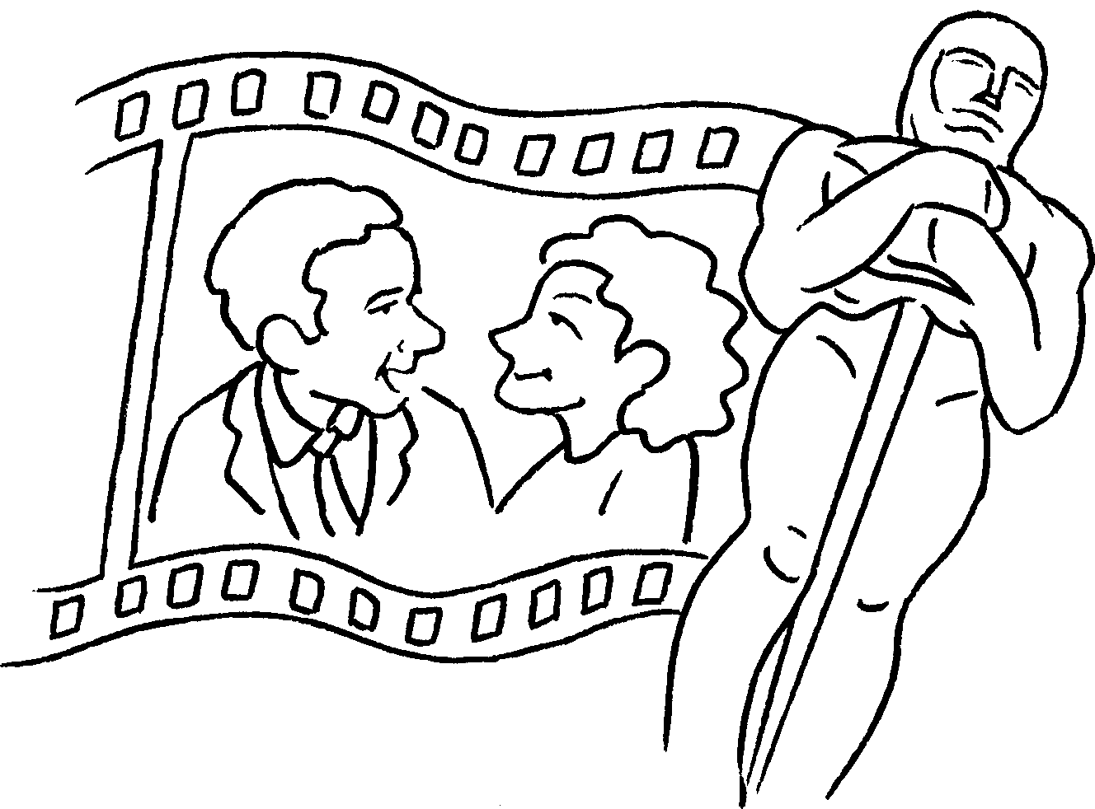 | 2 | 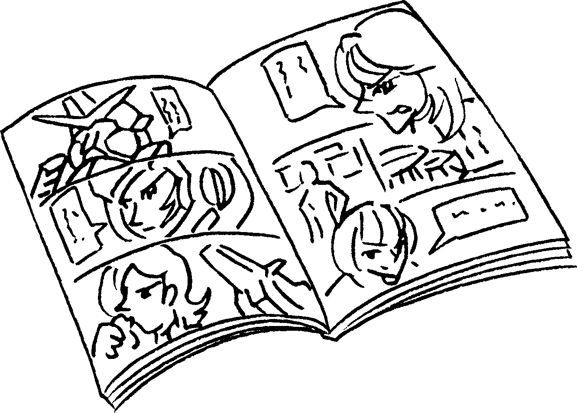 | 3 | 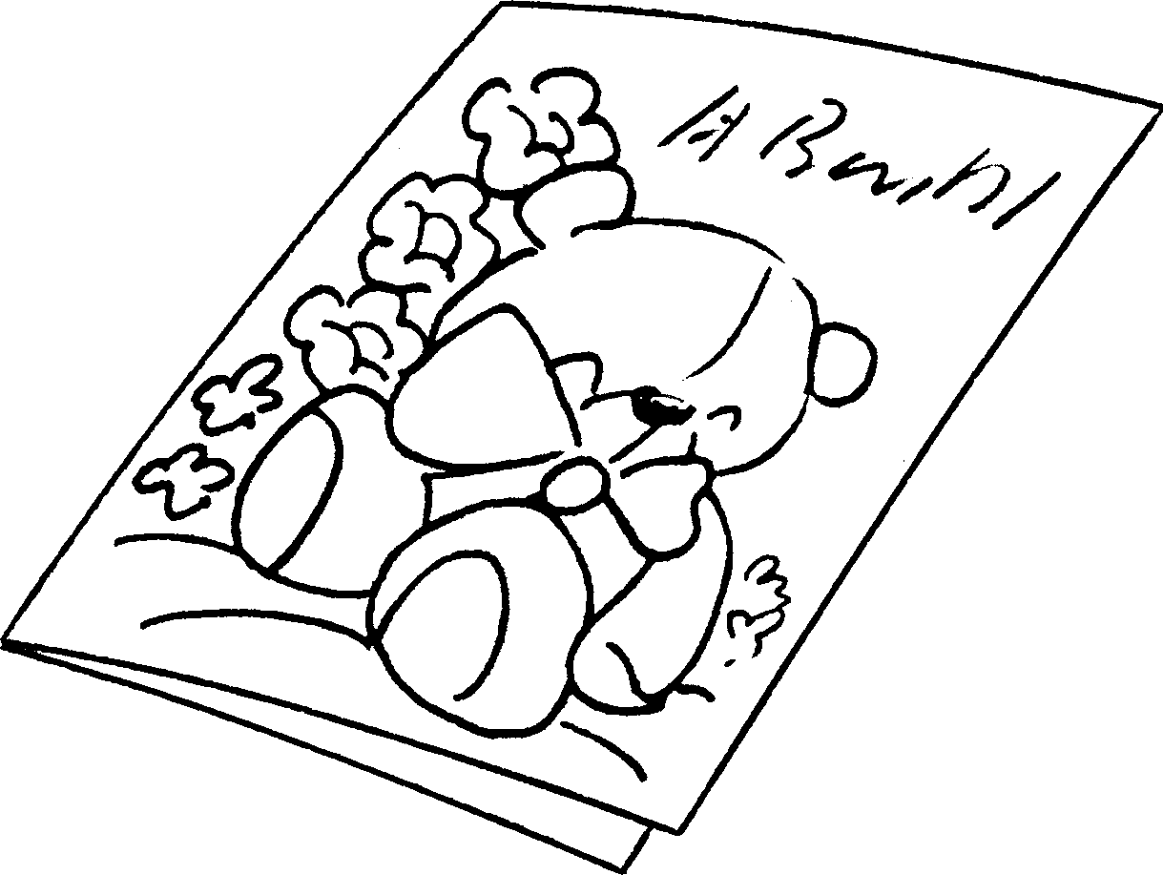
4 | 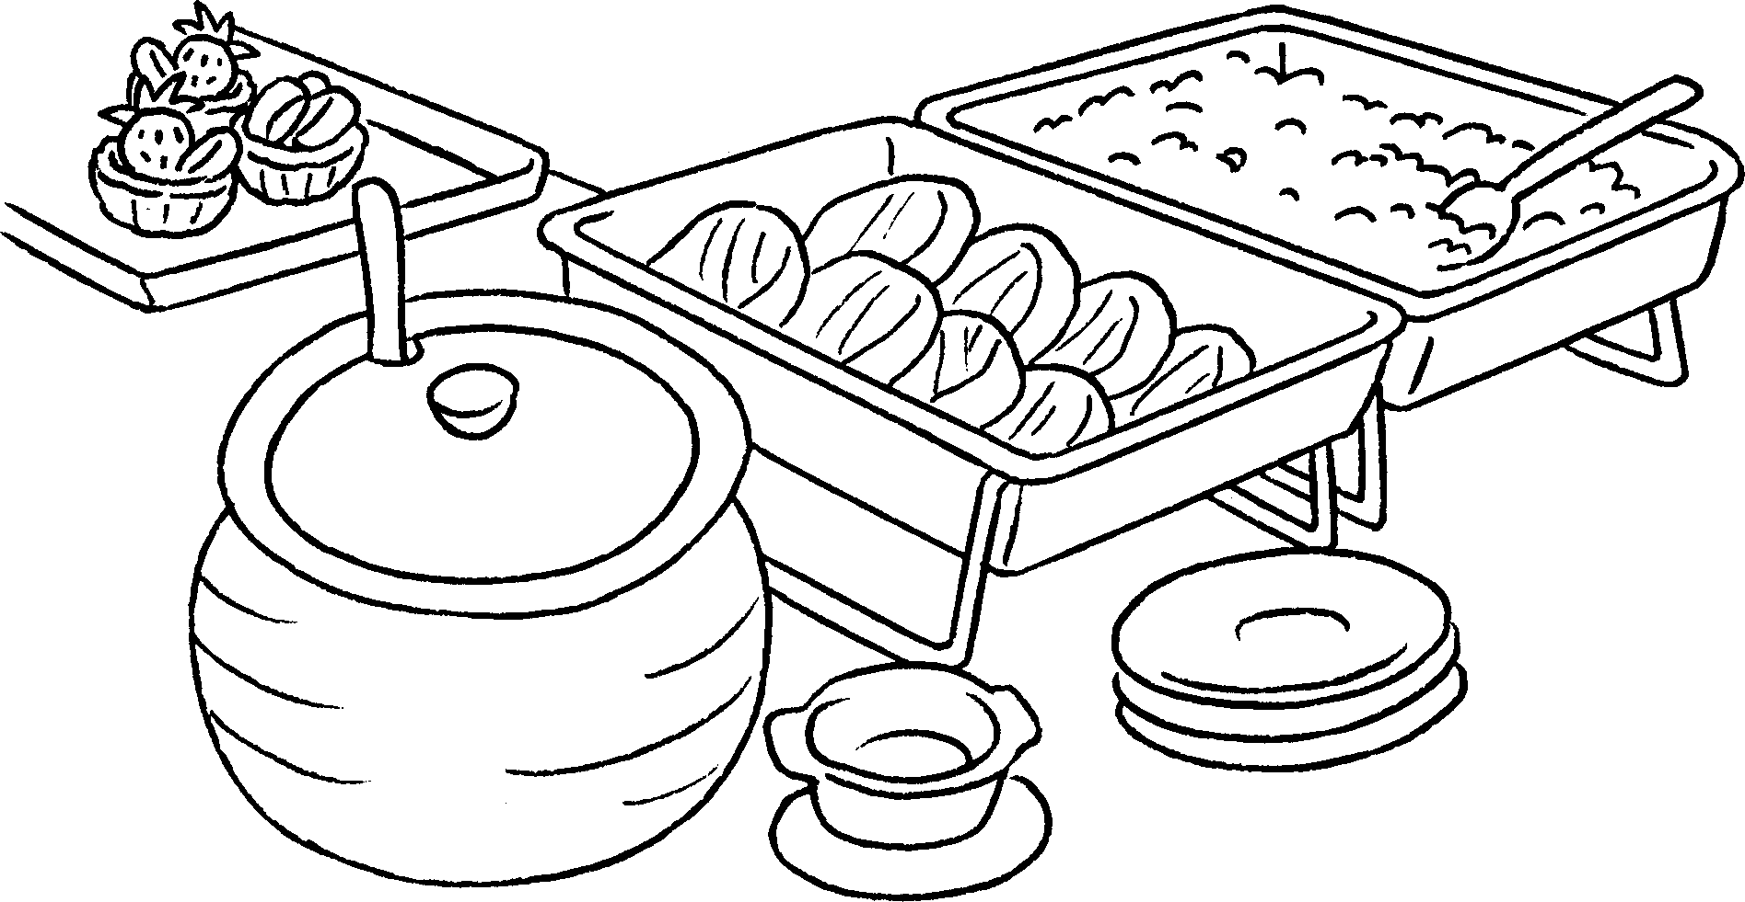 | 5 | 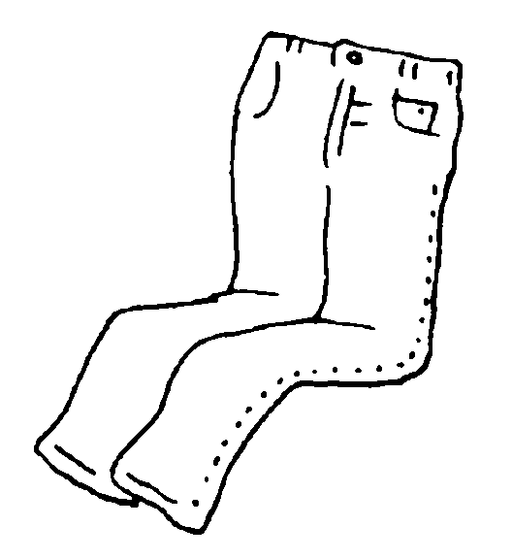 | 6 | 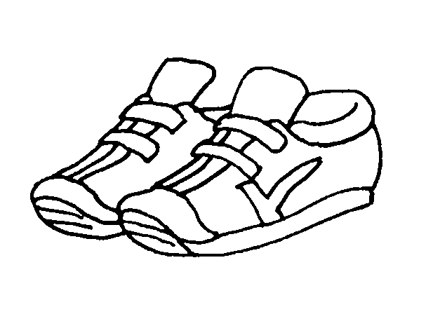
7 | 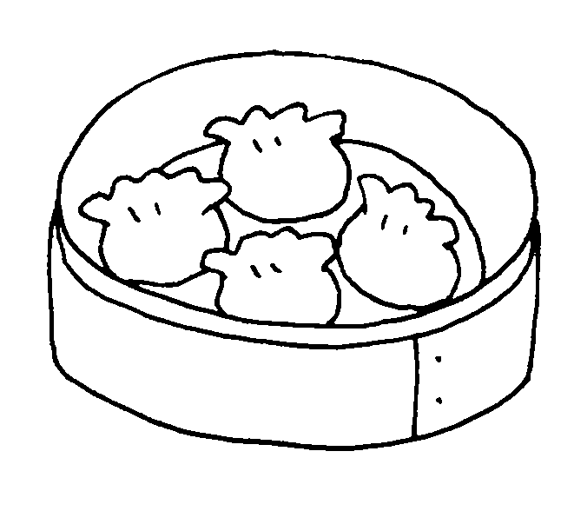 | 8 | 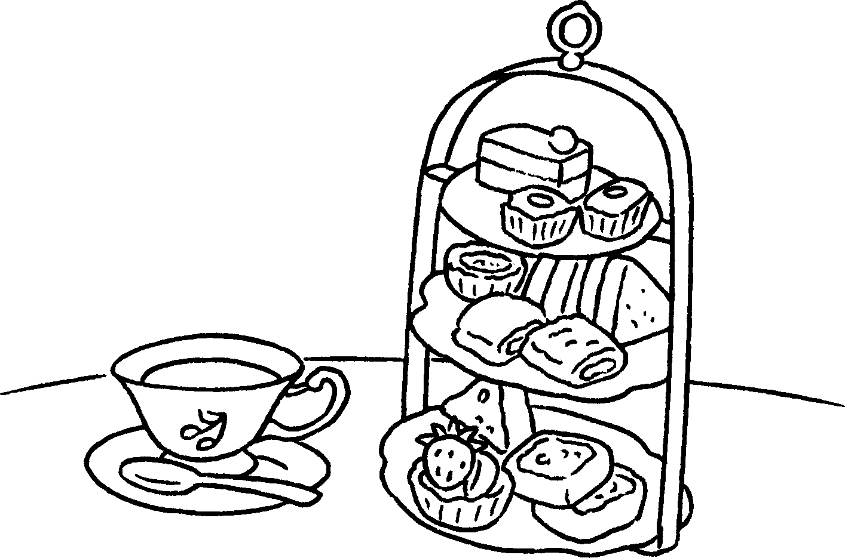 | 9 | 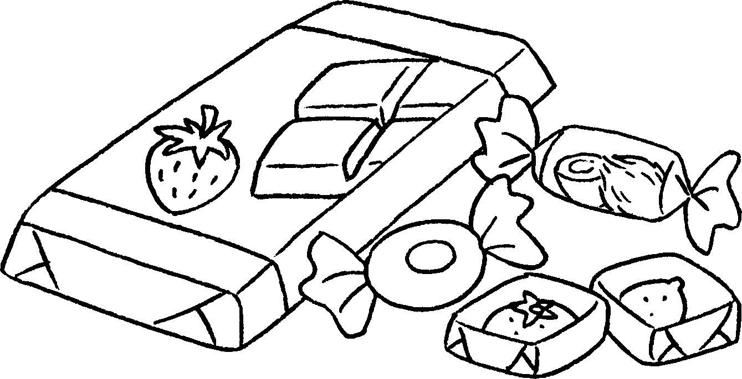

1 | a f |  | 2 | a c
3 | a c |  | 4 | a b l
5 | j |  | 6 | t
7 | d s |  | 8 | a t
9 | s and c


Book 3A Chapter 4 Graded Worksheets
Worksheet 1⬇⬇⬇
1 film 2 comic
3 card 4 buffet lunch
5 jeans 6 trainers
7 dim sum 8 afternoon tea
9 sweets and chocolate

