Choose and write.
What | want to | buy | watch | eat

1 | 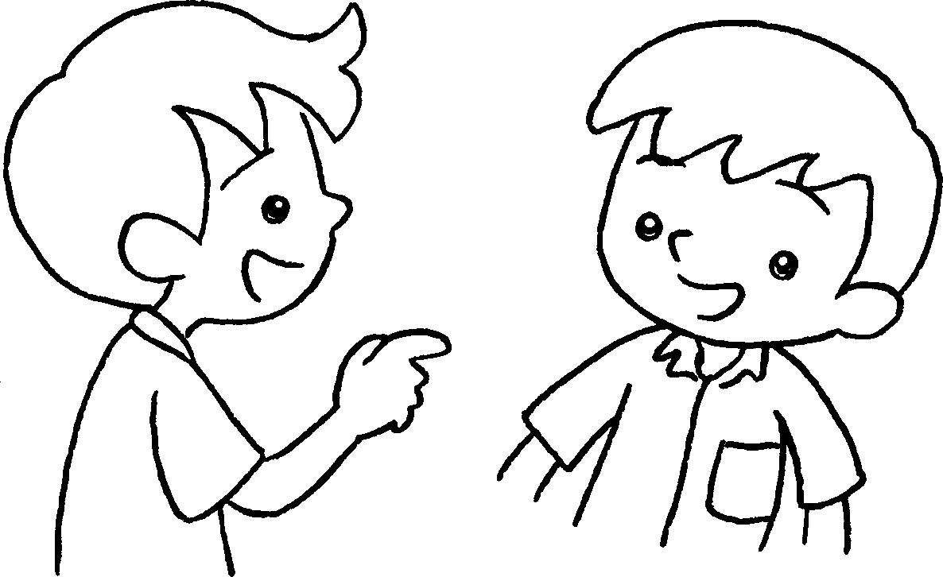 | 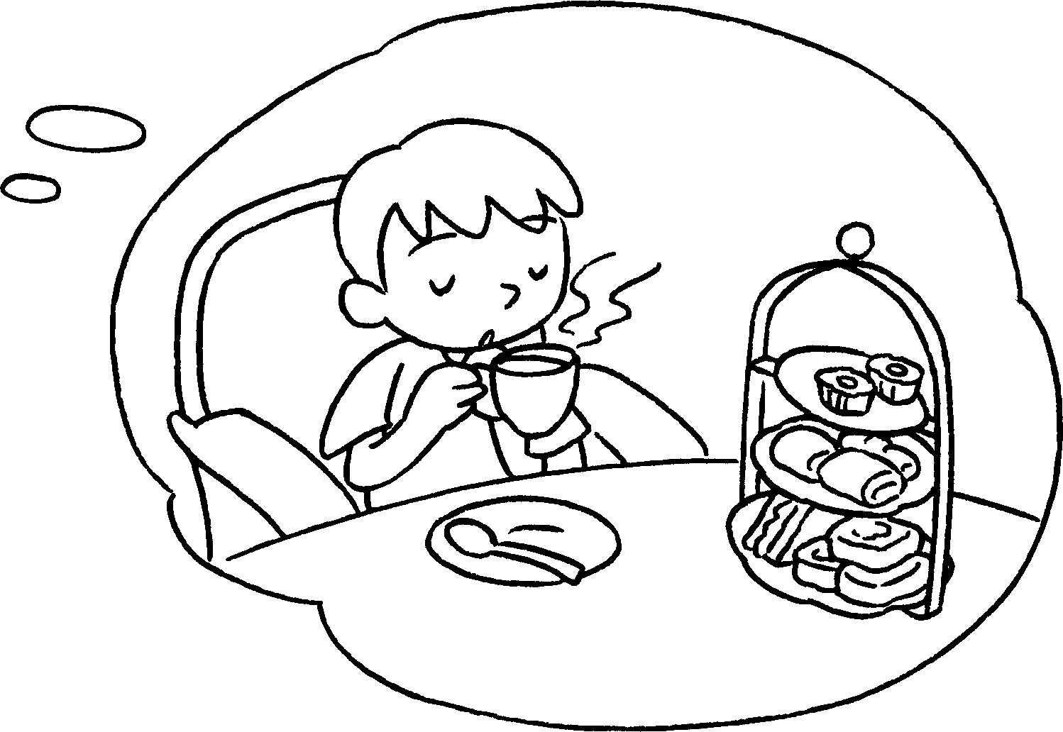 | A : do you  want to do?  B : I want to have afternoon tea.
2 | 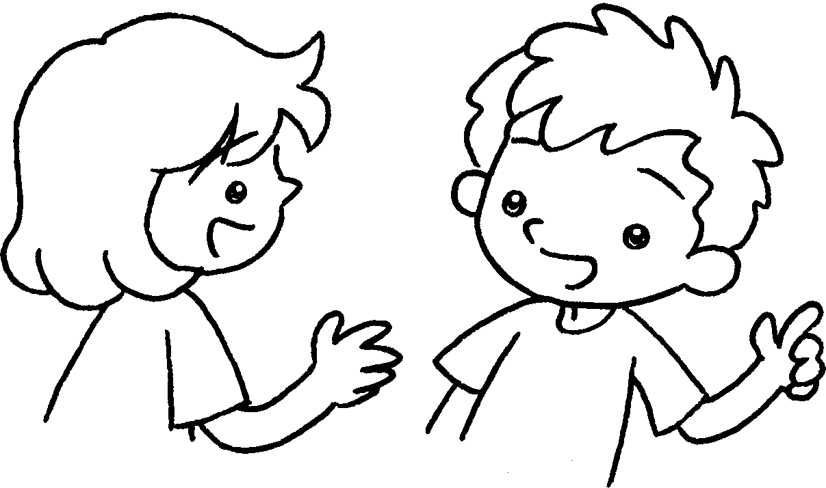 | 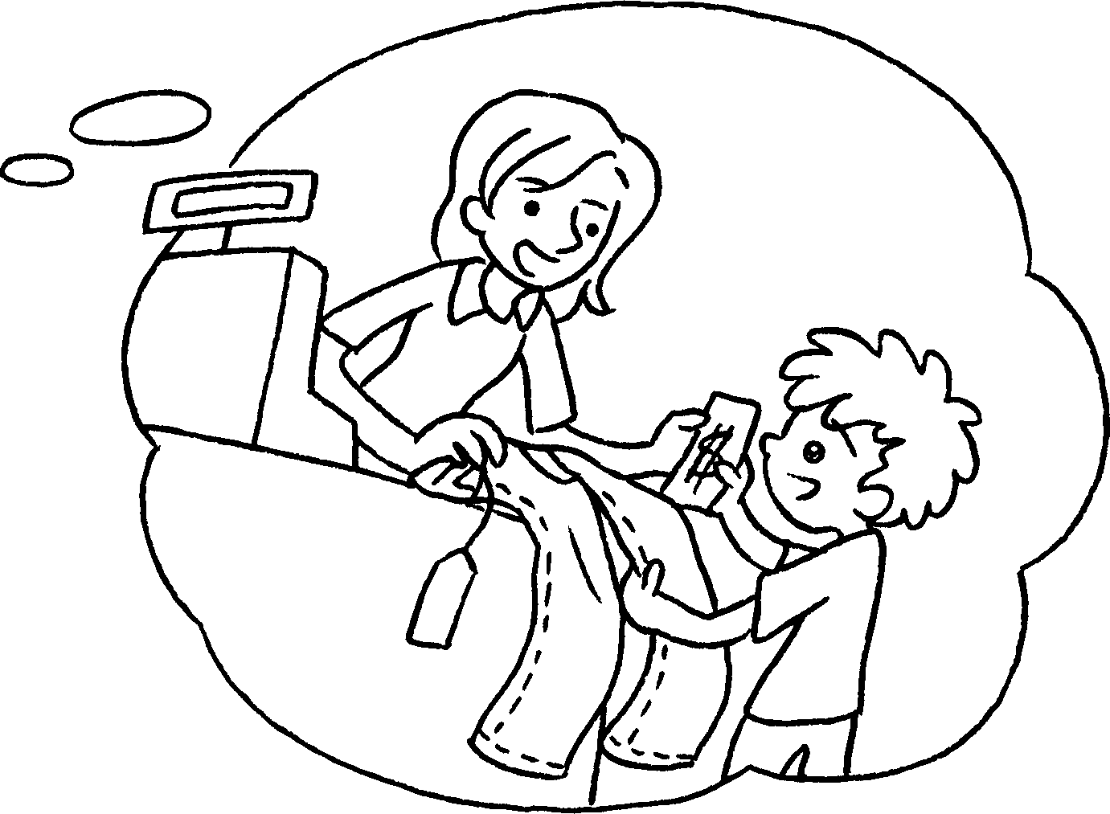 | A : do you  want to do?  B : I want to  jeans.
3 | 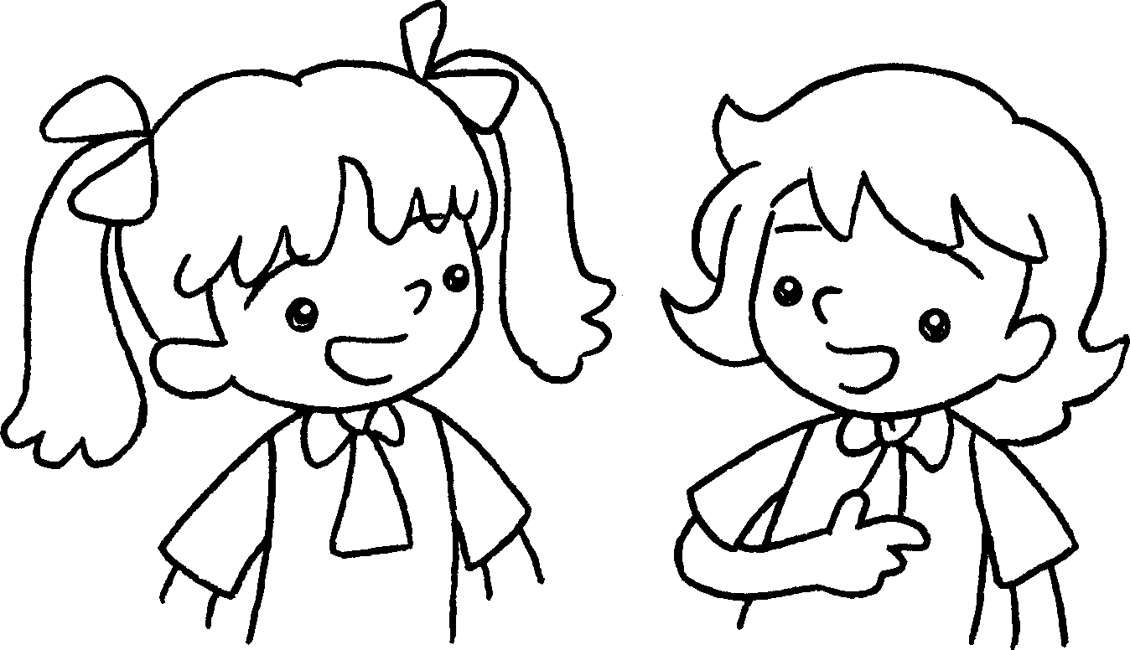 | 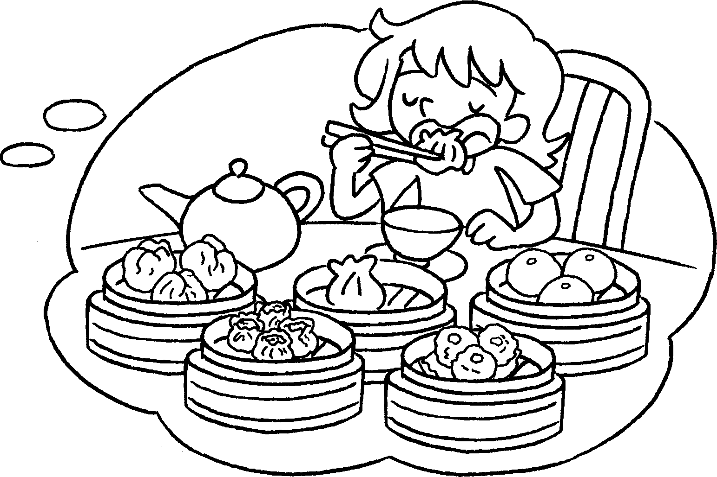 | A : do you  do?  B : I want to  dim sum.
4 | 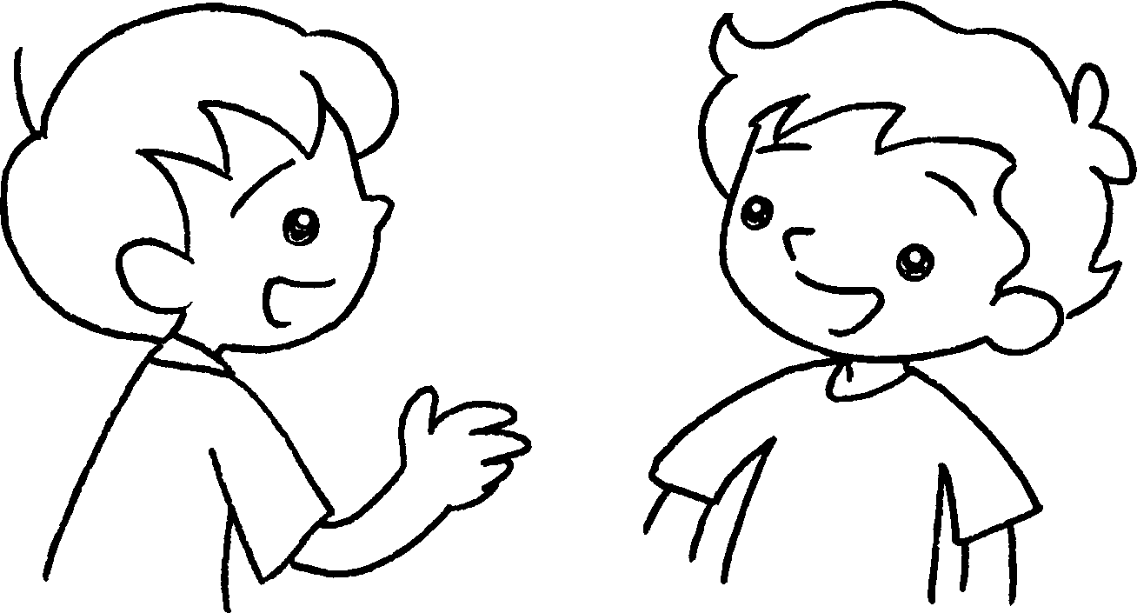 | 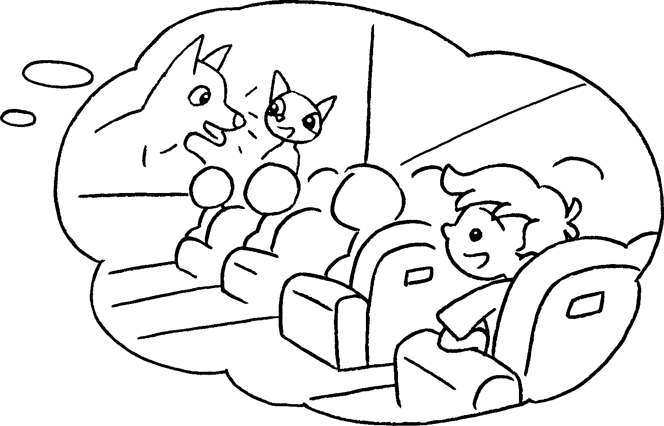 | A : do you  B  A  B  A  B  A  B  do?  B : I  a film.  A


Book 3A Chapter 4 Graded Worksheets
Worksheet 2⬇
- What
- What
buy
3 What want to
eat
4 What want to
want to watch

