What do the children want to do? Finish what they say.

1 | 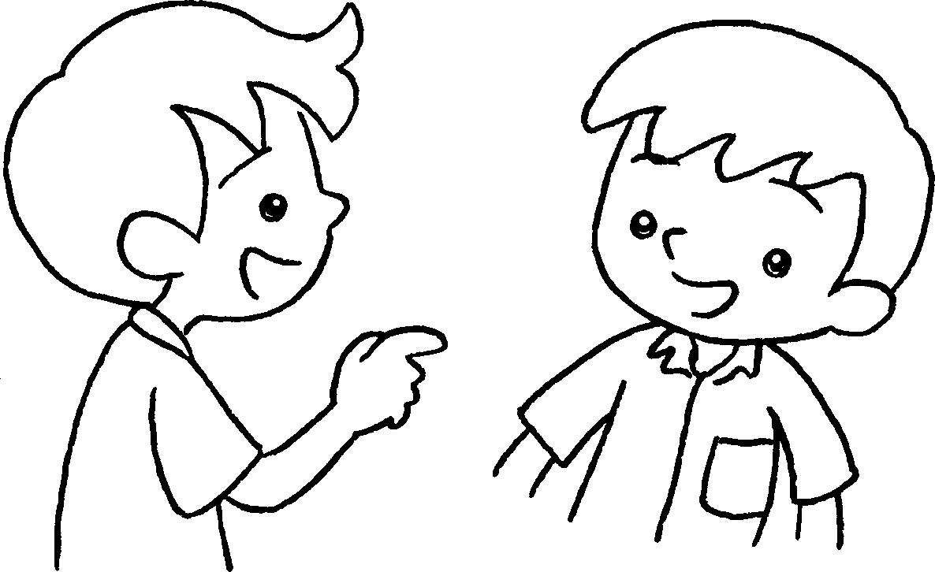 | 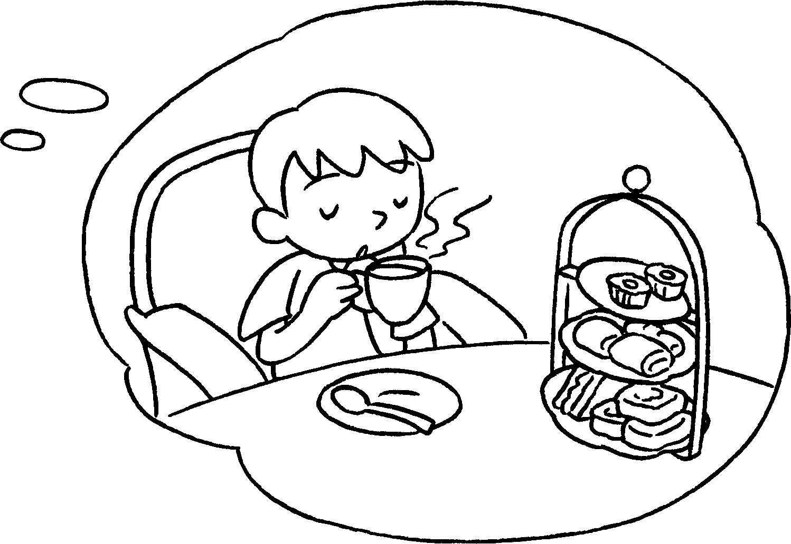 | What  A : do you  want to do?  B : I want to have  .
2 | 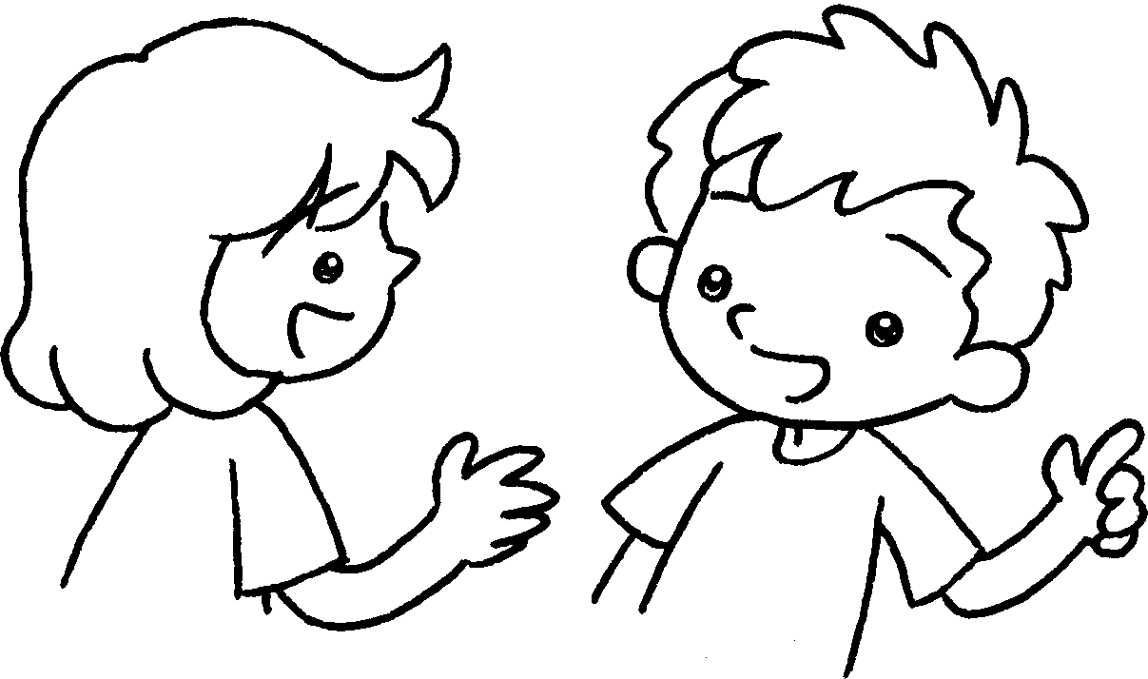 | 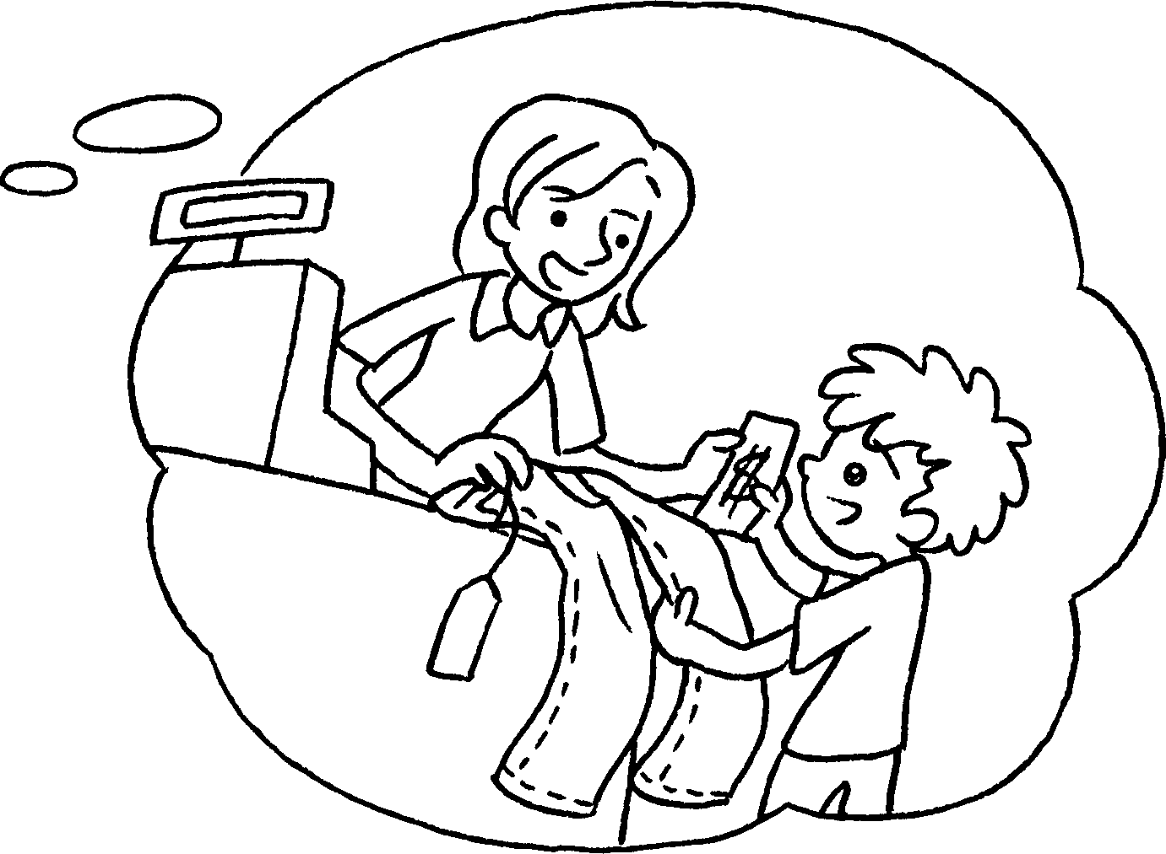 | A : do you  want to do?  B : I want to  .
3 | 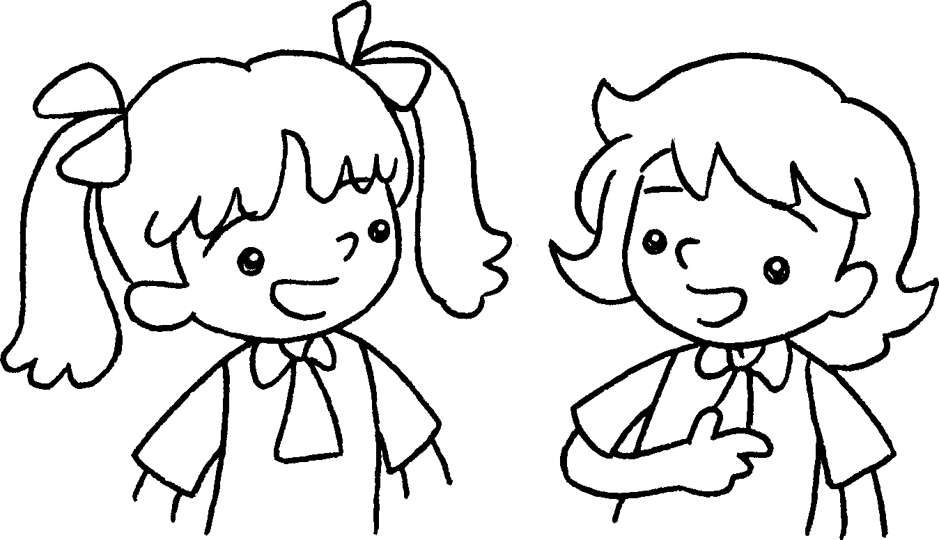 | 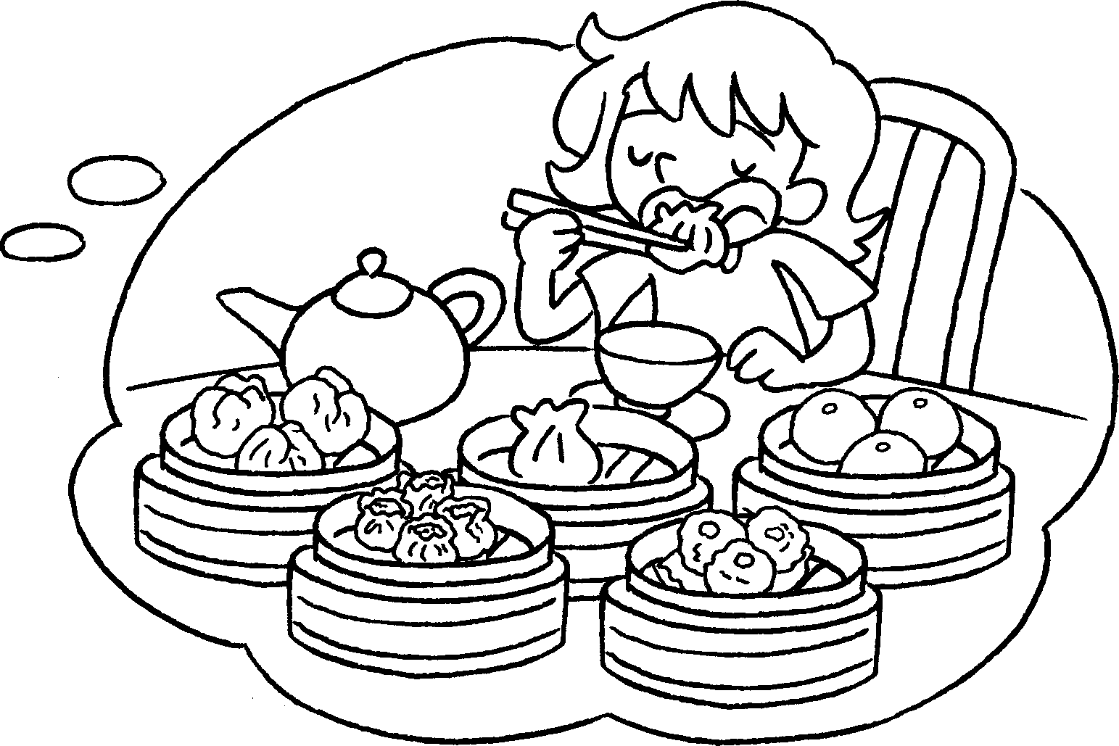 | A :  do?  B : I want to  .
4 | 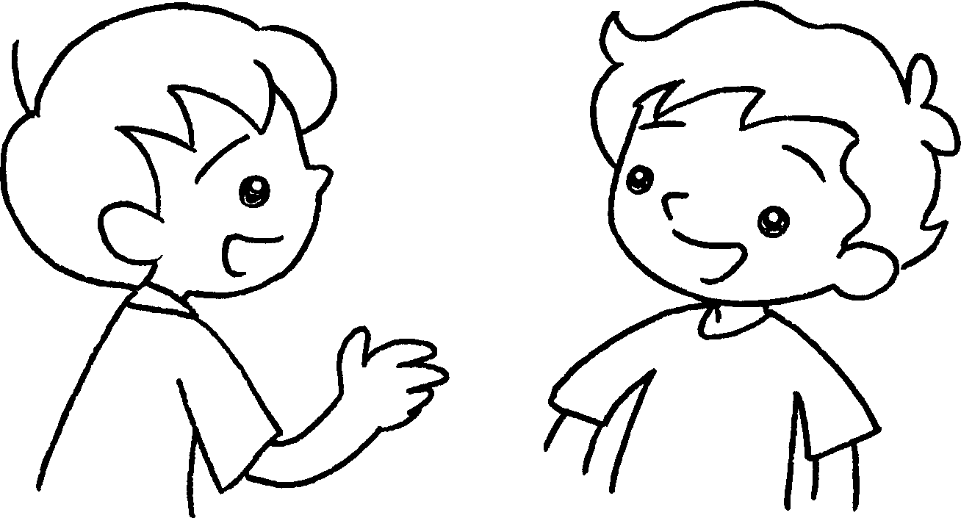 | 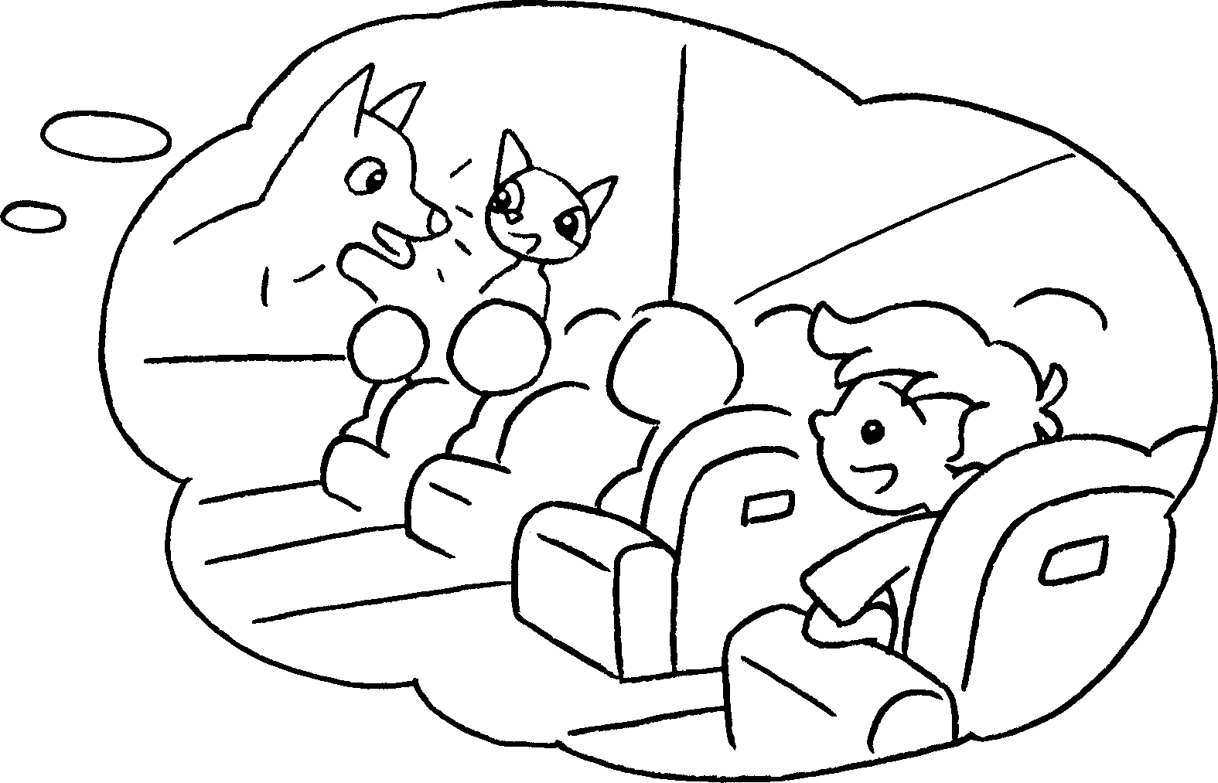 | A :  B  A  B  A  B  A  B  B :  A


Book 3A Chapter 4 Graded Worksheets
Worksheet 2⬇⬇⬇
- afternoon tea
- What
buy jeans
- What do you want to
eat dim sum
- What do you want to do?
I want to watch a film.
(Accept any reasonable answers.)

