A
B
A
B
A
B
A
B
Choose and write.
Where | go | hotel | gift shop | book shop

1 | 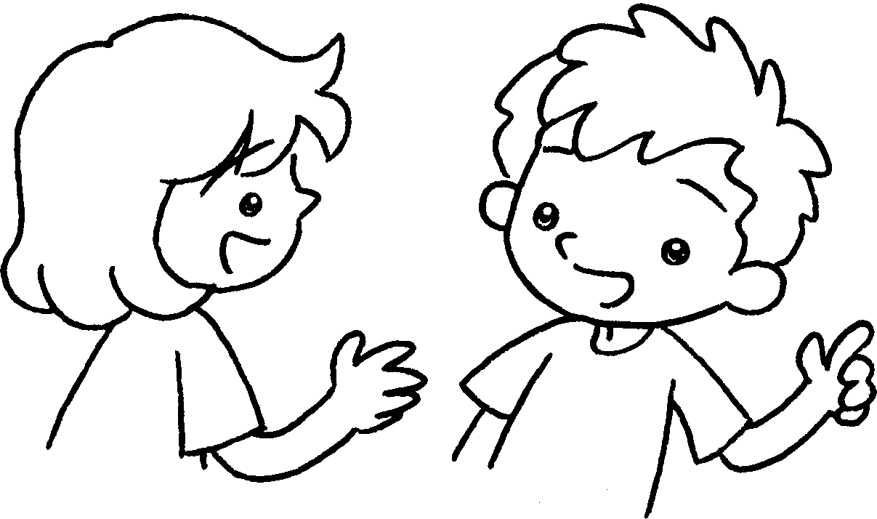 | 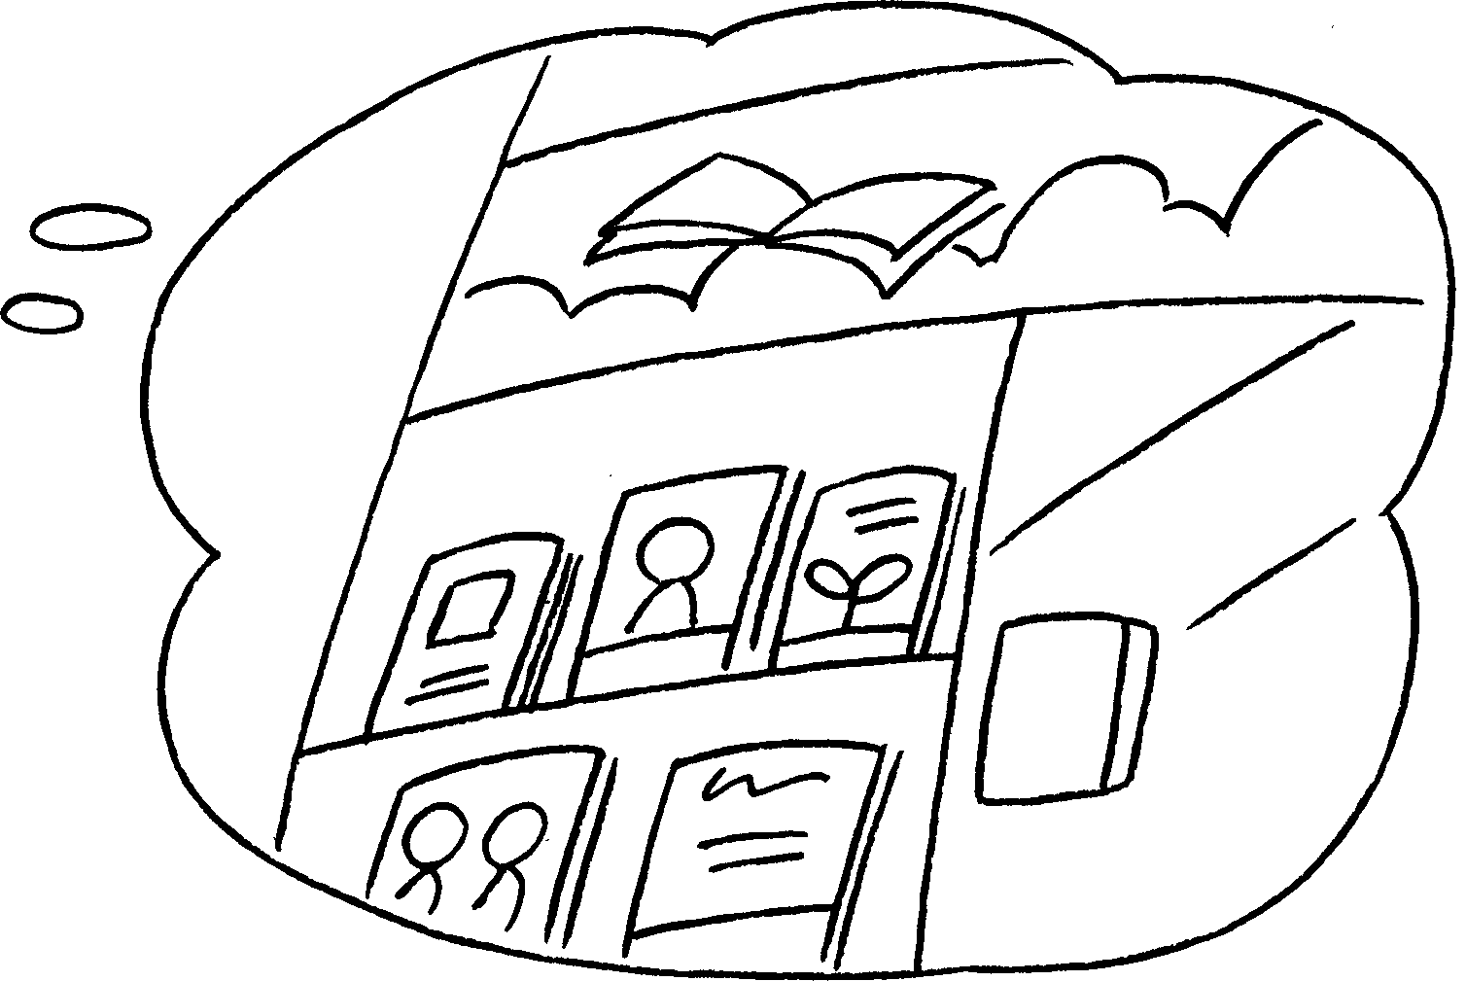 | A : do you  want to go?  B : I want to go to the  .
2 | 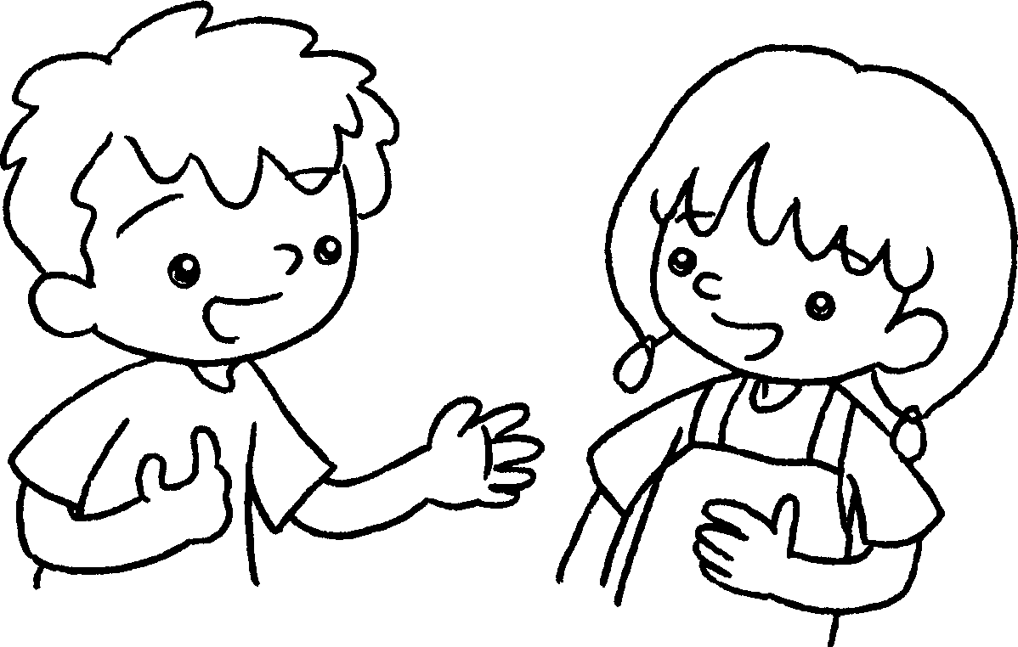 | 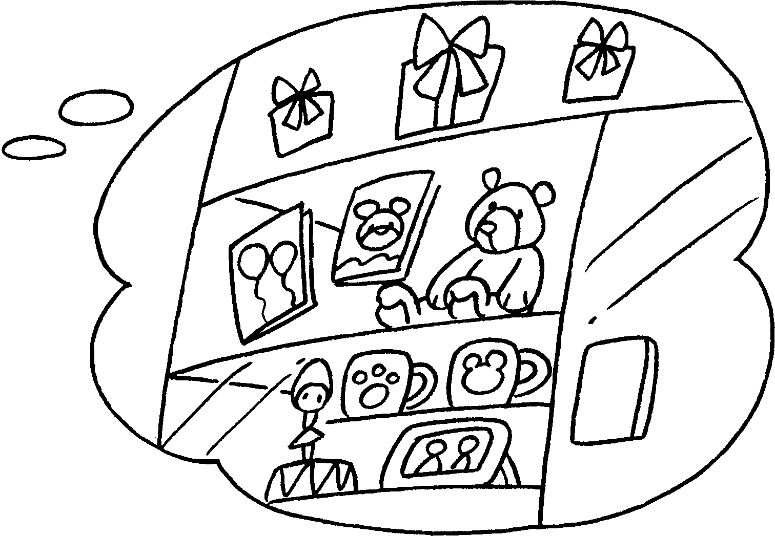 | A : do you  want to go?  B : I want to go to the  .
3 | 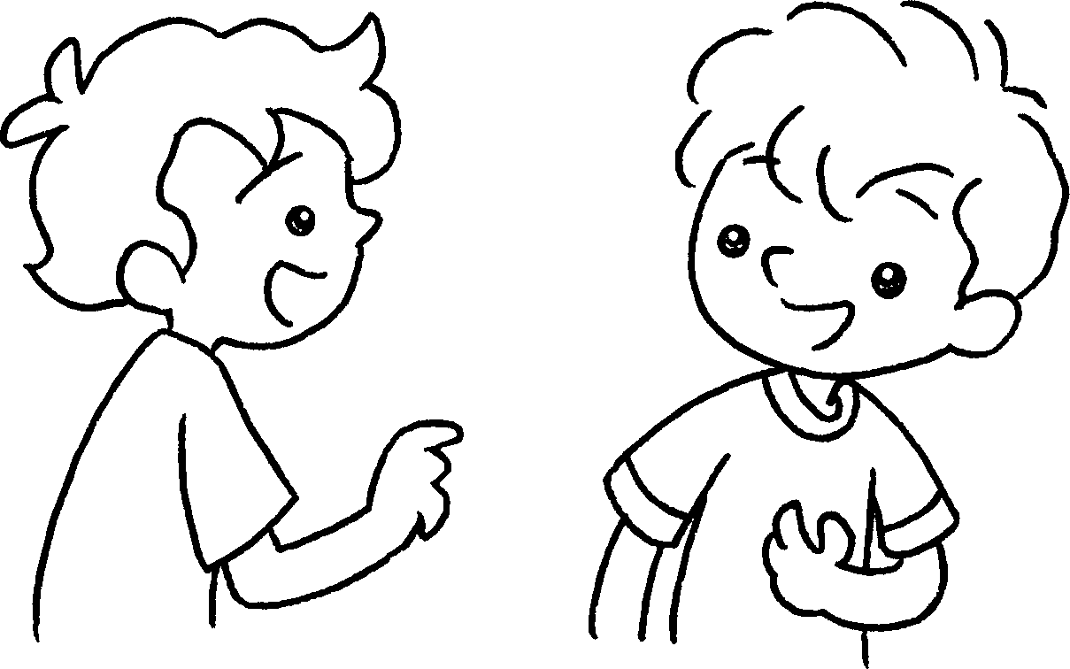 | 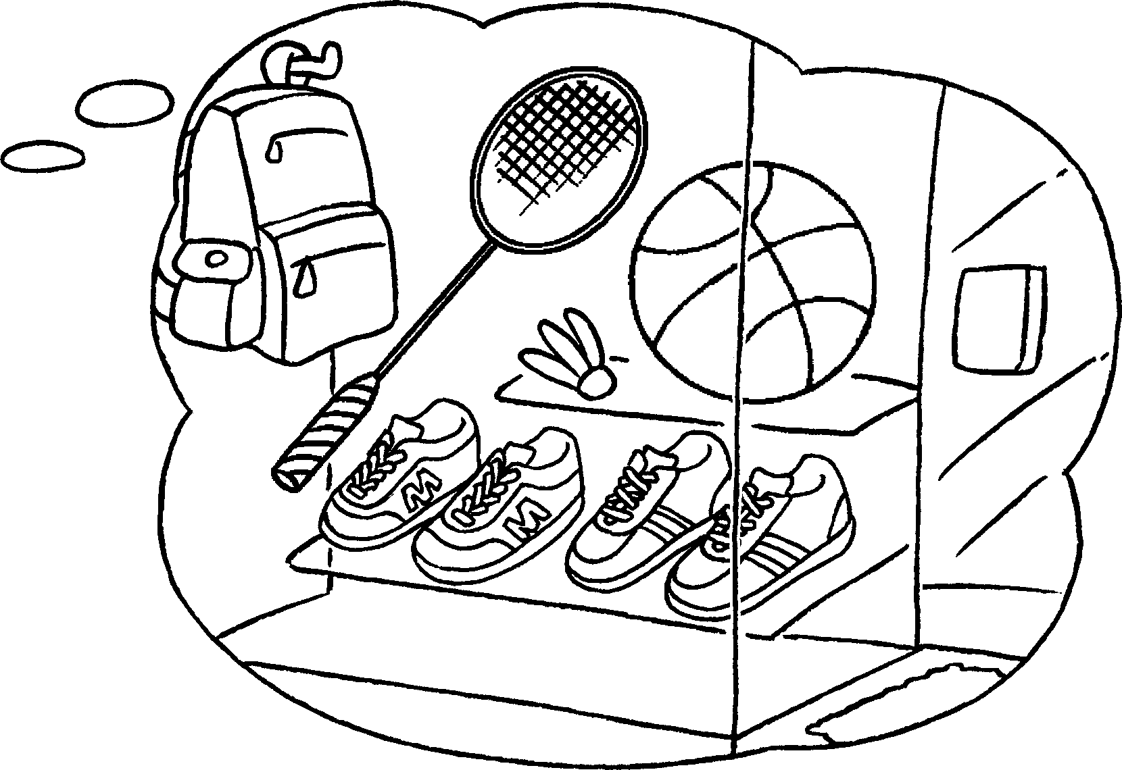 | A : do you  want to ?  B : I want to  to the sportswear shop.
4 | 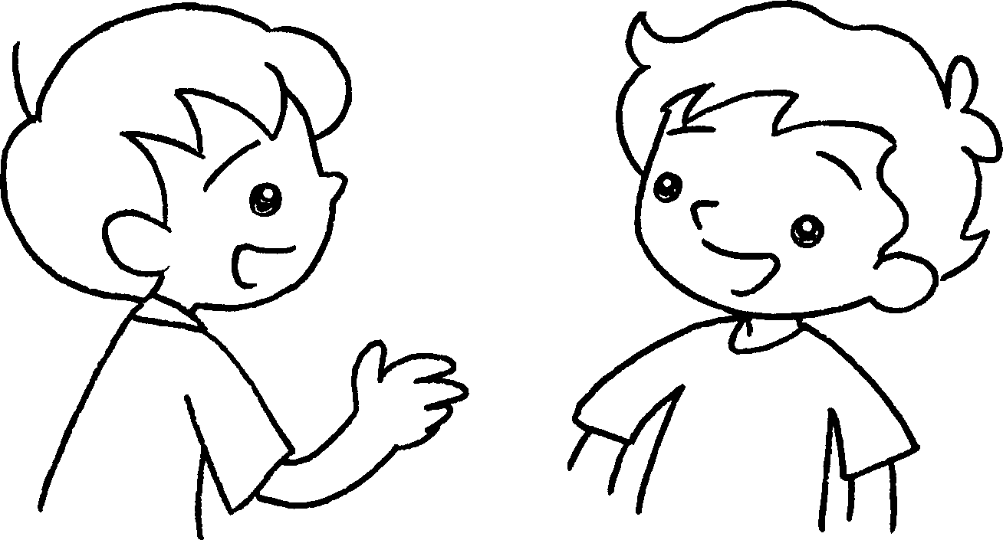 | 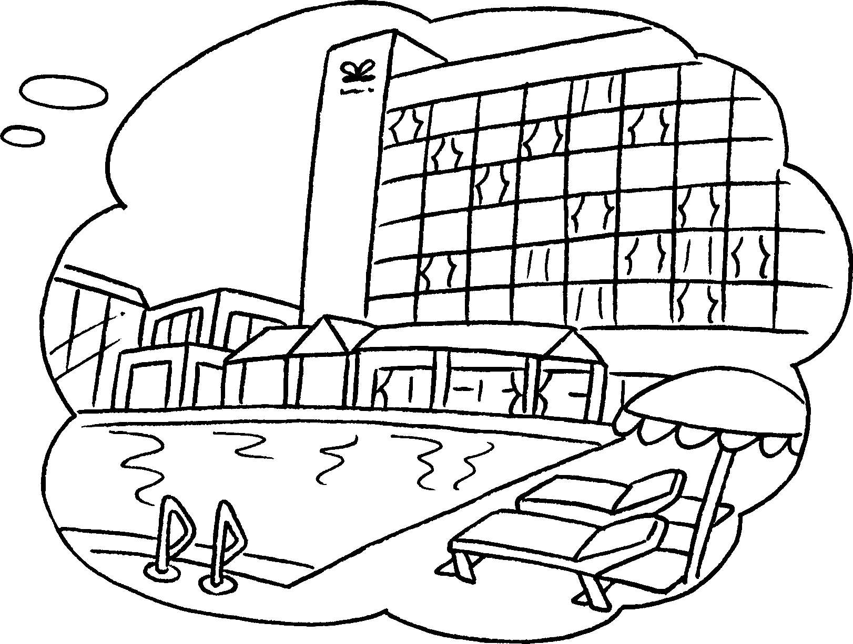 | A : do you  want to ?  B : I want to  to the .


Book 3A Chapter 4 Graded Worksheets
Worksheet 3⬇
- Where
book shop
- Where
gift shop
3 Where go
go
4 Where go
go hotel

