A
B
A
B
A
B
A
B
A
B
A
B
A
B
A
B
Where do the children want to go? Finish what they say.

1 | 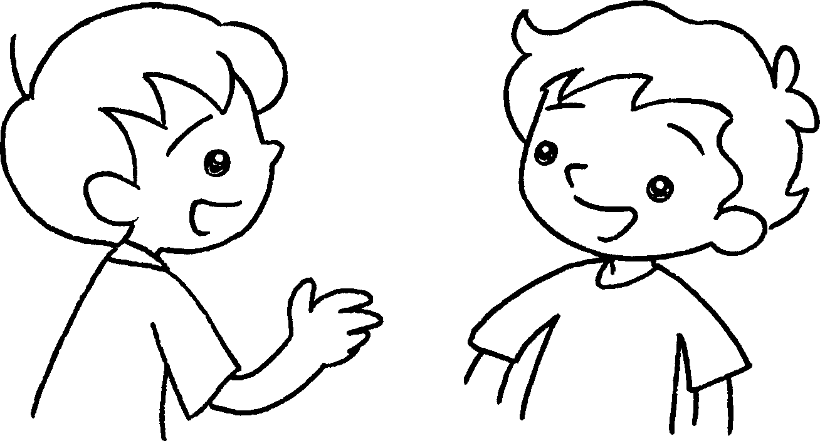 | 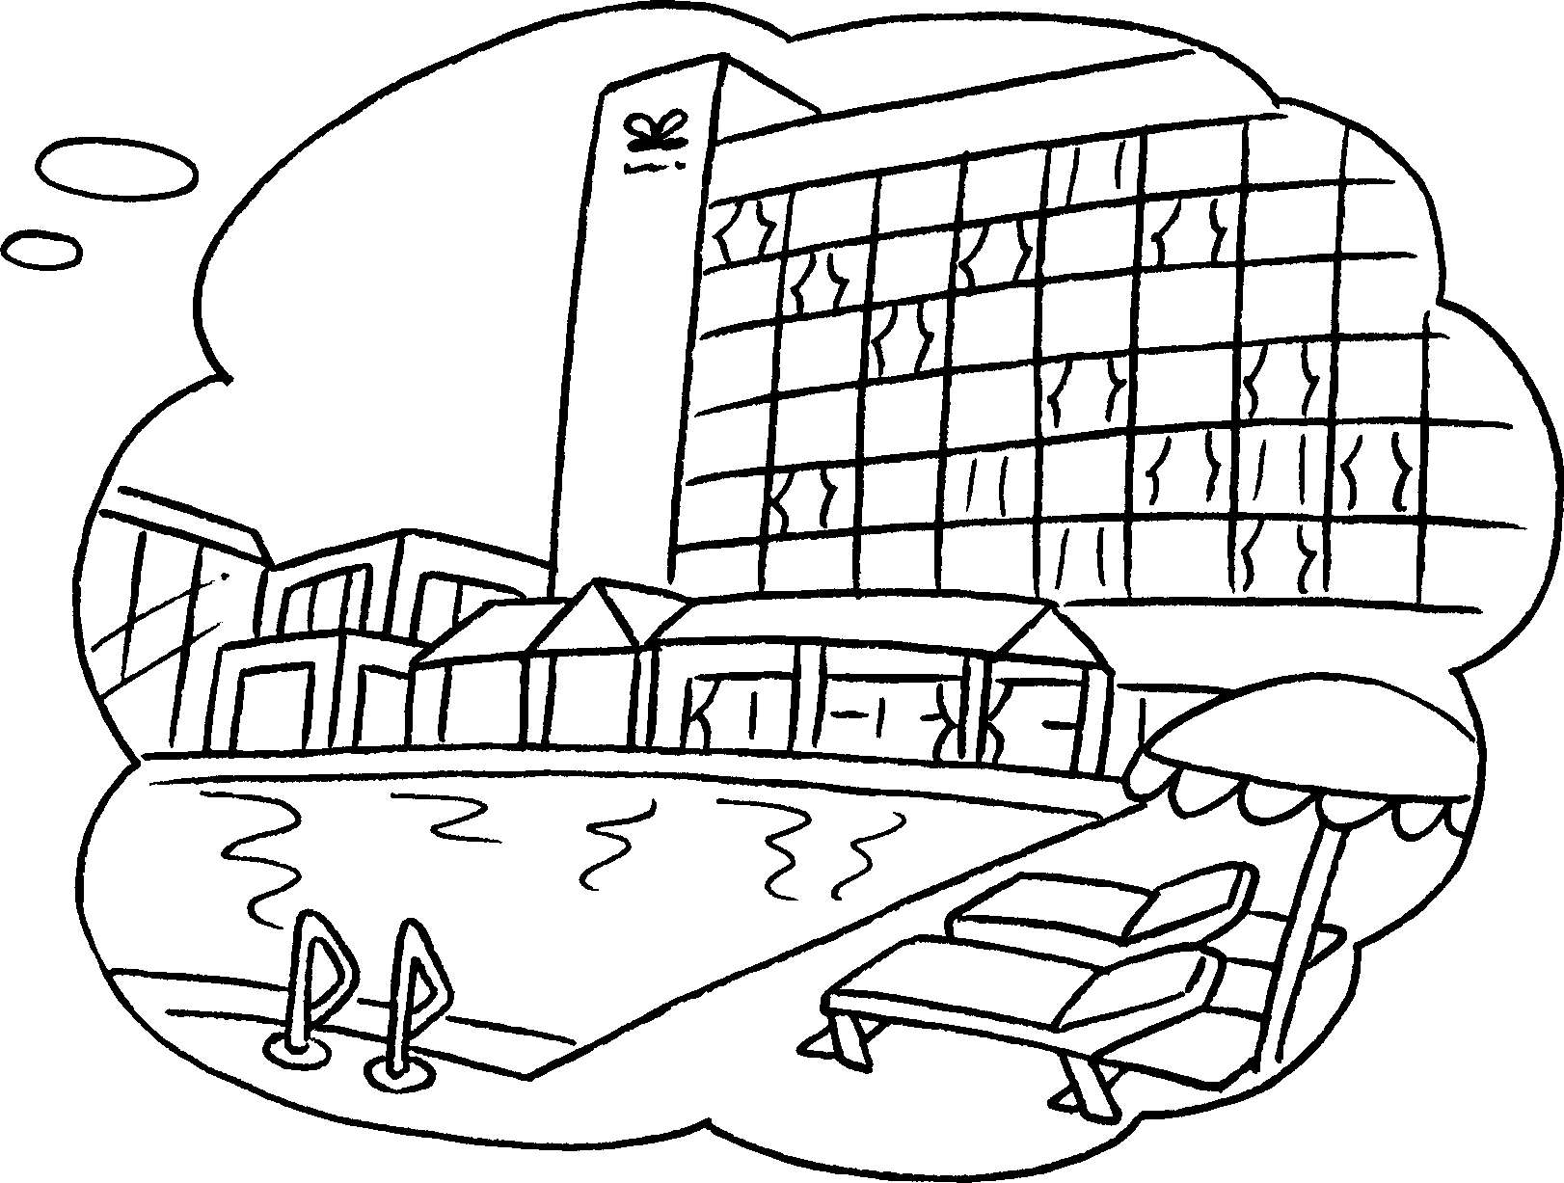 | Where  A : do you  want to go?  B : I want to  to the hotel.
2 | 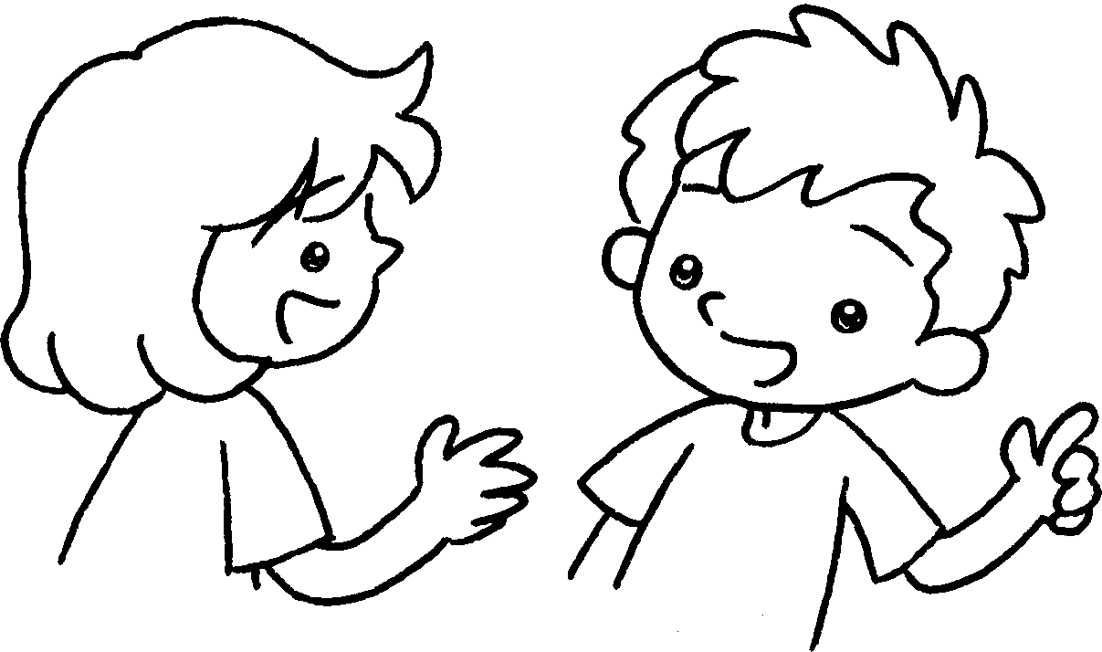 | 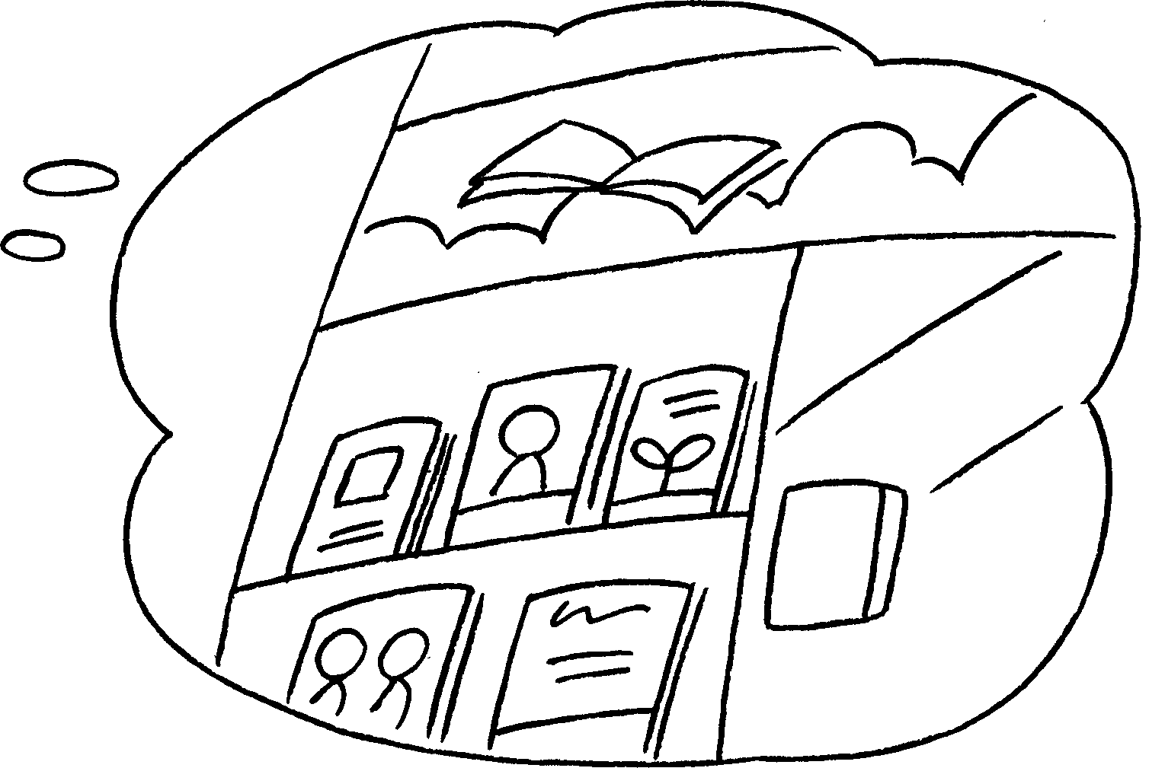 | A : do you  want to go?  B : I want to go to the  .
3 | 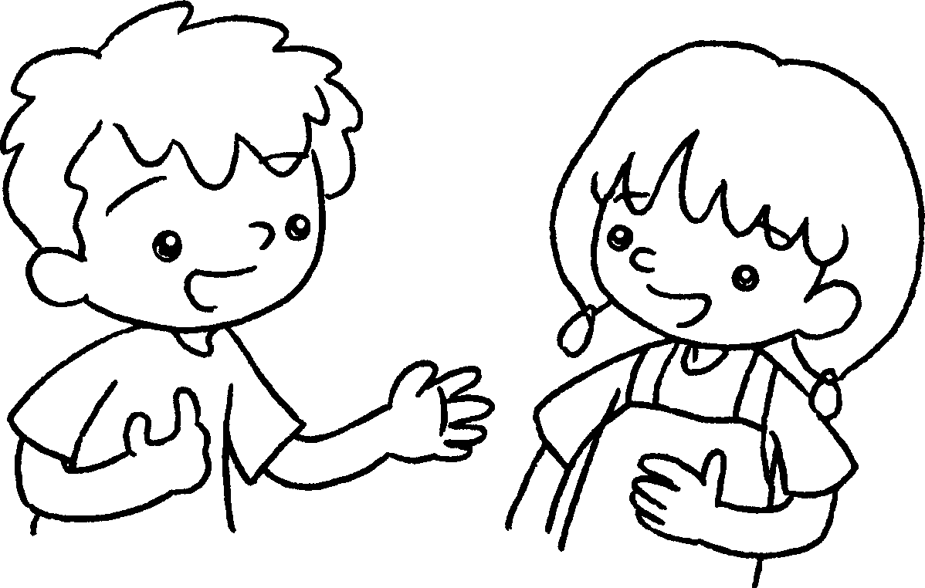 | 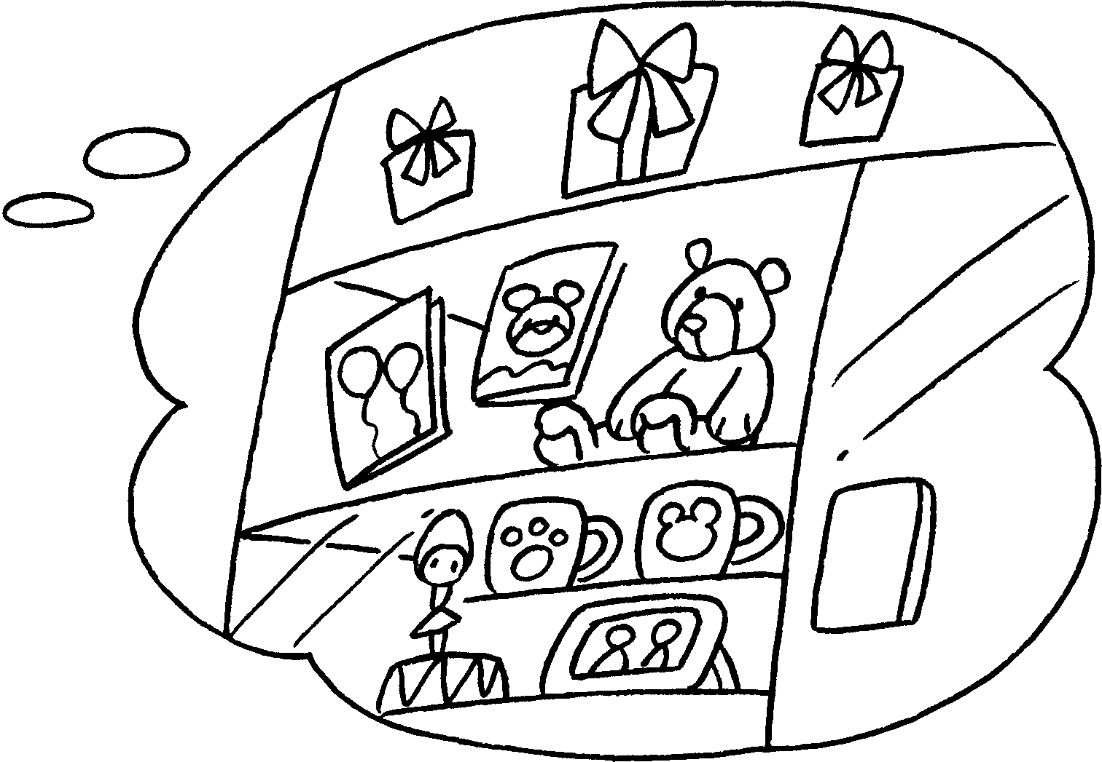 | A : do you  want to go?  B : I want to go to the  .
4 | 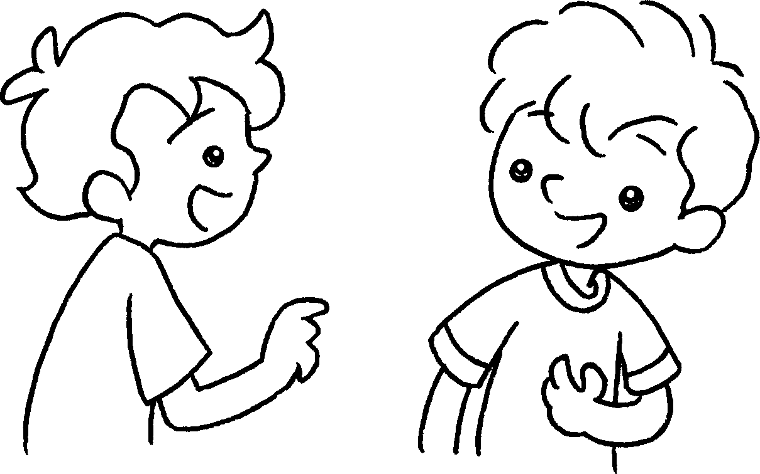 | 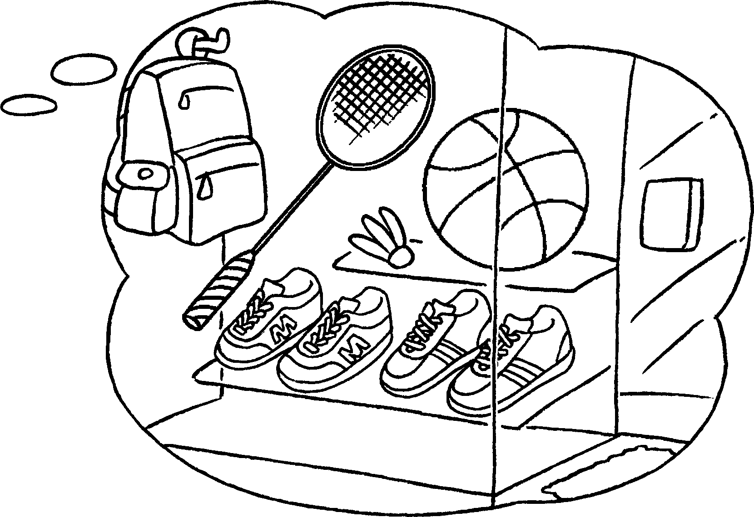 | A : do you  ?  B : I  .



Book 3A Chapter 4 Graded Worksheets
Worksheet 3⬇⬇
- go
- Where
book shop
- Where
gift shop
- Where want to go
want to go to the sportswear shop

