Where do the children want to go? Finish what they say.
A
1 | 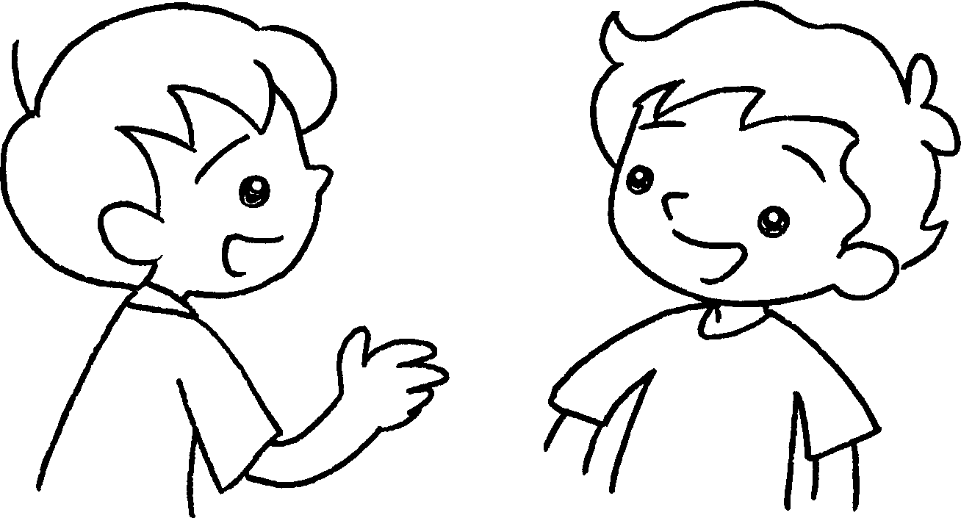  buffet lunch  B | 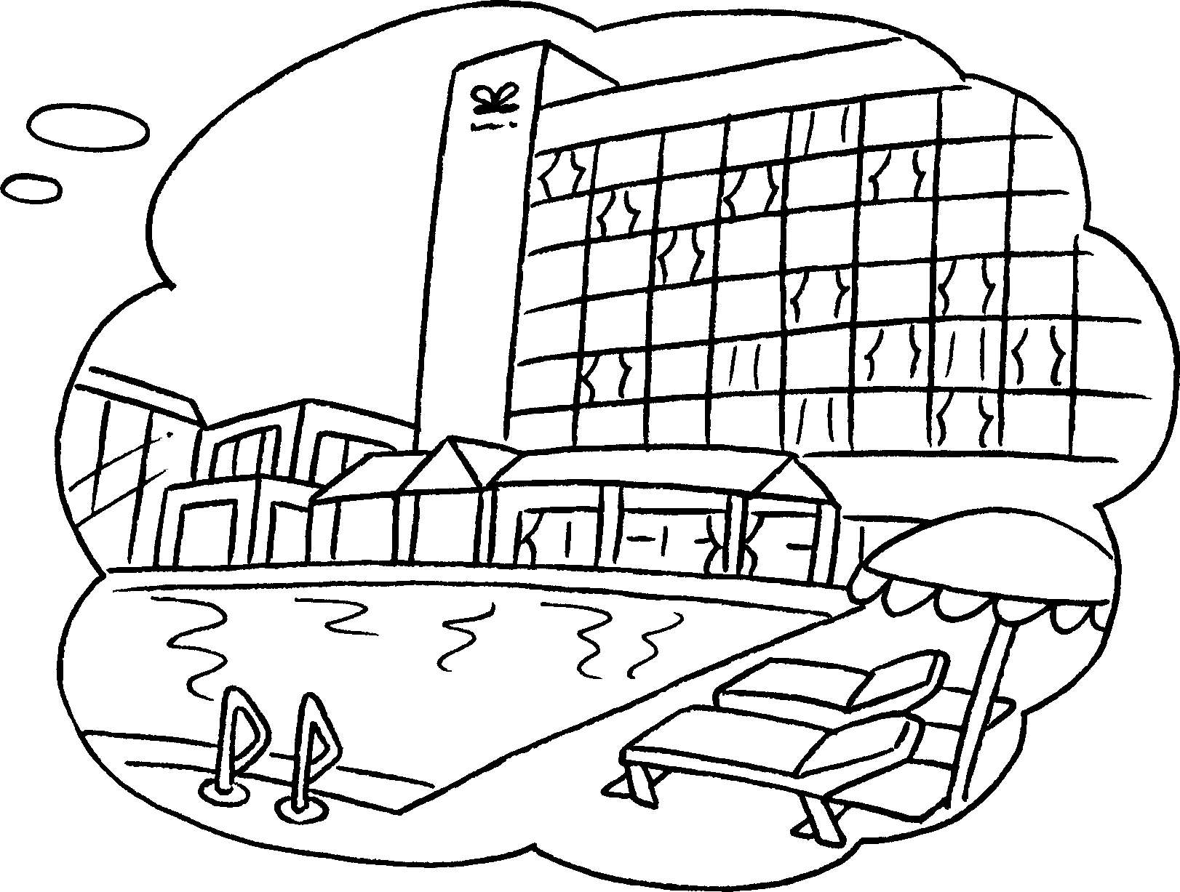 | Where  A : do you  want to go ?  B : I want to to the hotel because I want to have a buffet lunch.
2 | 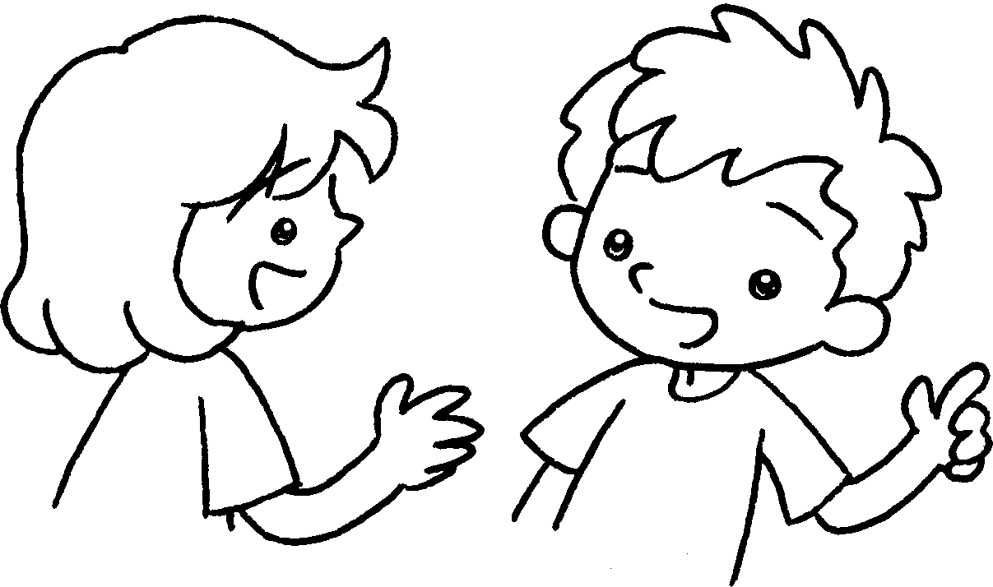  comic  B  A | 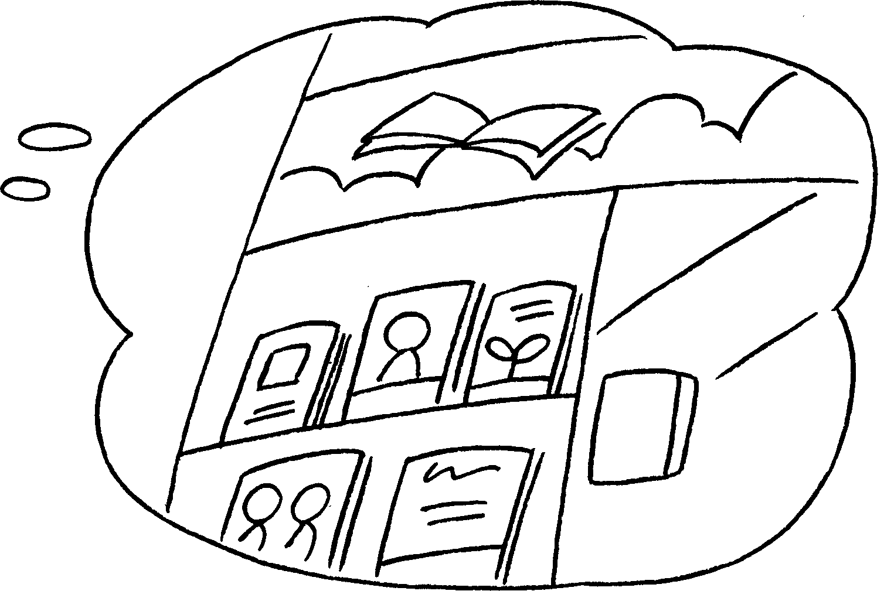 | A : do you  want to go?  B : I want to go to the  because I want to buy  .
3 | 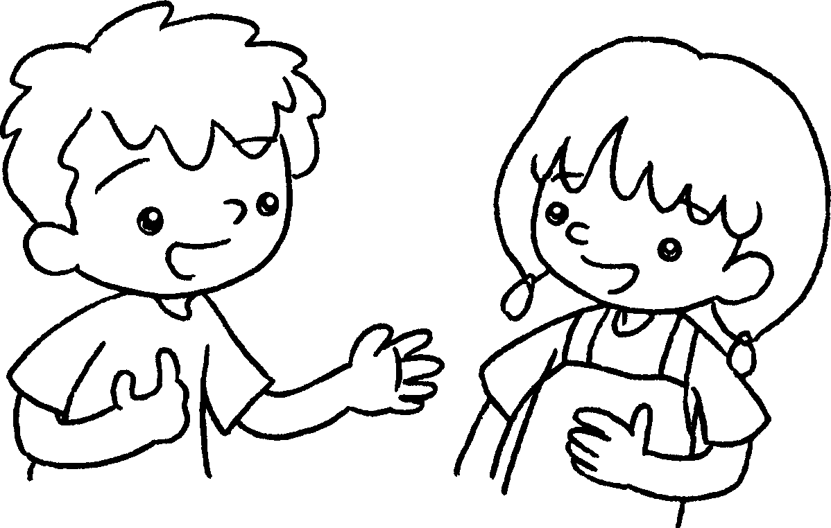  card  A  B | 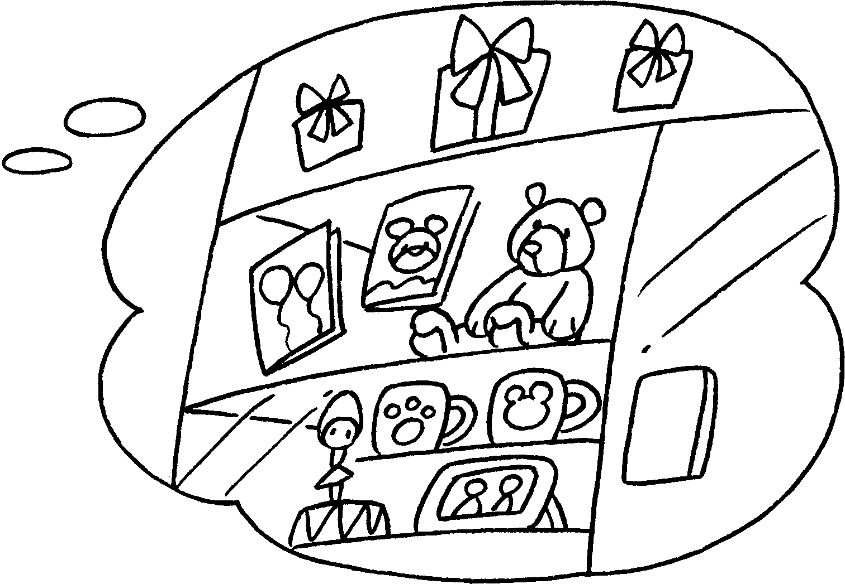 | A : do you  ?  B : I want to go to the  because  .
4 | 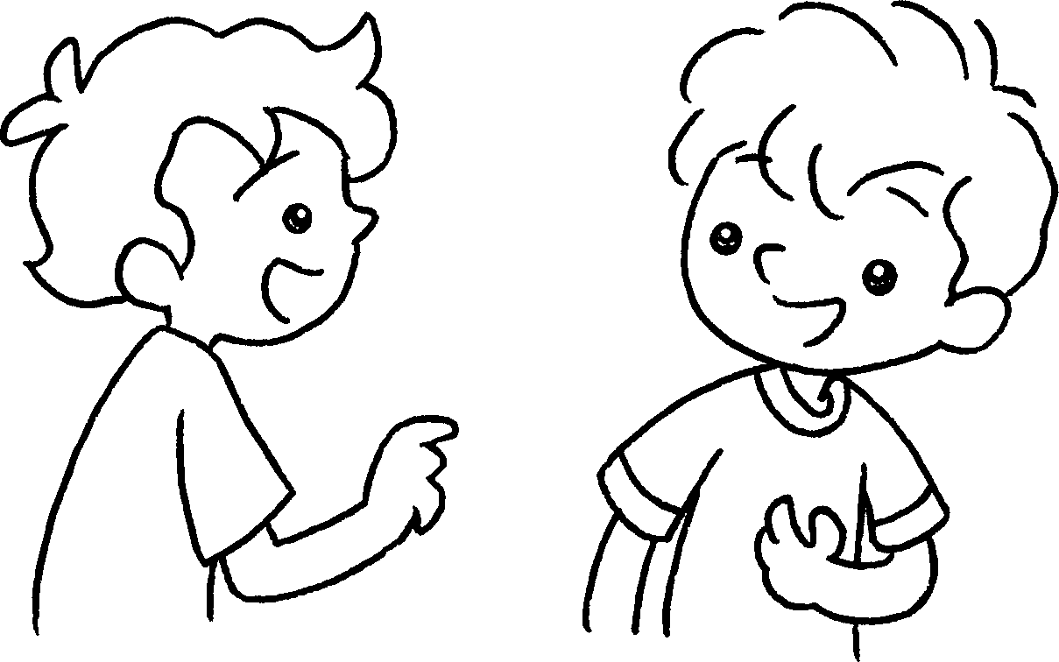  trainers  A  B | 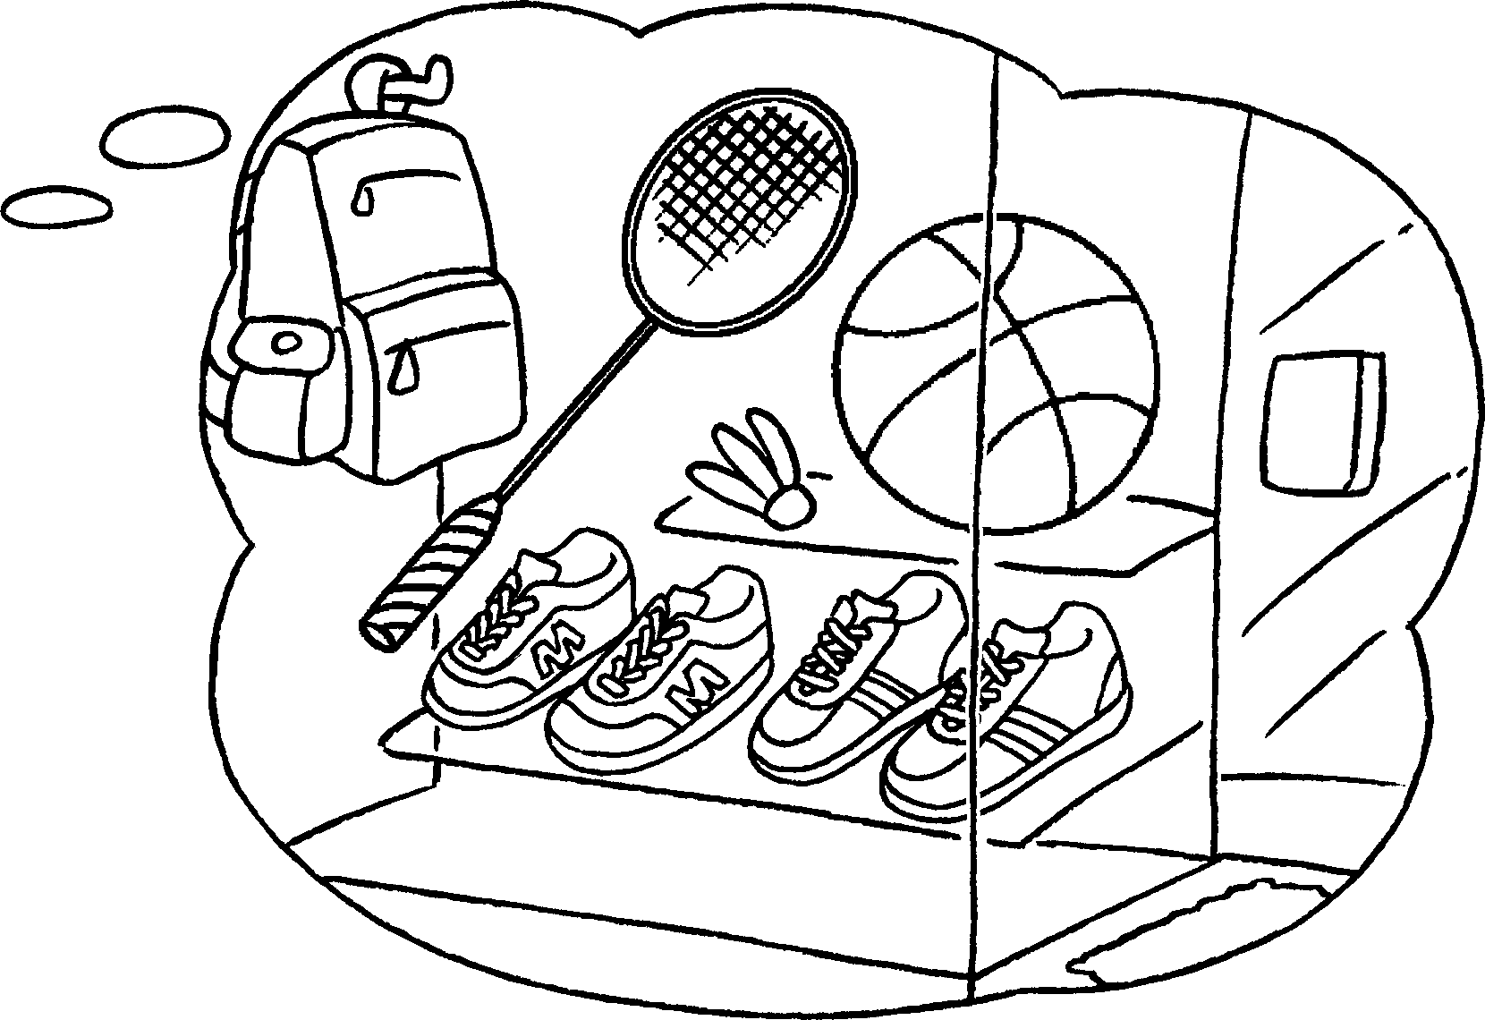 | A :  B :


Book 3A Chapter 4 Graded Worksheets
Worksheet 3⬇⬇⬇
- go
- Where
book shop a comic
3 Where want to go
gift shop I want to buy a card
4 Where do you want to go?
I want to go to the sportswear shop because I want to buy trainers.
(Accept any reasonable answers.)

