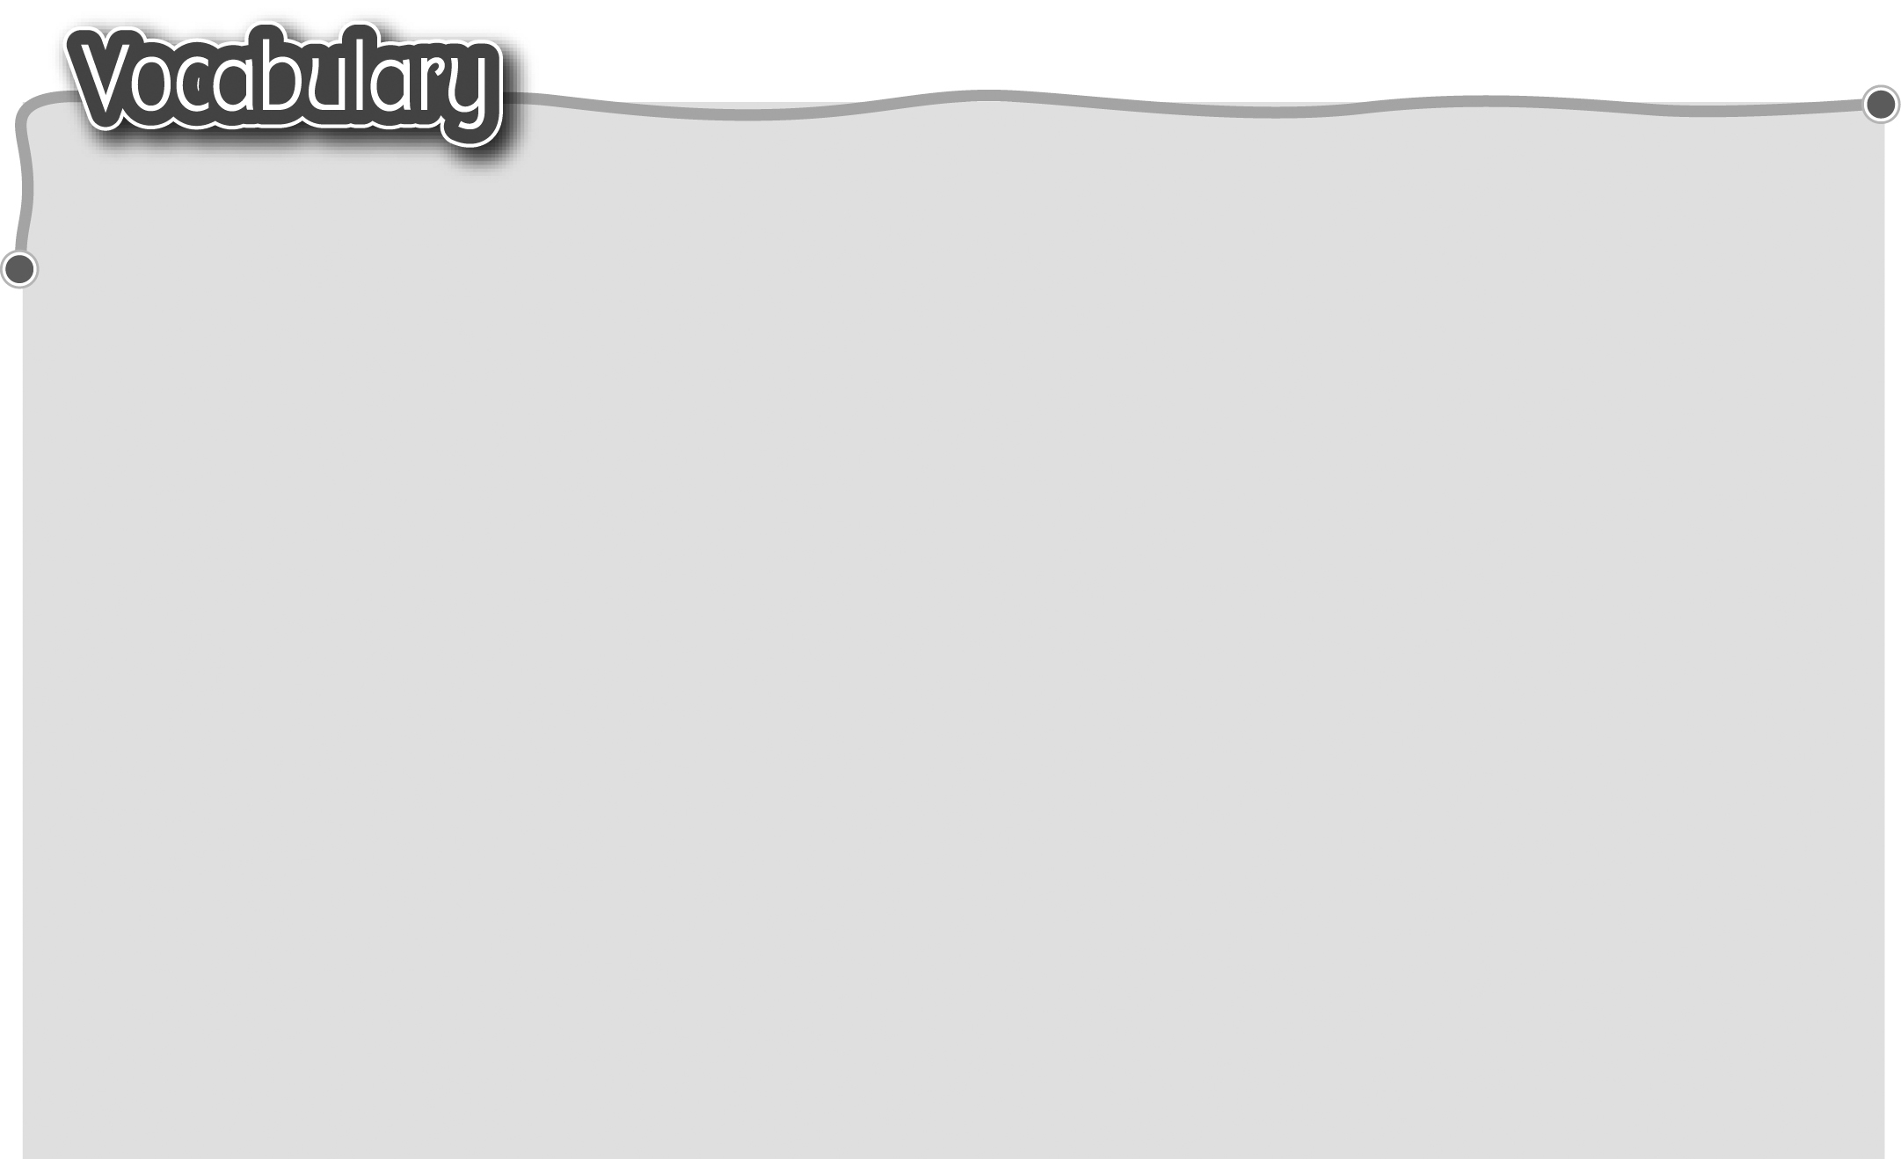
1 have afternoon tea 10 book shop 書店
The words marked with * have different meanings in other
contexts. You can look up those meanings in a dictionary.
喝下午茶 11 buy jeans 買牛仔褲
2 cafe 咖啡店 12 clothes shop 服裝店
3 have a buffet lunch 13 buy a card 買賀卡
吃自助午餐 14 gift shop 禮品店
4 hotel 酒店 15 buy trainers 買運動鞋
5 watch a film 看電影 16 sportswear shop 運動服裝店
6 cinema 戲院 17 buy sweets and chocolate
7 eat dim sum 吃點心 買糖果和朱古力
8 restaurant 酒樓/餐廳 18 sweet shop糖果店
9 buy a comic 買漫畫書

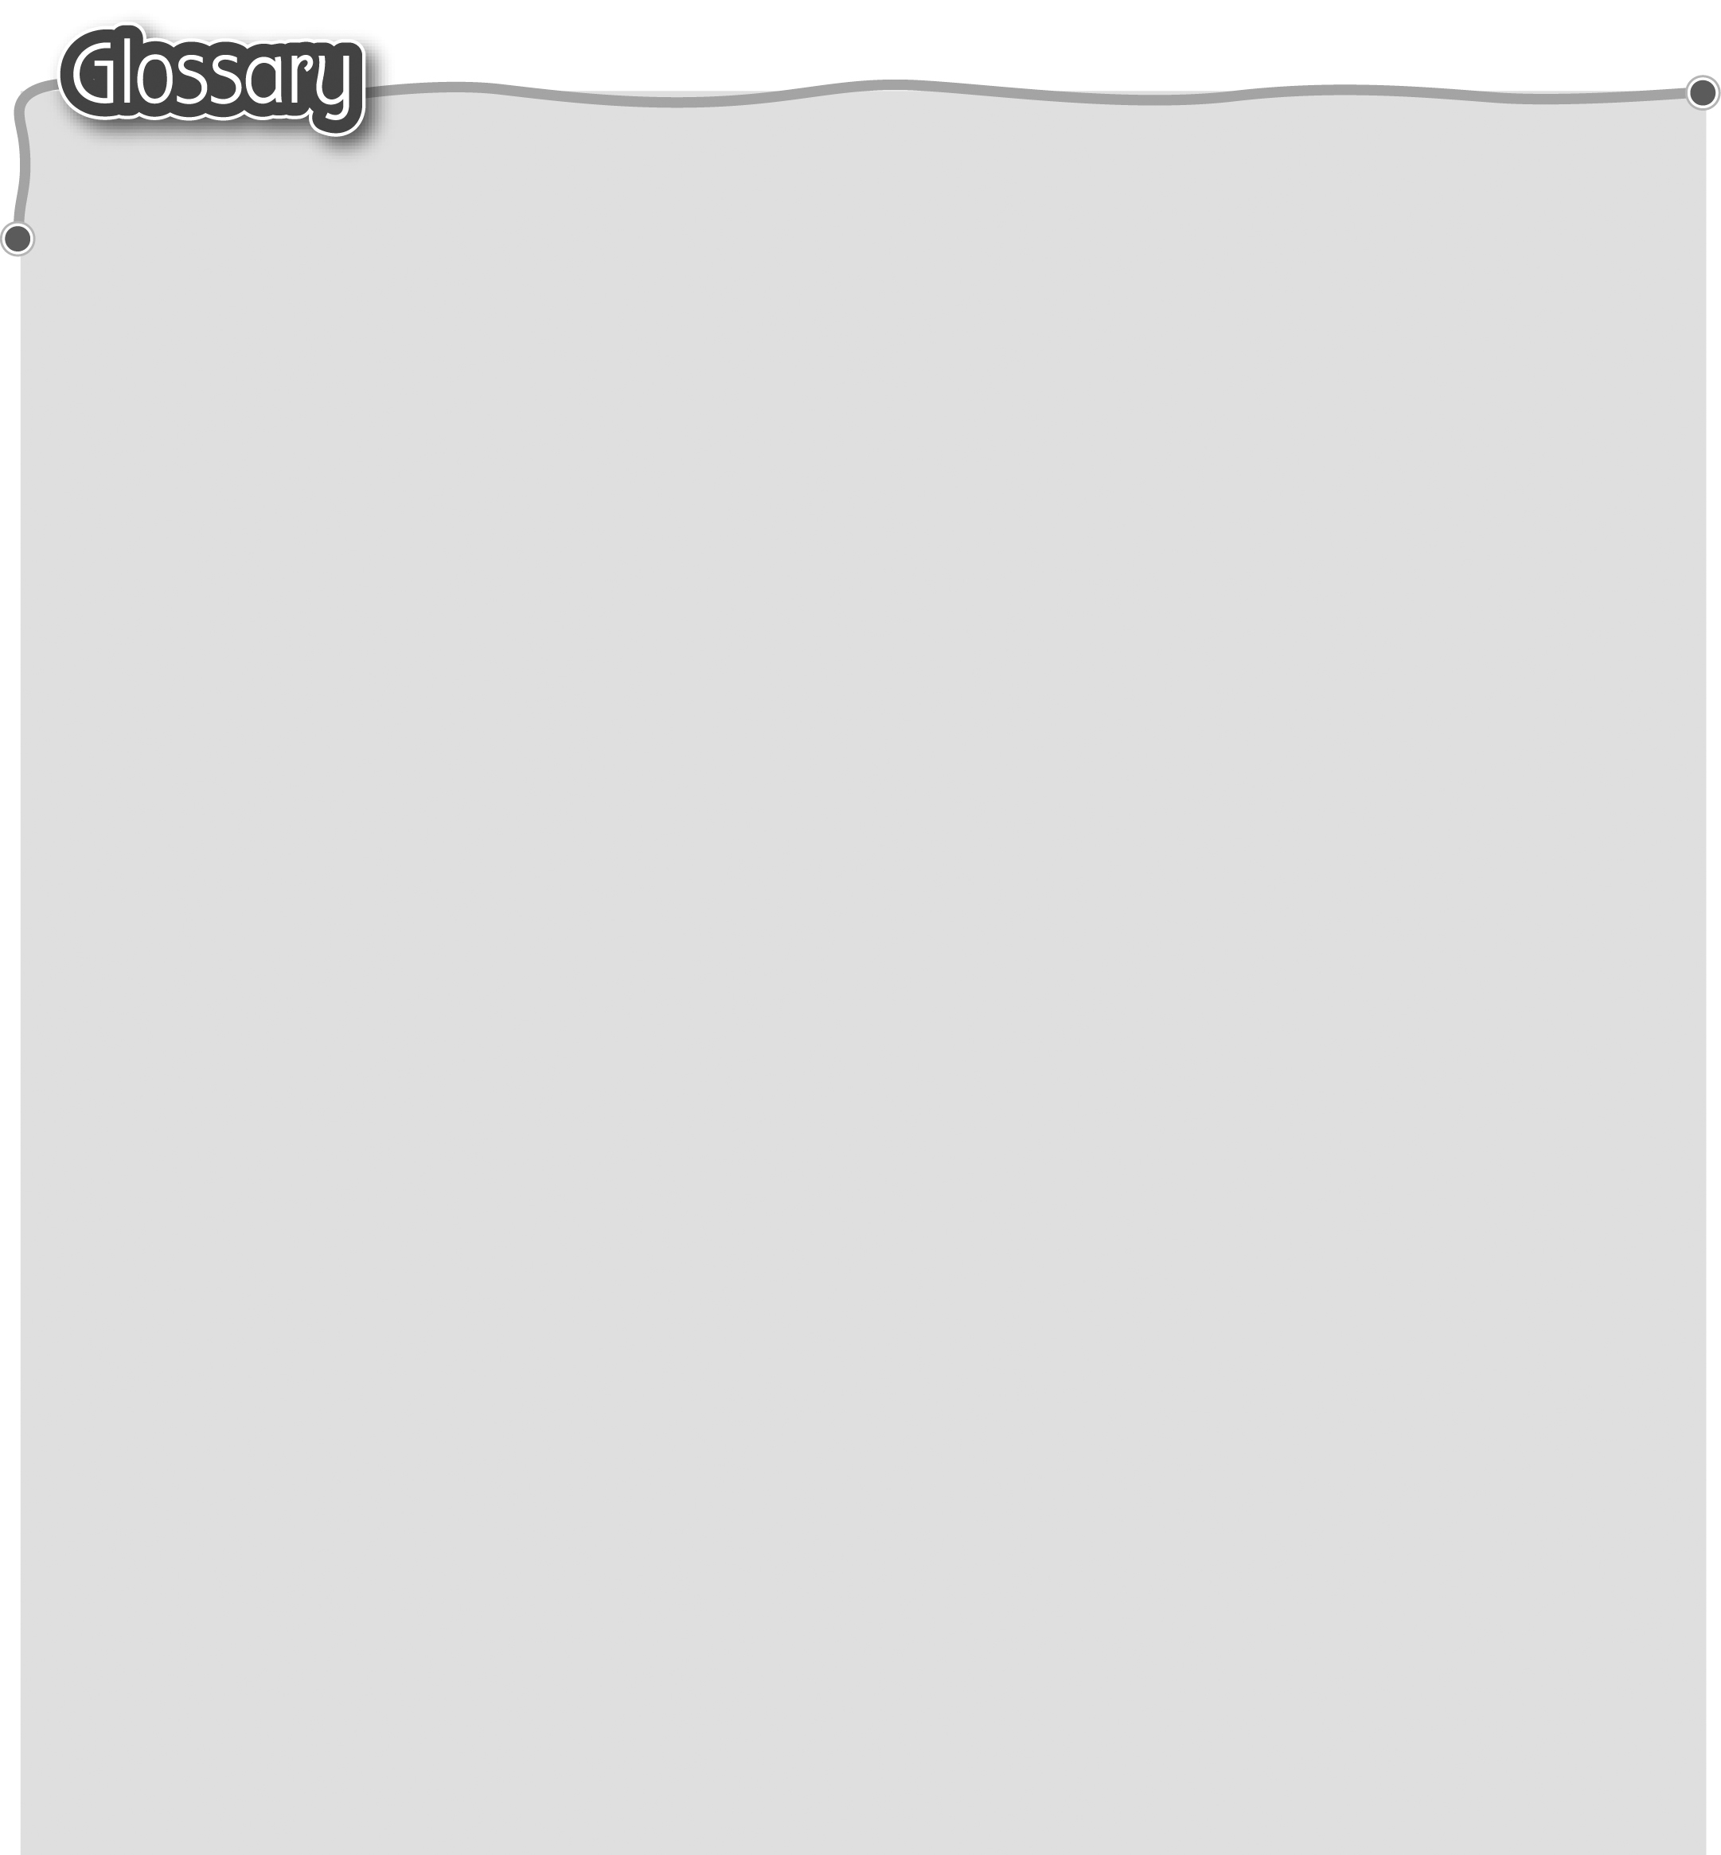
1 non-stop (p.28) 7 should (p.29) 應該
不停地（副詞） 8 enough (p.34) 足夠
2 another pair of (p.28) 9 take place (p.34) 發生
另一對 10 happen (p.34) 發生
3 all (p.28) 全部 11 present* (p.34) 禮物（名詞）
4 hop* (p.29) 單腳跳（動詞） 12 because (p.35) 因為
5 their* (p.29) 他們的 13 shopkeeper (p.35) 店主
6 maybe (p.29) 或許

