Choose and write.
English Camp | Exam Week |  | Open Day |  | Parents’ Day
Sports Day |  | school picnic |  | Test Week

1 |  |  |  |  | 2 | 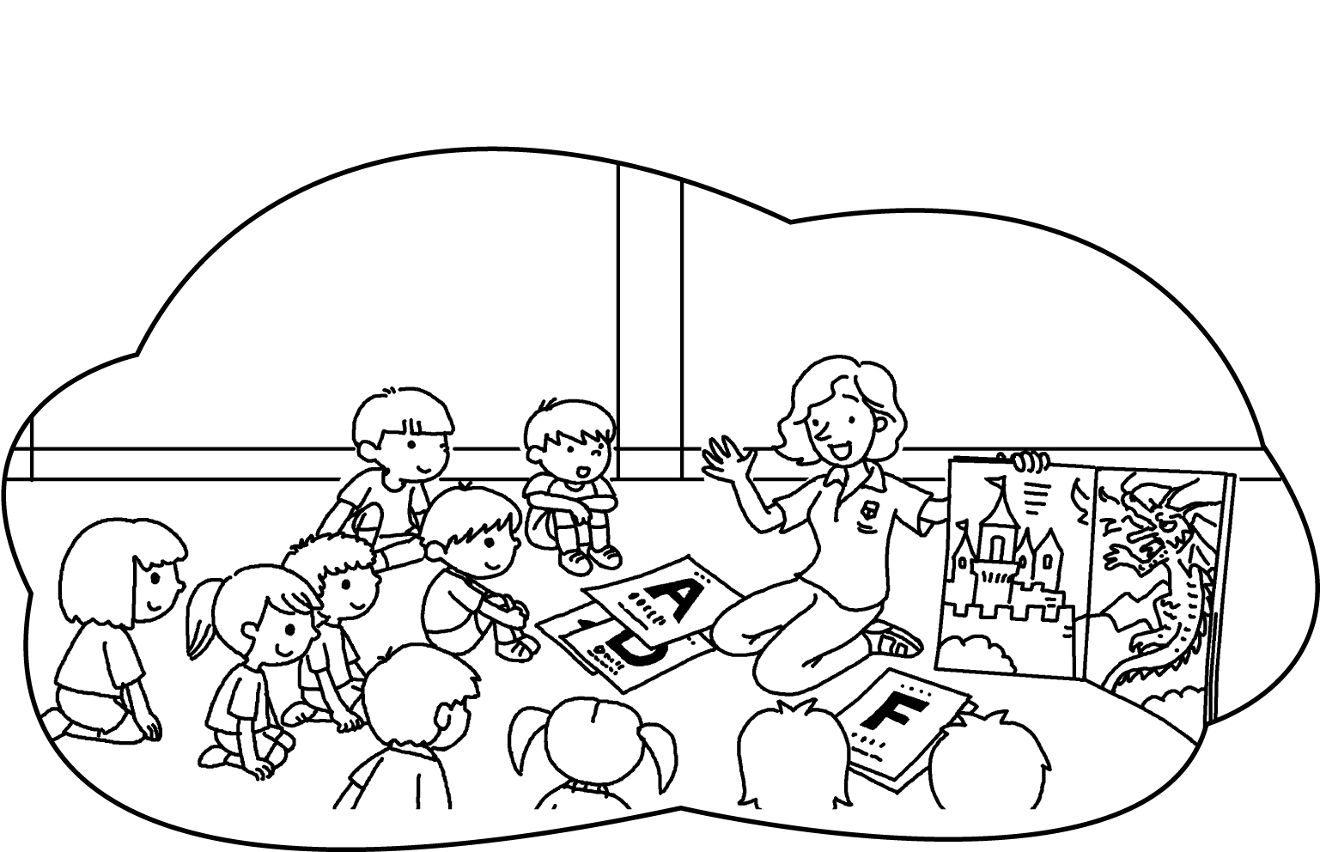
3 | 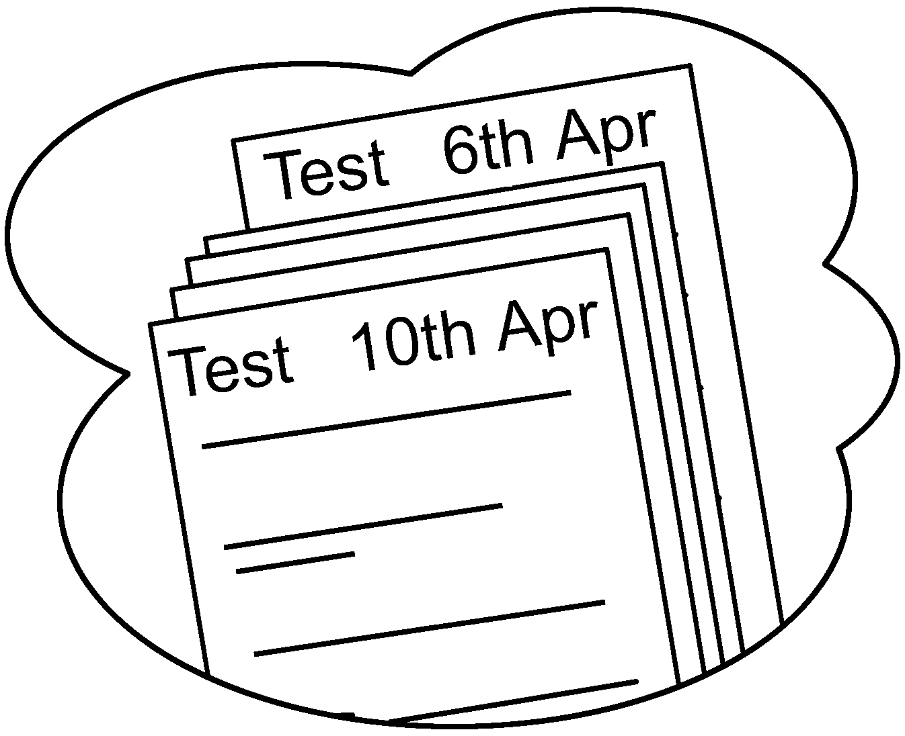 | 4 | 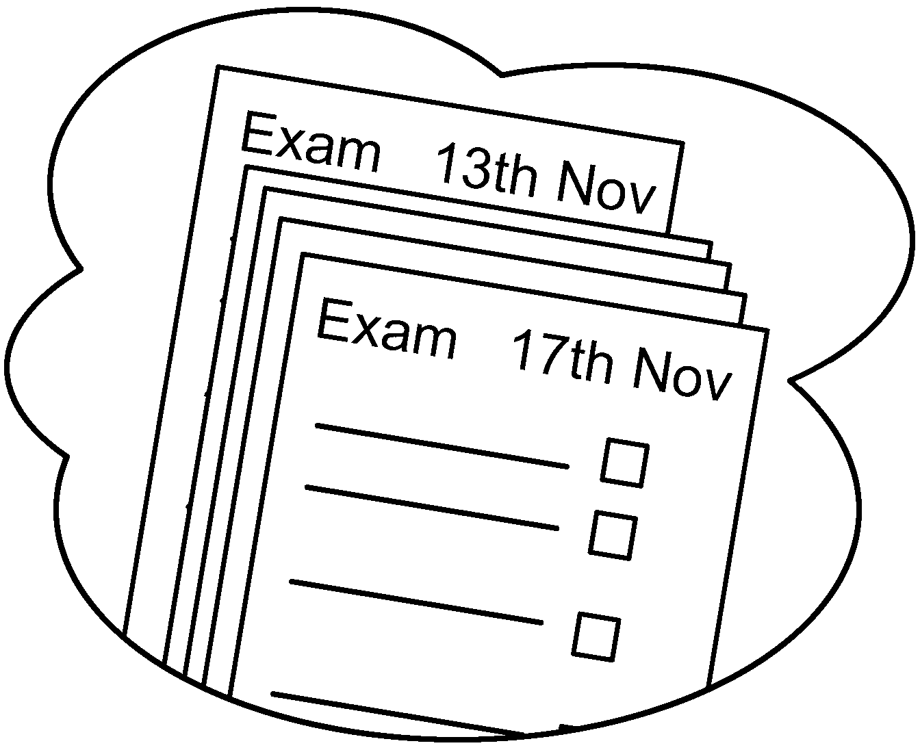 |  |  |  | 5 | 
6 | 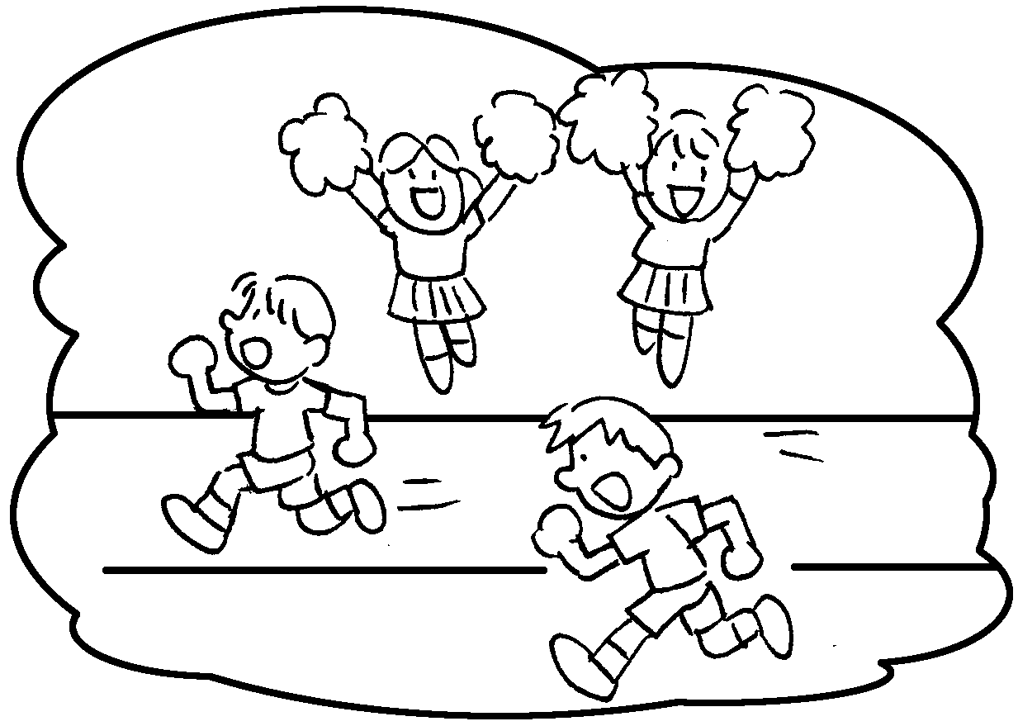 |  |  |  | 7 | 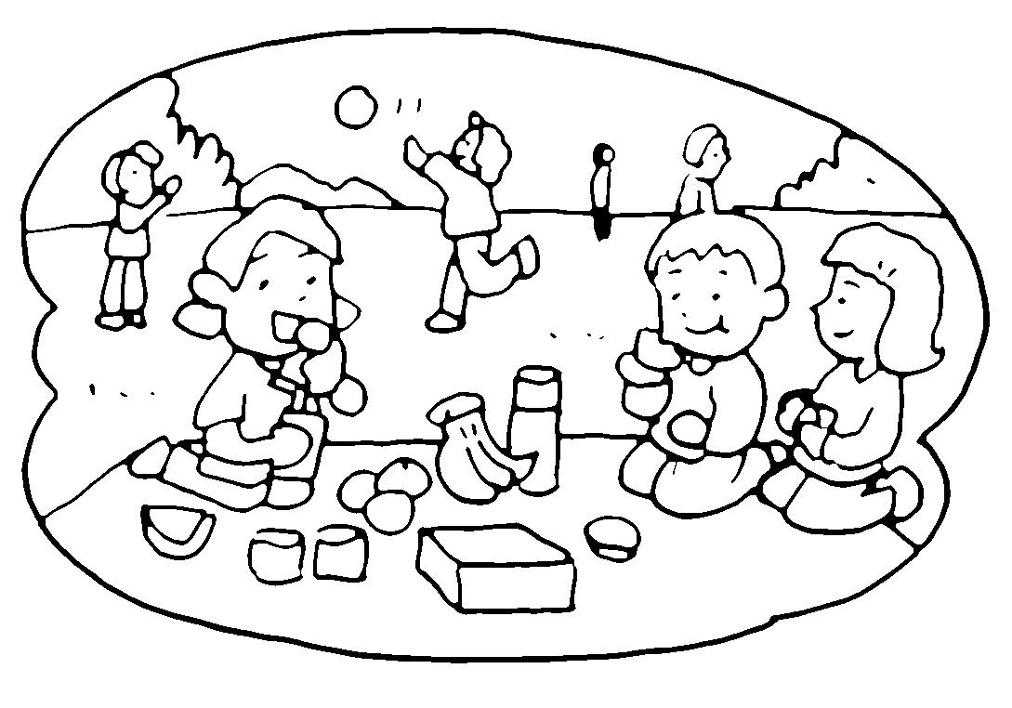

1 |  |  | 2
3 |  |  | 4
5 |  |  | 6
7 | the


Book 3A Chapter 5 Graded Worksheets
Worksheet 1⬇
1 Open Day 2 English Camp
3 Test Week 4 Exam Week
5 Parents’ Day 6 Sports Day
7 school picnic

