Choose and write.
When |  | on | from | to

1 | 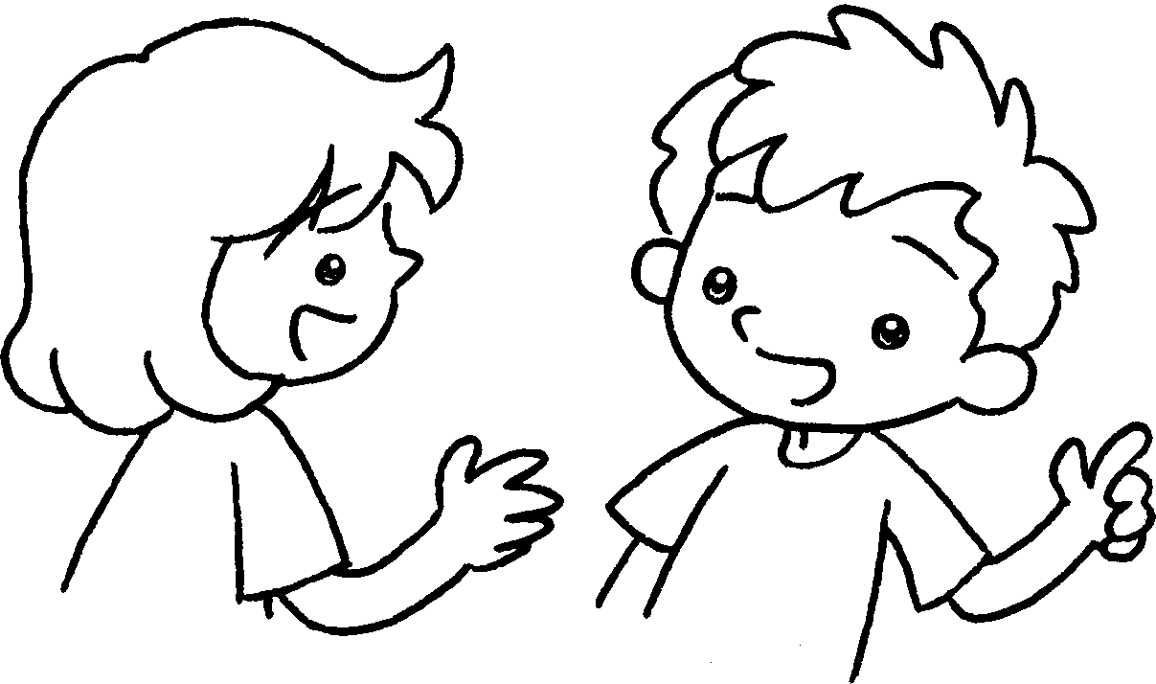 |  | A : ’s the school picnic?  B : It’s the twenty-fifth  of November.
2 |  |  | A : ’s English Camp?  B : It’s the thirteenth of  April the seventeenth  of April.
3 | 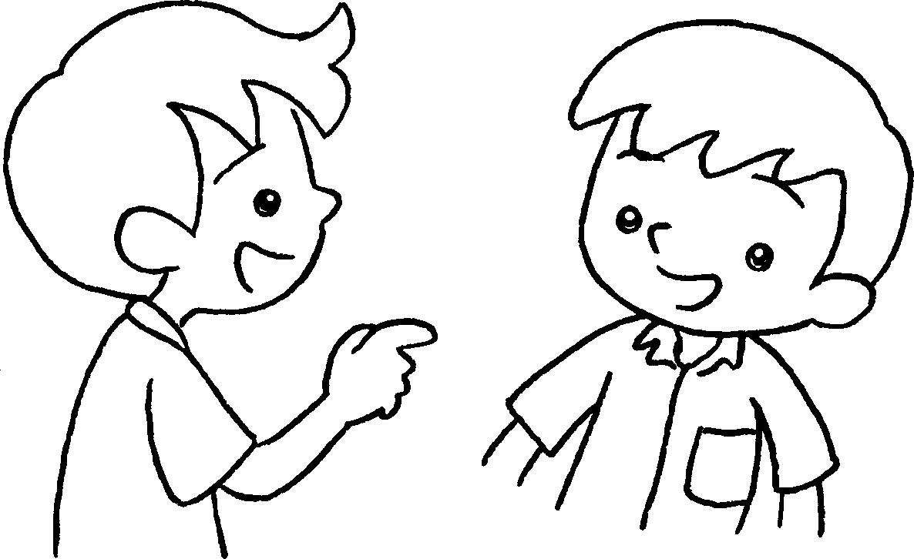 |  | A : ’s Parents’ Day?  B : It’s the tenth of  February.
4 |  |  | A : ’s Test Week?  B : It’s the third of June  the seventh of June.
25/11
13/4-17/4
10/2
3/6-7/6
A
B
A
B
A
B
A
B


Book 3A Chapter 5 Graded Worksheets
Worksheet 3⬇
- When
on
- When
from to
- When
on
- When
from to

