25/11
13/4-17/4
A
B
Finish what the children say.
on | from | to

1 | 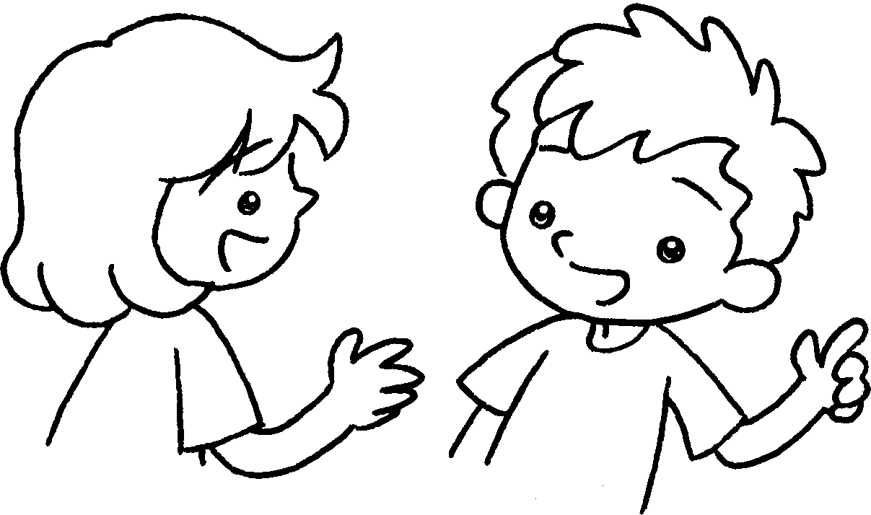 |  | When  A : ’s the school picnic?  B : It’s the twenty-fifth  of November.
2 | 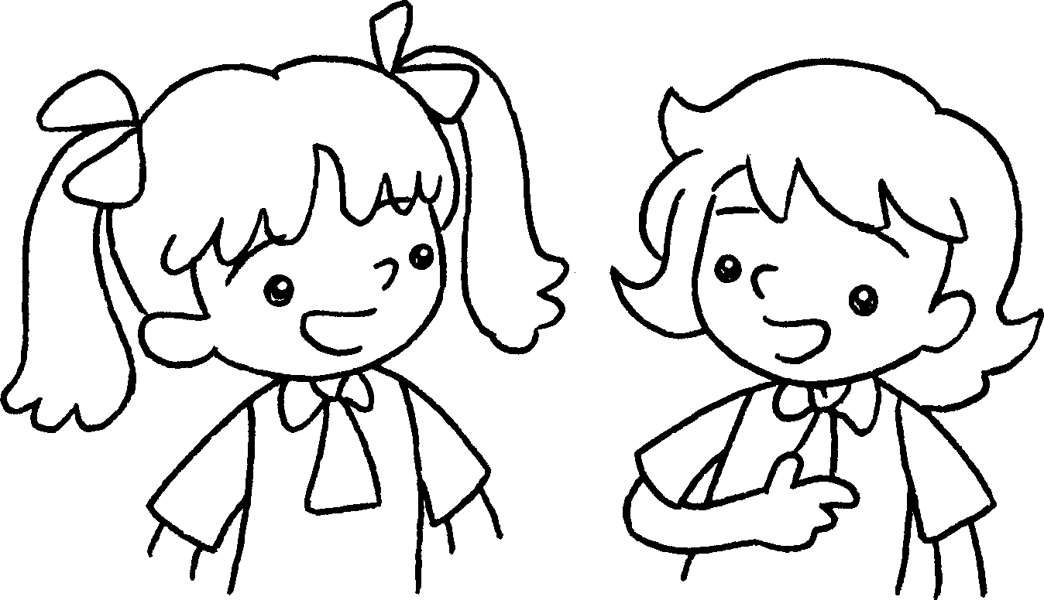 |  | A : ’s English Camp?  B :It’s the of April the  of April.
3 | 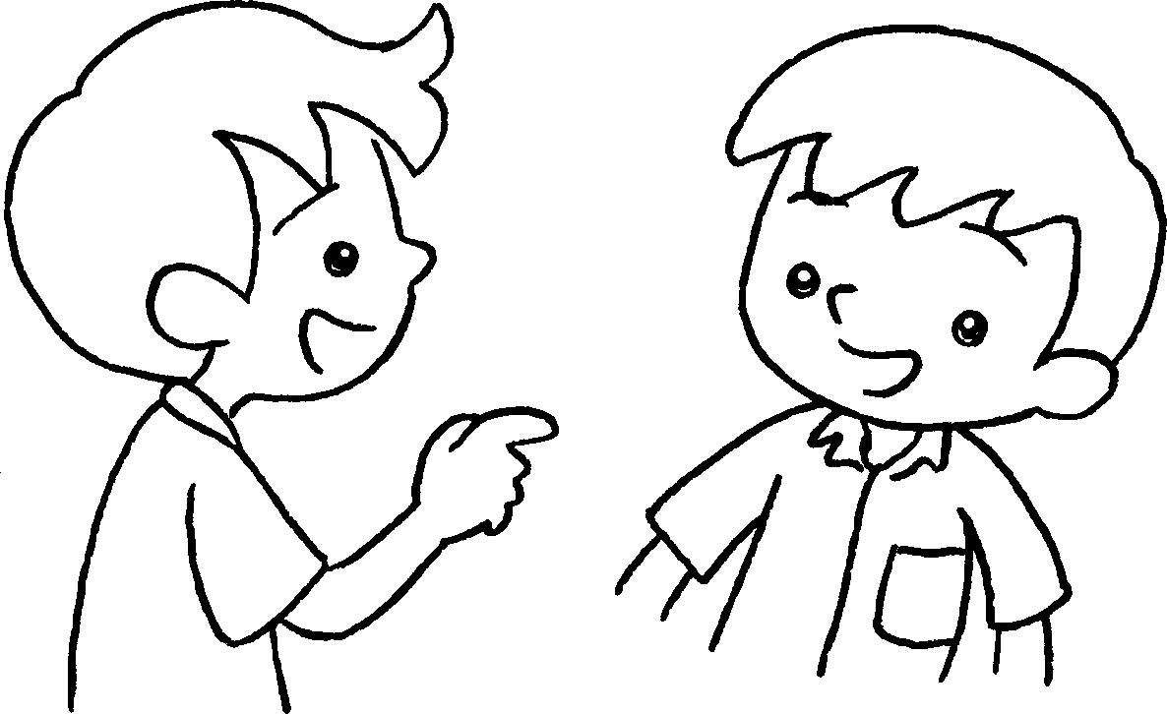 |  | A : ’s Parents’ Day?  B : It’s  .
4 |  |  | A : ’s Test Week?  B : It’s  .
25/11
13/4-17/4
10/2
3/6-7/6
A
B
A
B
A
B
A
B



Book 3A Chapter 5 Graded Worksheets
Worksheet 3⬇⬇
- on
- When
from thirteenth to seventeenth
- When
on the tenth of February
- When
from the third of June to the seventh of June

